Living on the edge: Forest edge effects on microclimate and terrestrial mammal activity in disturbed lowland forest in Sumatra, Indonesia

Helen D. Slater, Phillipa K. Gillingham, Victoria Pratt, Ben Eaton, Simon Fletcher, Abdullah Abdullah, Supriadi, and Amanda H. Korstjens

Supplementary material is published as supplied by the authors. It is not checked for accuracy, copyedited, typeset or proofread. The responsibility for scientific accuracy and file functionality remains with the authors.

SUPPLEMENTARY TABLE 1 Environmental variables collected from all monitoring locations at Sikundur.
Variable | Description(units)
T_{hour} | Hourly temperature (°C)
T_{day} | Mean temperature of each 24-hour period (°C)
T_{max} | Maximum temperature of each 24-hour period (°C)
T_{min} | Minimum temperature of each 24-hour period (°C)
Li_{hour} | Hourly light intensity (lux)
Li_{day} | Mean light intensity recorded of each 24-hour period (lux)
Li_{max} | Maximum light intensity recorded of each 24-hour period (lux)
Total height | Total tree height for each tree (m)
Bole height | Height to the first major branch for each tree (m)
Number of trees | Total number of trees DBH > 10 cm per plot
DBH | Diameter at breast height for each tree (cm)
HDR | Height to DBH ratio for each tree
Crown area | Estimated crown area for each tree (m²)
Connectivity | Estimated connectivity with neighbouring crowns for each tree (%)

SUPPLEMENTARY TABLE 2 Descriptive statistics of forest structure variables collected from plots at different distances from the forest edge at Aras Napal (µ = mean, SD = standard deviation).
 |  | All locations | 0 km | 0.5 km | 1 km | 1.5 km | 2 km
Number of trees per plot | N | 20 | 4 | 4 | 4 | 4 | 4
 | µ | 10.85 | 12.13 | 13.50 | 11.23 | 10.71 | 11.11
 | SD | 3.41 | 1.18 | 2.38 | 1.58 | 2.70 | 3.61
Tree height, m | N | 217 | 48 | 52 | 44 | 35 | 38
 | µ | 19.45 | 17.48 | 17.44 | 21.83 | 21.43 | 20.08
 | SD | 8.27 | 6.34 | 6.79 | 8.51 | 10.37 | 8.93
Bole height, m | N | 217 | 48 | 52 | 44 | 35 | 38
 | µ | 10.71 | 8.06 | 9.13 | 12.68 | 12.24 | 12.51
 | SD | 6.08 | 4.61 | 4.90 | 6.85 | 6.84 | 5.67
Diameter at breast height, cm | N | 217 | 48 | 52 | 44 | 35 | 38
 | µ | 33.45 | 34.62 | 30.11 | 33.68 | 32.49 | 31.36
 | SD | 13.58 | 13.26 | 9.98 | 17.96 | 14.55 | 11.40
Height:DBH ratio | N | 217 | 48 | 52 | 44 | 35 | 38
 | µ | 61.39 | 52.15 | 59.23 | 67.89 | 66.46 | 63.80
 | SD | 16.94 | 13.97 | 16.78 | 15.70 | 15.42 | 18.32
Crown area, m² | N | 217 | 48 | 52 | 44 | 35 | 38
 | µ | 44.86 | 45.73 | 38.09 | 53.76 | 50.76 | 37.31
 | SD | 36.74 | 33.98 | 29.37 | 45.83 | 42.74 | 29.26
Canopy connectivity, % | N | 217 | 48 | 52 | 44 | 35 | 38
 | µ | 45.00 | 44.27 | 44.23 | 44.43 | 43.86 | 48.68
 | SD | 25.33 | 20.68 | 24.22 | 23.33 | 20.37 | 28.18

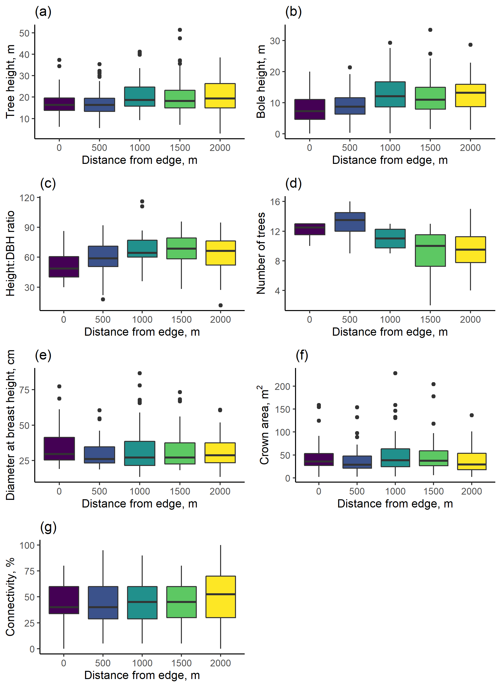
SUPPLEMENTARY FIG. 1 Forest structure variables recorded from plots at different distances form the forest edge at Aras Napal: (a) Tree top height, m; (b) height to first major branch, m; (c) height:DBH ratio; (d) number of trees per plot; (e) Diameter at breast height, cm; (f) crown area, m²; and (g) Crown connectivity, %.

SUPPLEMENTARY TABLE 3 Descriptive statistics of hourly and daily microclimate recorded at different distances from the forest edge at Aras Napal (µ = mean, SD = standard deviation).
 |  | All locations | 0 km | 0.5 km | 1 km | 1.5 km | 2 km
Hourly temperature, °C | N | 21071 | 4005 | 4266 | 4270 | 4274 | 4256
 | µ | 25.54 | 26.06 | 25.38 | 25.24 | 25.55 | 25.49
 | SD | 2.25 | 3.00 | 2.09 | 1.79 | 2.09 | 2.07
Hourly light intensity, lux | N | 21071 | 4005 | 4266 | 4270 | 4274 | 4256
 | µ | 1075.59 | 2866.37 | 751.40 | 474.54 | 663.04 | 732.70
 | SD | 2890.35 | 5847.67 | 1462.34 | 812.08 | 1068.53 | 1209.76
Daily mean temperature, °C | N | 244 | 49 | 49 | 49 | 49 | 48
 | µ | 25.55 | 26.05 | 25.38 | 25.23 | 25.56 | 25.51
 | SD | 0.75 | 0.83 | 0.72 | 0.61 | 0.68 | 0.66
Daily maximum temperature, °C | N | 244 | 49 | 49 | 49 | 49 | 48
 | µ | 30.33 | 33.75 | 30.44 | 28.58 | 29.50 | 29.36
 | SD | 2.45 | 2.32 | 1.98 | 1.15 | 1.24 | 1.21
Daily minimum temperature, °C | N | 244 | 49 | 49 | 49 | 49 | 48
 | µ | 22.99 | 22.81 | 22.87 | 23.07 | 23.12 | 23.06
 | SD | 0.72 | 0.76 | 0.76 | 0.70 | 0.68 | 0.68
Daily mean light intensity, lux | N | 244 | 49 | 49 | 49 | 49 | 48
 | µ | 1106.08 | 2842.93 | 771.93 | 474.78 | 674.50 | 759.19
 | SD | 1004.60 | 994.20 | 324.12 | 122.65 | 181.85 | 240.73
Daily maximum light intensity, lux | N | 244 | 49 | 49 | 49 | 49 | 48
 | µ | 9074.33 | 24899.23 | 7293.13 | 3523.55 | 4388.18 | 5188.22
 | SD | 8733.83 | 6720.61 | 2593.22 | 1006.51 | 1427.45 | 1854.69

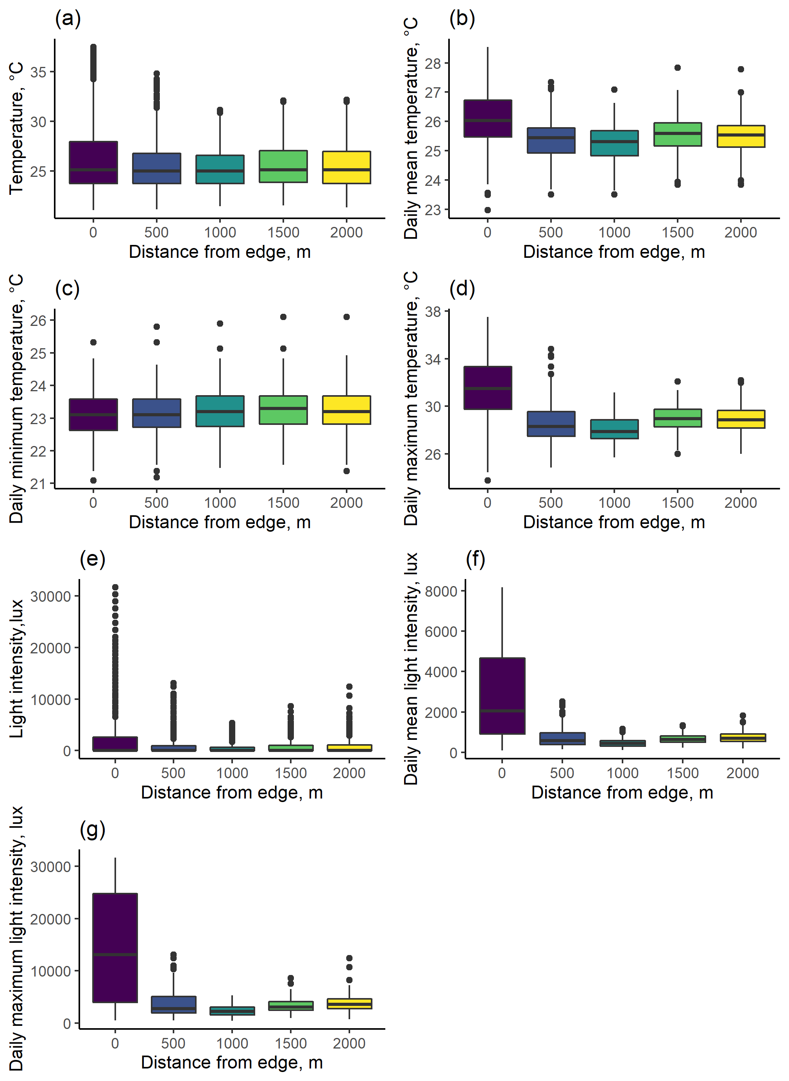
SUPPLEMENTARY FIG. 2: Microclimate conditions recorded from locations at different distances from the forest edge at Aras Napal. (a) Hourly temperature; (b) mean temperature of each day; (c) minimum temperature of each day; (d) maximum temperature of each day; (e) hourly light intensity; (f) mean light intensity of each day; and (g) maximum light intensity of each day.
SUPPLEMENTARY MATERIAL 1

The below text presents R code used to fit Generalized Linear Models and Generalized Linear Mixed Models to determine the effects of distance to the forest edge on forest conditions, and the relationship between microclimate and forest conditions on mammal detections in Sikundur, North Sumatra, Indonesia.

1) Edge effects on forest and microclimate
1a) Generalized Linear Mixed Models of the effects of distance from forest edge on Forest structure
# Load raw datafile
rawveg <- read.csv("trees.csv")
# Format vegetation data:
# Calculate basal area for all indvl trees
basal.area.fn <- function(x){ (pi*(x)^2)/40000 } # calculate basal area in m^2
rawveg["ba"] = basal.area.fn(rawveg$dbh)
# Calculate Lorey's mean height for each plot (mean tree height weighted by basal area)
loreys <- lorey.height(rawveg$ba,rawveg$Theight,group.id=rawveg$camID)
loreys <- rename(loreys, "camID" = group.id, "lorey" = lorey.height)
# Count number of trees per plot
n <- rawveg %>% count(camID)
# Calculate mean, max and min for tree variables
veg <- rawveg %>%
group_by(camID) %>%
summarise(dbh = mean(dbh),height = mean(Theight),bole = mean(Bheight),crown=mean(crown),conn=mean(conn))
# Combine data into one data frame
veg <- merge(veg,n)
veg <- merge(veg,loreys)
veg <- veg %>% rename(LocID=camID)
rawveg <- rawveg %>% rename(Transect=transect)
rawveg <- rawveg %>% rename(LocID=camID)
rawveg$Transect <- factor(rawveg$Transect)
# Run the models:
# Tree height
treeheight.glmm <- lmer(Theight ~ dist + (1|Transect),data = rawveg)
# check model fit
plot(treeheight.glmm)
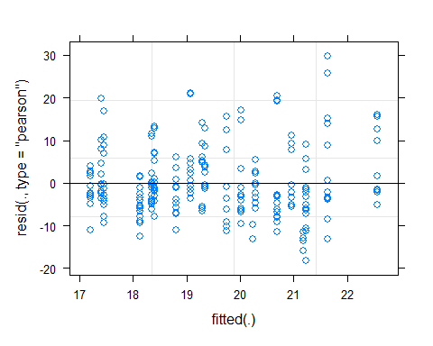
qqnorm(resid(treeheight.glmm))
qqline(resid(treeheight.glmm))
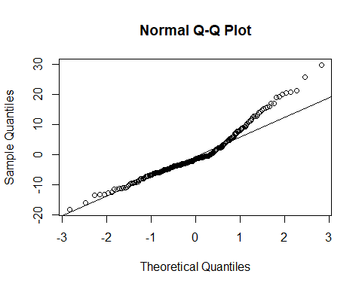
# Summary tables
summary(treeheight.glmm)
## Linear mixed model fit by REML ['lmerMod']
## Formula: Theight ~ dist + (1 | Transect)
## Data: rawveg
##
## REML criterion at convergence: 1536.5
##
## Scaled residuals:
## Min 1Q Median 3Q Max
## -2.2447 -0.6230 -0.1940 0.4627 3.6666
##
## Random effects:
## Groups Name Variance Std.Dev.
## Transect (Intercept) 1.133 1.065
## Residual 65.934 8.120
## Number of obs: 217, groups: Transect, 4
##
## Fixed effects:
## Estimate Std. Error t value
## (Intercept) 1.771e+01 1.052e+00 16.83
## dist 1.884e-03 7.917e-04 2.38
##
## Correlation of Fixed Effects:
## (Intr)
## dist -0.682
# Bole height
bole.glmm <- lmer(Bheight ~ dist + (1|Transect), data = rawveg)
# check model fit
plot(bole.glmm)
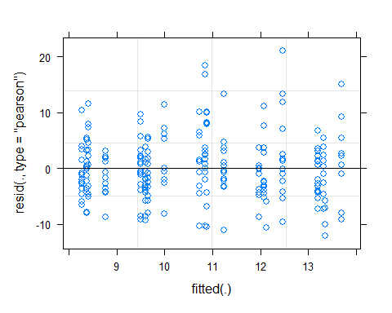
qqnorm(resid(bole.glmm))
qqline(resid(bole.glmm))
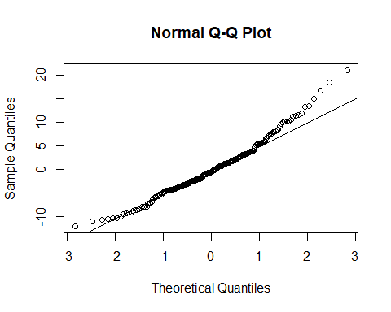
# Summary tables
summary(bole.glmm)
## Linear mixed model fit by REML ['lmerMod']
## Formula: Bheight ~ dist + (1 | Transect)
## Data: rawveg
##
## REML criterion at convergence: 1389
##
## Scaled residuals:
## Min 1Q Median 3Q Max
## -2.0864 -0.6522 -0.1049 0.5360 3.6406
##
## Random effects:
## Groups Name Variance Std.Dev.
## Transect (Intercept) 0.1961 0.4428
## Residual 33.3777 5.7773
## Number of obs: 217, groups: Transect, 4
##
## Fixed effects:
## Estimate Std. Error t value
## (Intercept) 8.4514056 0.6826742 12.380
## dist 0.0024707 0.0005619 4.397
##
## Correlation of Fixed Effects:
## (Intr)
## dist -0.750
# Diameter at breast height
dbh.glmm <- lmer(dbh ~ dist + (1|Transect),data = rawveg)
## boundary (singular) fit: see help('isSingular')
# check model fit
plot(dbh.glmm)
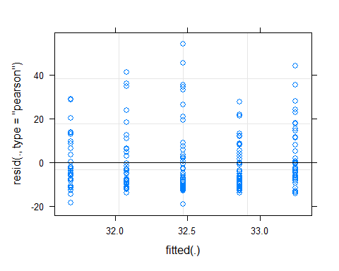
qqnorm(resid(dbh.glmm))
qqline(resid(dbh.glmm))
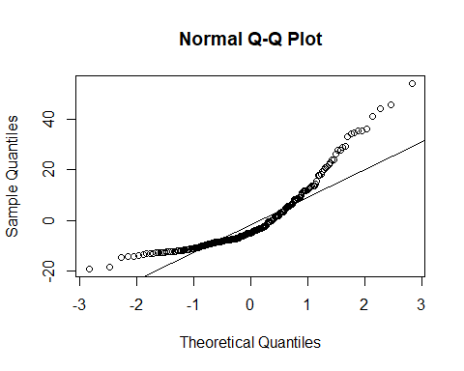
# Summary tables
summary(dbh.glmm)
## Linear mixed model fit by REML ['lmerMod']
## Formula: dbh ~ dist + (1 | Transect)
## Data: rawveg
##
## REML criterion at convergence: 1751.7
##
## Scaled residuals:
## Min 1Q Median 3Q Max
## -1.4197 -0.6681 -0.3681 0.4259 4.0220
##
## Random effects:
## Groups Name Variance Std.Dev.
## Transect (Intercept) 0 0.00
## Residual 181 13.45
## Number of obs: 217, groups: Transect, 4
##
## Fixed effects:
## Estimate Std. Error t value
## (Intercept) 33.2475793 1.5035111 22.113
## dist -0.0007778 0.0013057 -0.596
##
## Correlation of Fixed Effects:
## (Intr)
## dist -0.794
## optimizer (nloptwrap) convergence code: 0 (OK)
## boundary (singular) fit: see help('isSingular')
# Basal area
ba.glmm <- lmer(ba ~ dist + (1|Transect), data = rawveg)
## boundary (singular) fit: see help('isSingular')
# check model fit
plot(ba.glmm)
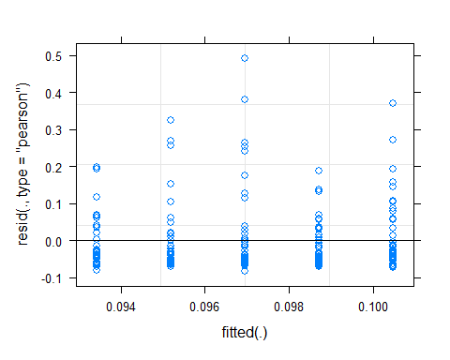
qqnorm(resid(ba.glmm))
qqline(resid(ba.glmm))
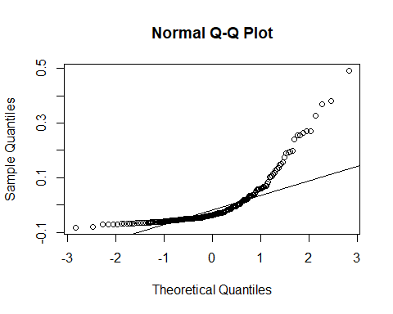
# Summary tables
summary(ba.glmm)
## Linear mixed model fit by REML ['lmerMod']
## Formula: ba ~ dist + (1 | Transect)
## Data: rawveg
##
## REML criterion at convergence: -390.8
##
## Scaled residuals:
## Min 1Q Median 3Q Max
## -0.8989 -0.5850 -0.4041 0.1914 5.3317
##
## Random effects:
## Groups Name Variance Std.Dev.
## Transect (Intercept) 0.000000 0.00000
## Residual 0.008508 0.09224
## Number of obs: 217, groups: Transect, 4
##
## Fixed effects:
## Estimate Std. Error t value
## (Intercept) 1.005e-01 1.031e-02 9.746
## dist -3.515e-06 8.952e-06 -0.393
##
## Correlation of Fixed Effects:
## (Intr)
## dist -0.794
## optimizer (nloptwrap) convergence code: 0 (OK)
## boundary (singular) fit: see help('isSingular')
# Height:DBH ratio
hdr.glmm <- lmer(HDR ~ dist + (1|Transect),data = rawveg)
## boundary (singular) fit: see help('isSingular')
# check model fit
plot(hdr.glmm)
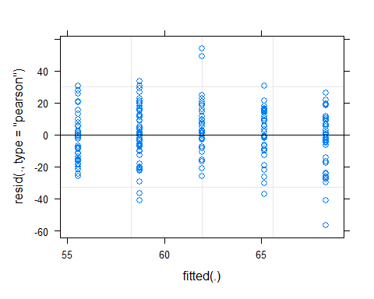
qqnorm(resid(hdr.glmm))
qqline(resid(hdr.glmm))
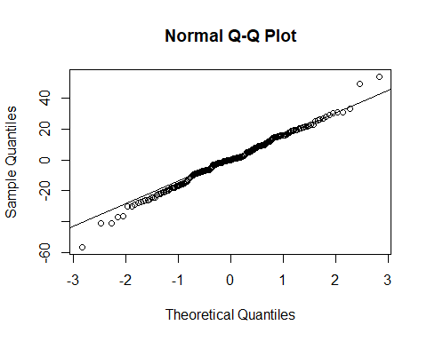
# Summary tables
summary(hdr.glmm)
## Linear mixed model fit by REML ['lmerMod']
## Formula: HDR ~ dist + (1 | Transect)
## Data: rawveg
##
## REML criterion at convergence: 1836
##
## Scaled residuals:
## Min 1Q Median 3Q Max
## -3.4548 -0.5482 0.0045 0.6647 3.2986
##
## Random effects:
## Groups Name Variance Std.Dev.
## Transect (Intercept) 0 0.00
## Residual 268 16.37
## Number of obs: 217, groups: Transect, 4
##
## Fixed effects:
## Estimate Std. Error t value
## (Intercept) 55.528937 1.829414 30.353
## dist 0.006404 0.001589 4.031
##
## Correlation of Fixed Effects:
## (Intr)
## dist -0.794
## optimizer (nloptwrap) convergence code: 0 (OK)
## boundary (singular) fit: see help('isSingular')
# Crown area
ca.glmm <- lmer(crown ~ dist + (1|Transect), data = rawveg)
## boundary (singular) fit: see help('isSingular')
# check model fit
plot(ca.glmm)
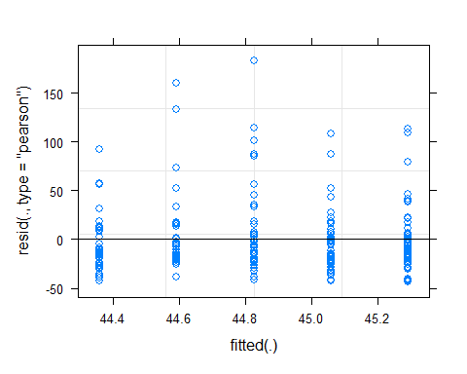
qqnorm(resid(ca.glmm))
qqline(resid(ca.glmm))
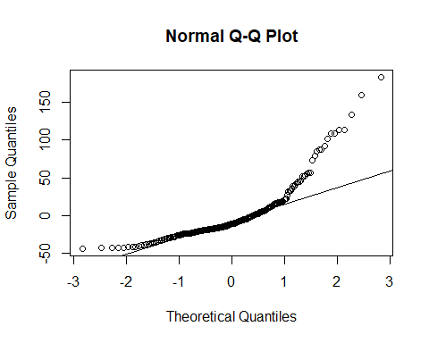
# Summary tables
summary(ca.glmm)
## Linear mixed model fit by REML ['lmerMod']
## Formula: crown ~ dist + (1 | Transect)
## Data: rawveg
##
## REML criterion at convergence: 2184.7
##
## Scaled residuals:
## Min 1Q Median 3Q Max
## -1.1793 -0.5830 -0.2925 0.2188 4.9736
##
## Random effects:
## Groups Name Variance Std.Dev.
## Transect (Intercept) 0 0.00
## Residual 1356 36.83
## Number of obs: 217, groups: Transect, 4
##
## Fixed effects:
## Estimate Std. Error t value
## (Intercept) 45.288582 4.115664 11.00
## dist -0.000464 0.003574 -0.13
##
## Correlation of Fixed Effects:
## (Intr)
## dist -0.794
## optimizer (nloptwrap) convergence code: 0 (OK)
## boundary (singular) fit: see help('isSingular')
# Canopy connectivity
conn.glmm <- lmer(conn ~ dist + (1|Transect),data = rawveg)
# check model fit
plot(conn.glmm)
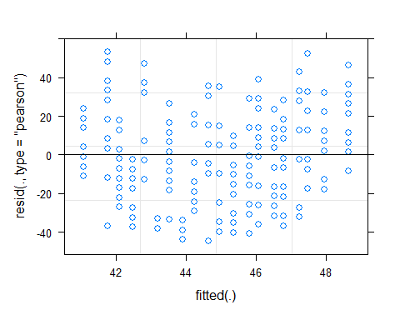
qqnorm(resid(conn.glmm))
qqline(resid(conn.glmm))
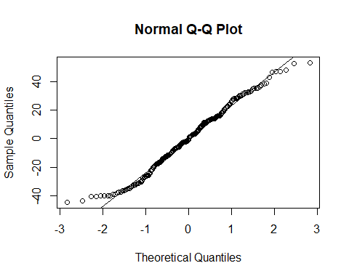
# Summary tables
summary(conn.glmm)
## Linear mixed model fit by REML ['lmerMod']
## Formula: conn ~ dist + (1 | Transect)
## Data: rawveg
##
## REML criterion at convergence: 1988
##
## Scaled residuals:
## Min 1Q Median 3Q Max
## -1.92434 -0.71227 -0.04584 0.66175 2.29420
##
## Random effects:
## Groups Name Variance Std.Dev.
## Transect (Intercept) 9.866 3.141
## Residual 538.291 23.201
## Number of obs: 217, groups: Transect, 4
##
## Fixed effects:
## Estimate Std. Error t value
## (Intercept) 43.408706 3.032277 14.316
## dist 0.001417 0.002262 0.626
##
## Correlation of Fixed Effects:
## (Intr)
## dist -0.676

1b) Generalized Linear Mixed Models of the effects of distance from forest edge on microclimate
# Read in raw data
clim <- read.csv("clim_hourly.csv")
# Clean climate data to remove instance where lux >32,000 or difference between consecutive temps is >5.
clim <- filter(clim,keep!="FALSE")
# Tidy dataframe
clim <- clim %>% dplyr::select(LocID,Transect,dist,DOY,hour,temp,LI) # remove unnecessary columns
clim$Transect <- as.factor(clim$Transect) # Set TransectID column as a factor, not a number
# Summarise data by monitoring location
clim.sum <- clim %>%
group_by(LocID) %>%
summarise(Tmean=mean(temp),LImean=mean(LI))
# Create daily summaries of climate data for each monitoring location
dailyclim <- clim %>%
group_by(Transect,LocID,dist,DOY) %>%
summarise(Tmean=mean(temp),Tmax=max(temp),Tmin=min(temp),
LImean=mean(LI),LImax=max(LI))
## `summarise()` has grouped output by 'Transect', 'LocID', 'dist'. You can
## override using the `.groups` argument.
# 1) All data, with location, day of year and hour included as random intercepts.
# Temperatures
Tall <- lmer(temp ~ dist + (1|Transect) + (1|DOY) + (1|hour),data = clim)
# check model fit
plot(Tall)
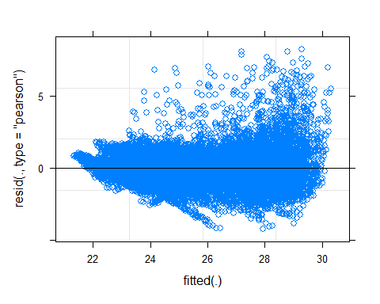
qqnorm(resid(Tall))
qqline(resid(Tall))
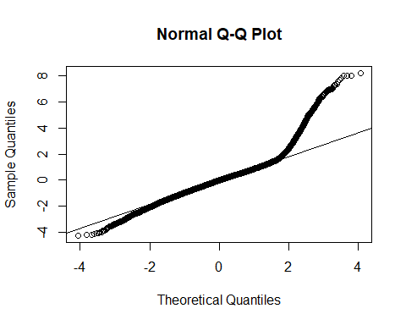
# Summary tables
summary(Tall)
## Linear mixed model fit by REML ['lmerMod']
## Formula: temp ~ dist + (1 | Transect) + (1 | DOY) + (1 | hour)
## Data: clim
##
## REML criterion at convergence: 64545.6
##
## Scaled residuals:
## Min 1Q Median 3Q Max
## -3.8343 -0.5908 -0.0089 0.5183 7.4188
##
## Random effects:
## Groups Name Variance Std.Dev.
## DOY (Intercept) 0.3624 0.6020
## hour (Intercept) 3.5780 1.8916
## Transect (Intercept) 0.0358 0.1892
## Residual 1.2262 1.1073
## Number of obs: 21071, groups: DOY, 49; hour, 24; Transect, 4
##
## Fixed effects:
## Estimate Std. Error t value
## (Intercept) 2.580e+01 4.070e-01 63.40
## dist -2.371e-04 1.087e-05 -21.81
##
## Correlation of Fixed Effects:
## (Intr)
## dist -0.027
# Light intensity
LIall <- lmer(LI ~ dist + (1|Transect) + (1|DOY) + (1|hour), data = clim)
# check model fit
plot(LIall)
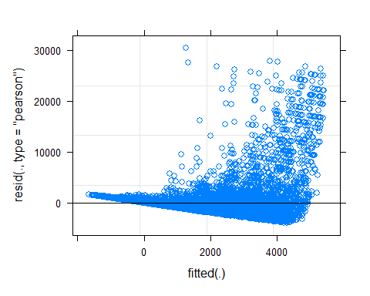
qqnorm(resid(LIall))
qqline(resid(LIall))
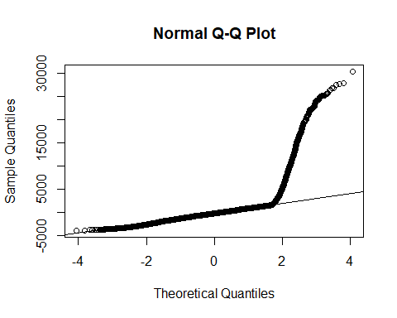
# Summary tables
summary(LIall)
## Linear mixed model fit by REML ['lmerMod']
## Formula: LI ~ dist + (1 | Transect) + (1 | DOY) + (1 | hour)
## Data: clim
##
## REML criterion at convergence: 388425.7
##
## Scaled residuals:
## Min 1Q Median 3Q Max
## -1.6275 -0.3987 -0.1026 0.1898 12.5453
##
## Random effects:
## Groups Name Variance Std.Dev.
## DOY (Intercept) 22638 150.5
## hour (Intercept) 2015973 1419.8
## Transect (Intercept) 273900 523.4
## Residual 5881034 2425.1
## Number of obs: 21071, groups: DOY, 49; hour, 24; Transect, 4
##
## Fixed effects:
## Estimate Std. Error t value
## (Intercept) 2025.9375 392.1956 5.166
## dist -0.9056 0.0238 -38.043
##
## Correlation of Fixed Effects:
## (Intr)
## dist -0.061
# 2) Maximum, minimum & mean daily temperature and maximum & mean daily light intensity, with location and day of year as random intercepts.
# Mean daily temp
Tmean <- lmer(Tmean ~ dist + (1|Transect) + (1|DOY),data = dailyclim)
# check model fit
plot(Tmean)
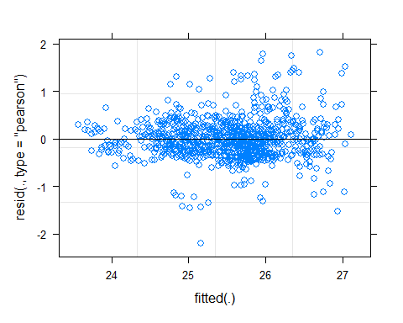
qqnorm(resid(Tmean))
qqline(resid(Tmean))
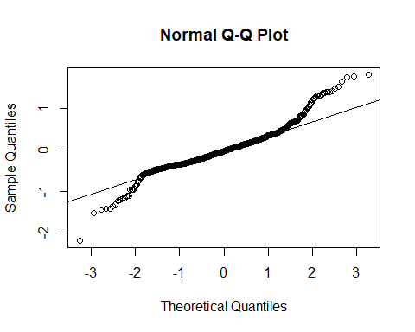
# Summary tables
summary(Tmean)
## Linear mixed model fit by REML ['lmerMod']
## Formula: Tmean ~ dist + (1 | Transect) + (1 | DOY)
## Data: dailyclim
##
## REML criterion at convergence: 1325.4
##
## Scaled residuals:
## Min 1Q Median 3Q Max
## -4.9232 -0.5966 -0.0694 0.4634 4.0830
##
## Random effects:
## Groups Name Variance Std.Dev.
## DOY (Intercept) 0.46896 0.6848
## Transect (Intercept) 0.02968 0.1723
## Residual 0.19880 0.4459
## Number of obs: 908, groups: DOY, 49; Transect, 4
##
## Fixed effects:
## Estimate Std. Error t value
## (Intercept) 2.571e+01 1.329e-01 193.386
## dist -1.789e-04 2.096e-05 -8.539
##
## Correlation of Fixed Effects:
## (Intr)
## dist -0.157
# Max daily temp
Tmax <- lmer(Tmax ~ dist + (1|Transect) + (1|DOY),data = dailyclim)
# check model fit
plot(Tmax)
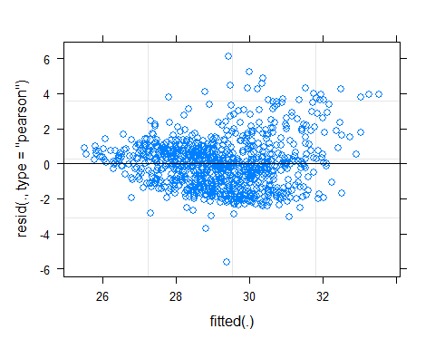
qqnorm(resid(Tmax))
qqline(resid(Tmax))
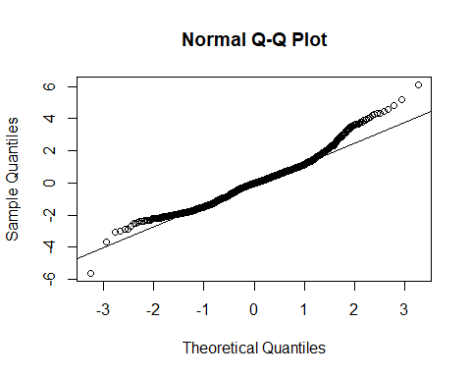
# Summary tables
summary(Tmax)
## Linear mixed model fit by REML ['lmerMod']
## Formula: Tmax ~ dist + (1 | Transect) + (1 | DOY)
## Data: dailyclim
##
## REML criterion at convergence: 3402.7
##
## Scaled residuals:
## Min 1Q Median 3Q Max
## -3.8707 -0.6835 -0.0205 0.5247 4.2119
##
## Random effects:
## Groups Name Variance Std.Dev.
## DOY (Intercept) 1.2600 1.1225
## Transect (Intercept) 0.4835 0.6954
## Residual 2.1063 1.4513
## Number of obs: 908, groups: DOY, 49; Transect, 4
##
## Fixed effects:
## Estimate Std. Error t value
## (Intercept) 3.018e+01 3.922e-01 76.96
## dist -1.002e-03 6.821e-05 -14.68
##
## Correlation of Fixed Effects:
## (Intr)
## dist -0.174
# Min daily temp
Tmin <- lmer(Tmin ~ dist + (1|Transect) + (1|DOY),data = dailyclim)
# check model fit
plot(Tmin)
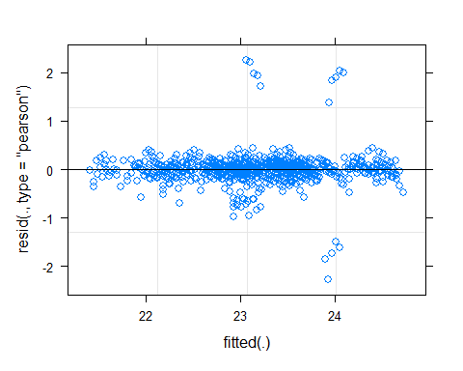
qqnorm(resid(Tmin))
qqline(resid(Tmin))
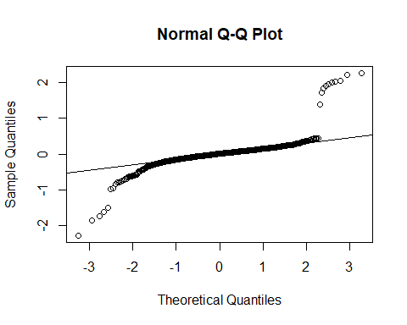
# Summary tables
summary(Tmin)
## Linear mixed model fit by REML ['lmerMod']
## Formula: Tmin ~ dist + (1 | Transect) + (1 | DOY)
## Data: dailyclim
##
## REML criterion at convergence: 725
##
## Scaled residuals:
## Min 1Q Median 3Q Max
## -7.2158 -0.3042 0.0361 0.3302 7.1668
##
## Random effects:
## Groups Name Variance Std.Dev.
## DOY (Intercept) 0.471665 0.68678
## Transect (Intercept) 0.006919 0.08318
## Residual 0.099035 0.31470
## Number of obs: 908, groups: DOY, 49; Transect, 4
##
## Fixed effects:
## Estimate Std. Error t value
## (Intercept) 2.311e+01 1.081e-01 213.679
## dist 7.711e-05 1.479e-05 5.213
##
## Correlation of Fixed Effects:
## (Intr)
## dist -0.136
# Mean daily light intensity
LImean <- lmer(LImean ~ dist + (1|Transect) + (1|DOY),data = dailyclim)
## boundary (singular) fit: see help('isSingular')
# check model fit
plot(LImean)
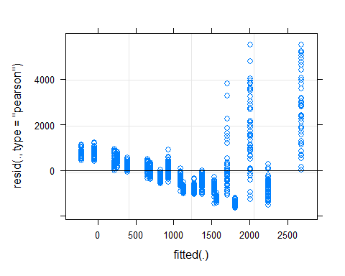
qqnorm(resid(LImean))
qqline(resid(LImean))
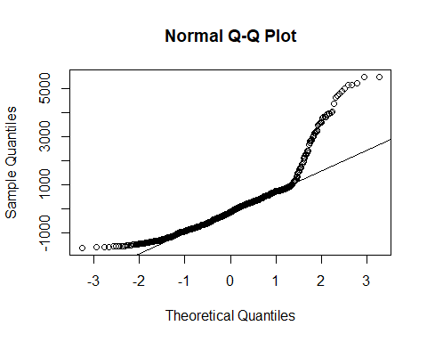
# Summary tables
summary(LImean)
## Linear mixed model fit by REML ['lmerMod']
## Formula: LImean ~ dist + (1 | Transect) + (1 | DOY)
## Data: dailyclim
##
## REML criterion at convergence: 15334.8
##
## Scaled residuals:
## Min 1Q Median 3Q Max
## -1.4660 -0.6591 -0.1311 0.3839 4.8957
##
## Random effects:
## Groups Name Variance Std.Dev.
## DOY (Intercept) 5.545e-11 7.446e-06
## Transect (Intercept) 2.629e+05 5.127e+02
## Residual 1.259e+06 1.122e+03
## Number of obs: 908, groups: DOY, 49; Transect, 4
##
## Fixed effects:
## Estimate Std. Error t value
## (Intercept) 1982.21074 264.35350 7.498
## dist -0.87646 0.05271 -16.627
##
## Correlation of Fixed Effects:
## (Intr)
## dist -0.199
## optimizer (nloptwrap) convergence code: 0 (OK)
## boundary (singular) fit: see help('isSingular')
# Max daily light intensity
LImax <- lmer(LImax ~ dist + (1|Transect) + (1|DOY),data = dailyclim)
## boundary (singular) fit: see help('isSingular')
# check model fit
plot(LImax)
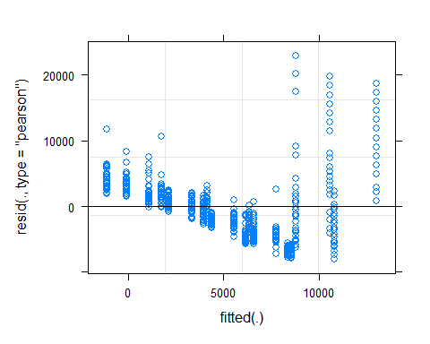
qqnorm(resid(LImax))
qqline(resid(LImax))
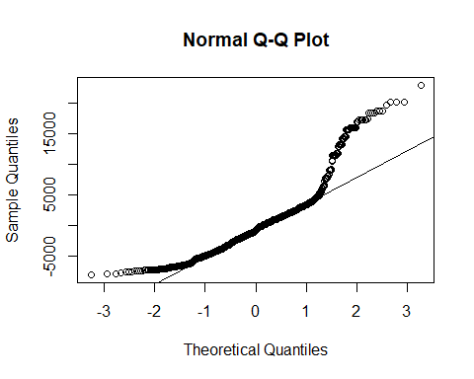
# Summary tables
summary(LImax)
## Linear mixed model fit by REML ['lmerMod']
## Formula: LImax ~ dist + (1 | Transect) + (1 | DOY)
## Data: dailyclim
##
## REML criterion at convergence: 18199
##
## Scaled residuals:
## Min 1Q Median 3Q Max
## -1.4726 -0.6995 -0.1533 0.3803 4.2006
##
## Random effects:
## Groups Name Variance Std.Dev.
## DOY (Intercept) 1.346e-07 3.668e-04
## Transect (Intercept) 5.416e+06 2.327e+03
## Residual 2.972e+07 5.452e+03
## Number of obs: 908, groups: DOY, 49; Transect, 4
##
## Fixed effects:
## Estimate Std. Error t value
## (Intercept) 10031.0313 1205.1180 8.324
## dist -4.4339 0.2562 -17.309
##
## Correlation of Fixed Effects:
## (Intr)
## dist -0.213
## optimizer (nloptwrap) convergence code: 0 (OK)
## boundary (singular) fit: see help('isSingular')

2) Relationships between mammal activity, forest structure & microclimate

2a) Generalized Linear Model of effects of structure & microclimate on mammal activity (ALL MAMMALS)
# Read raw data
transect <- read.csv("transects.csv")
# check for colineraity between predictor variables with a correlation matrix
vars <- dplyr::select(transect,-Camera,-dist,-detections_total)
cor <- rcorr(as.matrix(vars))
round(cor$P,2)
## Tmean Tmax Tmin Trange LImean LImax Theightmean BheightMean
## Tmean NA 0.00 0.05 0.00 0.00 0.00 0.58 0.27
## Tmax 0.00 NA 0.00 0.00 0.00 0.00 0.45 0.17
## Tmin 0.05 0.00 NA 0.01 0.01 0.01 0.03 0.01
## Trange 0.00 0.00 0.01 NA 0.00 0.00 0.42 0.15
## LImean 0.00 0.00 0.01 0.00 NA 0.00 0.69 0.26
## LImax 0.00 0.00 0.01 0.00 0.00 NA 0.27 0.06
## Theightmean 0.58 0.45 0.03 0.42 0.69 0.27 NA 0.00
## BheightMean 0.27 0.17 0.01 0.15 0.26 0.06 0.00 NA
## no_trees 0.45 0.53 0.34 0.40 0.41 0.62 0.08 0.15
## tree_density 0.45 0.53 0.34 0.40 0.41 0.62 0.08 0.15
## SBA 0.17 0.18 0.85 0.17 0.09 0.47 0.00 0.01
## DBH_mean 0.31 0.39 0.33 0.43 0.21 0.67 0.00 0.00
## HDR 0.15 0.11 0.03 0.10 0.19 0.06 0.00 0.00
## CA_mean 0.45 0.41 0.61 0.48 0.30 0.90 0.00 0.04
## conn_mean 0.56 0.35 0.10 0.40 0.58 0.45 0.02 0.03
## no_trees tree_density SBA DBH_mean HDR CA_mean conn_mean
## Tmean 0.45 0.45 0.17 0.31 0.15 0.45 0.56
## Tmax 0.53 0.53 0.18 0.39 0.11 0.41 0.35
## Tmin 0.34 0.34 0.85 0.33 0.03 0.61 0.10
## Trange 0.40 0.40 0.17 0.43 0.10 0.48 0.40
## LImean 0.41 0.41 0.09 0.21 0.19 0.30 0.58
## LImax 0.62 0.62 0.47 0.67 0.06 0.90 0.45
## Theightmean 0.08 0.08 0.00 0.00 0.00 0.00 0.02
## BheightMean 0.15 0.15 0.01 0.00 0.00 0.04 0.03
## no_trees NA 0.00 0.00 0.22 0.06 0.21 0.01
## tree_density 0.00 NA 0.00 0.22 0.06 0.21 0.01
## SBA 0.00 0.00 NA 0.00 0.02 0.00 0.02
## DBH_mean 0.22 0.22 0.00 NA 0.07 0.00 0.07
## HDR 0.06 0.06 0.02 0.07 NA 0.05 0.01
## CA_mean 0.21 0.21 0.00 0.00 0.05 NA 0.23
## conn_mean 0.01 0.01 0.02 0.07 0.01 0.23 NA
round(cor$r,2)
## Tmean Tmax Tmin Trange LImean LImax Theightmean BheightMean
## Tmean 1.00 0.95 -0.45 0.97 0.91 0.84 -0.13 -0.27
## Tmax 0.95 1.00 -0.62 0.99 0.98 0.79 -0.18 -0.33
## Tmin -0.45 -0.62 1.00 -0.61 -0.61 -0.55 0.49 0.61
## Trange 0.97 0.99 -0.61 1.00 0.97 0.83 -0.20 -0.35
## LImean 0.91 0.98 -0.61 0.97 1.00 0.79 -0.10 -0.27
## LImax 0.84 0.79 -0.55 0.83 0.79 1.00 -0.27 -0.43
## Theightmean -0.13 -0.18 0.49 -0.20 -0.10 -0.27 1.00 0.92
## BheightMean -0.27 -0.33 0.61 -0.35 -0.27 -0.43 0.92 1.00
## no_trees 0.18 0.15 -0.23 0.20 0.20 0.12 0.41 0.34
## tree_density 0.18 0.15 -0.23 0.20 0.20 0.12 0.41 0.34
## SBA 0.33 0.32 -0.05 0.33 0.40 0.18 0.67 0.55
## DBH_mean 0.25 0.21 0.23 0.19 0.30 0.10 0.75 0.63
## HDR -0.35 -0.38 0.50 -0.39 -0.32 -0.43 0.90 0.85
## CA_mean 0.18 0.20 0.12 0.17 0.25 -0.03 0.63 0.48
## conn_mean -0.14 -0.22 0.39 -0.20 -0.14 -0.18 0.54 0.51
## no_trees tree_density SBA DBH_mean HDR CA_mean conn_mean
## Tmean 0.18 0.18 0.33 0.25 -0.35 0.18 -0.14
## Tmax 0.15 0.15 0.32 0.21 -0.38 0.20 -0.22
## Tmin -0.23 -0.23 -0.05 0.23 0.50 0.12 0.39
## Trange 0.20 0.20 0.33 0.19 -0.39 0.17 -0.20
## LImean 0.20 0.20 0.40 0.30 -0.32 0.25 -0.14
## LImax 0.12 0.12 0.18 0.10 -0.43 -0.03 -0.18
## Theightmean 0.41 0.41 0.67 0.75 0.90 0.63 0.54
## BheightMean 0.34 0.34 0.55 0.63 0.85 0.48 0.51
## no_trees 1.00 1.00 0.77 0.29 0.45 0.30 0.56
## tree_density 1.00 1.00 0.77 0.29 0.45 0.30 0.56
## SBA 0.77 0.77 1.00 0.73 0.52 0.70 0.53
## DBH_mean 0.29 0.29 0.73 1.00 0.42 0.78 0.43
## HDR 0.45 0.45 0.52 0.42 1.00 0.45 0.57
## CA_mean 0.30 0.30 0.70 0.78 0.45 1.00 0.29
## conn_mean 0.56 0.56 0.53 0.43 0.57 0.29 1.00
diag(cor$P) <- 0
corrplot(cor$r, type="upper", order="hclust",
p.mat = cor$P, sig.level = 0.05, insig = "blank")
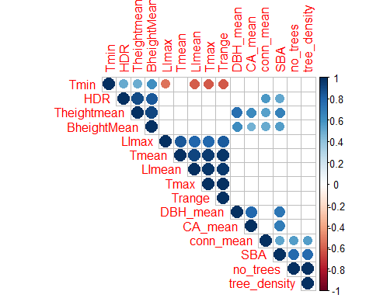
poisson <- glm(data = transect,
detections_total ~ dist + Tmax + Tmin +
Theightmean + no_trees + CA_mean + DBH_mean + conn_mean,
family = "poisson",na.action=na.fail)
dredge(poisson)
## Fixed term is "(Intercept)"
## Global model call: glm(formula = detections_total ~ dist + Tmax + Tmin + Theightmean +
## no_trees + CA_mean + DBH_mean + conn_mean, family = "poisson",
## data = transect, na.action = na.fail)
## ---
## Model selection table
## (Int) CA_men cnn_men DBH_men dst no_trs Thg
## 229 27.760000 0.18620 -0.112200
## 237 36.060000 0.21770 0.2425000 -0.123600
## 101 2.133000 0.16700 -0.118900
## 231 27.720000 -3.514e-03 0.18760 -0.106700
## 230 27.710000 5.706e-03 0.17960 -0.115000
## 245 27.620000 0.18650 0.0006855 -0.112700
## 117 2.149000 0.18110 0.0259100 -0.136800
## 109 1.661000 0.17880 0.0973000 -0.125100
## 103 2.218000 -3.784e-03 0.16830 -0.112400
## 253 32.790000 0.23620 0.2909000 0.0247200 -0.144400
## 102 2.255000 6.169e-03 0.15910 -0.121400
## 119 2.405000 -1.048e-02 0.20350 0.0582100 -0.142000
## 238 35.680000 3.237e-03 0.21260 0.2340000 -0.124400
## 239 35.820000 -6.045e-04 0.21720 0.2367000 -0.122300
## 125 1.207000 0.21450 0.1928000 0.0435300 -0.161300
## 127 1.349000 -1.134e-02 0.24420 0.2215000 0.0831900 -0.171500
## 118 2.294000 7.423e-03 0.17410 0.0290500 -0.142600
## 247 22.110000 -6.614e-03 0.20030 0.0266600 -0.121700
## 232 27.710000 4.633e-03 -2.928e-03 0.18190 -0.109700
## 110 1.818000 5.347e-03 0.17040 0.0866300 -0.126300
## 111 1.824000 -2.909e-03 0.17720 0.0774000 -0.118700
## 246 26.930000 5.872e-03 0.18110 0.0037390 -0.118000
## 104 2.299000 4.929e-03 -3.127e-03 0.16160 -0.115300
## 255 27.160000 -6.190e-03 0.24940 0.2869000 0.0497500 -0.153400
## 120 2.475000 4.770e-03 -9.848e-03 0.19760 0.0582200 -0.145100
## 254 32.060000 4.119e-03 0.23130 0.2843000 0.0265700 -0.147300
## 126 1.360000 6.678e-03 0.20730 0.1873000 0.0461800 -0.165600
## 240 35.590000 3.156e-03 -2.617e-04 0.21250 0.2317000 -0.123900
## 112 1.926000 4.515e-03 -2.361e-03 0.17030 0.0719400 -0.120800
## 128 1.418000 3.496e-03 -1.086e-02 0.23910 0.2172000 0.0828000 -0.173100
## 248 22.150000 4.665e-03 -6.018e-03 0.19480 0.0266600 -0.124900
## 213 46.400000 0.09829 -0.0680100
## 37 0.609200 0.10220 -0.071380
## 45 -0.129600 0.12910 0.1859000 -0.088560
## 256 27.030000 2.960e-03 -5.830e-03 0.24510 0.2826000 0.0495900 -0.154800
## 165 -9.037000 0.11320 -0.087480
## 53 0.736900 0.10190 -0.0244600 -0.063880
## 221 45.050000 0.09610 -0.0417300 -0.0696100
## 38 0.594900 -7.338e-04 0.10370 -0.071330
## 39 0.612500 -2.776e-04 0.10220 -0.070820
## 215 47.120000 1.015e-03 0.09760 -0.0711600
## 214 46.400000 -3.884e-04 0.09899 -0.0679300
## 173 -6.040000 0.13090 0.1476000 -0.095050
## 61 0.024910 0.12510 0.1592000 -0.0094920 -0.083140
## 47 -0.162600 1.077e-03 0.13020 0.1905000 -0.091210
## 46 -0.161100 -1.420e-03 0.13200 0.1868000 -0.088650
## 181 -6.506000 0.11010 -0.0117700 -0.079550
## 167 -9.380000 -1.399e-03 0.11320 -0.085120
## 166 -9.220000 1.380e-03 0.11080 -0.087920
## 55 0.736400 2.340e-03 0.10240 -0.0287500 -0.067330
## 197 34.070000 0.08297
## 54 0.733500 -1.738e-04 0.10220 -0.0244400 -0.063880
## 199 32.480000 -8.751e-03 0.09280
## 40 0.596400 -8.910e-04 -3.900e-04 0.10380 -0.070520
## 175 -5.980000 1.489e-04 0.13110 0.1486000 -0.095360
## 189 -5.923000 0.13060 0.1465000 -0.0006553 -0.094560
## 174 -6.030000 -6.188e-05 0.13110 0.1477000 -0.095040
## 63 0.029920 2.220e-03 0.12540 0.1569000 -0.0140700 -0.086090
## 223 45.510000 5.310e-04 0.09588 -0.0388800 -0.0711400
## 222 45.040000 1.396e-04 0.09582 -0.0421400 -0.0696500
## 216 47.100000 -1.635e-04 9.946e-04 0.09791 -0.0710600
## 62 -0.005726 -1.187e-03 0.12770 0.1608000 -0.0092470 -0.083370
## 48 -0.181000 -1.018e-03 9.450e-04 0.13210 0.1905000 -0.090950
## 198 34.210000 -3.178e-03 0.08908
## 205 35.350000 0.08482 0.0301100
## 182 -6.703000 1.062e-03 0.10830 -0.0115000 -0.080050
## 183 -6.508000 -2.118e-06 0.11010 -0.0117700 -0.079550
## 168 -9.468000 8.881e-04 -1.292e-03 0.11170 -0.085570
## 21 1.359000 0.05306 -0.0477000
## 56 0.753900 9.107e-04 2.496e-03 0.10070 -0.0291500 -0.067570
## 149 12.770000 0.05945 -0.0583200
## 200 32.590000 -3.901e-03 -8.824e-03 0.10030
## 207 30.950000 -9.183e-03 0.09118 -0.0366400
## 71 2.256000 -1.021e-02 0.06577
## 29 1.759000 0.04753 -0.1326000 -0.0556200
## 85 1.953000 0.05651 -0.0437200
## 79 3.031000 -1.167e-02 0.06306 -0.1734000
## 93 2.817000 0.05034 -0.1946000 -0.0530500
## 5 1.128000 0.04466
## 7 1.153000 -6.934e-03 0.05267
## 69 1.859000 0.05088
## 23 1.325000 -2.747e-03 0.05541 -0.0409600
## 22 1.344000 -7.133e-04 0.05443 -0.0475000
## 98 3.817000 2.509e-02 -0.048350
## 151 15.740000 3.491e-03 0.05799 -0.0695000
## 191 -5.514000 3.864e-04 0.13030 0.1469000 -0.0020640 -0.094280
## 176 -5.979000 -1.150e-05 1.476e-04 0.13110 0.1487000 -0.095350
## 190 -5.909000 -7.216e-05 0.13080 0.1466000 -0.0006665 -0.094540
## 157 11.010000 0.05603 -0.0599400 -0.0603200
## 87 2.179000 -7.118e-03 0.06470 -0.0240900
## 206 35.790000 -3.519e-03 0.09202 0.0367700
## 150 12.890000 -2.011e-03 0.06342 -0.0579800
## 64 0.025730 -1.625e-04 2.191e-03 0.12580 0.1571000 -0.0139800 -0.086080
## 133 6.987000 0.04700
## 77 2.396000 0.04697 -0.1295000
## 72 2.186000 -3.075e-03 -1.029e-02 0.07177
## 95 3.078000 -7.623e-03 0.06001 -0.2027000 -0.0332900
## 184 -6.534000 1.110e-03 1.725e-04 0.10810 -0.0121200 -0.079940
## 13 1.276000 0.04190 -0.0570500
## 224 45.510000 2.303e-04 5.524e-04 0.09542 -0.0394500 -0.0712800
## 106 4.357000 2.366e-02 -0.1508000 -0.047730
## 31 1.716000 -1.793e-03 0.04944 -0.1267000 -0.0510400
## 6 1.061000 -3.165e-03 0.05101
## 210 27.810000 1.991e-02 -0.0494300
## 30 1.767000 3.391e-04 0.04687 -0.1330000 -0.0557400
## 34 2.396000 1.908e-02 -0.034710
## 208 31.360000 -3.634e-03 -9.165e-03 0.09848 -0.0293500
## 86 1.955000 8.872e-05 0.05634 -0.0437400
## 26 2.803000 1.225e-02 -0.1886000 -0.0539700
## 15 1.289000 -6.906e-03 0.05008 -0.0523600
## 8 1.058000 -4.550e-03 -7.131e-03 0.06203
## 18 2.408000 1.366e-02 -0.0407800
## 135 3.809000 -6.284e-03 0.05289
## 70 1.812000 -1.952e-03 0.05465
## 90 3.963000 1.351e-02 -0.2588000 -0.0534400
## 226 12.990000 2.523e-02 -0.042210
## 80 2.982000 -1.730e-03 -1.168e-02 0.06641 -0.1708000
## 94 2.893000 2.258e-03 0.04603 -0.1999000 -0.0539400
## 218 23.660000 1.829e-02 -0.2077000 -0.0605200
## 24 1.287000 -1.676e-03 -2.925e-03 0.05879 -0.0400900
## 50 2.516000 1.905e-02 -0.0279800 -0.025400
## 114 3.732000 2.427e-02 -0.0133500 -0.041980
## 25 3.262000 -0.2176000 -0.0433300
## 100 3.826000 2.505e-02 -4.667e-04 -0.047350
## 2 2.118000 1.046e-02
## 134 7.261000 -4.150e-03 0.05550
## 146 10.140000 1.470e-02 -0.0464700
## 141 6.757000 0.04659 -0.0066640
## 122 4.376000 2.117e-02 -0.2109000 -0.0309400 -0.032780
## 159 13.910000 3.015e-03 0.05539 -0.0483500 -0.0695300
## 194 20.500000 1.538e-02
## 82 2.977000 1.445e-02 -0.0380400
## 89 4.310000 -0.2737000 -0.0425900
## 152 15.680000 -1.166e-03 3.336e-03 0.06035 -0.0688000
## 158 11.180000 -1.362e-03 0.05889 -0.0567000 -0.0599600
## 162 -2.529000 2.038e-02 -0.041270
## 88 2.143000 -1.708e-03 -7.285e-03 0.06808 -0.0232100
## 14 1.210000 -2.989e-03 0.04795 -0.0556800
## 78 2.366000 -1.033e-03 0.04898 -0.1282000
## 42 2.463000 1.791e-02 -0.0491400 -0.032880
## 1 2.581000
## 66 2.832000 1.185e-02
## 212 33.560000 1.937e-02 6.409e-03 -0.0708100
## 36 2.391000 1.920e-02 7.672e-04 -0.036410
## 58 2.792000 1.567e-02 -0.1505000 -0.0435400 -0.015290
## 9 2.717000 -0.1327000
## 242 21.690000 2.334e-02 -0.0342600 -0.020610
## 17 2.855000 -0.0259100
## 74 3.443000 1.076e-02 -0.1715000
## 10 2.274000 9.234e-03 -0.0997300
## 20 2.405000 1.355e-02 6.501e-04 -0.0425500
## 4 2.222000 1.189e-02 -4.055e-03
## 73 3.796000 -0.1929000
## 16 1.193000 -4.374e-03 -7.100e-03 0.05918 -0.0503900
## 154 5.618000 1.277e-02 -0.1699000 -0.0549200
## 28 2.801000 1.193e-02 1.745e-03 -0.1927000 -0.0588300
## 136 4.048000 -4.907e-03 -6.419e-03 0.06304
## 108 4.458000 2.328e-02 -2.473e-03 -0.1655000 -0.042350
## 234 8.821000 2.393e-02 -0.1327000 -0.044710
## 143 2.056000 -6.716e-03 0.05050 -0.0453700
## 76 4.108000 1.393e-02 -7.989e-03 -0.2122000
## 32 1.707000 -3.247e-04 -1.833e-03 0.05012 -0.1261000 -0.0508200
## 68 3.222000 1.448e-02 -6.078e-03
## 52 2.528000 1.972e-02 4.484e-03 -0.0366000 -0.032460
## 130 5.708000 1.073e-02
## 27 3.235000 3.201e-03 -0.2227000 -0.0527500
## 96 3.095000 5.560e-04 -7.570e-03 0.05889 -0.2039000 -0.0336400
## 57 3.184000 -0.2337000 -0.0512100 0.009370
## 192 -5.515000 3.943e-05 3.925e-04 0.13020 0.1468000 -0.0020800 -0.094290
## 65 3.141000
## 148 16.190000 1.431e-02 6.797e-03 -0.0694300
## 153 2.128000 -0.2240000 -0.0431200
## 92 4.117000 1.416e-02 -2.489e-03 -0.2638000 -0.0467400
## 178 3.998000 1.869e-02 -0.0304400 -0.022730
## 33 2.714000 -0.007020
## 196 18.770000 1.697e-02 -4.515e-03
## 228 12.970000 2.520e-02 -2.892e-04 -0.041620
## 202 16.940000 1.396e-02 -0.1124000
## 3 2.648000 -1.624e-03
## 129 4.999000
## 170 -6.191000 1.890e-02 -0.1079000 -0.042750
## 217 11.770000 -0.2565000 -0.0440100
## 116 3.684000 2.422e-02 1.425e-03 -0.0166700 -0.043480
## 75 4.260000 -4.661e-03 -0.2215000
## 12 2.390000 1.061e-02 -4.227e-03 -0.1027000
## 142 7.265000 -4.151e-03 0.05551 0.0001218
## 81 3.279000 -0.0239300
## 145 7.514000 -0.0283900
## 11 2.817000 -2.296e-03 -0.1385000
## 220 27.640000 1.810e-02 4.117e-03 -0.1878000 -0.0730300
## 41 2.838000 -0.1305000 -0.006506
## 250 19.540000 2.072e-02 -0.1948000 -0.0486400 -0.014730
## 19 2.833000 2.282e-03 -0.0326800
## 137 0.226800 -0.1499000
## 193 13.250000
## 84 3.070000 1.487e-02 -1.757e-03 -0.0328700
## 121 4.224000 -0.2782000 -0.0461500 0.004292
## 91 4.278000 4.468e-04 -0.2727000 -0.0438800
## 49 2.840000 -0.0268700 0.001348
## 105 4.119000 -0.1959000 -0.010980
## 164 -2.465000 2.043e-02 3.922e-04 -0.042070
## 44 2.459000 1.800e-02 3.456e-04 -0.0478300 -0.033690
## 201 8.901000 -0.1742000
## 138 2.435000 9.261e-03 -0.0984300
## 132 3.710000 1.187e-02 -3.694e-03
## 97 3.408000 -0.009406
## 60 2.792000 1.648e-02 4.288e-03 -0.1456000 -0.0507600 -0.022700
## 67 3.335000 -2.492e-03
## 209 15.740000 -0.0273000
## 156 10.660000 1.274e-02 5.091e-03 -0.1491000 -0.0709400
## 244 27.490000 2.265e-02 6.264e-03 -0.0557200 -0.019910
## 147 14.650000 7.487e-03 -0.0544700
## 124 4.363000 2.117e-02 3.035e-04 -0.2100000 -0.0315100 -0.033160
## 160 13.920000 -7.346e-04 2.930e-03 0.05696 -0.0468900 -0.0690800
## 186 1.160000 1.598e-02 -0.1551000 -0.0411500 -0.018020
## 204 12.920000 1.558e-02 -6.681e-03 -0.1678000
## 155 7.175000 4.899e-03 -0.2036000 -0.0585500
## 35 2.717000 -6.395e-04 -0.005809
## 161 3.599000 -0.006162
## 59 3.191000 2.371e-03 -0.2312000 -0.0552800 0.005990
## 131 4.233000 -1.257e-03
## 185 6.270000 -0.2238000 -0.0553900 0.013570
## 144 2.561000 -4.589e-03 -6.771e-03 0.06037 -0.0379100
## 180 10.080000 1.820e-02 6.737e-03 -0.0534300 -0.022440
## 177 11.770000 -0.0405400 0.013680
## 139 -3.114000 -3.972e-03 -0.1838000
## 169 -3.071000 -0.1695000 -0.012440
## 249 20.330000 -0.2625000 -0.0645100 0.022270
## 236 8.265000 2.357e-02 -2.193e-03 -0.1485000 -0.040430
## 83 3.206000 1.222e-03 -0.0278300
## 113 3.315000 -0.0227800 -0.001511
## 43 2.852000 -1.747e-03 -0.1360000 -0.003180
## 140 -1.595000 1.026e-02 -5.304e-03 -0.1363000
## 51 2.852000 2.548e-03 -0.0321200 -0.001912
## 211 23.220000 7.512e-03 -0.0533900
## 195 12.520000 -1.156e-03
## 225 12.400000 -0.002895
## 107 4.307000 -4.005e-03 -0.2186000 -0.003766
## 219 16.240000 4.359e-03 -0.2359000 -0.0575100
## 203 5.423000 -4.431e-03 -0.2159000
## 241 23.650000 -0.0449900 0.020050
## 172 -6.548000 1.868e-02 -9.796e-04 -0.1142000 -0.040810
## 233 5.950000 -0.1888000 -0.009507
## 99 3.443000 -1.335e-03 -0.006944
## 123 4.230000 -1.357e-04 -0.2786000 -0.0459000 0.004457
## 179 18.810000 7.429e-03 -0.0664100 0.013800
## 163 3.460000 -5.652e-04 -0.005232
## 252 23.480000 2.059e-02 4.257e-03 -0.1751000 -0.0612700 -0.015280
## 187 11.100000 4.785e-03 -0.2029000 -0.0700600 0.013290
## 188 6.172000 1.605e-02 5.300e-03 -0.1346000 -0.0573800 -0.018820
## 171 -4.424000 -2.950e-03 -0.1880000 -0.008100
## 243 31.280000 7.498e-03 -0.0713400 0.020580
## 115 3.258000 1.605e-03 -0.0266300 -0.003173
## 227 12.260000 -9.938e-04 -0.001228
## 251 24.460000 4.137e-03 -0.2410000 -0.0767700 0.021940
## 235 4.669000 -3.972e-03 -0.2170000 -0.003539
## Tmx Tmn df logLik AICc delta weight
## 229 -0.13110 -1.158000 5 -80.943 176.5 0.00 0.305
## 237 -0.13880 -1.582000 6 -79.089 177.2 0.68 0.217
## 101 -0.08511 4 -83.789 178.4 1.93 0.116
## 231 -0.13390 -1.153000 6 -80.647 180.3 3.79 0.046
## 230 -0.13380 -1.151000 6 -80.674 180.3 3.85 0.045
## 245 -0.13120 -1.152000 6 -80.943 180.9 4.38 0.034
## 117 -0.09788 5 -83.201 181.0 4.52 0.032
## 109 -0.08176 5 -83.429 181.5 4.97 0.025
## 103 -0.08804 5 -83.444 181.5 5.00 0.025
## 253 -0.14430 -1.446000 7 -78.681 181.5 5.04 0.024
## 102 -0.08799 5 -83.481 181.6 5.08 0.024
## 119 -0.12280 6 -81.522 182.0 5.54 0.019
## 238 -0.13980 -1.561000 7 -79.006 182.2 5.69 0.018
## 239 -0.13900 -1.570000 7 -79.080 182.3 5.84 0.016
## 125 -0.09999 6 -82.035 183.1 6.57 0.011
## 127 -0.12800 7 -80.070 184.3 7.82 0.006
## 118 -0.10320 6 -82.767 184.5 8.03 0.005
## 247 -0.13990 -0.896000 7 -80.375 184.9 8.43 0.005
## 232 -0.13560 -1.149000 7 -80.481 185.1 8.64 0.004
## 110 -0.08452 6 -83.204 185.4 8.91 0.004
## 111 -0.08462 6 -83.236 185.5 8.97 0.003
## 246 -0.13440 -1.116000 7 -80.665 185.5 9.01 0.003
## 104 -0.08972 6 -83.262 185.5 9.02 0.003
## 255 -0.15210 -1.185000 8 -78.192 186.8 10.28 0.002
## 120 -0.12460 7 -81.359 186.9 10.40 0.002
## 254 -0.14610 -1.409000 8 -78.550 187.5 11.00 0.001
## 126 -0.10480 7 -81.691 187.6 11.06 0.001
## 240 -0.13980 -1.556000 8 -79.004 188.4 11.91 0.001
## 112 -0.08637 7 -83.084 190.4 13.85 0.000
## 128 -0.12920 8 -79.986 190.4 13.87 0.000
## 248 -0.14170 -0.894700 8 -80.211 190.8 14.32 0.000
## 213 -0.10180 -2.001000 5 -88.944 192.5 16.00 0.000
## 37 3 -92.965 193.5 17.03 0.000
## 45 4 -91.624 194.1 17.60 0.000
## 256 -0.15300 -1.176000 9 -78.129 194.3 17.76 0.000
## 165 0.446200 4 -92.041 194.9 18.44 0.000
## 53 4 -92.257 195.4 18.87 0.000
## 221 -0.10150 -1.933000 6 -88.885 196.8 20.27 0.000
## 38 4 -92.961 196.8 20.28 0.000
## 39 4 -92.963 196.8 20.28 0.000
## 215 -0.10120 -2.035000 6 -88.929 196.9 20.36 0.000
## 214 -0.10170 -2.002000 6 -88.943 196.9 20.38 0.000
## 173 0.279700 5 -91.325 197.3 20.76 0.000
## 61 5 -91.542 197.7 21.20 0.000
## 47 5 -91.597 197.8 21.31 0.000
## 46 5 -91.610 197.8 21.33 0.000
## 181 0.332000 5 -91.939 198.5 21.99 0.000
## 167 0.462800 5 -91.997 198.6 22.11 0.000
## 166 0.455900 5 -92.027 198.7 22.17 0.000
## 55 5 -92.150 198.9 22.41 0.000
## 197 -0.08976 -1.456000 4 -94.133 199.1 22.62 0.000
## 54 5 -92.257 199.1 22.63 0.000
## 199 -0.09842 -1.367000 5 -92.297 199.2 22.71 0.000
## 40 5 -92.957 200.5 24.03 0.000
## 175 0.276600 6 -91.325 201.6 25.15 0.000
## 189 0.274600 6 -91.325 201.7 25.15 0.000
## 174 0.279100 6 -91.325 201.7 25.15 0.000
## 63 6 -91.445 201.9 25.39 0.000
## 223 -0.10120 -1.955000 7 -88.881 201.9 25.44 0.000
## 222 -0.10150 -1.932000 7 -88.884 202.0 25.45 0.000
## 216 -0.10120 -2.035000 7 -88.929 202.0 25.54 0.000
## 62 6 -91.532 202.1 25.56 0.000
## 48 6 -91.590 202.2 25.68 0.000
## 198 -0.08951 -1.466000 5 -94.055 202.7 26.22 0.000
## 205 -0.09031 -1.519000 5 -94.101 202.8 26.32 0.000
## 182 0.342000 6 -91.931 202.9 26.36 0.000
## 183 0.332100 6 -91.939 202.9 26.38 0.000
## 168 0.467600 6 -91.992 203.0 26.48 0.000
## 21 3 -97.765 203.1 26.63 0.000
## 56 6 -92.144 203.3 26.79 0.000
## 149 -0.535100 4 -96.249 203.4 26.85 0.000
## 200 -0.09814 -1.376000 6 -92.187 203.4 26.87 0.000
## 207 -0.09842 -1.291000 6 -92.253 203.5 27.00 0.000
## 71 -0.04346 4 -96.607 204.1 27.57 0.000
## 29 4 -96.912 204.7 28.18 0.000
## 85 -0.02329 4 -97.002 204.9 28.36 0.000
## 79 -0.05752 5 -95.269 205.2 28.65 0.000
## 93 -0.03469 5 -95.352 205.3 28.82 0.000
## 5 2 -100.454 205.7 29.16 0.000
## 7 3 -99.141 205.9 29.38 0.000
## 69 -0.02911 3 -99.212 206.0 29.52 0.000
## 23 4 -97.603 206.1 29.56 0.000
## 22 4 -97.762 206.4 29.88 0.000
## 98 -0.04453 4 -97.828 206.5 30.01 0.000
## 151 -0.672200 5 -96.080 206.8 30.27 0.000
## 191 0.255800 7 -91.323 206.8 30.33 0.000
## 176 0.276500 7 -91.325 206.8 30.33 0.000
## 190 0.273900 7 -91.325 206.8 30.33 0.000
## 157 -0.444400 5 -96.122 206.9 30.36 0.000
## 87 -0.03600 5 -96.147 206.9 30.41 0.000
## 206 -0.09018 -1.544000 6 -94.008 207.0 30.51 0.000
## 150 -0.542500 5 -96.220 207.1 30.55 0.000
## 64 7 -91.445 207.1 30.57 0.000
## 133 -0.276100 3 -99.995 207.6 31.09 0.000
## 77 -0.03778 4 -98.416 207.7 31.19 0.000
## 72 -0.04304 5 -96.541 207.7 31.20 0.000
## 95 -0.04915 6 -94.398 207.8 31.29 0.000
## 184 0.334300 7 -91.931 208.0 31.54 0.000
## 13 3 -100.275 208.2 31.65 0.000
## 224 -0.10120 -1.955000 8 -88.880 208.2 31.66 0.000
## 106 -0.05496 5 -96.827 208.3 31.77 0.000
## 31 5 -96.844 208.3 31.80 0.000
## 6 3 -100.381 208.4 31.86 0.000
## 210 -0.06104 -1.099000 5 -96.879 208.4 31.87 0.000
## 30 5 -96.911 208.4 31.94 0.000
## 34 3 -100.425 208.4 31.95 0.000
## 208 -0.09814 -1.314000 7 -92.158 208.5 32.00 0.000
## 86 -0.02331 5 -97.002 208.6 32.12 0.000
## 26 4 -98.947 208.8 32.25 0.000
## 15 4 -98.990 208.8 32.34 0.000
## 8 4 -99.001 208.9 32.36 0.000
## 18 3 -100.641 208.9 32.38 0.000
## 135 -0.125100 4 -99.057 209.0 32.47 0.000
## 70 -0.02876 4 -99.184 209.2 32.72 0.000
## 90 -0.03584 5 -97.320 209.3 32.75 0.000
## 226 -0.05822 -0.411900 5 -97.387 209.4 32.89 0.000
## 80 -0.05706 6 -95.248 209.5 32.99 0.000
## 94 -0.03536 6 -95.313 209.6 33.13 0.000
## 218 -0.06550 -0.880600 6 -95.374 209.7 33.25 0.000
## 24 5 -97.583 209.8 33.28 0.000
## 50 4 -99.485 209.8 33.33 0.000
## 114 -0.04011 5 -97.636 209.9 33.38 0.000
## 25 3 -101.291 210.2 33.68 0.000
## 100 -0.04474 5 -97.823 210.3 33.76 0.000
## 2 2 -102.802 210.4 33.85 0.000
## 134 -0.293100 4 -99.874 210.6 34.10 0.000
## 146 -0.358900 4 -99.958 210.8 34.27 0.000
## 141 -0.264400 4 -99.993 210.8 34.34 0.000
## 122 -0.04883 6 -95.989 211.0 34.48 0.000
## 159 -0.579900 6 -96.000 211.0 34.50 0.000
## 194 -0.05479 -0.783500 4 -100.086 211.0 34.53 0.000
## 82 -0.01971 4 -100.106 211.1 34.57 0.000
## 89 -0.03112 4 -100.121 211.1 34.60 0.000
## 152 -0.670500 6 -96.070 211.1 34.64 0.000
## 158 -0.454100 6 -96.109 211.2 34.72 0.000
## 162 0.232200 4 -100.190 211.2 34.73 0.000
## 88 -0.03604 6 -96.126 211.3 34.75 0.000
## 14 4 -100.210 211.3 34.78 0.000
## 78 -0.03750 5 -98.408 211.4 34.93 0.000
## 42 4 -100.302 211.5 34.96 0.000
## 1 1 -104.643 211.5 35.02 0.000
## 66 -0.02417 3 -101.970 211.5 35.04 0.000
## 212 -0.06008 -1.368000 6 -96.314 211.6 35.13 0.000
## 36 4 -100.412 211.7 35.18 0.000
## 58 5 -98.605 211.8 35.32 0.000
## 9 2 -103.600 211.9 35.45 0.000
## 242 -0.06035 -0.811600 6 -96.475 212.0 35.45 0.000
## 17 2 -103.632 212.0 35.51 0.000
## 74 -0.03625 4 -100.589 212.0 35.53 0.000
## 10 3 -102.253 212.1 35.60 0.000
## 20 4 -100.632 212.1 35.62 0.000
## 4 3 -102.313 212.2 35.72 0.000
## 73 -0.03172 3 -102.366 212.3 35.83 0.000
## 16 5 -98.861 212.3 35.83 0.000
## 154 -0.132400 5 -98.870 212.4 35.85 0.000
## 28 5 -98.879 212.4 35.87 0.000
## 136 -0.141200 5 -98.896 212.4 35.91 0.000
## 108 -0.05712 6 -96.710 212.4 35.92 0.000
## 234 -0.06043 -0.203500 6 -96.732 212.5 35.96 0.000
## 143 -0.036980 5 -98.986 212.6 36.09 0.000
## 76 -0.04982 5 -98.994 212.6 36.10 0.000
## 32 6 -96.843 212.7 36.19 0.000
## 68 -0.03217 4 -100.947 212.8 36.25 0.000
## 52 5 -99.126 212.9 36.37 0.000
## 130 -0.167500 3 -102.637 212.9 36.37 0.000
## 27 4 -101.047 213.0 36.45 0.000
## 96 -0.04922 7 -94.396 213.0 36.47 0.000
## 57 4 -101.089 213.0 36.53 0.000
## 192 0.255900 8 -91.323 213.0 36.54 0.000
## 65 -0.01745 2 -104.232 213.2 36.71 0.000
## 148 -0.641100 5 -99.335 213.3 36.78 0.000
## 153 0.052930 4 -101.279 213.4 36.91 0.000
## 92 -0.04040 6 -97.208 213.4 36.91 0.000
## 178 -0.069290 5 -99.472 213.6 37.06 0.000
## 33 2 -104.488 213.7 37.23 0.000
## 196 -0.05731 -0.693800 5 -99.557 213.7 37.23 0.000
## 228 -0.05832 -0.410900 6 -97.385 213.8 37.27 0.000
## 202 -0.05579 -0.607800 5 -99.608 213.8 37.33 0.000
## 3 2 -104.552 213.9 37.35 0.000
## 129 -0.112500 2 -104.572 213.9 37.39 0.000
## 170 0.411900 5 -99.730 214.1 37.57 0.000
## 217 -0.04176 -0.331100 5 -99.780 214.2 37.67 0.000
## 116 -0.03836 6 -97.603 214.2 37.70 0.000
## 75 -0.03931 4 -101.732 214.3 37.82 0.000
## 12 4 -101.735 214.3 37.83 0.000
## 142 -0.293300 5 -99.874 214.4 37.86 0.000
## 81 -0.01386 3 -103.386 214.4 37.87 0.000
## 145 -0.215400 3 -103.390 214.4 37.88 0.000
## 11 3 -103.430 214.5 37.96 0.000
## 220 -0.06419 -1.070000 7 -95.153 214.5 37.99 0.000
## 41 3 -103.477 214.6 38.05 0.000
## 250 -0.06476 -0.688300 7 -95.188 214.6 38.06 0.000
## 19 3 -103.509 214.6 38.12 0.000
## 137 0.116600 3 -103.538 214.7 38.17 0.000
## 193 -0.03391 -0.445700 3 -103.548 214.7 38.20 0.000
## 84 -0.02264 5 -100.050 214.7 38.21 0.000
## 121 -0.02967 5 -100.081 214.8 38.28 0.000
## 91 -0.03032 5 -100.117 214.8 38.35 0.000
## 49 3 -103.627 214.9 38.35 0.000
## 105 -0.03522 4 -102.033 214.9 38.42 0.000
## 164 0.229000 5 -100.186 215.0 38.49 0.000
## 44 5 -100.299 215.2 38.71 0.000
## 201 -0.03867 -0.228000 4 -102.201 215.3 38.76 0.000
## 138 -0.007612 4 -102.253 215.4 38.86 0.000
## 132 -0.069870 4 -102.288 215.4 38.93 0.000
## 97 -0.02022 3 -103.961 215.5 39.02 0.000
## 60 6 -98.278 215.6 39.05 0.000
## 67 -0.02032 3 -104.025 215.6 39.15 0.000
## 209 -0.03365 -0.548400 4 -102.412 215.7 39.18 0.000
## 156 -0.369700 6 -98.534 216.1 39.57 0.000
## 244 -0.05931 -1.083000 7 -95.949 216.1 39.58 0.000
## 147 -0.548800 4 -102.618 216.1 39.59 0.000
## 124 -0.04843 7 -95.987 216.2 39.65 0.000
## 160 -0.581500 7 -95.996 216.2 39.67 0.000
## 186 0.076730 6 -98.590 216.2 39.68 0.000
## 204 -0.06062 -0.401700 6 -98.605 216.2 39.71 0.000
## 155 -0.184600 5 -100.962 216.5 40.04 0.000
## 35 3 -104.479 216.6 40.06 0.000
## 161 -0.041890 3 -104.481 216.6 40.06 0.000
## 59 5 -100.982 216.6 40.08 0.000
## 131 -0.074410 3 -104.525 216.7 40.15 0.000
## 185 -0.145700 5 -101.033 216.7 40.18 0.000
## 144 -0.066240 6 -98.846 216.7 40.19 0.000
## 180 -0.353000 6 -98.875 216.7 40.25 0.000
## 177 -0.419700 4 -103.112 217.1 40.58 0.000
## 139 0.281200 4 -103.157 217.2 40.67 0.000
## 169 0.281900 4 -103.217 217.3 40.79 0.000
## 249 -0.04715 -0.730700 6 -99.166 217.3 40.83 0.000
## 236 -0.06158 -0.174100 7 -96.641 217.5 40.96 0.000
## 83 -0.01185 4 -103.356 217.6 41.07 0.000
## 113 -0.01447 4 -103.381 217.6 41.12 0.000
## 43 4 -103.410 217.7 41.17 0.000
## 140 0.189700 5 -101.610 217.8 41.33 0.000
## 51 4 -103.501 217.9 41.36 0.000
## 211 -0.03361 -0.897800 5 -101.624 217.9 41.36 0.000
## 195 -0.03393 -0.409500 4 -103.508 217.9 41.37 0.000
## 225 -0.03326 -0.404500 4 -103.529 217.9 41.41 0.000
## 107 -0.03948 5 -101.704 218.0 41.52 0.000
## 219 -0.04066 -0.543700 6 -99.527 218.1 41.55 0.000
## 203 -0.04057 -0.052930 5 -101.725 218.1 41.56 0.000
## 241 -0.03869 -0.917500 5 -101.843 218.3 41.80 0.000
## 172 0.429400 6 -99.711 218.4 41.92 0.000
## 233 -0.03732 -0.083660 5 -102.016 218.6 42.15 0.000
## 99 -0.02105 4 -103.919 218.7 42.19 0.000
## 123 -0.02986 6 -100.081 219.2 42.66 0.000
## 179 -0.748500 5 -102.342 219.3 42.80 0.000
## 163 -0.035200 4 -104.473 219.8 43.30 0.000
## 252 -0.06337 -0.875900 8 -94.954 220.3 43.81 0.000
## 187 -0.372900 6 -100.729 220.5 43.96 0.000
## 188 -0.158900 7 -98.232 220.6 44.14 0.000
## 171 0.347500 5 -103.042 220.7 44.20 0.000
## 243 -0.03890 -1.274000 6 -101.042 221.1 44.58 0.000
## 115 -0.01249 5 -103.335 221.3 44.78 0.000
## 227 -0.03365 -0.396900 5 -103.505 221.6 45.12 0.000
## 251 -0.04605 -0.926800 7 -98.935 222.1 45.55 0.000
## 235 -0.03986 -0.016630 6 -101.703 222.4 45.91 0.000
## Models ranked by AICc(x)
poisson2 <- glm(data = transect,
detections_total ~ Tmax + Tmin +
Theightmean + DBH_mean,
family = "poisson",na.action=na.fail)
summary(poisson2)
##
## Call:
## glm(formula = detections_total ~ Tmax + Tmin + Theightmean +
## DBH_mean, family = "poisson", data = transect, na.action = na.fail)
##
## Deviance Residuals:
## Min 1Q Median 3Q Max
## -3.7420 -1.7817 0.0123 0.9462 3.6463
##
## Coefficients:
## Estimate Std. Error z value Pr(>|z|)
## (Intercept) 27.75857 10.83941 2.561 0.0104 *
## Tmax -0.13112 0.02885 -4.545 5.49e-06 ***
## Tmin -1.15827 0.48958 -2.366 0.0180 *
## Theightmean -0.11216 0.02131 -5.264 1.41e-07 ***
## DBH_mean 0.18618 0.02961 6.288 3.23e-10 ***
## ---
## Signif. codes: 0 '***' 0.001 '**' 0.01 '*' 0.05 '.' 0.1 ' ' 1
##
## (Dispersion parameter for poisson family taken to be 1)
##
## Null deviance: 134.116 on 18 degrees of freedom
## Residual deviance: 86.717 on 14 degrees of freedom
## AIC: 171.89
##
## Number of Fisher Scoring iterations: 5
plot(poisson2)
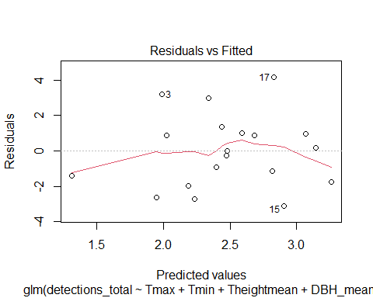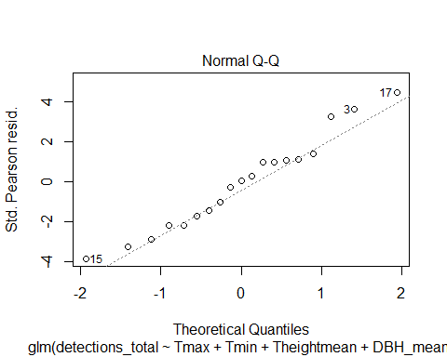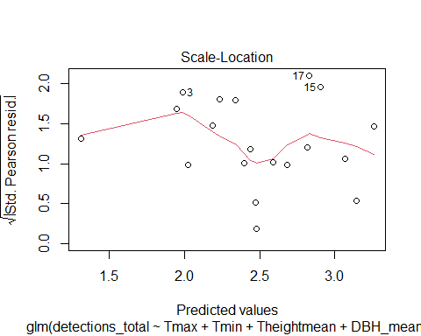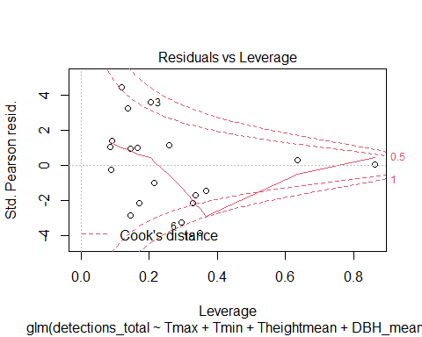
qqnorm(resid(poisson2))
qqline(resid(poisson2))
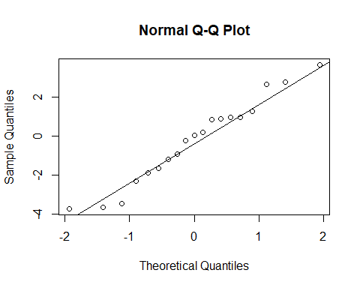
2b) GLMM of structure & microclimate effects on mammal activity, with Order included as a random factor
camtraps <- read.csv("transects_order.csv")
mem <- glmmTMB(detections ~
Tmax+height+dbh+crown+conn+n+
(1|order),
data = camtraps,family=nbinom2,na.action="na.fail")
summary(mem)
## Family: nbinom2 ( log )
## Formula:
## detections ~ Tmax + height + dbh + crown + conn + n + (1 | order)
## Data: camtraps
##
## AIC BIC logLik deviance df.resid
## 433.6 458.3 -207.8 415.6 105
##
## Random effects:
##
## Conditional model:
## Groups Name Variance Std.Dev.
## order (Intercept) 0.9653 0.9825
## Number of obs: 114, groups: order, 6
##
## Dispersion parameter for nbinom2 family (): 0.684
##
## Conditional model:
## Estimate Std. Error z value Pr(>|z|)
## (Intercept) -0.346849 1.894620 -0.183 0.854743
## Tmax -0.183244 0.062560 -2.929 0.003400 **
## height -0.213762 0.065111 -3.283 0.001027 **
## dbh 0.291361 0.086560 3.366 0.000763 ***
## crown 0.016992 0.019021 0.893 0.371688
## conn -0.003055 0.012974 -0.236 0.813818
## n 0.064078 0.068790 0.932 0.351593
## ---
## Signif. codes: 0 '***' 0.001 '**' 0.01 '*' 0.05 '.' 0.1 ' ' 1
dredge(mem)
## Fixed terms are "cond((Int))" and "disp((Int))"
## Global model call: glmmTMB(formula = detections ~ Tmax + height + dbh + crown +
## conn + n + (1 | order), data = camtraps, family = nbinom2,
## na.action = "na.fail", ziformula = ~0, dispformula = ~1)
## ---
## Model selection table
## cnd((Int)) dsp((Int)) cnd(cnn) cnd(crw) cnd(dbh) cnd(hgh) cnd(n)
## 45 -0.6757 + 0.29070 -0.179400
## 61 -0.8524 + 0.31860 -0.208600 0.053840
## 47 -0.2439 + 0.017090 0.26040 -0.186100
## 46 -0.8474 + 0.0036600 0.29270 -0.185700
## 63 -0.4525 + 0.017300 0.28760 -0.214000 0.054560
## 62 -0.7157 + -0.0037830 0.32240 -0.208100 0.065560
## 48 -0.4363 + 0.0040680 0.017500 0.26150 -0.192600
## 64 -0.3468 + -0.0030550 0.016990 0.29140 -0.213800 0.064080
## 13 -4.0570 + 0.20240 -0.103400
## 15 -3.8020 + 0.014840 0.17680 -0.108400
## 14 -4.2770 + 0.0074200 0.20950 -0.120400
## 5 -2.6280 + 0.09819
## 29 -3.9280 + 0.19900 -0.099200 -0.009502
## 37 -0.9018 + 0.10660
## 21 -2.3670 + 0.10490 -0.045520
## 16 -4.0190 + 0.0080620 0.016220 0.18180 -0.126600
## 3 -0.6786 + 0.027840
## 30 -3.8960 + 0.0112700 0.20060 -0.113000 -0.036940
## 7 -2.4210 + 0.010670 0.07698
## 38 -0.6109 + -0.0083500 0.12150
## 53 -0.8823 + 0.11150 -0.036280
## 31 -3.6940 + 0.014710 0.17430 -0.105100 -0.007819
## 6 -2.6650 + -0.0032630 0.10350
## 39 -0.6804 + 0.010560 0.08527
## 35 0.9719 + 0.029900
## 1 0.5937 +
## 19 -0.3056 + 0.028620 -0.038570
## 23 -2.1610 + 0.009937 0.08454 -0.044850
## 43 2.0040 + 0.042110 -0.050070
## 11 -0.4341 + 0.034400 -0.028300
## 22 -2.2770 + 0.0038040 0.10080 -0.056170
## 32 -3.6220 + 0.0118000 0.016240 0.17250 -0.119400 -0.036820
## 4 -0.7198 + 0.0012530 0.027600
## 40 -0.4289 + -0.0078820 0.009029 0.10220
## 55 -0.6659 + 0.009895 0.09096 -0.035470
## 8 -2.4610 + -0.0028350 0.010150 0.08253
## 54 -0.6992 + -0.0053900 0.11870 -0.019360
## 51 1.0760 + 0.030330 -0.028670
## 33 1.8650 +
## 36 1.1180 + -0.0019450 0.030380
## 17 0.9352 + -0.032240
## 20 -0.3558 + 0.0080960 0.027590 -0.061350
## 9 0.3095 + 0.014800
## 2 0.4423 + 0.0036400
## 27 -0.1981 + 0.033140 -0.020250 -0.031440
## 12 -0.5313 + 0.0060950 0.036280 -0.040950
## 24 -2.0520 + 0.0041610 0.010410 0.07901 -0.056440
## 44 1.8530 + 0.0037480 0.042920 -0.056640
## 59 1.9850 + 0.041640 -0.047660 -0.008013
## 18 0.8073 + 0.0104100 -0.061130
## 56 -0.5149 + -0.0047740 0.009286 0.09860 -0.020520
## 49 1.9650 + -0.023490
## 28 -0.1881 + 0.0119600 0.035740 -0.037770 -0.058920
## 52 0.8756 + 0.0031340 0.029720 -0.038790
## 25 0.5611 + 0.025570 -0.043320
## 41 1.6160 + 0.009198
## 34 1.7430 + 0.0015380
## 10 0.2965 + 0.0020660 0.011000
## 60 1.6670 + 0.0067310 0.041950 -0.053570 -0.027010
## 50 1.4420 + 0.0078910 -0.049040
## 26 0.6126 + 0.0085900 0.014910 -0.062640
## 57 1.4960 + 0.018630 -0.033380
## 42 1.6030 + 0.0003773 0.008559
## 58 1.1990 + 0.0066050 0.012910 -0.051790
## cnd(Tmx) df logLik AICc delta weight
## 45 -0.15100 6 -208.721 430.2 0.00 0.293
## 61 -0.17460 7 -208.249 431.6 1.33 0.151
## 47 -0.15390 7 -208.326 431.7 1.48 0.140
## 46 -0.14870 7 -208.662 432.4 2.15 0.100
## 63 -0.17720 8 -207.840 433.1 2.82 0.071
## 62 -0.18200 8 -208.208 433.8 3.56 0.049
## 48 -0.15100 8 -208.251 433.9 3.65 0.047
## 64 -0.18320 9 -207.812 435.4 5.13 0.023
## 13 5 -212.474 435.5 5.28 0.021
## 15 6 -212.182 437.1 6.92 0.009
## 14 6 -212.236 437.3 7.03 0.009
## 5 4 -214.507 437.4 7.15 0.008
## 29 6 -212.458 437.7 7.47 0.007
## 37 -0.06271 5 -213.606 437.8 7.54 0.007
## 21 5 -214.012 438.6 8.35 0.004
## 16 7 -211.894 438.8 8.62 0.004
## 3 4 -215.274 438.9 8.69 0.004
## 30 7 -212.047 439.1 8.92 0.003
## 7 5 -214.356 439.3 9.04 0.003
## 38 -0.07619 6 -213.265 439.3 9.09 0.003
## 53 -0.05628 6 -213.293 439.4 9.14 0.003
## 31 7 -212.171 439.4 9.17 0.003
## 6 5 -214.449 439.5 9.23 0.003
## 39 -0.06289 6 -213.459 439.7 9.48 0.003
## 35 -0.05461 5 -214.582 439.7 9.49 0.003
## 1 3 -217.079 440.4 10.15 0.002
## 19 5 -214.954 440.5 10.24 0.002
## 23 6 -213.880 440.5 10.32 0.002
## 43 -0.07420 6 -213.909 440.6 10.38 0.002
## 11 5 -215.029 440.6 10.39 0.002
## 22 6 -213.961 440.7 10.48 0.002
## 32 8 -211.706 440.8 10.56 0.001
## 4 5 -215.265 441.1 10.86 0.001
## 40 -0.07560 7 -213.156 441.4 11.14 0.001
## 55 -0.05647 7 -213.163 441.4 11.15 0.001
## 8 6 -214.312 441.4 11.18 0.001
## 54 -0.06798 7 -213.219 441.5 11.27 0.001
## 51 -0.04897 6 -214.409 441.6 11.37 0.001
## 33 -0.03981 4 -216.676 441.7 11.49 0.001
## 36 -0.05732 6 -214.562 441.9 11.68 0.001
## 17 4 -216.874 442.1 11.89 0.001
## 20 6 -214.696 442.2 11.95 0.001
## 9 4 -216.985 442.3 12.11 0.001
## 2 4 -217.007 442.4 12.15 0.001
## 27 6 -214.845 442.5 12.25 0.001
## 12 6 -214.867 442.5 12.29 0.001
## 24 7 -213.818 442.7 12.47 0.001
## 44 -0.07160 7 -213.848 442.8 12.53 0.001
## 59 -0.07174 7 -213.898 442.9 12.63 0.001
## 18 5 -216.473 443.5 13.27 0.000
## 56 -0.06688 8 -213.104 443.6 13.35 0.000
## 49 -0.03514 5 -216.571 443.7 13.47 0.000
## 28 7 -214.361 443.8 13.55 0.000
## 52 -0.04259 7 -214.379 443.8 13.59 0.000
## 25 5 -216.634 443.8 13.60 0.000
## 41 -0.03753 5 -216.641 443.8 13.61 0.000
## 34 -0.03800 5 -216.664 443.9 13.66 0.000
## 10 5 -216.967 444.5 14.26 0.000
## 60 -0.06115 8 -213.763 444.9 14.67 0.000
## 50 -0.02058 6 -216.392 445.6 15.34 0.000
## 26 6 -216.400 445.6 15.36 0.000
## 57 -0.02839 6 -216.453 445.7 15.46 0.000
## 42 -0.03724 6 -216.640 446.1 15.84 0.000
## 58 -0.01817 7 -216.339 447.7 17.51 0.000
## Models ranked by AICc(x)
## Random terms (all models):
## 'cond(1 | order)'
mem2 <- glmer.nb(detections ~
Tmax+height+dbh+
(1|order),
data = camtraps,na.action="na.fail")
summary (mem2)
## Generalized linear mixed model fit by maximum likelihood (Laplace
## Approximation) [glmerMod]
## Family: Negative Binomial(0.6652) ( log )
## Formula: detections ~ Tmax + height + dbh + (1 | order)
## Data: camtraps
##
## AIC BIC logLik deviance df.resid
## 429.4 445.9 -208.7 417.4 108
##
## Scaled residuals:
## Min 1Q Median 3Q Max
## -0.7837 -0.5935 -0.4605 0.2735 4.7401
##
## Random effects:
## Groups Name Variance Std.Dev.
## order (Intercept) 0.93 0.9644
## Number of obs: 114, groups: order, 6
##
## Fixed effects:
## Estimate Std. Error z value Pr(>|z|)
## (Intercept) -0.70293 1.75282 -0.401 0.68840
## Tmax -0.14962 0.05146 -2.907 0.00365 **
## height -0.17802 0.05862 -3.037 0.00239 **
## dbh 0.28827 0.07256 3.973 7.11e-05 ***
## ---
## Signif. codes: 0 '***' 0.001 '**' 0.01 '*' 0.05 '.' 0.1 ' ' 1
##
## Correlation of Fixed Effects:
## (Intr) Tmax height
## Tmax -0.534
## height -0.081 0.580
## dbh -0.284 -0.577 -0.819
plot(mem2)
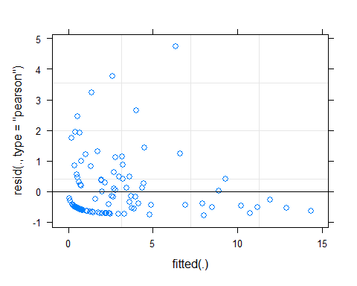
qqnorm(resid(mem2))
qqline(resid(mem2))
