Secrets of the clouded leopard: abundance, habitat use and coexistence in tropical forest of Manas National Park, Assam, India
Urjit Bhatt and Salvador Lyngdoh

Supplementary material is published as supplied by the authors. It is not checked for accuracy, copyedited, typeset or proofread. The responsibility for scientific accuracy and file functionality remains with the authors.

Supplementary Material 1 Format of a questionnaire survey conducted with the forest officials (n=75) to gather baseline information on clouded leopard sightings across all three ranges in Manas National Park.
Name: ………………………………………………… Age: ………. Gender: Male / Female Designation: …………………………………………………………………………………… Education status ……………………………. Salary………………………………………….. Range: ……………………………………… Beat: …………………………………………... Place: ………………………… Village: ……………………… District: ……………………. Latitude: ……………………………………. Longitude: ……………………………………..
- How long have you been working in the forest department?
…………………………………...
- Have you seen any carnivore while working with the forest department? If yes, which all?
……………………………………………………………………………………………….
- Have you ever seen Clouded Leopard? Yes / No
If seen, what time period are you reporting about?
(1) 1981-1985 (2) 1986-1990 (3) 1991-1995 (4) 1996-2000 (5) 2001-2005 (6) 2006-2010 (7) 2011-2015 (8) 2016-2020
Exact Year: ……………………….
- What kind of general area are you reporting about?
(1) Riverine Forest (2) Grassland Forest (3) Moist-mixed Deciduous Forest (4) Semi-evergreen Forest
- Name of the Beat / Range of Clouded Leopard sighting: ……….…………………………..
If outside the PA, then Village name: ……………………………………………………….
- How well did you know the place in the period mentioned above?
(1) I live here (2) I worked there (3) I studied there
- How frequently did you see Clouded Leopard in the time period and locality / area chosen above?
(1) Never: I saw no Clouded Leopard (2) Occasionally: Several times in a month (3) Rarely: A few times in a year
- Do you have the presence of clouded leopard cub in your area in the last 12 months?
Yes / No
If yes, mention the month of sighting
……………………………………………………………………………………………….
- What is your view on clouded leopard population in your area?
(1) Increasing (2) Decreasing (3) Stable (4) No Idea

- If decreasing, then what are the main reasons behind it?
(1) Depletion of prey species (2) Loss of habitat / Conversion of habitat (3) Poached and smuggled for the skin
Any other reason ……………………………………………………………………………
- Have you ever come across any livestock lifting (e.g., goat, ducks, hen) by clouded leopard in the surrounding villages?
Yes / No
If yes, please mention village name and district …………………………………………….
- Have you heard of any report of carnivore conflict with locals or forest staff? If yes, then mention details.
………………………………………………………………………………........................
- Have you come across clouded leopard being sold in the market?
Yes / No
If yes, please mention name and the address of the market place
……………………………………………………………………………………………
14. Additional information if any.
……………………………………………………………………………………………...

……………………………………………………………………………………………...

……………………………………………………………………………………………...

Supplementary Table 1 Independent records (n) and Relative Abundance Index (RAI) of photo-captured predator & prey species through camera-trapping in Manas National Park. RAI was calculated as independent records × 100 / trap nights. Estimated RAI for each species with associated standard errors were given in parenthesis. The mean average body mass of mammals was taken from Prater (1971), Menon (2003) and Karanth & Sunquist (1992). Potential prey species of clouded leopards are highlighted in red. Species with less than 10 encounters were removed from the analysis and are indicated with an asterisk (*).
S. No. | Species | n | RAI | Mean Body Mass (kg)
Carnivore species
1 | Tiger Panthera tigris | 466 | 4.09 (±0.33) | 218
2 | Leopard Panthera pardus | 452 | 3.97 (±0.34) | 59
3 | Asiatic black bear Ursus thibetanus | 28 | 0.25 (±0.04) | 102.5
4 | Dhole Cuon alpinus | 163 | 1.43 (±0.39) | 15
5 | Clouded leopard Neofelis nebulosa | 21 | 0.18 (±0.05) | 19
6 | Leopard cat Prionailurus bengalensis | 377 | 3.31 (±0.30) | 3.5
7 | Jungle cat Felis chaus * | 5 | 0.04 (±0.02) | 5.5
8 | Large Indian civet Viverra zibetha | 309 | 2.71 (±0.38) | 7.5
9 | Small Indian civet Viverricula indica | 402 | 3.53 (±0.49) | 3.6
10 | Asian Palm civet Paradoxurus hermaphroditus | 221 | 1.94 (±0.20) | 3.5
11 | Crab-eating mongoose Herpestes urva | 133 | 1.17 (±0.18) | 0.75
12 | Small Indian mongoose Herpestes auropunctatus | 34 | 0.30 (±0.14) | 1.4
13 | Indian grey mongoose Herpestes edwardsii | 28 | 0.25 (±0.18) | 2.29
14 | Yellow-throated marten Martes flavigula | 17 | 0.15 (±0.05) | 1.8
15 | Chinese ferret badger Melogale moschata * | 3 | 0.03 (±0.01) | 2
16 | Smooth-coated otter Lutrogale perspicillata | 10 | 0.09 (±0.06) | 8.9
17 | Chinese pangolin Manis pentadactyla * | 2 | 0.02 (±0.01) | 4.5
Prey species
18 | Asiatic elephant Elephas maximus | 6386 | 56.08 (±6.29) | 2088
19 | One-horned rhinoceros Rhinoceros unicornis * | 54 | 0.47 (±0.25) | 1900
20 | Gaur Bos gaurus | 3643 | 31.99 (±3.54) | 450
21 | Wild buffalo Bubalus arnee | 324 | 2.85 (±0.38) | 900
22 | Sambar Rusa unicolor | 4302 | 37.78 (±3.16) | 134
23 | Himalayan goral Naemorhedus goral * | 1 | 0.01 (±0.01) | 38
24 | Chital Axis axis * | 1 | 0.01 (±0.02) | 47
25 | Northern red muntjac Muntiacus vaginalis | 1523 | 13.37 (±1.27) | 21
26 | Hog deer Axis porcinus * | 229 | 2.01 (±1.19) | 40
27 | Wild boar Sus scrofa | 2310 | 20.28 (±2.71) | 32
28 | Himalayan crestless porcupine Hystrix brachyura | 596 | 5.23 (±0.58) | 8
29 | Asiatic brush-tailed porcupine Atherurus macrourus * | 3 | 0.03 (±0.02) | 2
30 | Indian peafowl Pavo cristatus | 640 | 6.26 (±1.04) | 5
31 | Red junglefowl Gallus gallus | 1162 | 11.24 (±1.16) | 0.78
32 | Kalij pheasant Lophura leucomelanos | 300 | 2.87 (±0.70) | 0.98
33 | Indian hare Lepus nigricollis | 92 | 0.81 (±0.17) | 2.3
34 | Hispid hare Caprolagus hispidus * | 8 | 0.07 (±0.06) | 2.25
35 | Capped langur Trachypithecus pileatus | 12 | 0.11 (±0.05) | 10
36 | Assamese macaque Macaca assamensis * | 6 | 0.05 (±0.02) | 8.5
37 | Rhesus macaque Macaca mulatta | 577 | 5.07 (±1.12) | 8

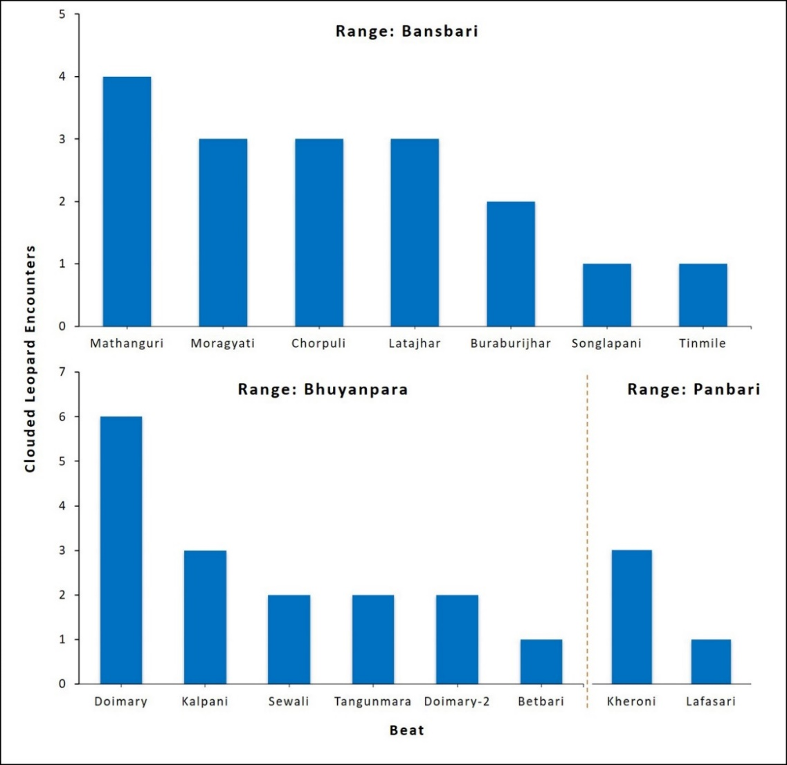
Supplementary Fig. 1 Range-wise (Panbari, Bansbari, and Bhuyanpara) beat level clouded leopard encounters by forest officials in Manas National Park.

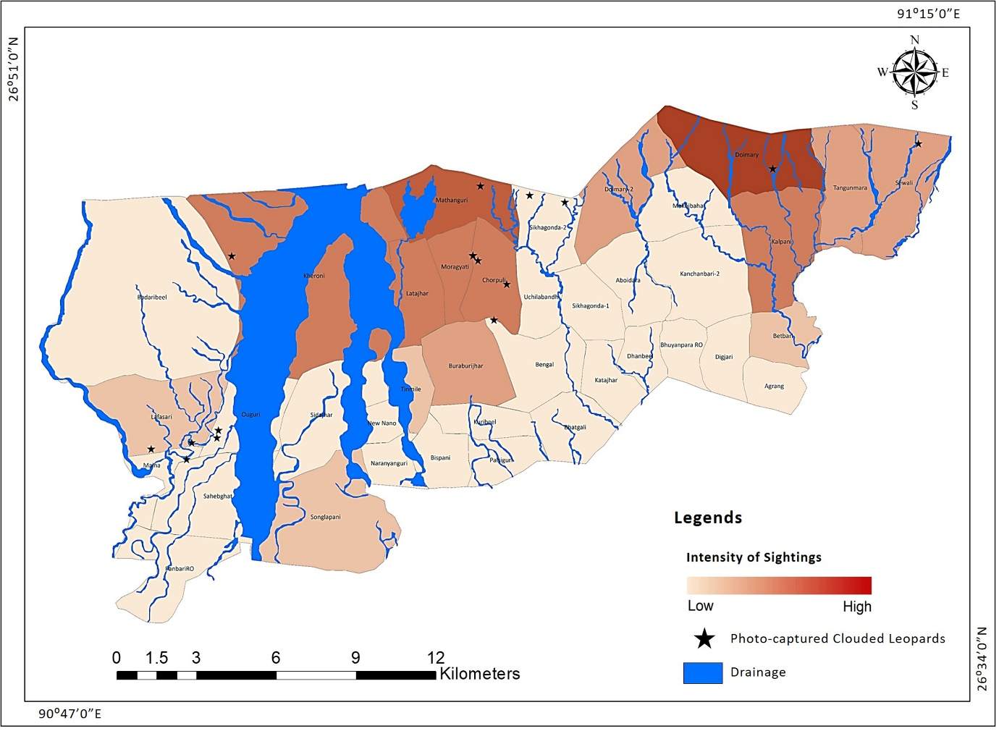
Supplementary Fig. 2 Map (Manas National Park) showing range-wise beat level clouded leopard sightings by forest officials along with photo-captured clouded leopards through camera-trapping.

Supplementary Fig. 3 Recaptures of individual clouded leopards in Manas National Park.
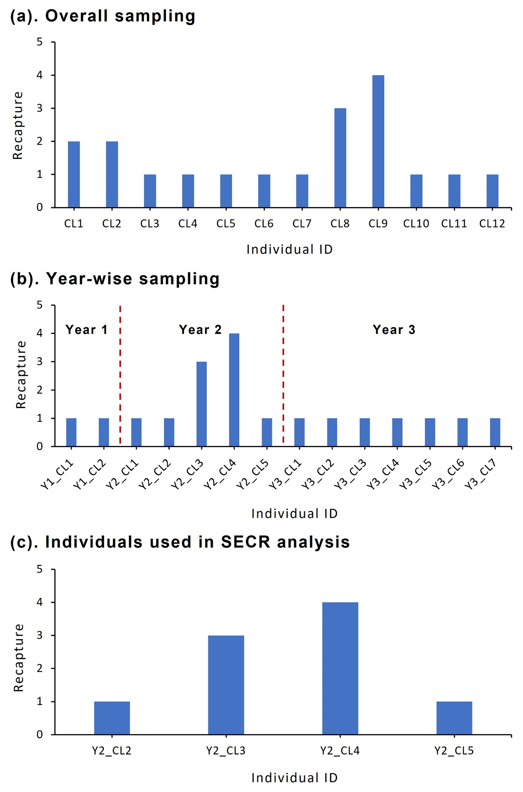

Supplementary Table 2 The results of population closure using closure test for camera-trap data of the mainland clouded leopard in Manas National Park.
Sampling period | Number of independent records (right flank) | Number of individuals  (right flank) | Sampling days | Statistic (z) | p
Sampling Period: December 2017 – May 2018
December 2017 – May 2018 | 10 | 5 | 153 | -2.462005195 | 0.006908133
March 2018 – May 2018 | 9 | 4 | 88 | -2.04616604 | 0.02037002
April 2018 – May 2018 | 9 | 4 | 49 | -1.2569204 | 0.1043912

Supplementary Table 3 Clouded leopard density estimates (with associated SE and CI) per 100 km² from maximum-likelihood-based SECR in Manas National Park. Abbreviations used are D: Density, g0: home range centre, and σ: movement.
 | Estimate | SE | Lower CI | Upper CI
D | 1.728461 | 1.27 | 0.48 | 6.27
g0 | 0.001615434 | 0.0009 | 0.0005 | 0.0051
σ | 1.92927 | 0.72 | 0.95 | 3.91

Supplementary Table 4 Beta coefficients with standard errors, z value, and Pr(>|z|) of the habitat, anthropogenic, and ecological variables of clouded leopard habitat use in Manas National Park. Significance codes: 0 – ‘***’, 0.001 – ‘**’, 0.01 – ‘*’, 0.01 – ‘*’.
Variables | β Estimate | Std. error | z value | Pr(>|z|) | Significance codes
Habitat variables
canopy cover | 2.3659 | 0.6816 | 3.4710 | 0.0005 | ***
elevation | -0.2808 | 0.3051 | -0.9200 | 0.3570
ndvi | 1.7132 | 0.4455 | 3.8450 | 0.0001 | ***
distance to grassland | 0.3057 | 0.2157 | 1.4170 | 0.1560
Anthropogenic variables
distance to settlements | -0.0086 | 0.2473 | -0.0350 | 0.9720
distance to roads | 0.0008 | 0.0039 | 0.2020 | 0.8400
Ecological variables
Species groups
dominant predators (tiger, leopard) | 0.0244 | 0.2388 | 0.1020 | 0.9190
small carnivores (civets, mongooses, martens) | -0.0268 | 0.2569 | -0.1040 | 0.9170
civets | 0.0062 | 0.2449 | 0.0260 | 0.9800
mongooses | -0.0747 | 0.3095 | -0.2410 | 0.8090
medium prey (wild boar, northern red muntjac) | 0.0149 | 0.2304 | 0.0650 | 0.9490
small prey (hares, porcupines, galliformes, primates) | 0.4250 | 0.1595 | 2.6640 | 0.0077 | **
hares | -0.1032 | 0.3291 | -0.3140 | 0.7540
porcupines | 0.1761 | 0.1813 | 0.9710 | 0.3310
galliformes | 0.5043 | 0.1285 | 3.9250 | 0.0001 | ***
primates | -0.3489 | 0.6317 | -0.5520 | 0.5810
Species
tiger | 0.1153 | 0.2029 | 0.5680 | 0.5700
leopard | -0.1416 | 0.3359 | -0.4220 | 0.6730
wild boar | 0.0738 | 0.1567 | 0.4710 | 0.6380
northern red muntjac | -0.5939 | 0.6134 | -0.9680 | 0.3330
indian hare | -0.1032 | 0.3291 | -0.3140 | 0.7540
himalayan crestless porcupine | 0.1761 | 0.1813 | 0.9710 | 0.3310
indian peafowl | -3.7165 | 3.2060 | -1.1590 | 0.2460
red junglefowl | 0.3098 | 0.1304 | 2.3750 | 0.0175 | *
kalij pheasant | 0.4414 | 0.1579 | 2.7960 | 0.0052 | **
rhesus macaque | -0.3489 | 0.6317 | -0.5520 | 0.5810
large indian civet | -0.7396 | 0.7681 | -0.9630 | 0.3360
small indian civet | 0.0296 | 0.2317 | 0.1280 | 0.8980
asiatic palm civet | 0.2654 | 0.1731 | 1.5330 | 0.1250
crab-eating mongoose | 0.0034 | 0.2450 | 0.0140 | 0.9890
small indian mongoose | -0.0264 | 0.2815 | -0.0940 | 0.9250
indian grey mongoose | -17.2600 | 1899.0430 | -0.0090 | 0.9930
yellow-throated marten | -4.0850 | 395.1500 | -0.0100 | 0.9920
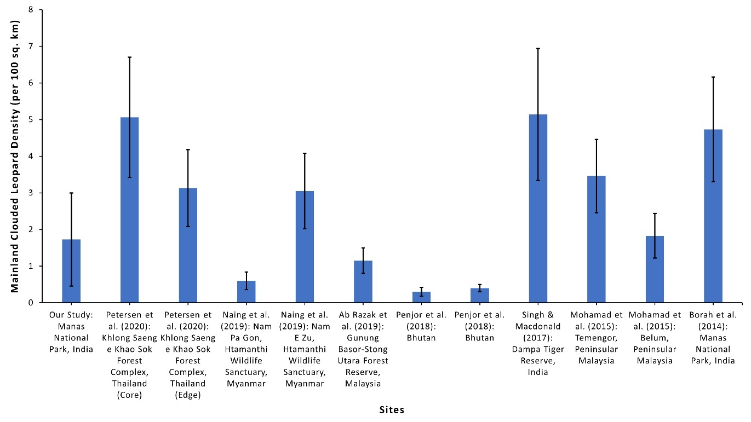
Supplementary Fig 4 Comparison of density estimates (D; individual/100 km²) and standard errors (SE) from published studies of mainland clouded leopards based on spatially explicit capture-recapture analysis.

Supplementary Table 5 Density trends (individuals per 100² km with associated SE) of top predators, i.e., tiger and leopard, in Manas National Park. NA, data not available.
 | 2010–2011 | 2013–2014 | 2018–2019
Tiger Panthera tigris | 1.79 ± SE 1.14  (Jhala et al., 2011) | 1.82 ± SE 0.63  (Jhala et al., 2015) | 3.3 SE ± 0.6  (Jhala et al., 2020)
Leopard Panthera pardus | 3.4 ± SE 0.68  (Borah et al., 2014) | NA | 3.69 ± SE 0.68  (Jhala et al., 2021)

References
BORAH, J., SHARMA, T., DAS, D., RABHA, N., KAKATI, N., BASUMATARY, A., et al. (2014) Abundance and density estimates for common leopard Panthera pardus and clouded leopard Neofelis nebulosa in Manas National Park, Assam, India. Oryx, 48, 149–155.
JHALA, Y.V., QURESHI, Q. & GOPAL R. (2015) The status of tigers, copredators & prey in India 2014. National Tiger Conservation Authority, New Delhi & Wildlife Institute of India, Dehradun.
Jhala, Y.V., Qureshi, Q. & Nayak, A.K. (2020) Status of tigers, copredators and prey in India, 2018. National Tiger Conservation Authority, Government of India, New Delhi, and Wildlife Institute of India, Dehradun.
Jhala, Y.V., Qureshi, Q. & Yadav, S.P. (2021) Status of leopards, co-predators, and megaherbivores in India, 2018. National Tiger Conservation Authority, Government of India, New Delhi, and Wildlife Institute of India, Dehradun.
Jhala, Y.V., Qureshi, Q., Gopal R. & Sinha, P.R. (2011) Status of the Tigers, Co-predators, and Prey in India, 2010. National Tiger Conservation Authority, Govt. of India, New Delhi, and Wildlife Institute of India, Dehradun.
Karanth, K.U., & Sunquist, M.E. (1992) Population structure, density and biomass of large herbivores in the tropical forests of Nagarahole, India. Journal of Tropical Ecology, 8, 21–35.
Menon, V. (2003) A Field Guide to Indian Mammals. Christopher Helm, London, UK.
Prater, S.H. (1971) The Book of Indian Animals. Bombay Natural History Society, Mumbai, India.

