Occurrence, crystal chemistry and morphology of erionite from New Zealand
Janki P. Patel^{1*}, Martin S. Brook¹, Ayrton Hamilton¹, Melanie Kah¹, Enrico Mugnaioli², and Alessandro F. Gualtieri³
¹School of Environment, The University of Auckland, Auckland, New Zealand
²Department of Earth Sciences, University of Pisa, Via S. Maria 53, 56126 Pisa, Italy
³Department of Chemical and Geological Sciences, University of Modena and Reggio Emilia, Via G. Campi 103, 41125, Modena, Italy

Supplementary material B - Figures S1 – S12

XRD Patterns:

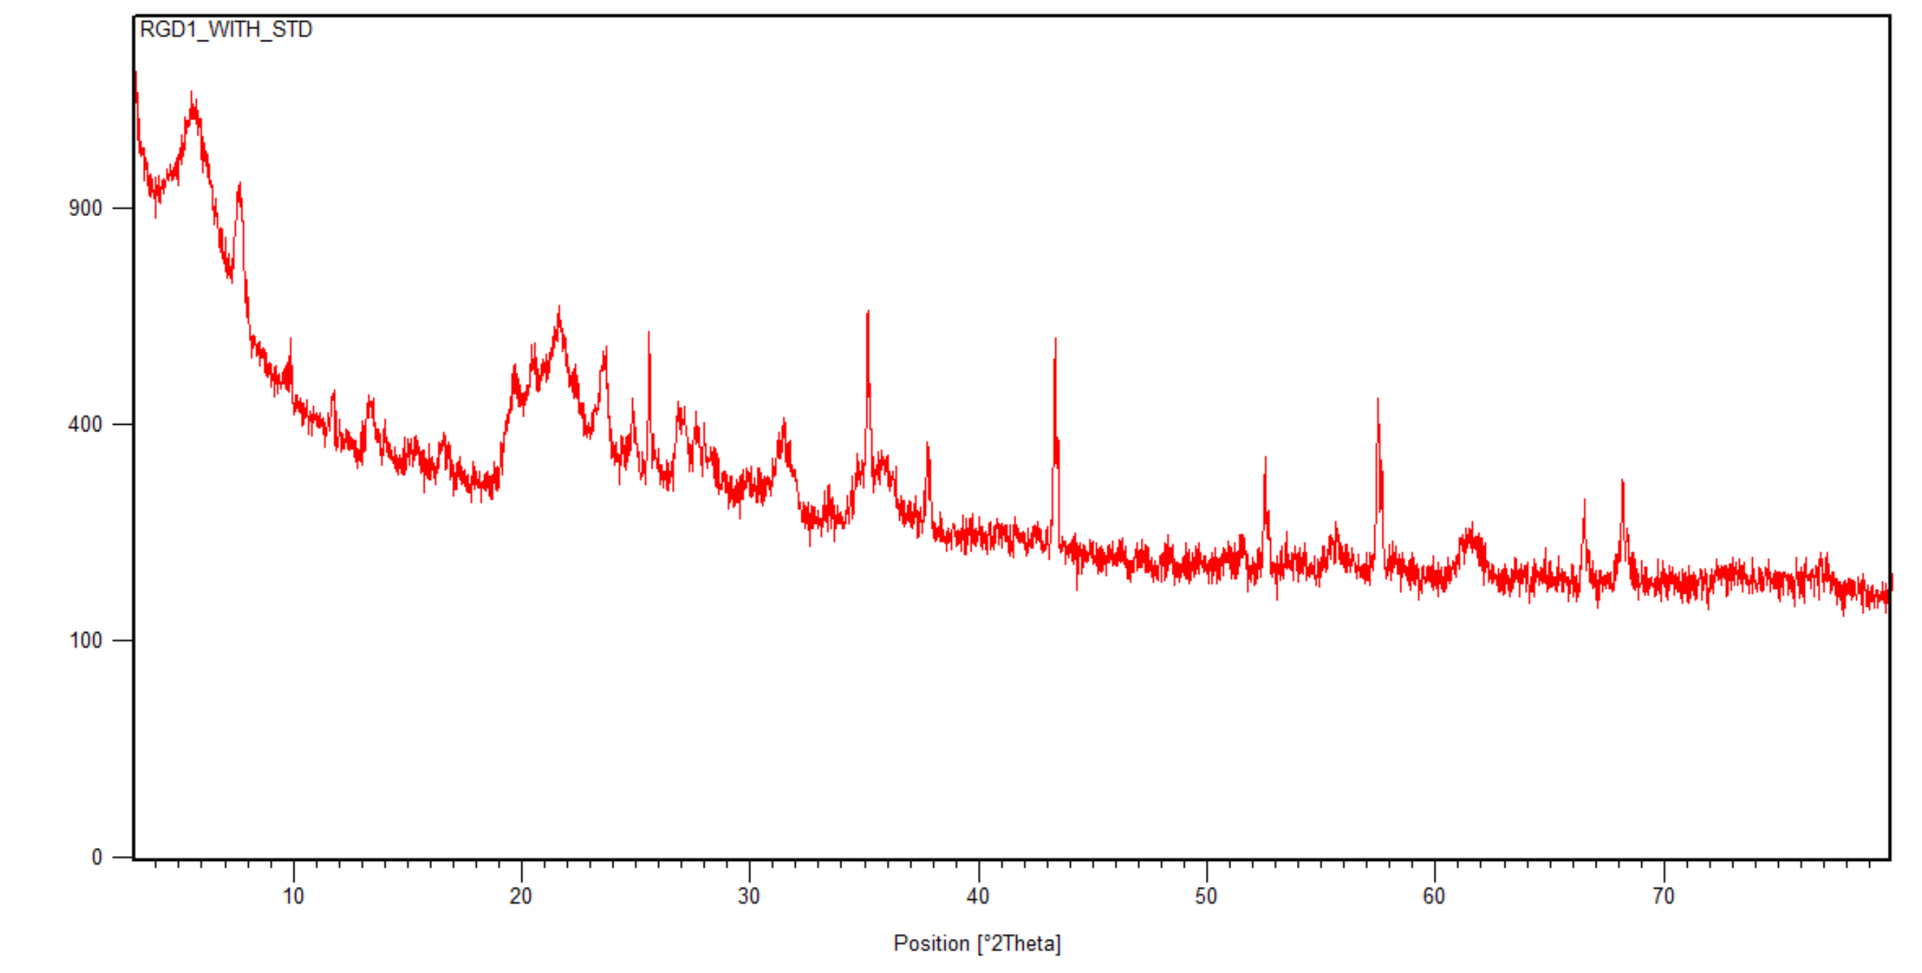
Figure S1: RGD1 with Alumina STD

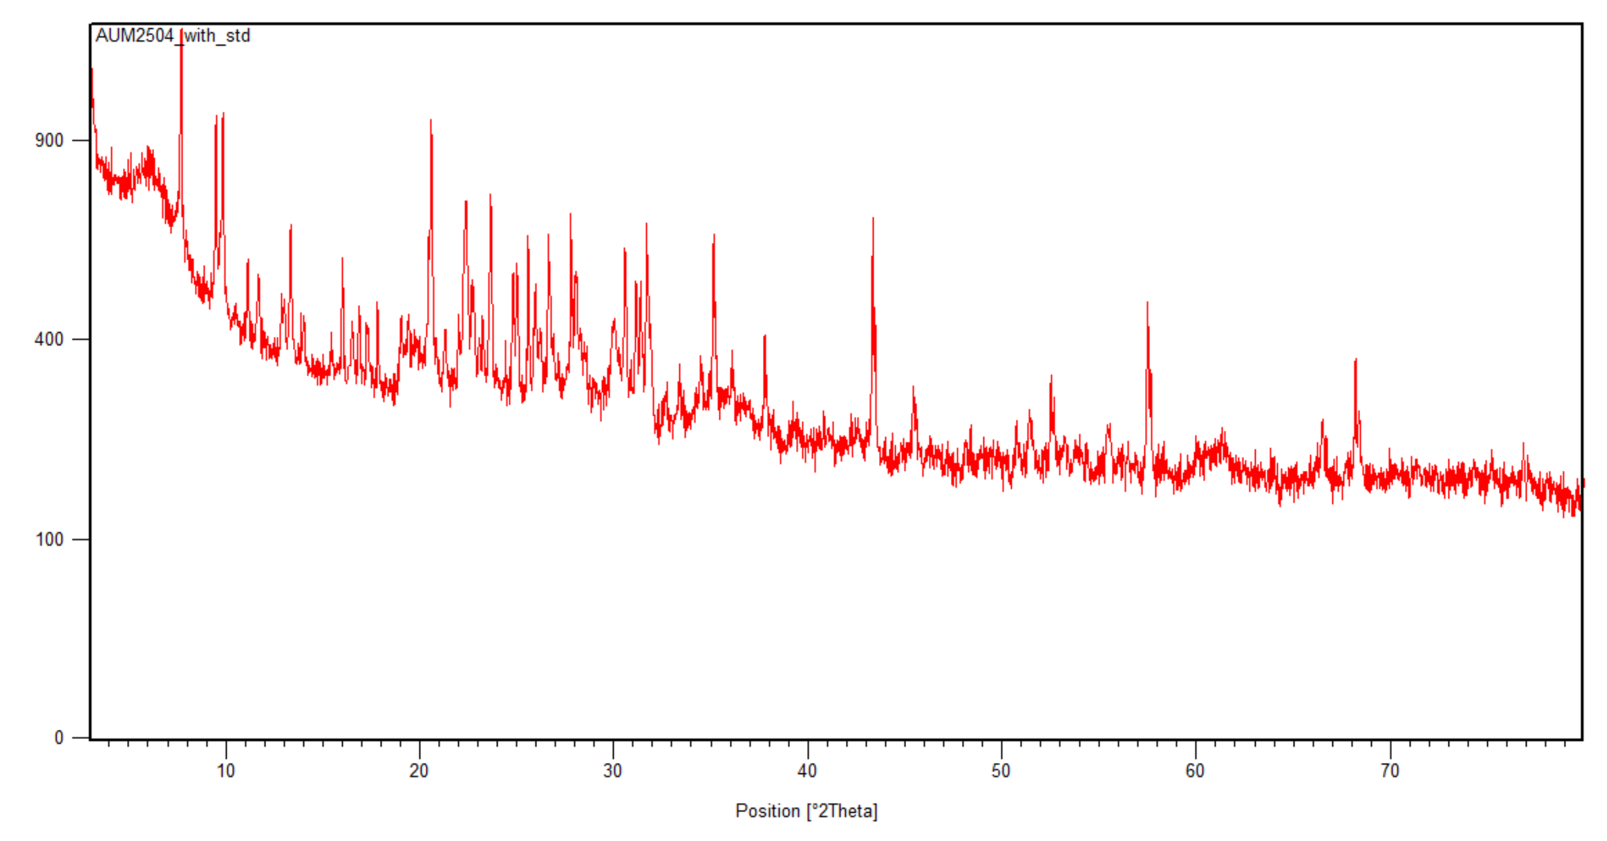
Figure S2: AUM2504 with STD

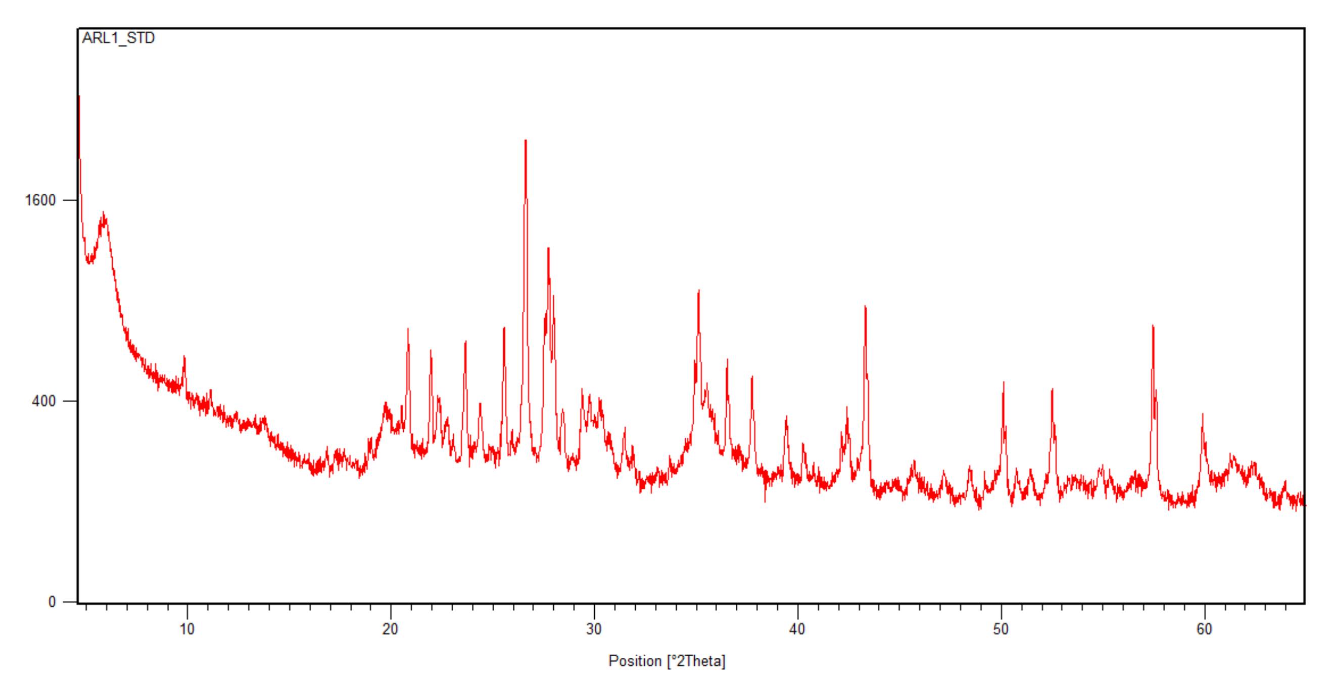
Figure S3: ARL1 with STD

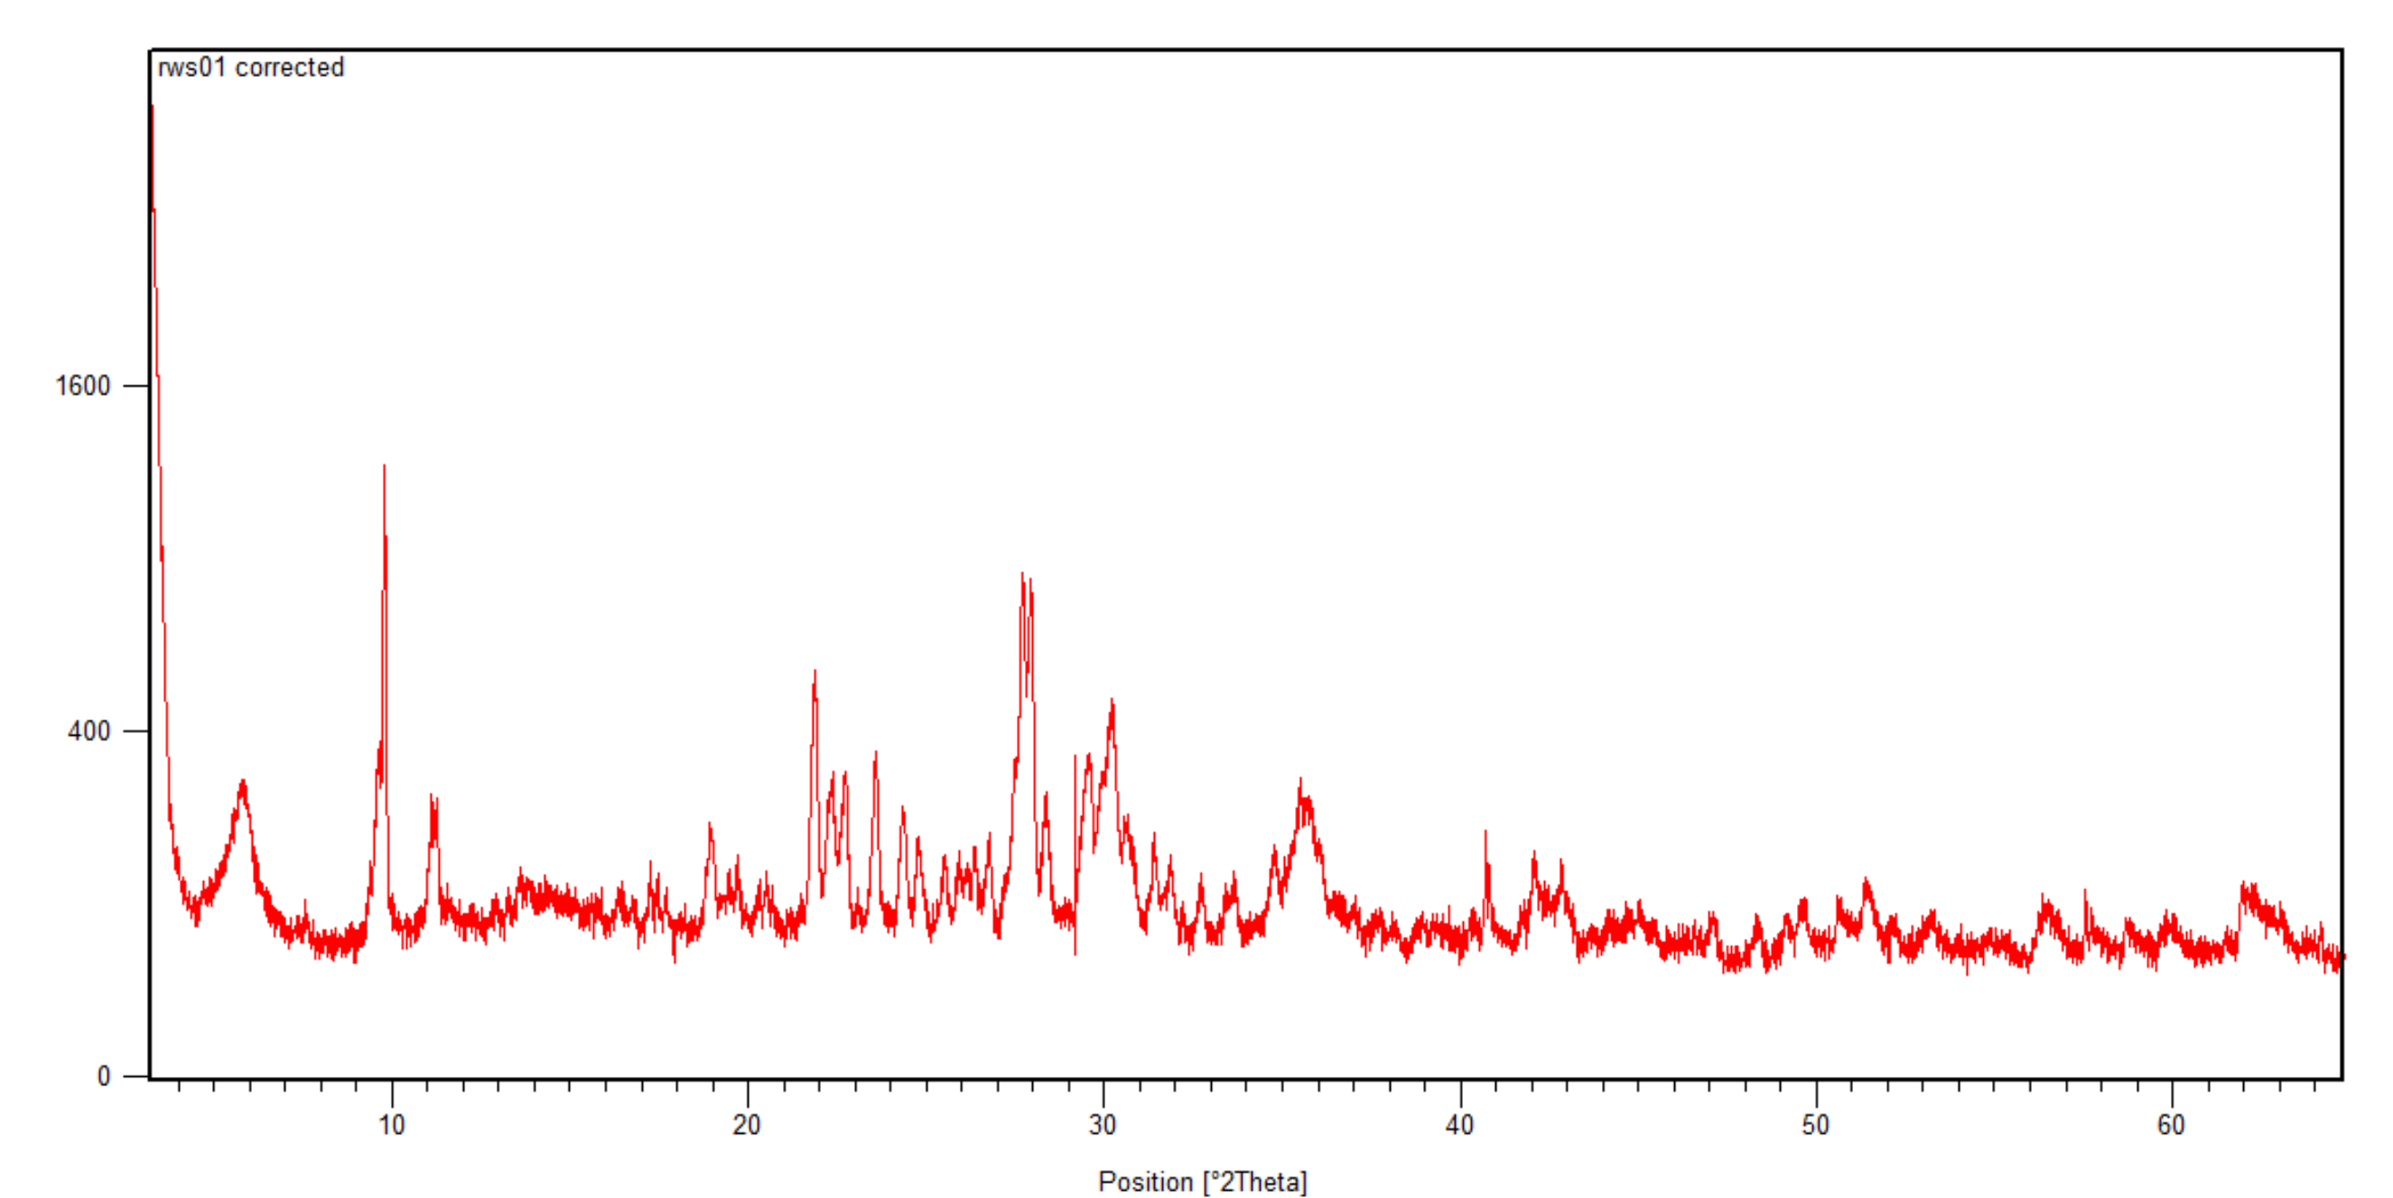
Figure S4: WS01

Note: Was unable to conduct XRPD analysis on samples AUM3143 and GD1a.

SEM Patterns:
Unlabelled peak at 2.048 is Pt which was the coating used for the stubs.
B
A
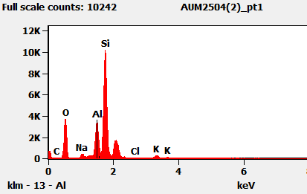
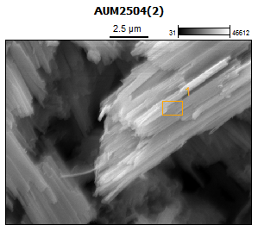
Figure S5: AUM2504; (A) SEM image and (B) corresponding EDS for point 1

B
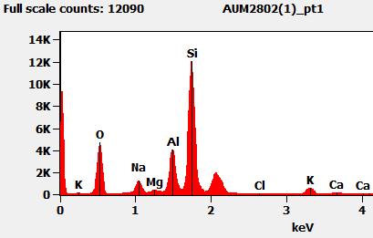
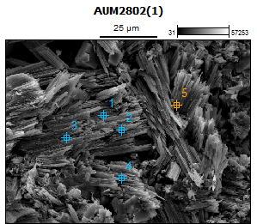
A
Figure S6: AUM2802; (A) SEM image and (B) corresponding EDS for point 1

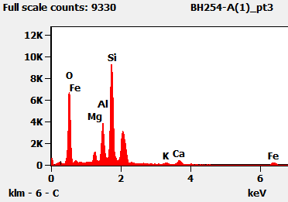
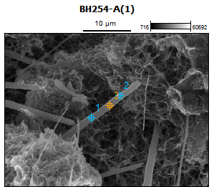
B
A
Figure S7: BH254a; (A) SEM image and (B) corresponding EDS for point 3
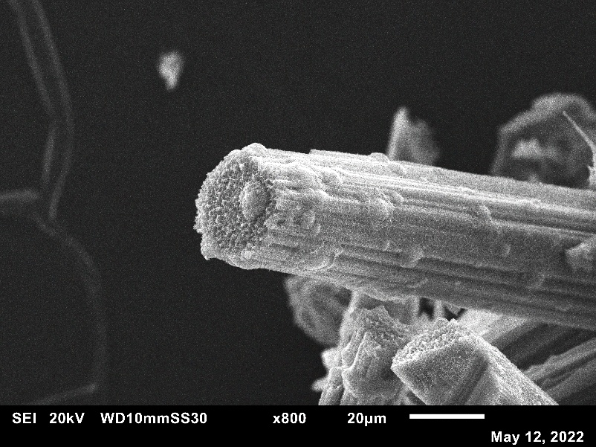
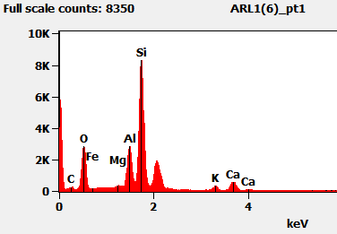
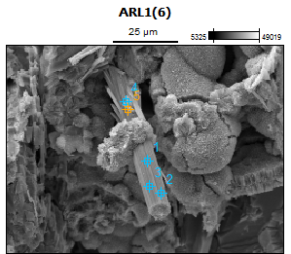
B
A
Figure S8: ARL1; (A) SEM image and (B) corresponding EDS for point 1

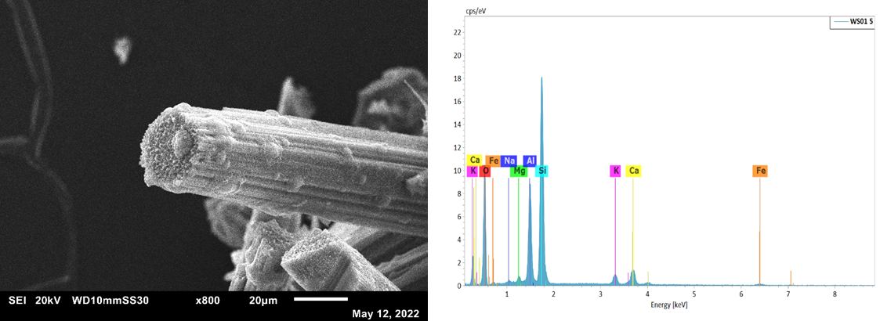
B
A
Figure S9: WS01 (A) SEM image and (B) corresponding EDS
B
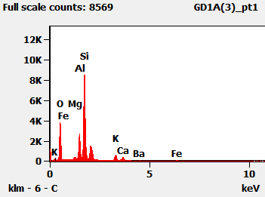
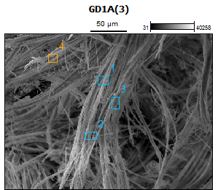
A
Figure S10: GD1a; (A) SEM image and (B) corresponding EDS for point 1

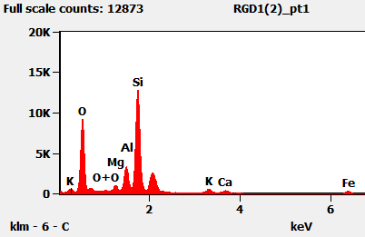
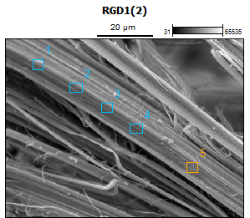
B
A
Figure S11: RGD1; (A) SEM image and (B) corresponding EDS for point 1

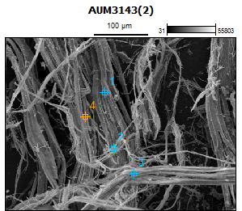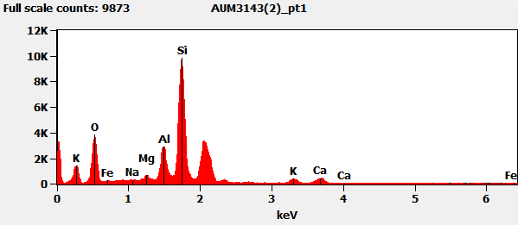
B
A
Figure S12: AUM3143; (A) SEM image and (B) corresponding EDS for point 1

