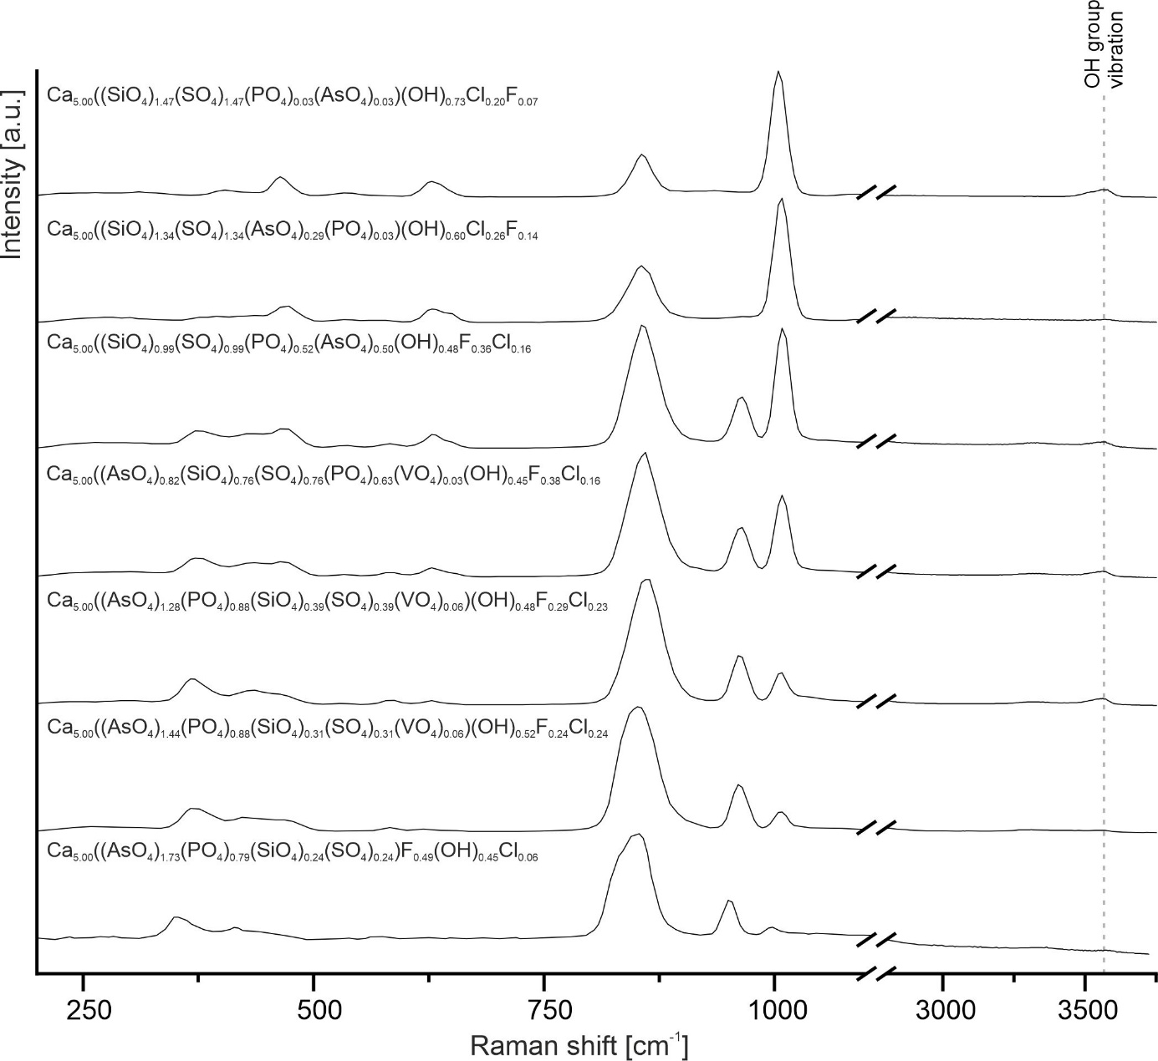

Figure S1. The Raman spectra of the hydroxylellestadite - johnbaumite-svabite mineral series from xenolith no. 11, Upper Chegem Caldera with a OH group vibrations range.