10.1180/mgm.2024.xx

Importance of Ca-rich fluids for the formation of secondary Sc-minerals. An example from metaluminous pegmatite Kožichovice II, Czech Republic

Jakub Výravský^{1,2}, Radek Škoda¹, and Milan Novák¹
¹Department of Geological Sciences, Faculty of Science, Masaryk University, Kotlářská 2, 61 137 Brno, Czech Republic.
²TESCAN GROUP, a.s., Libušina třída 21, 62300 Brno, Czech Republic.

Supplementary data

CaNb₂O₆, columbite-type structure |  |  |  |  |  |  | ScNbO₄, wolframite-type structure
fersmite |  |  | CaNb₂O₆⁽¹⁾ |  | CaNb₂O₆⁽²⁾ |  | Niobo  heftetjernite |  | ScNbO₄⁽³⁾ |  | Niobo  heftetjernite⁽⁴⁾
Kožichovice |  |  | synthetic |  | synthetic |  | Kožichovice |  | synthetic |  | Befanamo
904 | s | 904 |  | s | 906 | s | 895 | sh |  |  | 850 | sh
854 | w | 853 |  | w | 852 | w | 838 | s | 827 | s | 834 | s
630 | w | 627 |  | w | 629 | w | 793 | sh
540 | s | 540 |  | s | 540 | m | 661 | sh | 660 | sh
496 | m | 495 |  | s | 498 | w | 633 | s | 633 | s | 626 | m
463 | sh | 461 |  | w | 461 | w | 590 | sh | 603 | sh
428 | w | 430 |  | w | 431 | w | 507 | w | 512 | m
381 | w | 379, 381 |  | w | 379, 380 | w | 470 | w | 477 | w
367 | w | 367 |  | w | 365 | w | 438 | sh | 438 | sh
315 | w | 316 |  | w | 315 | w | 413 | m | 417 | s | 415 | m
291 | m | 291 |  | m | 293, 294 | w | 367 | m | 367 | m | 376 | sh
266 | w | 265 |  | m | 267 | m | 305 | m | 308 | sh
241 | m | 241 |  | m | 242 | m | 280 | m | 280 | m | 292 | m
224 | m | 225 |  | m | 227 | m | 251 | sh | 243 | w
210 | w | 213 |  | m | 215 | m | 230 | w | 210 | w
195 | m | 195 |  | m | 197 | m | 190 | w | 187 | w
161 | w | 163 |  | w | 167 | w | 133 | s | 145 | s | 138 | m
136 | w | 139 |  | m | 140 | w | 114 | sh
125 | w | 128 |  | w | 130 | w

Table ST1. Raman vibration bands in (cm⁻¹) of fersmite and nioboheftetjernite from Kožichovice and their comparison to the published data: 1-Husson et al. (1977); 2-Moreira et al. (2010); 3-Ouahrani et al. (2022); 4- Lykova et al. (2021). Intensity: s-strong, m-medium, w-weak, sh-shoulder

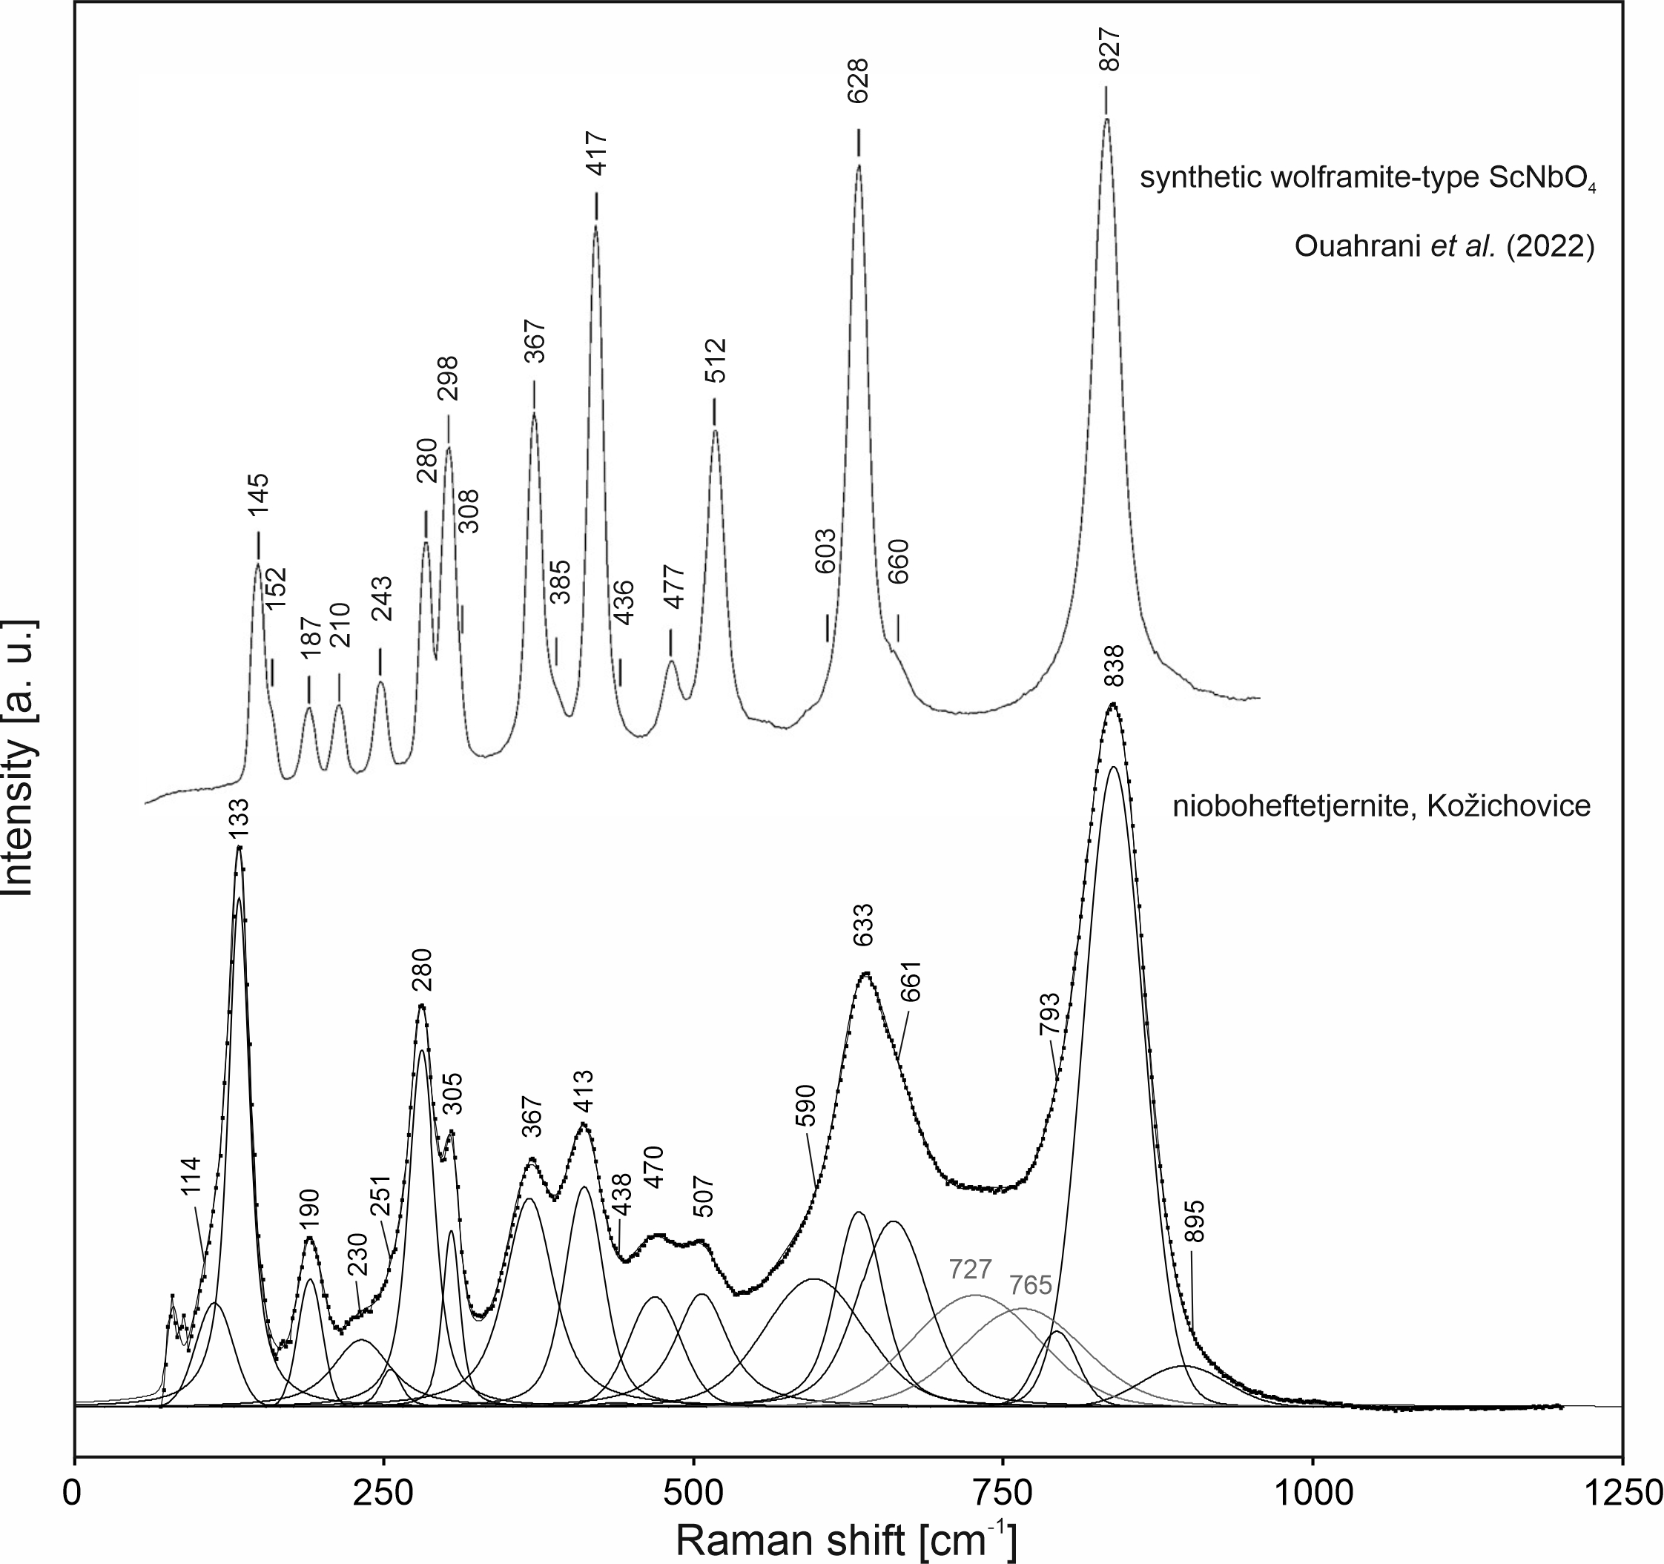
Figure S1. Raman spectrum of nioboheftetjernite from Kožichovice excited by 532 nm laser compared to the spectrum of its synthetic analogue (Ouahrani et al. 2022).

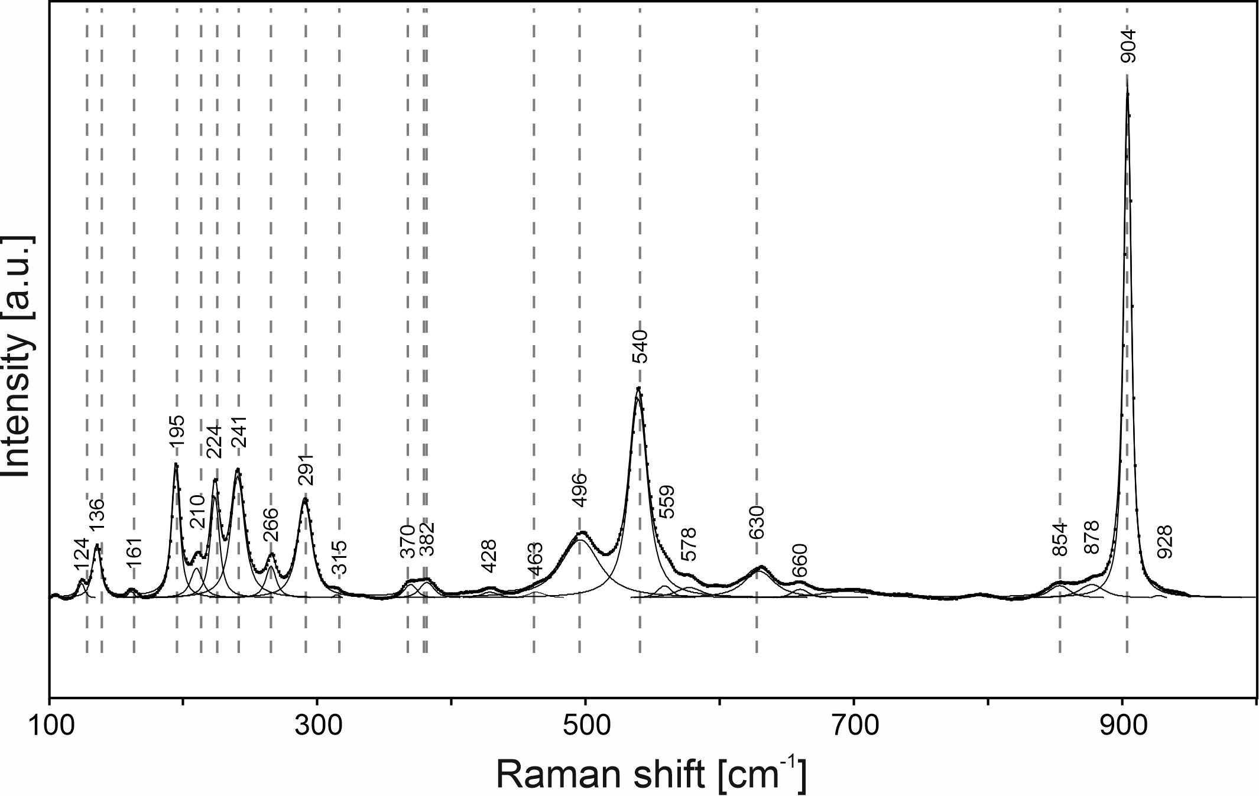
Figure S2. Raman spectrum of fersmite from Kožichovice excited by 532 nm laser. The dashed lines indicate the vibration bands observed on the synthetic analogue (Husson et al. 1977).
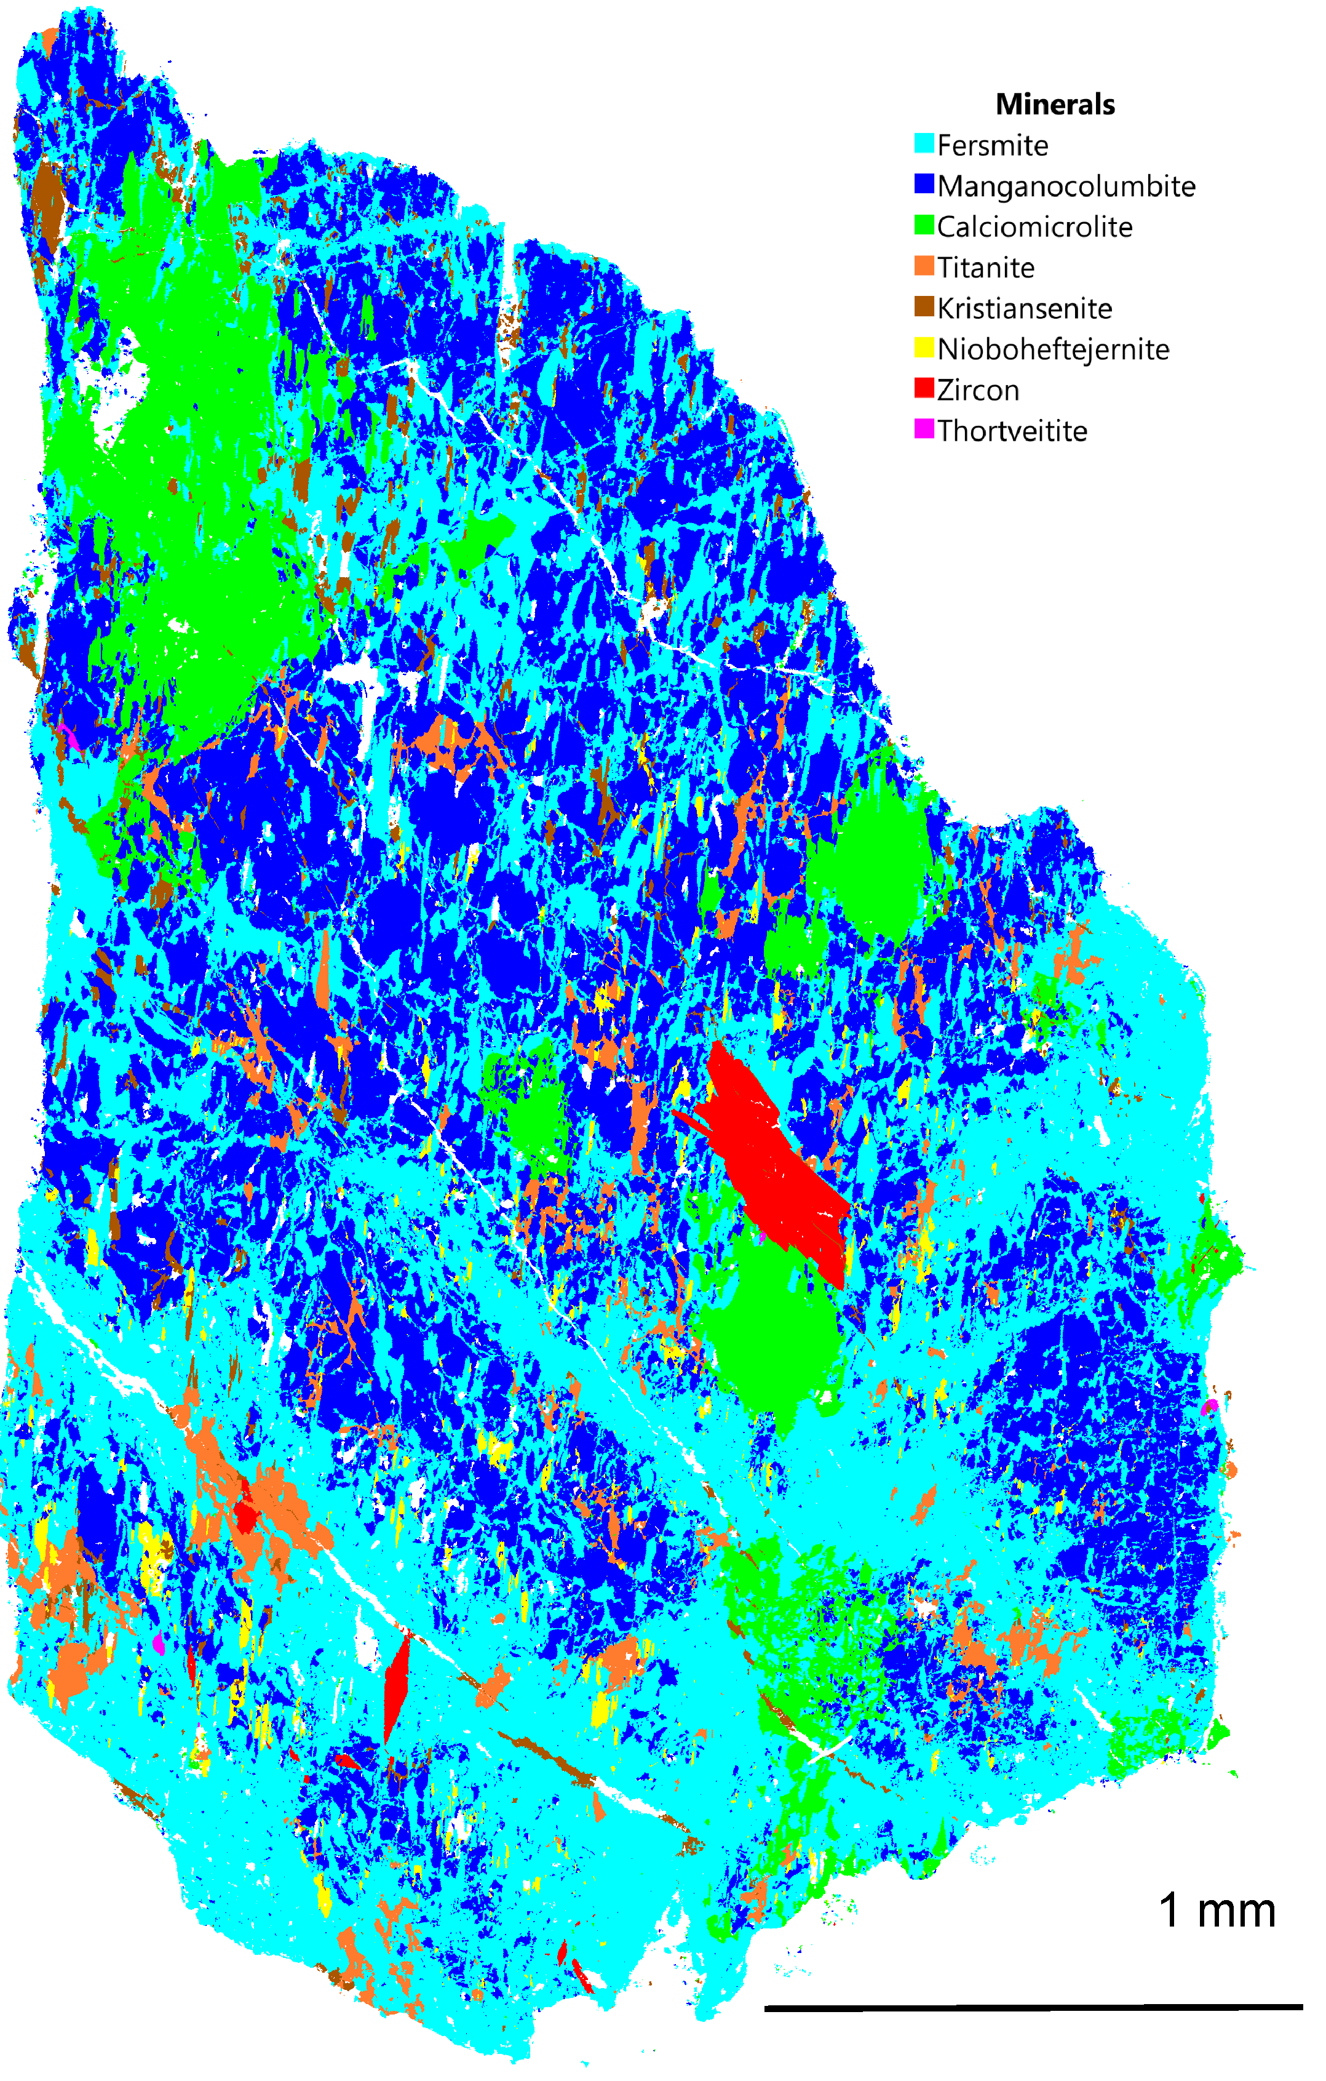
Figure S3. TIMA phase map of RS88.
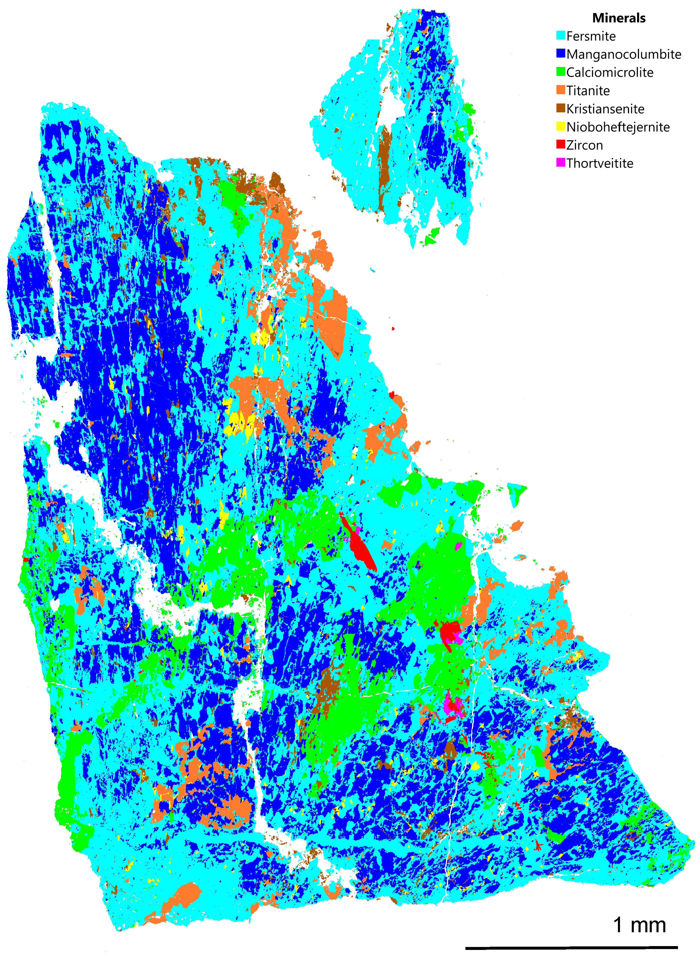
Figure S4. TIMA phase map of RS169.

