Supplementary Table 1. Number of fish caught per species and treatment (h = harvest, c = control; total n =303) with length (cm) and weight (g) ranges.
Species | n (tot) | n (h) | n (c) | Length (cm) | Weight (g)
Pollachius virens | 132 | 105 | 27 | 7.5-27.5 | 5-230
Myoxocephalus scorpius | 107 | 51 | 56 | 7-24 | 5-200
Gadus morhua | 29 | 12 | 17 | 9-21 | 5-120
Pleuronectes platessa | 13 | 5 | 8 | 11-27 | 30-250
Pholis gunnellus | 11 | 8 | 3 | 12.5-19.5 | 5-30
Platichthys flesus | 4 | 1 | 3 | 22-41 | 130-770
Salvelinus alpinus | 3 | 3 | 0 | 22-29.5 | 70-190
Gasterosteus aculeatus | 2 | 0 | 2 | 5.5 | 5
Limanda limanda | 2 | 2 | 0 | 19-24 | 80-190

Supplementary Table 2. Size (length, cm) range for age groups of the species aged (data pooled across treatments and dates).
 | 0+ | 1+ | 2+ | 3+ | 4+ | 5+ | 6+ | 7+ | 8+ | 9+
P. virens | 9-12.5 | 12-27.5 | - | - | - | - | - | - | - | -
G. morhua | 9 | 10.5-21 | - | - | - | - | - | - | - | -
P. gunnellus | - | - | - | 12.5 | - | 15-16.5 | 16-17 | - | 18.5 | 19.5
M. scorpius | - | 7.0-14 | 10.5-19 | 12.5-23.5 | 16-24 | 21-23 | - | - | - | -

Supplementary Table 3. Stomach content analysis of three most commonly caught fish pooled across species, treatments and dates. %f; frequency of occurrence. %p; percentage of the total stomach contents of all predators that is comprised by each prey type.
Taxa | Control |  | Harvest |  | Total
Taxa | n = 109 |  | n = 198 |  | n = 307
Taxa | f_{i} | p_{i} | f_{i} | p_{i} | f_{i} | p_{i}
Crustacea
Amphipoda | 59.5 | 70.2 | 46.3 | 66.6 | 51.2 | 67.8
Decapoda (unid.) | 1.3 | 0.2 | 1.2 | 0.2 | 3.7 | 0.4
Idotea granulosa | 24.1 | 10.4 | 9.8 | 3.7 | 15.2 | 6
Hyas araneus | 6.3 | 1.7 | 2.4 | 0.5 | 4.5 | 0.9
Jaera albifrons | 1.3 | 0.2 | 0 | 0 | 1.2 | 0.1
Calanus finmarchicus | 0 | 0 | 0.6 | 0.1 | 1.2 | 0.1
Caprellidae | 1.3 | 0.2 | 0 | 0 | 1.2 | 0.1
Euphasia | 1.3 | 0.4 | 0 | 0 | 0.4 | 0.2
Teleostei
Digested fish | 15.2 | 3.6 | 13.4 | 4 | 14.8 | 3.9
Fish (unid.) | 0 | 0 | 1.2 | 0.2 | 2.4 | 0.2
Pholis gunnellus | 0 | 0 | 1.2 | 1 | 1.6 | 0.7
Pollachius virens | 1.3 | 0.2 | 0.6 | 0.1 | 1.6 | 0.2
Ammodytidae | 0 | 0 | 1.8 | 3.7 | 2.1 | 2.4
Chelicerata
Pygnoconida | 0 | 0 | 0.6 | 0.2 | 1.2 | 0.2
Mollusca
Nudibranchia | 1.3 | 0.2 | 0.6 | 0.9 | 1.6 | 0.7
Bivalvia (unid.) | 1.3 | 0.2 | 0 | 0 | 1.2 | 0.1
Lacuna vincta | 1.3 | 0.2 | 0 | 0 | 1.2 | 0.1
Nucella lapillus | 0 | 0 | 0.6 | 0.1 | 1.2 | 0.1
Littorina obtusata | 3.8 | 1.9 | 2.4 | 0.6 | 3.7 | 1
Gastropoda (unid.) | 2.5 | 0.4 | 2.4 | 2.7 | 2.5 | 1.9
Littorina saxitalis | 1.3 | 0.2 | 0 | 0 | 0.4 | 0.1
Echinodermata
Ophiuroidea | 1.3 | 0.2 | 0.6 | 0.1 | 1.6 | 0.2
Holothuria | 0 | 0 | 1.8 | 0.3 | 2.1 | 0.2
Annelida
Annelida (unid.) | 10.1 | 3.8 | 12.2 | 2.8 | 12.3 | 3.1
Polychaeta | 2.5 | 0.4 | 1.2 | 1.5 | 2.5 | 1.1
Sipunculida | 1.3 | 0.6 | 2.4 | 0.5 | 2.1 | 0.5
Nemertea
Nemertea | 0 | 0 | 0.6 | 1.5 | 1.2 | 1
Nematoida
Nematoda | 1.3 | 0.4 | 1.2 | 0.2 | 2.8 | 0.4
Scalidophora
Priapulida | 0 | 0 | 0.6 | 0.1 | 0.4 | 0.1
Misc.
Larvae (unid.) | 0 | 0 | 0.6 | 0.1 | 0.4 | 0.7
Other | 24.1 | 4 | 40.2 | 7.4 | 34.8 | 6.2

Supplementary Table 4. Results of Similarity Percentage Analyses (SIMPER) identifying the prey species most contributing for differences in P. virens, G. morhua and M. scorpius diet between treatments. The Bray-Curtis similarity matrix and 999 permutations were used in all permutational analyses. Cut off for low contributions: 90.00%.
 | P. virens group Harvest (Avg. similarity: 28.5)
 | Species |  | Avg. Abund. |  | Avg. Sim. |  |  | Sim/SD |  |  | Contrib% |  |  | Cum%
 | Other |  | 0.5 |  | 17.9 |  |  | 0.5 |  |  | 62.9 |  |  | 62.9
 | Amphipoda |  | 0.97 |  | 9.1 |  |  | 0.4 |  |  | 32 |  |  | 94.8
P. virens group Control (Avg. similarity: 29.3)
 | Species |  | Avg. Abund. |  | Avg. Sim. |  |  | Sim/SD |  |  | Contrib% |  |  | Cum%
 | Amphipoda |  | 1.3 |  | 15.3 |  |  | 0.7 |  |  | 52.1 |  |  | 52
 | Other |  | 0.5 |  | 11.6 |  |  | 0.5 |  |  | 39.7 |  |  | 91.7
P. virens groups Harvest & Control (Avg. dissimilarity: 71)
 | Species |  | Avg. Abund. (Harvest) |  | Avg. Abund. (Control) |  |  | Av. Diss |  | Diss/SD |  |  | Contrib% |  | Cum%
 | Amphipoda |  | 0.97 |  | 1.28 |  |  | 30.3 |  |  | 1.14 |  |  | 42.6 |  |  | 42.6
 | Other |  | 0.5 |  | 0.5 |  |  | 14.4 |  |  | 0.75 |  |  | 20.3 |  |  | 62.9
 | Digested fish |  | 0.2 |  | 0.3 |  |  | 9.2 |  |  | 0.53 |  |  | 12.9 |  |  | 75.9
 | Annelida (un.) |  | 0.14 |  | 0.12 |  |  | 4.9 |  |  | 0.44 |  |  | 6.9 |  |  | 82.8
 | I. granulosa |  | 0.1 |  | 0.15 |  |  | 4.6 |  |  | 0.47 |  |  | 6.5 |  |  | 89.3
 | Gastropoda (un) |  | 0.1 |  | 0.04 |  |  | 2.2 |  |  | 0.3 |  |  | 3.1 |  |  | 92.4
 |  | G. morhua group Harvest (Avg. similarity: 18.6)
 |  | Species |  | Avg. Abund. |  | Avg. Sim. | Sim/SD |  | Contrib% |  |  | Cum%
 |  | Amphipoda |  | 1.4 |  | 17.7 | 0.6 |  | 95 |  |  | 95
G. morhua group Control (Avg. similarity: 38.3)
 |  | Species |  | Avg. Abund. |  | Avg. Sim. | Sim/SD |  | Contrib% |  |  | Cum%
 |  | Amphipoda |  | 2.4 |  | 34.5 | 1.1 |  | 90 |  |  | 90
 |  | Other |  | 0.3 |  | 2.4 | 0.2 |  | 6.2 |  |  | 96.1
G. morhua groups Harvest & Control (Avg. dissimilarity: 70.1)
Species |  |  | Avg. Abund. (Harvest) |  | Avg. Abund. (Control) |  |  | Av. Diss |  | Diss/SD |  |  | Contrib% |  |  | Cum%
Amphipoda |  |  | 2.4 |  | 1.4 |  |  | 45.3 |  |  | 1.4 |  |  | 64.1 |  |  |  | 64.1
Digested fish |  |  | 0.2 |  | 0.2 |  |  | 9.3 |  |  | 0.5 |  |  | 13.1 |  |  |  | 77.2
Other |  |  | 0.3 |  | 0.1 |  |  | 9.2 |  |  | 0.5 |  |  | 13.1 |  |  |  | 90.3
M. scorpius group Harvest (Avg. similarity: 8.6)
Species |  |  |  | Avg. Abund. |  | Avg. Sim. | Sim/SD |  | Contrib% |  |  | Cum%
Amphipoda |  |  |  | 0.6 |  | 5 | 0.3 |  | 58 |  |  | 58
Other |  |  |  | 0.2 |  | 1.7 | 0.2 |  | 19.3 |  |  | 77.3
I. granulosa |  |  |  | 0.2 |  | 0.9 | 0.1 |  | 10 |  |  | 87.3
Digested fish |  |  |  | 0.1 |  | 0.5 | 0.1 |  | 6.3 |  |  | 93.5
M. scorpius group Control (Avg. similarity: 11)
Species |  |  |  | Avg. Abund. |  | Avg. Sim. | Sim/SD |  | Contrib% |  |  | Cum%
Amphipoda |  |  |  | 0.8 |  | 7.4 | 0.4 |  | 67.3 |  |  | 67.3
I. granulosa |  |  |  | 0.5 |  | 2.7 | 0.3 |  | 24.5 |  |  | 91.8
M. scorpius groups Harvest & Control (Avg. dissimilarity: 90.3)
Species |  |  | Avg. Abund. (Harvest) |  | Avg. Abund. (Control) |  |  | Av. Diss |  | Diss/SD |  |  | Contrib% |  |  | Cum%
Amphipoda |  |  | 0.6 |  | 0.8 |  |  | 28.8 |  |  | 1 |  |  | 31.8 |  |  |  | 31.8
I. granulosa |  |  | 0.2 |  | 0.5 |  |  | 13.6 |  |  | 0.7 |  |  | 15 |  |  |  | 46.9
Other |  |  | 0.2 |  | 0.1 |  |  | 8.7 |  |  | 0.4 |  |  | 9.7 |  |  |  | 56.5
NI Digested Fish |  |  | 0.13 |  | 0.1 |  |  | 6.8 |  |  | 0.4 |  |  | 7.5 |  |  |  | 64
H. araneus |  |  | 0.07 |  | 0.1 |  |  | 5.1 |  |  | 0.4 |  |  | 5.7 |  |  |  | 69.7
L. obtusata |  |  | 0.05 |  | 0.1 |  |  | 4.9 |  |  | 0.3 |  |  | 5.5 |  |  |  | 75.2
Annelida (un.) |  |  | 0.07 |  | 0.1 |  |  | 4.4 |  |  | 0.4 |  |  | 4.9 |  |  |  | 80
Sipuncula |  |  | 0.04 |  | 0.03 |  |  | 2.7 |  |  | 0.2 |  |  | 3 |  |  |  | 83
Decapoda (un.) |  |  | 0.02 |  | 0.04 |  |  | 2.4 |  |  | 0.2 |  |  | 2.6 |  |  |  | 85.6
Ophiuroidea |  |  | 0.02 |  | 0.02 |  |  | 2.1 |  |  | 0.2 |  |  | 2.3 |  |  |  | 87.9
Fish (un.) |  |  | 0.04 |  | 0.0 |  |  | 1.6 |  |  | 0.2 |  |  | 1.8 |  |  |  | 89.7
Nudibranchia |  |  | 0.05 |  | 0.02 |  |  | 1.3 |  |  | 0.2 |  |  | 1.4 |  |  |  | 91.1
Supplementary figures
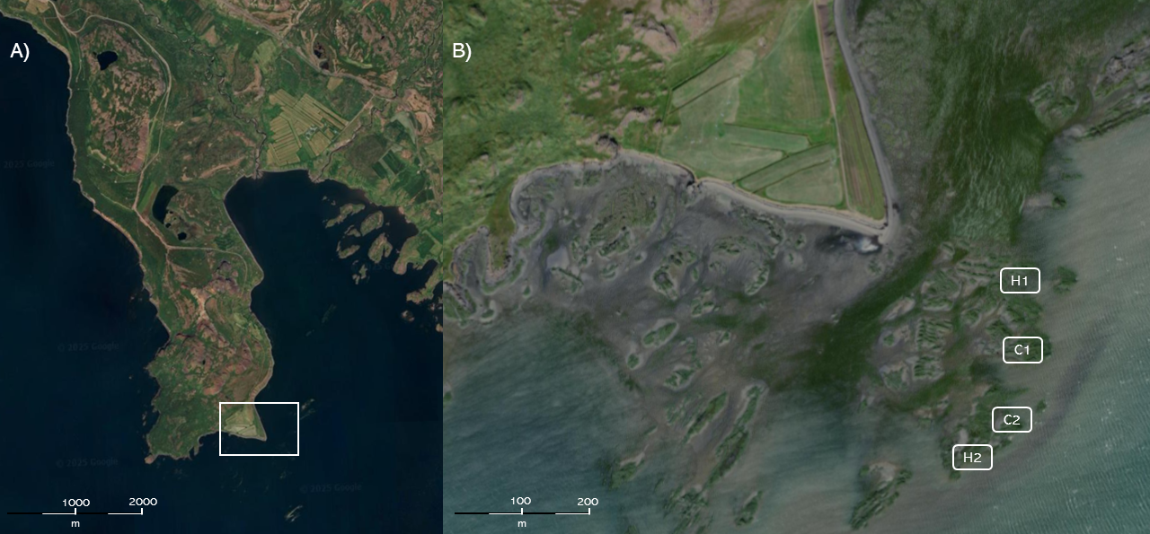
Supplementary figure 1. Satellite image of the general area (left; A) and detail of the study area Borg (right; B) with harvested and control plots.
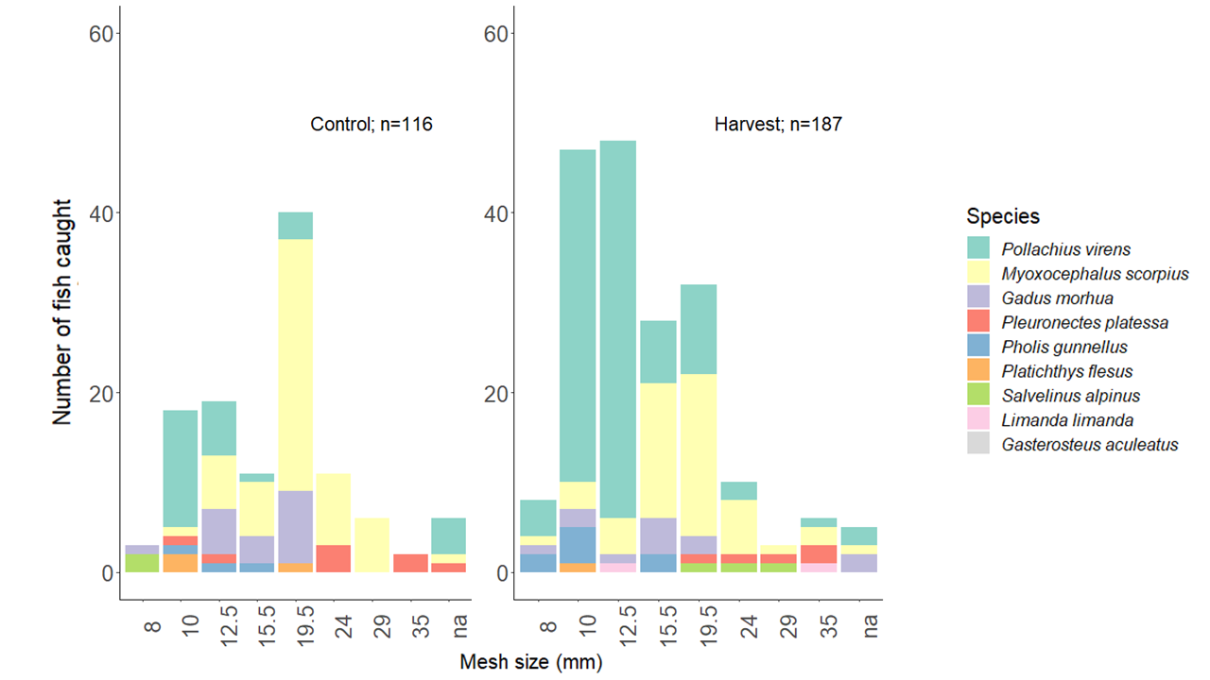
Supplementary figure 2. Number of fish caught per species, mesh size (mm) and treatment (left = control, right = harvested; total n = 303). “na” are fish that were entangled in the net but not stuck in any particular mesh size. All data were pooled across all sampling dates (total numbers for each species is provided in the Supplementary Table S1).
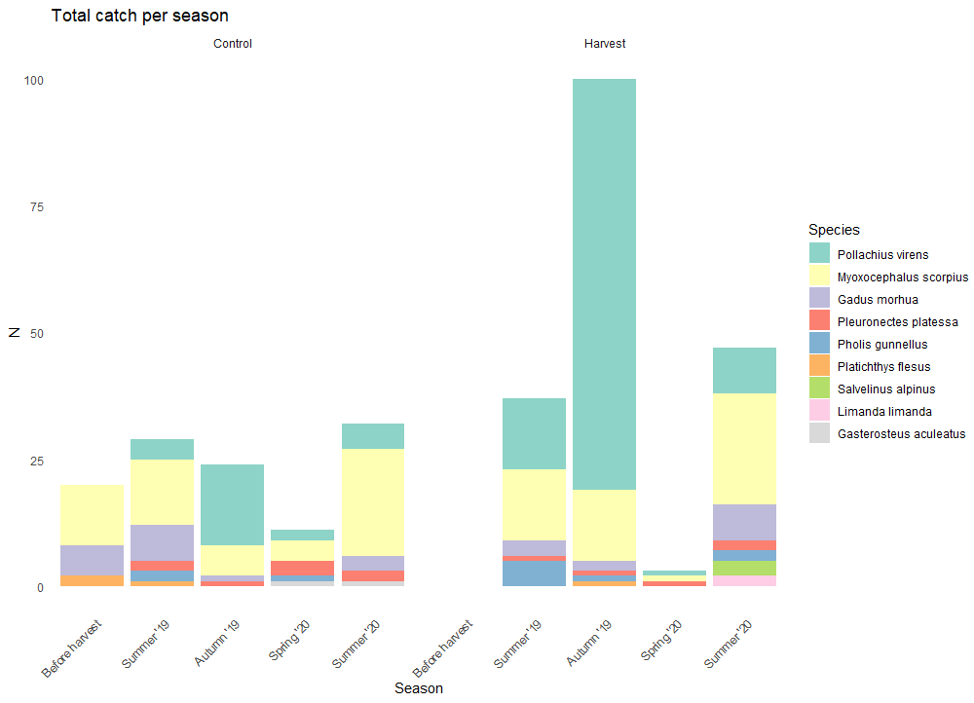
Supplementary figure 3. Number of fish caught per species, season and treatment (left = control, right = harvested; total n = 303).

