SUPPLEMENTARY MATERIAL

**Ongoing tropicalisation of marine fishes: Is range expansion and establishment occurring in the Gulf of Cadiz (southernmost Europe)?**

Gustavo F. de Carvalho-Souza1*, Cristóbal Lobato Gómez2, Diego Arana2 and Enrique González-Ortegón1

1 Instituto de Ciencias Marinas de Andalucía (ICMAN-CSIC), Campus Universitario Río San Pedro, 11519, Puerto Real, Cádiz, Spain

2 Agencia de Gestión Agraria y Pesquera de Andalucía, c/ Bergantín 39, 41012 Sevilla, Spain

Corresponding authors: [gustavo.souza@csic.es](mailto:gustavo.souza@csic.es)

**Table S1**

**Figures S1, S2, S3, S4, S5, S6, S7, S8, S9, S10, S11, S12, S13, S14 and S15**

Table S1. Occurrence records of the new, unusual, and rare occurrences of fifteen fish species expanding and potentially establishing their ranges in the Gulf of Cadiz are reported. Coordinates estimated from record description.

|  |  |  |  |  |
| --- | --- | --- | --- | --- |
| Date | N | Species | Latitude | Longitude |
| 2021 | 1 | *Carlarius parkii* | 36º 77’43” N | 6º 45’37” W |
| 2022 | 1 | *Grammicolepis brachiusculus* | 36º 79’24” N | 6º 40’46” W |
| 2023 | 2 | *Grammicolepis brachiusculus* | 36º 78’48” N | 6º 40’40” W |
| 2022 | 1 | *Diretmichthys parini* | 36º 78’29” N | 6º 39’46” W |
| 2023 | 1 | *Diretmichthys parini* | 36º 77’30” N | 6º 43’25” W |
| 2017 | 1 | *Caranx crysos* | 36º 60’49” N | 6º 37’62” W |
| 2018 | 1 | *Caranx crysos* | 36º 60’50” N | 6º 37’44” W |
| 2020 | 1 | *Caranx crysos* | 36º 60’01” N | 6º 38’35” W |
| 2022 | 2 | *Caranx crysos* | 36º 60’87” N | 6º 38’43” W |
| 2024 | 2 | *Caranx crysos* | 36º 60’63” N | 6º 38’61” W |
| 2010 | 1 | *Pseudocaranx dentex* | 36º 62’03” N | 6º 40’98” W |
| 2013 | 1 | *Pseudocaranx dentex* | 36º 73’52” N | 6º 48’90” W |
| 2016 | 1 | *Pseudocaranx dentex* | 36º 59’66” N | 6º 37’45” W |
| 2018 | 2 | *Pseudocaranx dentex* | 36º 60’34” N | 6º 35’93” W |
| 2023 | 1 | *Pseudocaranx dentex* | 36º 56’87” N | 6º 35’59” W |
| 2024 | 5 | *Pseudocaranx dentex* | 36º 13’04” N | 5º 95’34” W |
| 2017 | 1 | *Selene dorsalis* | 36º 78’45” N | 6º 47’08” W |
| 2016 | 4 | *Seriola rivoliana* | 36º 59’60” N | 6º 39’92” W |
| 2017 | 3 | *Seriola rivoliana* | 36º 59’60” N | 6º 39’92” W |
| 2019 | 10 | *Seriola rivoliana* | 36º 59’60” N | 6º 39’92” W |
| 2020 | 8 | *Seriola rivoliana* | 36º 73’47” N | 6º 50’73” W |
| 2020 | 3 | *Seriola rivoliana* | 36º 59’60” N | 6º 39’92” W |
| 2020 | 1 | *Seriola rivoliana* | 36º 56’10” N | 6º 39’77” W |
| 2020 | 5 | *Seriola rivoliana* | 36º 78’21” N | 6º 42’73” W |
| 2021 | 18 | *Seriola rivoliana* | 36º 78’21” N | 6º 42’73” W |
| 2021 | 12 | *Seriola rivoliana* | 36º 72’54” N | 6º 50’58” W |
| 2021 | 30 | *Seriola rivoliana* | 36º 59’60” N | 6º 39’92” W |
| 2021 | 28 | *Seriola rivoliana* | 36º 23’97” N | 6º 15’35” W |
| 2021 | 6 | *Seriola rivoliana* | 36º 56’10” N | 6º 39’77” W |
| 2022 | 1 | *Seriola rivoliana* | 36º 56’10” N | 6º 39’77” W |
| 2022 | 13 | *Seriola rivoliana* | 36º 23’97” N | 6º 15’35” W |
| 2022 | 9 | *Seriola rivoliana* | 36º 78’21” N | 6º 42’73” W |
| 2022 | 9 | *Seriola rivoliana* | 36º 59’60” N | 6º 39’92” W |
| 2022 | 5 | *Seriola rivoliana* | 36º 72’54” N | 6º 50’58” W |
| 2023 | 3 | *Seriola rivoliana* | 36º 23’97” N | 6º 15’35” W |
| 2023 | 1 | *Seriola rivoliana* | 36º 72’54” N | 6º 50’58” W |
| 2023 | 1 | *Seriola rivoliana* | 36º 59’60” N | 6º 39’92” W |
| 2015 | 1 | *Kyphosus vaigiensis* | 36º 72’71” N | 6º 49’81” W |
| 2015 | 1 | *Kyphosus vaigiensis* | 36º 60’96” N | 6º 38’95” W |
| 2020 | 1 | *Kyphosus vaigiensis* | 36º 72’71” N | 6º 49’81” W |
| 2021 | 1 | *Kyphosus vaigiensis* | 36º 72’71” N | 6º 49’81” W |
| 2021 | 2 | *Kyphosus vaigiensis* | 36º 78’61” N | 6º 41’98” W |
| 2022 | 4 | *Kyphosus vaigiensis* | 36º 59’60” N | 6º 39’92” W |
| 2022 | 1 | *Kyphosus vaigiensis* | 36º 72’71” N | 6º 49’81” W |
| 2008 | 1 | *Sparisoma cretense* | 36º 15’02” N | 5º 94’94” W |
| 2010 | 3 | *Sparisoma cretense* | 35º 97’34” N | 5º 54’52” W |
| 2012 | 6 | *Sparisoma cretense* | 36º 72’75” N | 6º 51’33” W |
| 2013 | 8 | *Sparisoma cretense* | 36º 72’54” N | 6º 50’58” W |
| 2013 | 4 | *Sparisoma cretense* | 36º 69’27” N | 6º 49’27” W |
| 2015 | 9 | *Sparisoma cretense* | 36º 70’28” N | 6º 53’10” W |
| 2016 | 11 | *Sparisoma cretense* | 36º 72’54” N | 6º 50’58” W |
| 2018 | 6 | *Sparisoma cretense* | 36º 72’54” N | 6º 50’58” W |
| 2020 | 10 | *Sparisoma cretense* | 36º 66’60” N | 6º 50’54” W |
| 2021 | 12 | *Sparisoma cretense* | 36º 71’71” N | 6º 53’87” W |
| 2022 | 10 | *Sparisoma cretense* | 36º 70’28” N | 6º 53’10” W |
| 2023 | 12 | *Sparisoma cretense* | 36º 72’54” N | 6º 50’58” W |
| 2024 | 8 | *Sparisoma cretense* | 36º 72’75” N | 6º 51’33” W |
| 2010 | 1 | *Pomadasys rogerii* | 36º 78’49” N | 6º 48’02” W |
| 2015 | 1 | *Lobotes surinamensis* | 36º 72’75” N | 6º 51’33” W |
| 2018 | 1 | *Lobotes surinamensis* | 36º 72’75” N | 6º 51’33” W |
| 2018 | 1 | *Lobotes surinamensis* | 36º 59’60” N | 6º 39’92” W |
| 2018 | 2 | *Lobotes surinamensis* | 36º 78’49” N | 6º 48’02” W |
| 2019 | 2 | *Lobotes surinamensis* | 36º 78’49” N | 6º 48’02” W |
| 2019 | 2 | *Lobotes surinamensis* | 36º 72’75” N | 6º 51’33” W |
| 2020 | 5 | *Lobotes surinamensis* | 36º 72’75” N | 6º 51’33” W |
| 2020 | 9 | *Lobotes surinamensis* | 36º 78’49” N | 6º 48’02” W |
| 2021 | 4 | *Lobotes surinamensis* | 36º 78’49” N | 6º 48’02” W |
| 2021 | 3 | *Lobotes surinamensis* | 36º 72’75” N | 6º 51’33” W |
| 2022 | 2 | *Lobotes surinamensis* | 36º 59’60” N | 6º 39’92” W |
| 2022 | 2 | *Lobotes surinamensis* | 36º 78’49” N | 6º 48’02” W |
| 2022 | 1 | *Lobotes surinamensis* | 36º 72’75” N | 6º 51’33” W |
| 2023 | 1 | *Lobotes surinamensis* | 36º 56’79” N | 6º 36’47” W |
| 2021 | 1 | *Acanthurus coeruleus* | 36º 78’34” N | 6º 41’03” W |
| 2022 | 1 | *Diodon holocanthus* | 36º 52’89” N | 6º 23’57” W |
| 2017 | 1 | *Lagocephalus laevigatus* | 36º 78’51” N | 6º 43’54” W |
| 2017 | 1 | *Aluterus monoceros* | 36º 27’12” N | 6º 12’95” W |

Figure S1. Historical occurrence records of *Carlarius parkii*. Red dots indicate the location of the *C. parkii* recorded in the Gulf of Cadiz. Blue dots indicate previous native locations of *C. parkii* in the Atlantic Ocean.

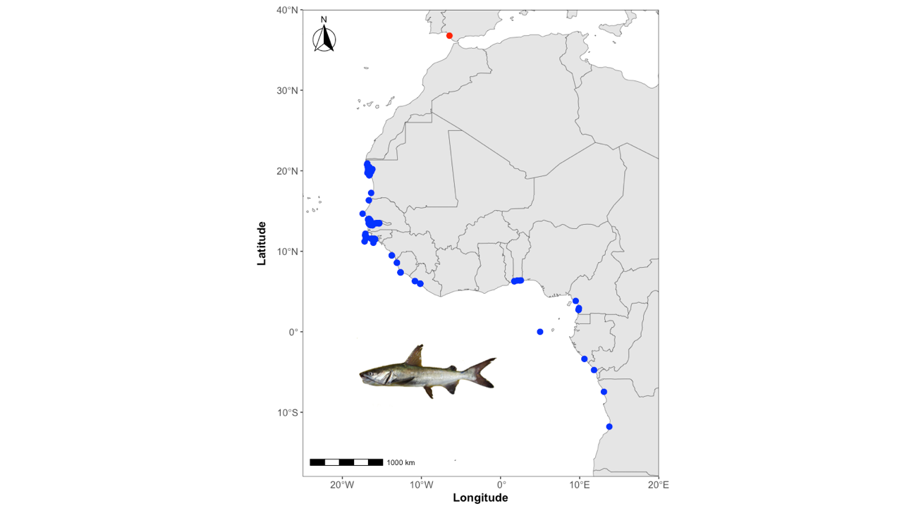

Figure S2. Historical occurrence records of *Grammicolepis brachiusculus*. Red dots indicate the location of the *G. brachiusculus* recorded in the Gulf of Cadiz. Blue dots indicate previous native locations of *G. brachiusculus* in the Atlantic Ocean.

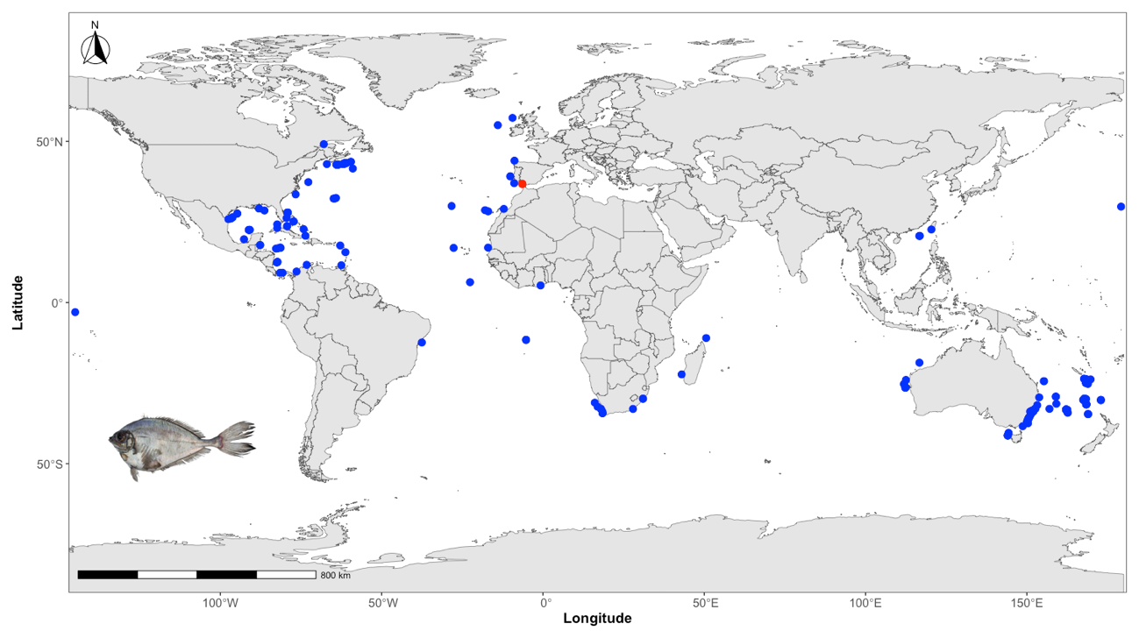

Figure S3. Historical occurrence records of *Diretmichthys parini*. Red dots indicate the location of the *D. parini* recorded in the Gulf of Cadiz. Blue dots indicate previous native locations of *D. parini* in the Atlantic Ocean.

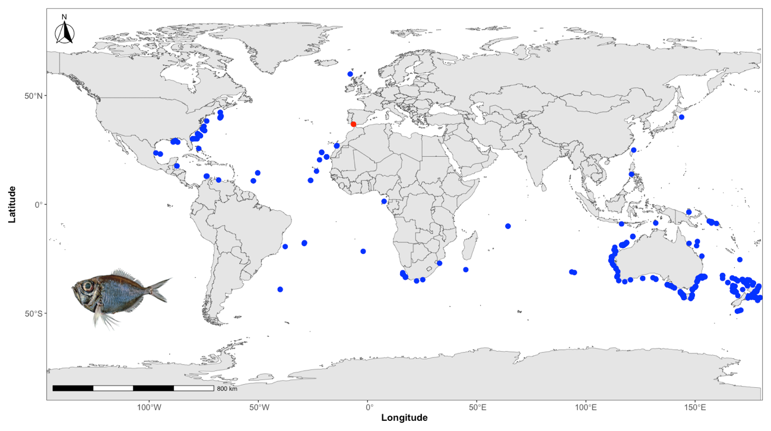

Figure S4. Historical occurrence records of *Caranx crysos*. Red dots indicate the location of the *C. crysos* recorded in the Gulf of Cadiz. Blue dots indicate previous native locations of *C. crysos* in the Atlantic Ocean.

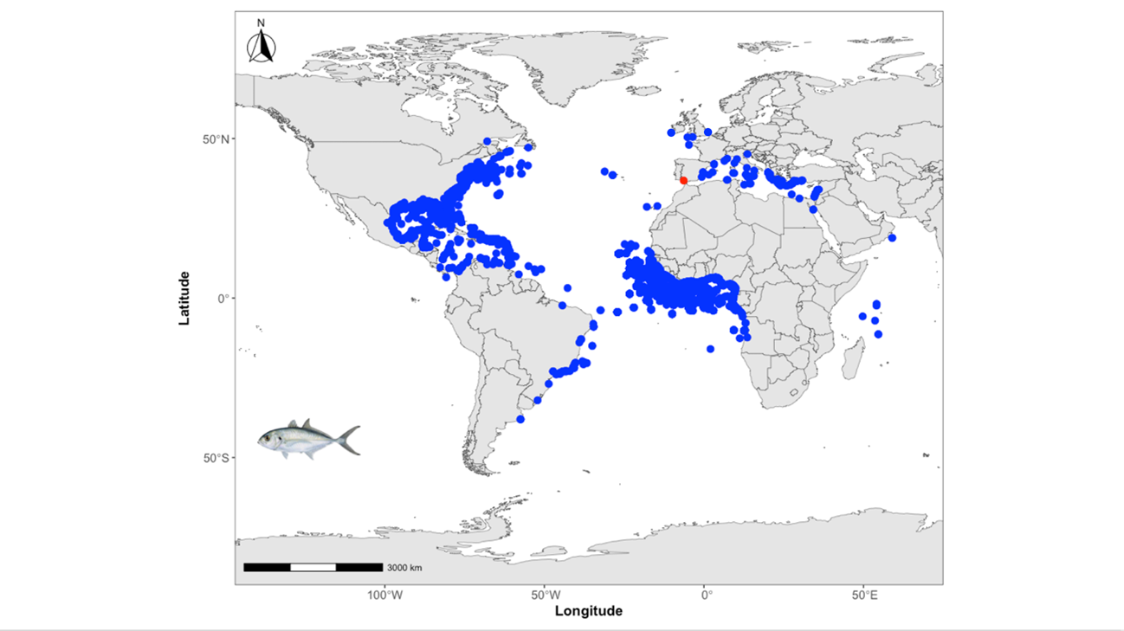

Figure S5. Historical occurrence records of *Pseudocaranx dentex*. Red dots indicate the location of the *P. dentex* recorded in the Gulf of Cadiz. Blue dots indicate previous native locations of *P. dentex* in the Atlantic Ocean.

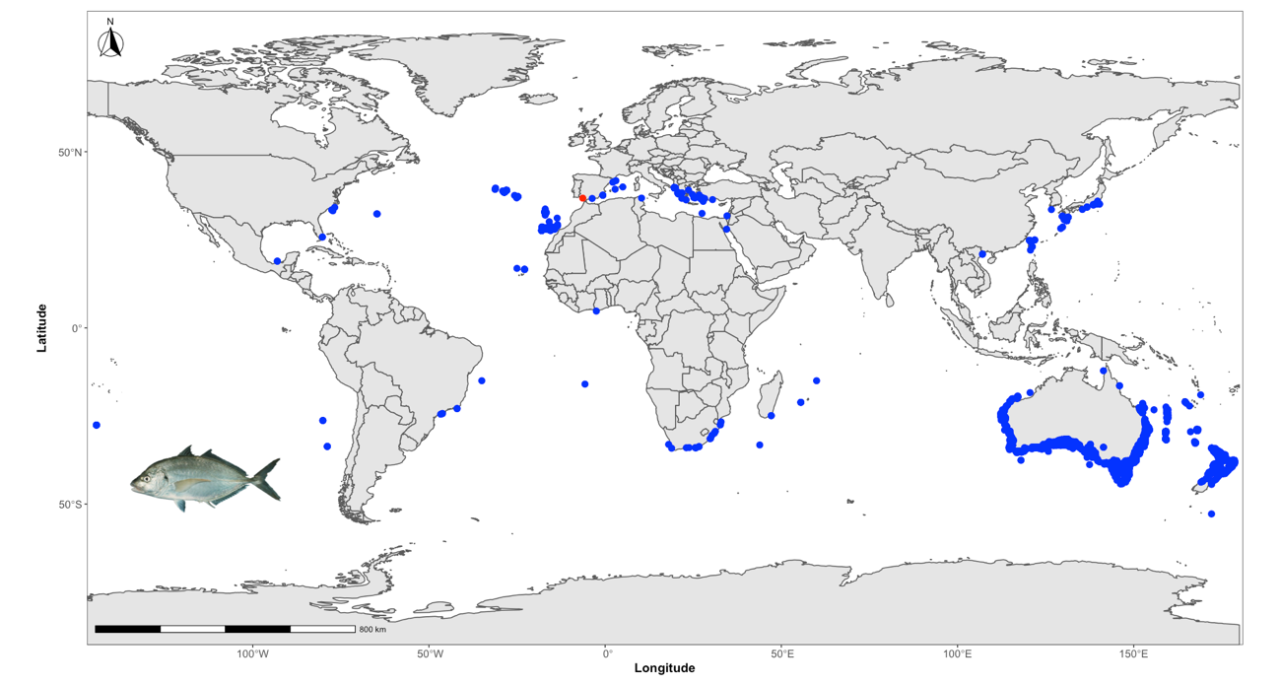

Figure S6. Historical occurrence records of *Selene dorsalis*. Red dots indicate the location of the *S. dorsalis* recorded in the Gulf of Cadiz. Blue dots indicate previous native locations of *S. dorsalis* in the Atlantic Ocean.

Figure S7. Historical occurrence records of *Seriola rivoliana*. Red dots indicate the location of the *S. rivoliana* recorded in the Gulf of Cadiz. Blue dots indicate previous native locations of *S. rivoliana* in the Atlantic Ocean.

Figure S8. Historical occurrence records of *Kyphosus vaigiensis*. Red dots indicate the location of the *K. vaigiensis* recorded in the Gulf of Cadiz. Blue dots indicate previous native locations of *K. vaigiensis* in the Atlantic Ocean.

Figure S9. Historical occurrence records of *Sparisoma cretense*. Red dots indicate the location of the *K. vaigiensis* recorded in the Gulf of Cadiz. Blue dots indicate previous native locations of *S. K. vaigiensis* in the Atlantic Ocean.

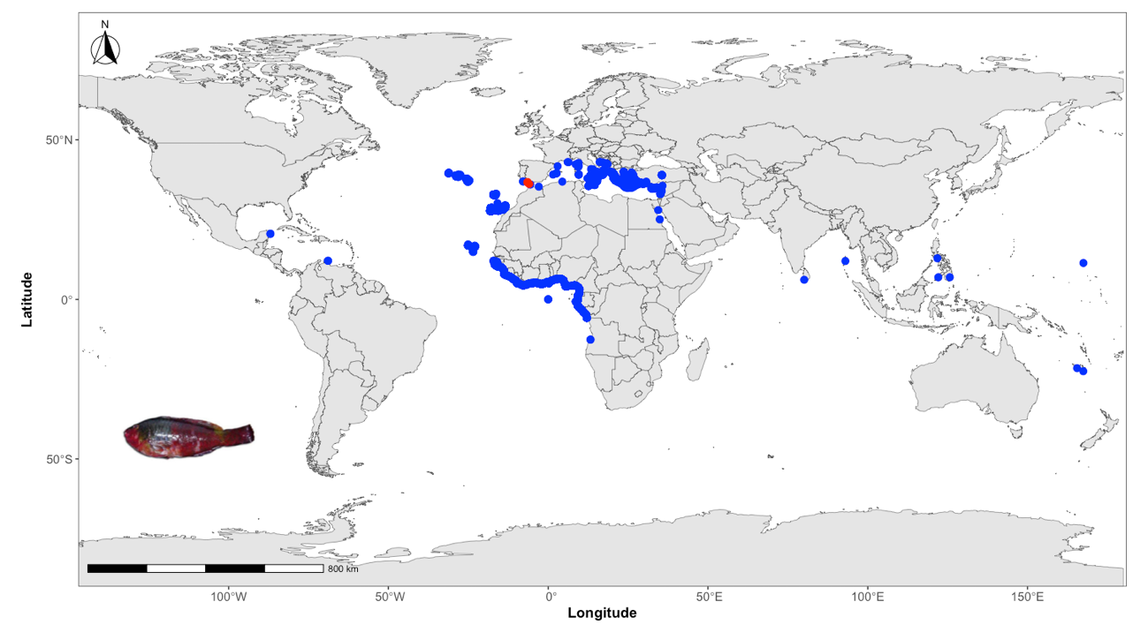

Figure S10. Historical occurrence records of *Pomadasys rogerii*. Red dots indicate the location of the *P. rogerii* recorded in the Gulf of Cadiz. Blue dots indicate previous native locations of *P. rogerii* in the Atlantic Ocean.

Figure S11. Historical occurrence records of *Lobotes surinamensis*. Red dots indicate the location of the *L. surinamensis* recorded in the Gulf of Cadiz. Blue dots indicate previous native locations of *L. surinamensis* in the Atlantic Ocean.

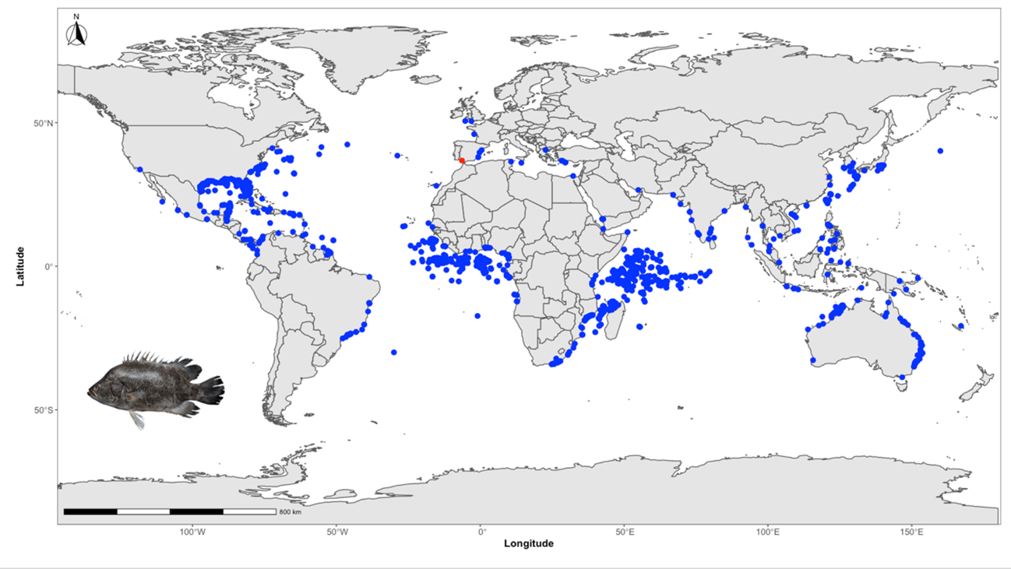

Figure S12. Historical occurrence records of *Acanthurus coeruleus*. Red dots indicate the location of the *A. coeruleus* recorded in the Gulf of Cadiz. Blue dots indicate previous native locations of *A. coeruleus* in the Atlantic Ocean.

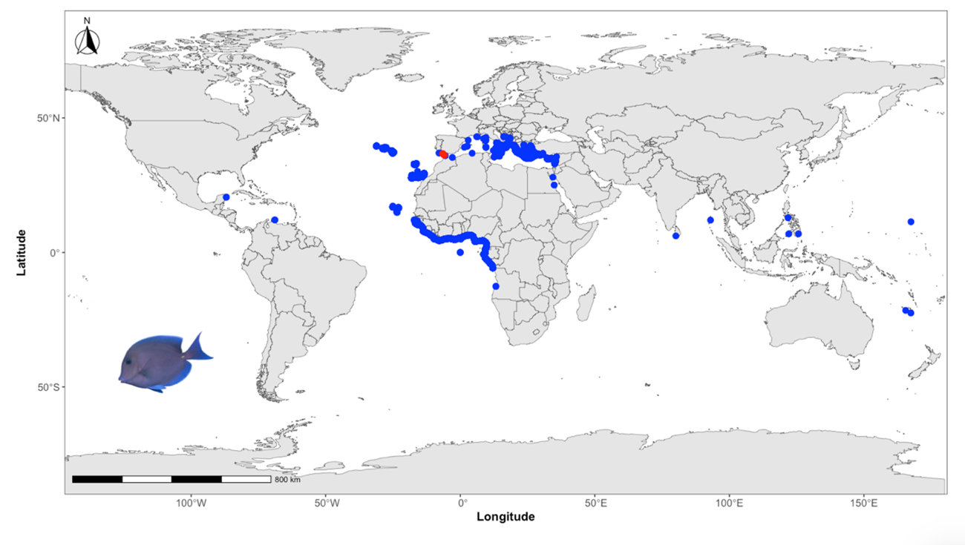

Figure S13. Historical occurrence records of *Diodon holocanthus*. Red dots indicate the location of the *D. holocanthus* recorded in the Gulf of Cadiz. Blue dots indicate previous native locations of *D. holocanthus* in the Atlantic Ocean.

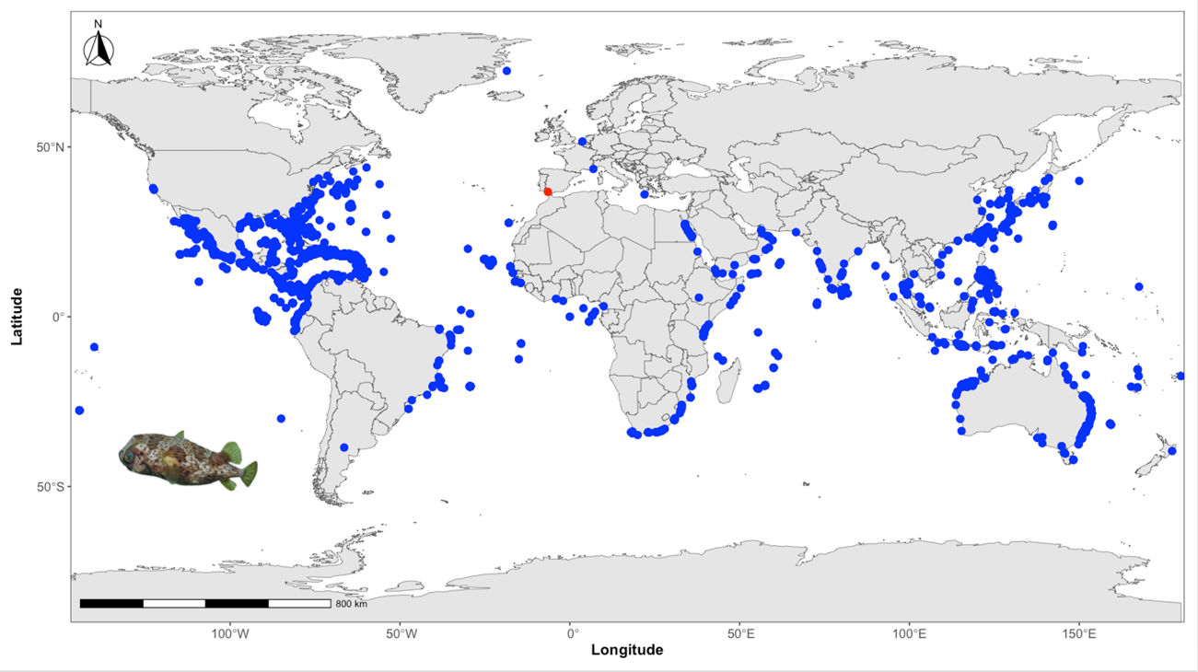

Figure S14. Historical occurrence records of *Lagocephalus laevigatus*. Red dots indicate the location of the *L. laevigatus* recorded in the Gulf of Cadiz. Blue dots indicate previous native locations of *L. laevigatus* in the Atlantic Ocean.

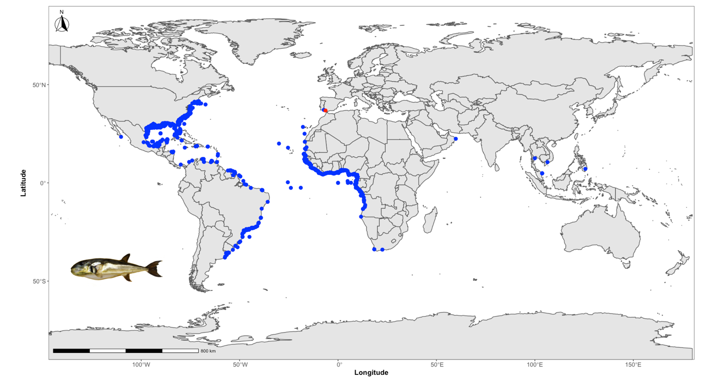

Figure S15. Historical occurrence records of *Aluterus monocero*s. Red dots indicate the location of the *A. monocero*s recorded in the Gulf of Cadiz. Blue dots indicate previous native locations of *A. monocero*s in the Atlantic Ocean.

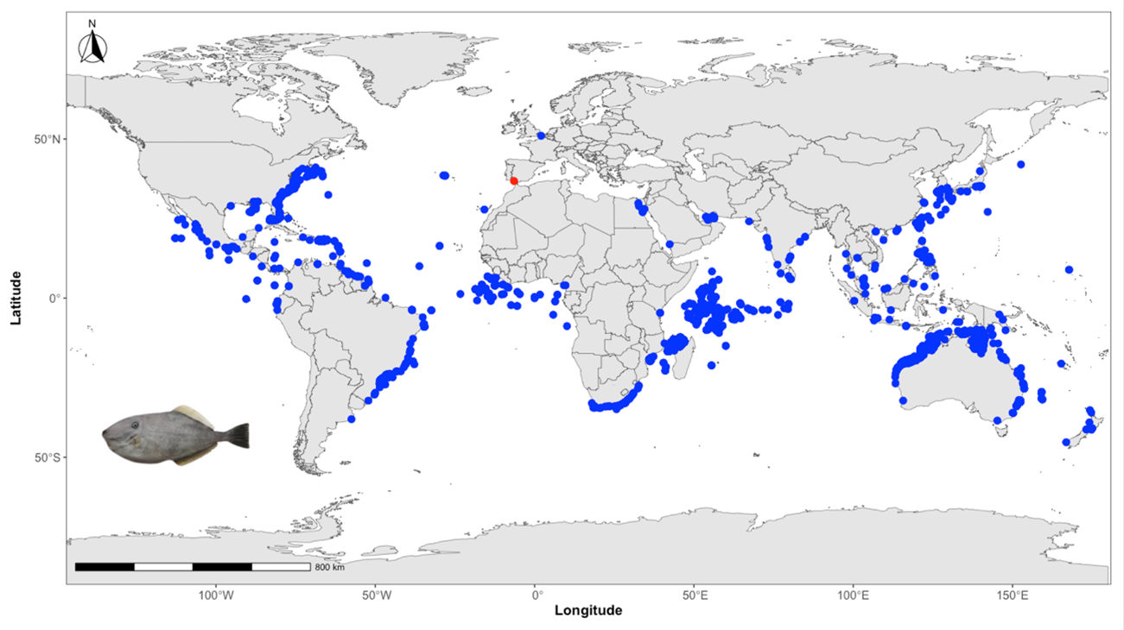

Figure S16. Multi-decadal time series of sea surface temperature anomalies in the Gulf of Cádiz, spanning from 1975 to 2025. The data were obtained from the NOAA Extended Reconstructed Sea Surface Temperature dataset (ERSSTv5) (Huang et al., 2017). The blue line represents monthly anomalies, while the smoother trend red line (5-year moving average) highlights long-term variability.

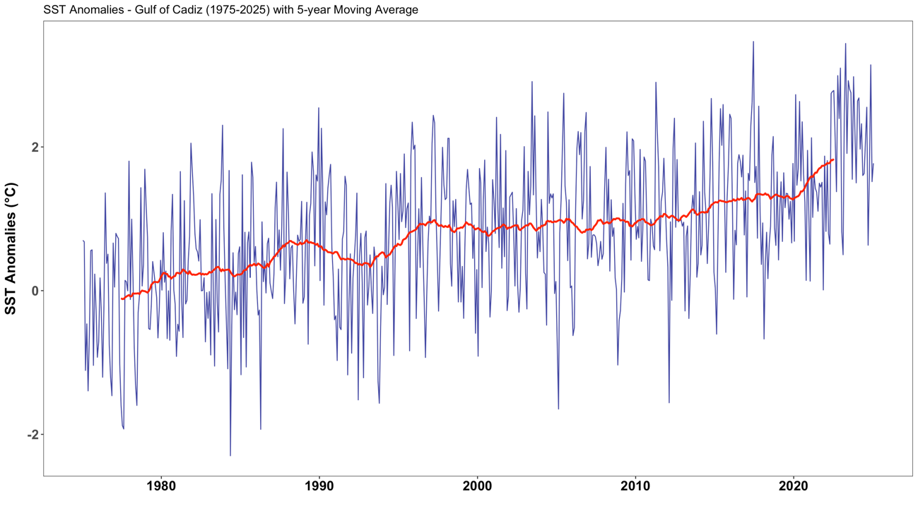

Supplementary References

GBIF.org (06 November 2024) GBIF Occurrence Download. <https://doi.org/10.15468/dl.wtwcjn>

GBIF.org (06 November 2024) GBIF Occurrence Download <https://doi.org/10.15468/dl.e8mc9q>

GBIF.org (06 November 2024) GBIF Occurrence Download <https://doi.org/10.15468/dl.f9k6wz>

GBIF.org (06 November 2024) GBIF Occurrence Download <https://doi.org/10.15468/dl.qywq6h>

GBIF.org (06 November 2024) GBIF Occurrence Download <https://doi.org/10.15468/dl.amx8xv>

[GBIF.org](http://GBIF.org) (20 July 2023) GBIF Occurrence Download <https://doi.org/10.15468/dl.2puma4>

[GBIF.org](http://GBIF.org) (20 July 2023) GBIF Occurrence Download <https://doi.org/10.15468/dl.h2nzyv>

[GBIF.org](http://GBIF.org) (20 July 2023) GBIF Occurrence Download <https://doi.org/10.15468/dl.tbq8b2>

[GBIF.org](http://GBIF.org) (20 July 2023) GBIF Occurrence Download <https://doi.org/10.15468/dl.xc4ma6>

[GBIF.org](http://GBIF.org) (20 July 2023) GBIF Occurrence Download <https://doi.org/10.15468/dl.sgv2sn>

[GBIF.org](http://GBIF.org) (20 July 2023) GBIF Occurrence Download <https://doi.org/10.15468/dl.yapwak>

[GBIF.org](http://GBIF.org) (19 July 2023) GBIF Occurrence Download <https://doi.org/10.15468/dl.3rtb4t>

[GBIF.org](http://GBIF.org) (19 July 2023) GBIF Occurrence Download <https://doi.org/10.15468/dl.cfkqhf>

[GBIF.org](http://GBIF.org) (19 July 2023) GBIF Occurrence Download <https://doi.org/10.15468/dl.d6xw3c>

[GBIF.org](http://GBIF.org) (19 July 2023) GBIF Occurrence Download <https://doi.org/10.15468/dl.vyngcs>

[GBIF.org](http://GBIF.org) (17 July 2023) GBIF Occurrence Download <https://doi.org/10.15468/dl.jqujp3>

[GBIF.org](http://GBIF.org) (17 July 2023) GBIF Occurrence Download <https://doi.org/10.15468/dl.vw5exz>

[GBIF.org](http://GBIF.org) (12 July 2023) GBIF Occurrence Download <https://doi.org/10.15468/dl.3ur8y2>

Huang, B., Thorne, P., Banzon, V., Boyer, T., Chepurin, G., Lawrimore, J. H., et al. (2017). Extended reconstructed sea surface temperature, version 5 (ERSSTv5): upgrades, validations, and intercomparisons. J. Clim. 30, 8179–8205. <https://doi.org/10.1175/JCLI-D-16-0836.1>