Supplementary material

Filtering
The analysis of the temporal series of positions showed that the filter had little effect on smoothing the data, with minimal differences (Figure S1b-c). The most significant differences were in the velocity estimates, as the noise in the positions could generate erroneous spikes in Tico's propagation estimates (Figure S1d-e).

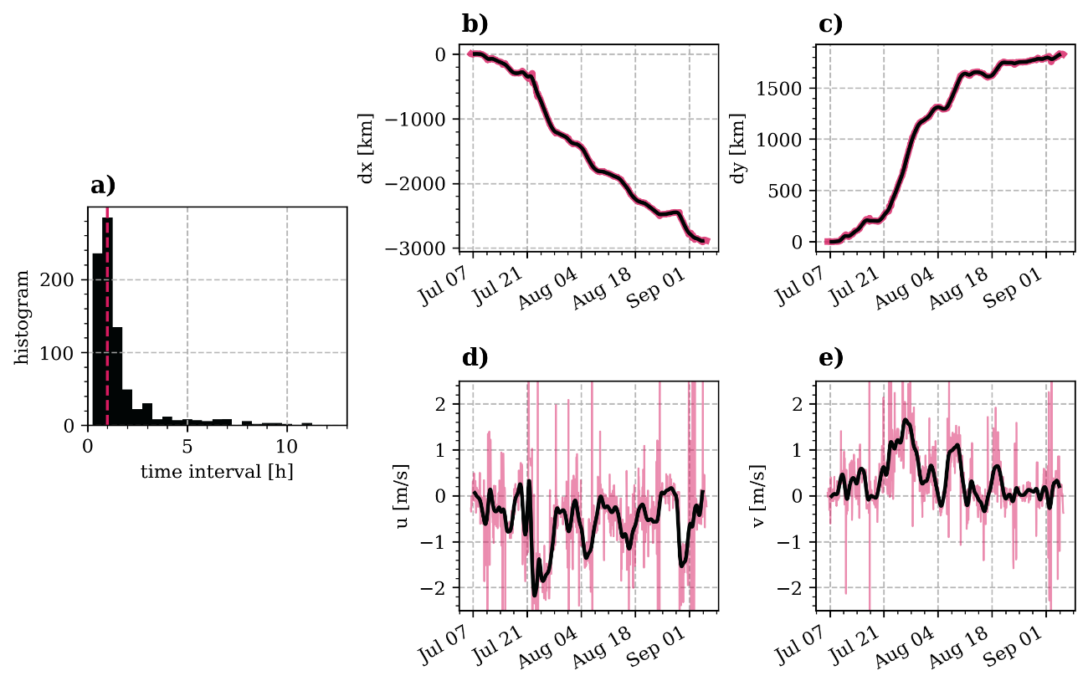
Figure S1. Histogram for the time interval between consecutive measurements retaining classes G, QFP and B (a). The mode (1 h) is represented by the vertical dashed line. Zonal and meridional displacements (b and c) and velocities (d and e) for raw (red) and 2-day running averaged positions (black).

