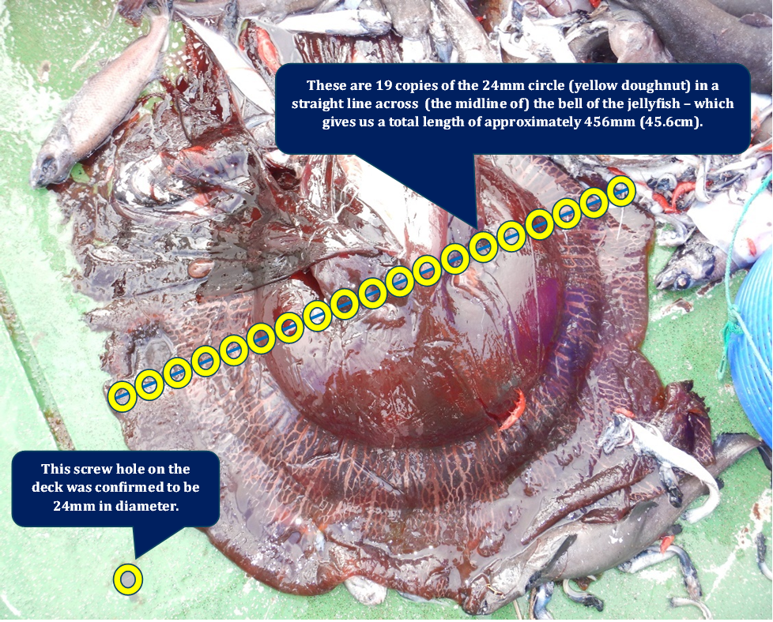

**Supporting Figure 1:** The size of the specimen of *Stygiomedusa gigantea* was estimated with a knowledge of the screw hole on the deck of the RV *Mirabilis.*