Supplementary Material:
Additional methods:
Sponges were cleaned using tweezers to remove non-sponge material (i.e. small rocks and pieces of shell) and associated organisms, such as algae or macroinvertebrates. Sponges were then haphazardly placed in tanks, with a total of 13 sponges in each tank (6 tanks in total). Once in the experimental system, sponges were acclimated for two weeks, after which a secondary acclimation period began where the pH was reduced in the treatment tanks by 0.1 units per day until the desired pH/pCO₂ was reached to simulate a gradual OA decline (e.g., Johnson et al., 2019). Sponges were attached to small 2 cm x 2 cm tiles using thin elastic line and aquarium pumps (50W) were placed inside experimental tanks to mix the water.

The sponges were kept at the average mean temperature (13°C) for the Wellington South Coast (Greater Wellington Regional Council, 2021), which was also similar to the temperature at the time of collection. Temperature was manipulated inside a 100L header tank (see Figure S1), which was kept at a target temperature of 13°C (see Table 1) using a heater and chiller that were controlled automatically using a Neptune APEX controller (Neptune System LLC, USA). This header tank fed into six independently supplied and operated flow-through tanks, the secondary header tanks. Three of these tanks were randomly allocated, based on assigning tanks a number and using a random number generator, as the treatment and three as the control. These secondary header tanks were also used to manipulate the seawater pH using the APEX controller, where pH probes (calibrated using NBS buffers) in the header tank sent feedback to the APEX system. The APEX was configured to keep the tanks within 0.1 unit of the target value via the slow-release bubbling of CO₂ from a solenoid box connected to a 6.8kg CO₂ cylinder. The water of each individual secondary header tank then flowed into a corresponding tank where the 13 sponges per tank were housed (n=39 per treatment). Each tank included a APEX temperature probe that sent feedback to the controller that would then automatically switch on the chiller or heaters inside the 100L main header tank. Temperature and pH were monitored weekly (Supplemental Table S1) throughout the experiment using the APEX probes and real-time measurements of pH(T) (mV) using a HQ40d portable pH multi-parameter (HACH, USA). The probe was calibrated using TRIS/HCL and 2-aminopyridine/HCL buffer solutions (Dickson et al., 2007), temperature and salinity were measured using a hand-held PRO30 Conductivity/TDS/Salinity/Temperature Meter (YSI®, Yellow Springs, OH, USA). In all cases calibrations were within 0.02 unit of reference solutions.

To determine the carbonate chemistry of the system pHT [H+], total alkalinity (TA), temperature and salinity were measured throughout the experiment to complete the calculations using dissociation constant of water and Henry’s law (Zeebe, 2012) (Tables 1 and S1). During the acclimation period, temperature and pHT [H+] were measured daily, however no total alkalinity (TA) samples were taken during this period (indicated by NA in Table S2). On the first day of the experiment (T0) the total alkalinity (TA), pH in total scale (pHT [H+]) and salinity were measured every 4 hrs for a 24-hr period (Table S1) to assess if the control (pH 8.0) and treatment (pH 7.6) were close to their target range during the duration of the experiment (see Table S1 for pHT [H+]averages per treatment across n = 3 tanks). Thereafter, TA was measured weekly (T0, T7, T14 and T28) by collecting 250 mL water samples from the secondary header tank and the experimental sponge tanks (n= 12 tanks total), which were then filtered through 0.4 μm pore size filters (Munktell micro-glass fibre paper) and stored in the refrigerator until later titration, which occurred within two weeks (Meron et al., 2012). This 24-hr sampling period was later replicated on the last day of the experiment (T28) (Table S1). Filtered water samples were then analysed using an AS-AL K 2 Alkalinity Titrator (Apollo SciTech Inc., Bogart, GA, USA) (Dickson et al., 2007; Lesser et al., 2016). TA of seawater samples were calculated using R studio (version 1.4.1717) and the Seacarb package (Proye and Gattuso, 2003) using a custom-made code developed by the Cornwall research group at Victoria University of Wellington. The parameters of carbonate chemistry (Table 1 and S1) were calculated using CO2 sys version 2.1 (Pierrot and Wallace, 2006). Regular titrations (Apollo SciTech Inc., Bogart, GA, USA) of certified reference material (CRM, batch 176 provided by A .G. Dickson lab) yielded AT values within ± 6 µmol kg⁻¹ of standards.
At T0, baseline respiration measurements were made for three randomly selected sponges per tank (meaning a total n = 9 per treatment), thereafter respiration rates were measured on day T3, T6, T14, T17, T24, and T28 (Tend). Randomisation was achieved using the numbers on the tiles and random number tables. We used a similar method as Bates and Bell (2018), Cummings et al. (2020), and Micaroni et al. (2021).

Separate sponges were placed in individual 250 mL sealed cylindrical glass respiration chambers with PreSens oxygen sensor spots (SP-PSt3-NAU) attached to their inside. Sponges were placed inside the chambers inside the experimental tanks, and the lid was sealed underwater, ensuring no air bubbles remained inside. The chambers were then removed from the experimental system and placed inside a water bath maintained at a constant temperature of 13°C in a temperature-controlled room. After 20 min of acclimation in the chambers, oxygen concentration inside the chambers was measured every 10 min for 40 minutes, using a Fibox 4 oxygen meter with a polymer optical fibre (POF). The observation period was based on a preliminary experiment, where sponges were acclimated for 20 minutes then oxygen concentration was measured every 10 minutes using a PreSens oxygen meter for 60 minutes to determine the rate at which oxygen declined in the chambers (after Micaroni et al., 2022). After this a 40-min period was adopted to ensure the oxygen concentration in the chambers did not fall below 80% of the original concentration. Blank incubations, containing only seawater were conducted for every respiration run and used to correct for any microbial community respiration in the seawater. A two-point calibration was performed on the oxygen sensor spots before each measurement session. This was achieved by bubbling air continuously into the respiration chambers for 10 min for 100% saturation and by adding 5 g of sodium dithionite for 0%. The respiration chambers were located on top of a magnetic plate set to 180 rpm, and the water inside the chambers was agitated using a magnetic stirring rod. Respiration measurements were conducted in the dark to reduce the potential for photosynthetic activity of plankton to affect the results (after Strano et al., 2022). Sponges were returned to treatment or control tanks after the measurements had been made.

We recorded buoyant weight (BW) of each sponge immediately after respiration measurements (after Bates and Bell 2018; Strano et al., 2022; Micaroni et al., 2022). After the final respiration measurements on T28 (T_{end}), BW, tile weight, dry weight, and ash free dry weight of all sponges (AFDW) were recorded. Sponges were placed inside a drying oven at 60°C for 48 h and then placed in a muffle furnace at 500°C for 5 h (Cummings et al., 2020); the ash free dry weight of the sponges was then calculated by subtracting the weight of sponge ash to the weight of the dry sponge. We used these data to create a regression line of ash free dry weight (y) as a function of buoyant weight (x) (Figure S2). The strong relationship between AFDW and BW allowed us to estimate the AFDW of the sponges at each respiration sampling interval (Trussel et al., 2006). Respiration rates (mg O₂ L⁻¹ g⁻¹ AFDW h⁻¹) were calculated as mg O₂ (mg O₂ (oxygen difference*volume of chamber) / time difference) / AFDW (BW of the sponge at sampling period multiplied by the calibration curve equation).

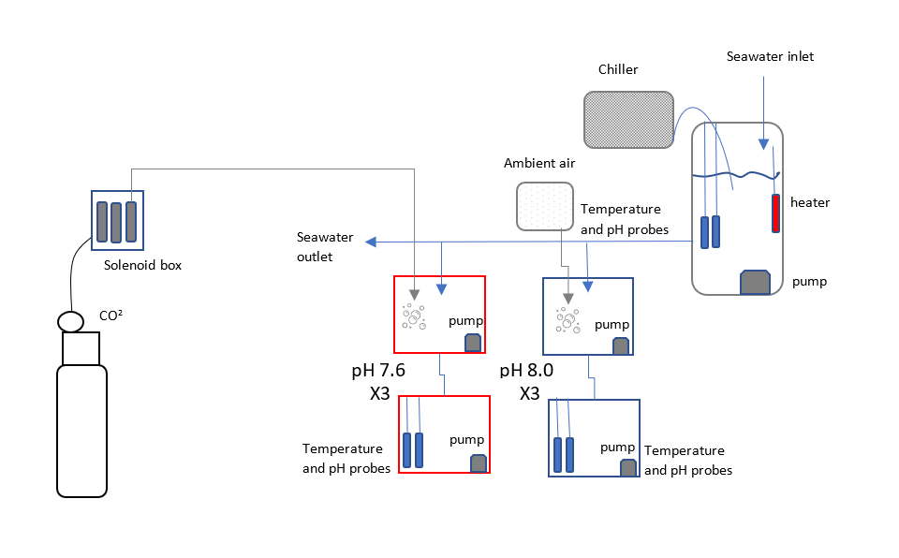
Figure S1. Experimental design of the 28-day experiment of pH stress using Grantia sp. as a study species. Flow through aquarium system: pH 7.6 (pCO₂ 1131.9 ± 113 μ atm) / 13 °C, pH 8.0 (pCO₂ 512.59 ±23 μ atm) / 13°C. CO₂ cylinder connected to a solenoid box was used to distribute CO₂ at APEX-control pH level of pH 7.6 into the treatment tanks. Ambient air was bubbled into the control header tanks. Pumps (grey squares) were placed in all tanks to keep water flowing through the system and to increase water circulation. pH and temperature probes (blue probes) were placed in the sponge tanks and the 100L header tank. The main header tank had a heater and a chiller controlling the water temperature to an average of 13 °C via APEX control.

Table S1. Experimental monitoring data of measured (*) and calculated (**) seawater parameters taken during the 24hr-cycles before and after the experiment (T0 and T28) and weekly during the experiment. Measured values of temperature, salinity, pH (pH$T$), and total alkalinity (A$T$) were measured in all aquaria weekly. pCO₂ (μ atm) and saturation states (Ωca and Ωar) were calculated by entering the recorded values (temperature, pH$T$, salinity and A$T$ into CO2 calc software (Robbins et al. 2010).
Time point | TANK | AT (μ mol/kg-1) * | Salinity * | Temperature (oC) * | pHT * | pCO2 (matm) ** | CO2 (mmol/kgSW) ** | ΩCa ** | Ωar **
24hr cycle T0  0000 | Control  (5C) | 2273.63 | 34.1 | 13 | 7.99 | 466.7 | 18.6 | 3.05 | 1.95
0000 | Treatment (T2) | 2273.38 | 34.1 | 13 | 7.65 | 1080.6 | 43.1 | 1.54 | 0.98
0400 | Control  (5C) | 2270.59 | 34.5 | 12.8 | 7.99 | 463.7 | 18.6 | 3.05 | 1.95
0400 | Treatment (T2) | 2273.01 | 34.5 | 12.8 | 7.64 | 1118.7 | 44.8 | 1.49 | 0.95
1200 | Control  (5C) | 2280.95 | 34.5 | 12.8 | 7.92 | 497.0 | 19.9 | 2.92 | 1.86
1200 | Treatment (T2) | 2268.30 | 34.5 | 12. | 7.65 | 1091.3 | 43.6 | 1.52 | 0.97
1600 | Control  (5C) | 2293.81 | 34.9 | 12.9 | 7.98 | 480.1 | 19.1 | 3.05 | 1.95
1600 | Treatment (T2) | 2279.81 | 34.9 | 13 | 7.67 | 1047.4 | 41.6 | 1.60 | 1.03
2000 | Control  (5C) | 2271.93 | 34.4 | 12.8 | 7.98 | 468.6 | 18.8 | 3.03 | 1.93
2000 | Treatment (T2) | 2274.74 | 34.5 | 12.9 | 7.62 | 1173.0 | 46.8 | 1.44 | 0.93
T0 | Control  (6C) | 2299.13 | 34.9 | 13.200 | 7.945 | 522.6 | 20.6 | 2.90 | 1.85
T0 | Control  (5C) | 2290.04 | 34.9 | 12.900 | 7.953 | 509.1 | 20.3 | 2.91 | 1.86
T0 | Treatment (T4) | 2299.93 | 34.9 | 13.000 | 7.611 | 1212.0 | 48.1 | 1.44 | 0.92
T0 | Control  (3C) | 2295.33 | 34.7 | 13.000 | 7.949 | 516.3 | 20.5 | 2.89 | 1.85
T0 | Treatment (T2) | 2296.59 | 34.9 | 13.000 | 7.644 | 1114.7 | 44.3 | 1.54 | 0.99
T0 | Treatment (T1) | 2295.33 | 34.9 | 12.800 | 7.645 | 1111.4 | 44.4 | 1.53 | 0.98
T7 | Control  (6C) | 2284.37 | 34.5 | 13.300 | 7.953 | 509.8 | 20.1 | 2.92 | 1.87
T7 | Control  (5C) | 2279.76 | 34.5 | 12.900 | 7.956 | 504.8 | 20.2 | 2.89 | 1.85
T7 | Treatment (T4) | 2283.73 | 34.5 | 13.200 | 7.658 | 1074.2 | 42.5 | 1.58 | 1.01
T7 | Control  (3C) | 2274.49 | 34.5 | 13.200 | 7.957 | 501.4 | 19.8 | 2.93 | 1.87
T7 | Treatment (T2) | 2279.15 | 34.3 | 13.100 | 7.617 | 1187.1 | 47.2 | 1.43 | 0.92
T7 | Treatment (T1) | 2289.98 | 34.5 | 12.800 | 7.639 | 1126.5 | 45.1 | 1.50 | 0.96
T14 | Control  (6C) | 2273.05 | 34.5 | 12.700 | 7.931 | 535.7 | 21.5 | 2.73 | 1.74
T14 | Control  (5C) | 2274.89 | 34.1 | 12.500 | 7.948 | 515.0 | 20.9 | 2.79 | 1.78
T14 | Treatment (T4) | 2286.22 | 34.4 | 12.600 | 7.611 | 1204.0 | 48.6 | 1.40 | 0.89
T14 | Control  (3C) | 2275.59 | 34.4 | 12.500 | 7.953 | 507.2 | 20.5 | 2.83 | 1.81
T14 | Treatment (T2) | 2277.68 | 34.6 | 12.600 | 7.661 | 1061.4 | 42.8 | 1.55 | 0.99
T14 | Treatment (T1) | 2277.39 | 34.3 | 12.300 | 7.644 | 1105.0 | 45.0 | 1.48 | 0.94
T28 | Control  (6C) | 2281.95 | 34.6 | 12.900 | 7.964 | 493.3 | 19.7 | 2.95 | 1.89
T28 | Control  (5C) | 2293.81 | 34.6 | 12.900 | 7.956 | 507.5 | 20.3 | 2.91 | 1.86
T28 | Treatment (T4) | 2282.23 | 34.6 | 13.200 | 7.625 | 1165.2 | 46.1 | 1.47 | 0.94
T28 | Control  (3C) | 2287.35 | 34.6 | 13.100 | 7.939 | 528.4 | 21.0 | 2.83 | 1.81
T28 | Treatment (T2) | 2279.81 | 34.6 | 13.100 | 7.640 | 1120.9 | 44.5 | 1.51 | 0.97
T28 | Treatment (T1) | 2290.11 | 34.6 | 12.900 | 7.649 | 1100.0 | 43.9 | 1.54 | 0.98
24hr cycle Tend  0000 | Control  (5C) | 2285.26 | 34.6 | 13.1 | 7.91 | 555.1 | 22.0 | 2.73 | 1.74
0000 | Treatment (T2) | 2285.27 | 34.7 | 13.3 | 7.58 | 1274.8 | 50.2 | 1.38 | 0.88
0400 | Control  (5C) | 2283.33 | 34.6 | 13 | 7.9 | 563.1 | 22.4 | 2.68 | 1.72
0400 | Treatment (T2) | 2285.10 | 34.5 | 13.3 | 7.6 | 1275.9 | 50.3 | 1.37 | 0.88
0800 | Control  (5C) | 2281.56 | 34.5 | 13 | 7.91 | 550.3 | 21.9 | 2.73 | 1.74
0800 | Treatment (T2) | 2288.72 | 34.6 | 13.3 | 7.58 | 1266.4 | 49.9 | 1.39 | 0.89
1200 | Control  (5C) | 2287.34 | 34.7 | 12.3 | 7.90 | 583.0 | 23.7 | 2.56 | 1.63
1200 | Treatment (T2) | 2288.27 | 34.6 | 13.3 | 7.60 | 1223.2 | 48.2 | 1.43 | 0.91
1600 | Control  (5C) | 2293.81 | 34.6 | 12.9 | 7.96 | 493.9 | 19.7 | 2.98 | 1.91
1600 | Treatment (T2) | 2279.81 | 34.6 | 13.1 | 7.64 | 1092.2 | 43.3 | 1.55 | 0.99
2000 | Control  (5C) | 2282.16 | 34.6 | 13.1 | 7.91 | 556.8 | 22.1 | 2.71 | 1.74
2000 | Treatment (T2) | 2282.16 | 34.6 | 13.3 | 7.61 | 1193.8 | 47.1 | 1.45 | 0.93

Figure S2. Calibration curve equation used to standardise sponge respiration rate to ash-free dry weight (g) by replacing (x) with buoyant weight (g) recorded after each respiration sampling period.

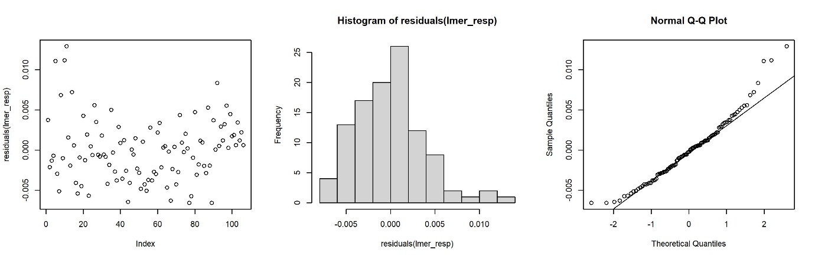

Figure S3. Scatterplot of residuals (left), histogram of residuals (middle), and quantile-quantile plots (right) of the Linear Mixed effects Model (LMM) evaluating the effect of business-as-usual (RCP8.5, pH 7.6) ocean acidification conditions and current ambient (pH 8) conditions on the mean respiration rate (mgO₂ g⁻¹ min⁻¹) of Grantia sp. over a 28-day experiment.

Table S2. Results of the linear mixed effect model (lmer) evaluating the effect of business-as-usual (RCP8.5, pH 7.6) ocean acidification conditions and current ambient (pH 8) conditions on the mean respiration rate (mgO₂ g⁻¹ min⁻¹) of Grantia sp. over a 28-day experiment. In fixed effect table: sum sq: sum of squares; mean sq: means quare; Num. df: numerator degrees of freedom; Den. df: denominator degrees of freedom. In random effects table: n par.: number of model parameters; logLik: log-likelihood; AIC: Akaike information criterion; LRT: likelihood ratio test statistic; df: degrees of freedom.
Formula: Respiration_Rate ~ Treatment * Time + (1 | Tank)
Fixed effect test (anova)
 | Sum Sq. | Mean Sq. | Num. df | Den. df | F-value | p-value
Treatment | 0.0 | 0.0 | 1 | 102.0 | 3.87 | 0.0519
Time | 0.0 | 0.0 | 1 | 102.0 | 9.27 | 0.0030
Treatment:Time | 0.0 | 0.0 | 1 | 102.0 | 2.18 | 0.1428
Random effect test (Ranova)
 | n par. | logLik | AIC | LRT | df | p-value
<none> | 6 | 408.3 | -805
(1 | Tank) | 5 | 408.3 | -807 | 0 | 1 | 1.0000

Table S3. Results of the PERMANOVA model evaluating the effect of business-as-usual (RCP8.5, pH 7.6) ocean acidification conditions and current ambient (pH 8) conditions on the mean respiration rate (mgO₂ g⁻¹ min⁻¹) of Grantia sp. over a 28-day experiment. df : degrees of freedom; SS: sum of squares; MS: mean squares.
 | df | SS | MS | F-value | R² | p-value
Treatment | 1 | 0 | 0 | 1.99 | 0.017 | 0.1669
Time | 1 | 0 | 0 | 9.09 | 0.079 | 0.0032
Treatment:Time | 1 | 0 | 0 | 2.18 | 0.019 | 0.1451
Residuals | 102 | 0 | 0 |  | 0.885
Total | 105 | 0 |  |  | 1.000

