Supplementary Material

Appendix 1. Image of a sediment traps deployed at Browns Bay. Each trap had a volume of 800 ml, a height of 21.5 cm, a width of 6.5 cm, and an aspect ratio of 3.3:1. All traps were covered by a 0.5 cm mesh baffle and were attached to sandbags and elevated from the substrate by ~5 cm to minimise current fluxing.
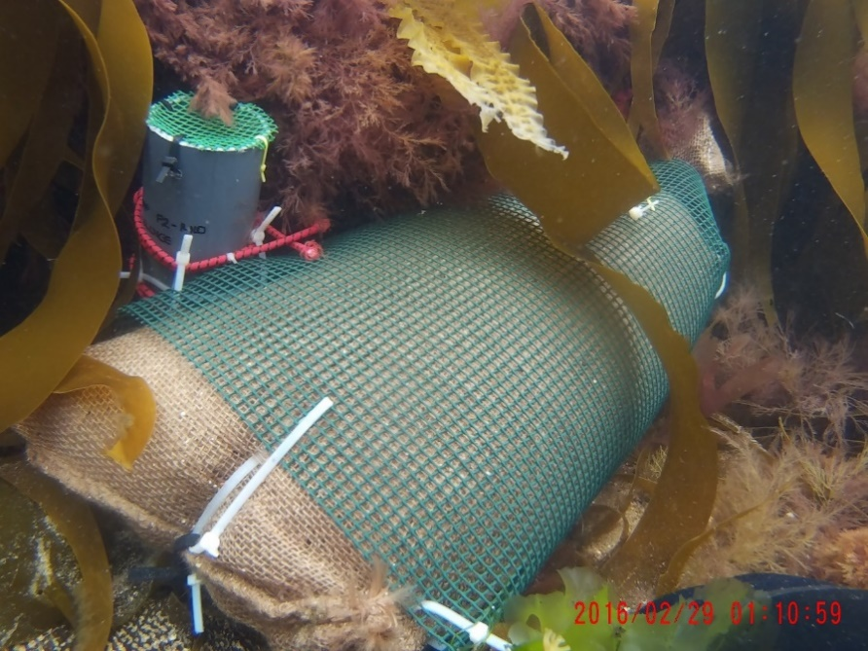
Data logger
Sandbag
Sediment trap

Appendix 2. Table of n values for the density and maximum length of S. latissima on gravel and cobbles outplanted at the two sites and in the aquarium controls from the installation period in March to the final monitoring point in November 2021.
Month | Seaton Sluice |  | Browns Bay |  | Aquarium Control
 | Cobble | Gravel | Cobble | Gravel | Cobble | Gravel
March | 10 | 10 | 10 | 10 | 10 | 10
April | 10 | 10 | 6 | 1 | 6 | 7
May | 9 | 5 | 5 | 0 | 6 | 8
June | 7 | 3 | 4 | 0 | 6 | 8
July | 6 | 0 | 4 | 0 | 6 | 8
August | 4 | 0 | 2 | 0 | 6 | 8
September | 4 | 0 | 1 | 0 | 6 | 8
October | 1 | 1 | 1 | 1 | 6 | 8
November | 1 | 1 | 1 | 1 | 6 | 7

Appendix 3. Additional environmental information from the restoration sites. Maximum wave height from the Newbiggin Ness Waverider Buoy (Northeast Regional Coastal Monitoring Programme) (A.). Average seawater temperature and light intensity (± 1 standard error) obtained from HOBO data loggers at the study sites (B.). Generalised linear model to test for differences in sediment deposition across time points at the sites (C.), with significance accepted at p < 0.05 and significant values indicated in bold.
A.
Month 2021 | Maximum Wave Height (m)
March* | 3.41
April | 6.94
May | 5.06
June | 4.23
July | 2.52
August | 4.14
September | 3.35
October | 5.46
November* | 4.07
* Data average for study period only, 30-31st March and 1st-5th November 2021.

B.
Site | Date Range 2021 | Average Temperature (˚C) | Average Light Intensity (Lux)
Seaton Sluice | 28th July – 23rd August | 14.14 ± 0.04 | 1227.37 ± 116.71
 | 22nd September – 10th October | 13.66 ±0.03 | 815.59 ± 107.16
Browns Bay | 27th July – 23rd August  25th August – 19th September  21st September – 9th October | 14.10 ± 0.02  14.80 ± 0.02  13.74 ± 0.03 | 2315.94 ± 190.28  1364.91 ± 117.49  1557.10 ± 159.93

C.
Variable | df | F-value | p
Site | 1 | 22.7039 | 0.005
Month | 3 | 4.4207 | 0.071
Site * Month | 3 | 0.5156 | 0.689
Residuals | 5

