Supplementary material for

First record of Ramari´s beaked whale Mesoplodon eueu (Cetacea: Ziphiidae) for Uruguay

Meica Valdivia¹, Lucía Frones¹, Emilia Rossini², Paula Laporta^{3,4}, Emma L. Carroll⁵, Michael R. McGowen⁶, Felix G. Marx^{7,8}, Néstor Ríos⁹

¹ Sección Mamíferos, Museo Nacional de Historia Natural, Montevideo, Uruguay.
² Departamento de Patología, Facultad de Veterinaria, Universidad de la República, Montevideo, Uruguay.
³ Asociación civil Yaqu Pacha Uruguay, Punta del Diablo, Rocha, Uruguay.
⁴ Centro Universitario Regional del Este, Universidad de la República, Rocha, Uruguay.
⁵ School of Biological Sciences, University of Auckland Waipapa Taumata Rau, Auckland, Aotearoa New Zealand.
⁶ Department of Vertebrate Zoology, Smithsonian National Museum of Natural History, Washington DC, USA.
⁷ Museum of New Zealand Te Papa Tongarewa, Wellington, New Zealand.
⁸ Department of Geology, University of Otago, Dunedin, New Zealand.
⁹ Sección Genética Evolutiva, Facultad de Ciencias, Universidad de la República, Montevideo, Uruguay.

This document contains Supplementary table S1-S4 and figures S1-S2.

Table S1: GenBank accession numbers of control region sequences from Mesoplodon specimens used in phylogenetic analyses.
Accession Number Genbank | Species
MH922777.1 | M. bidens
NC042218.1 | M. bidens
KF032860.2 | M. densirostris
NC021974.2 | M. densirostris
KF032871.2 | M. densirostris
KF032861.2 | M. densirostris
KF032862.2 | M. densirostris
KF032863.2 | M. densirostris
KF032864.2 | M. densirostris
KF032869.2 | M. densirostris
KF032870.2 | M. densirostris
KF032867.2 | M. densirostris
KF032868.2 | M. densirostris
KF032872.2 | M. densirostris
KF032873.1 | M. densirostris
KF032874.2 | M. densirostris
KF032875.2 | M. densirostris
KF032876.2 | M. densirostris
KF032877.2 | M. densirostris
KF032878.2 | M. densirostris
KF032865.1 | M. densirostris
KF032866.2 | M. densirostris
KC776688.2 | M. europaeus
NC021434.2 | M. europaeus
KC776689.2 | M. europaeus
KC776690.2 | M. europaeus
KC776691.2 | M. europaeus
KC776692.2 | M. europaeus
KC776693.2 | M. europaeus
KC776694.2 | M. europaeus
KC776695.1 | M. europaeus
KR534596.1 | M. ginkgodens
NC027593.1 | M. ginkgodens
KF981442.1 | M. grayi
NC023830.1 | M. grayi
MH922776.1 | M. mirus
NC042217.1 | M. mirus
OK326891.1 | M. mirus
OK326890.1 | M. mirus
OK326889.1 | M. mirus
OK326888.1 | M. mirus
OK326887.1 | M. mirus
OK326886.1 | M. mirus
OK326885.1 | M. mirus
OK326884.1 | M. mirus
OK326893.1 | M. eueu
OK326892.1 | M. eueu
MG000980.1 | M. stejnegeri
NC036997.1 | M. stejnegeri

Table S2. GenBank accession numbers of whole mitochondrial genome from Mesoplodon specimens used in divergence time estimation analysis.
Accession Number Genbank | Species
MH922777.1 | M. bidens
NC042218.1 | M. bidens
KC776688.2 | M. europaeus
NC021434.2 | M. europaeus
KC776689.2 | M. europaeus
KC776690.2 | M. europaeus
KC776691.2 | M. europaeus
KC776692.2 | M. europaeus
KC776693.2 | M. europaeus
KC776694.2 | M. europaeus
KC776695.1 | M. europaeus
KR534596.1 | M. ginkgodens
NC027593.1 | M. ginkgodens
MH922776.1 | M. mirus
NC042217.1 | M. mirus
OK326891.1 | M. mirus
OK326890.1 | M. mirus
OK326889.1 | M. mirus
OK326888.1 | M. mirus
OK326887.1 | M. mirus
OK326886.1 | M. mirus
OK326885.1 | M. mirus
OK326884.1 | M. mirus
OK326893.1 | M. eueu
OK326892.1 | M. eueu

Table S3: Subsets of the mitochondrial genome identified with PartitionFinder2 (Lanfear et al., 2017) and evolutive models identified and used on BEAST v.2.6.7 (Bouckaert et al. 2014).
Subset | Partition names | Model | Number of sites | Beast model used
1 | ND6_pos2 | TRN+G+X | 3855 | TN93
 | tRNA-P (CCA)
 | tRNA-L (CTA)
 | tRNA-G (GGA)
 | tRNA-R (CGA)
 | tRNA-D (GAC)
 | tRNA-K (AAA)
 | tRNA-I (ATC)
 | tRNA-H (CAC)
 | tRNA-S (AGC)
 | tRNA-M (ATG)
 | tRNA-N (AAC)
 | tRNA-V (GTA)
 | tRNA-L (TTA)
 | tRNA-Q (CAA)
 | tRNA-F (TTC)
 | 12s
 | tRNA-E (GAA)
 | 16s
2 | tRNA-A (GCA) | TRN+G+X | 3002 | TN93
 | COX3_pos1
 | tRNA-T (ACA)
 | tRNA-S (TCA)
 | ND4L_pos1
 | CYTB_pos1
 | ND3_pos1
 | tRNA-W (TGA)
 | ND2_pos1
 | ATP6_pos1
 | ND5_pos1
 | ND4pos2
3 | ND4L_pos2 | HKY+I+X | 2023 | HKY
 | ND2_pos2
 | ND3_pos2
 | ATP6_pos2
 | ND5_pos2
 | ND6_pos3
 | ND4_pos3
4 | ATP8_pos3 | TRN+G+X | 1755 | TN93
 | ND6_pos1
 | ND4_pos1
 | ND4L_pos3
 | ATP6_pos3
 | COX2_pos3
 | COX1_pos3
5 | ATP8_pos1 | HKY+G+X | 593 | HKY
 | COX3_pos3
 | ATP8_pos2
6 | tRNA-C (TGC) | TRNEF+G | 1164 | TN93
 | COX1_pos1
 | COX2_pos1
 | ND1_pos2
7 | COX1_pos2 | HKY+I | 1445 | HKY
 | COX2_pos2
 | CYTB_pos2
 | ND1_pos2
8 | tRNA-Y (TAC) | HKY+I+G+X | 1436 | HKY
 | D-loop
 | COX3_pos2
9 | ND5_pos3 | TRN+G+X | 1763 | TN93
 | CYTB_pos3
 | ND3_pos3
 | ND1_pos3
 | ND2_pos3

Table S4. Time to the Most Recent Common Ancestor node priors used to calibrate divergence time analysis. Mean Age (mya) is based on the analysis of Carroll et al. (2021); see for more information on how these were derived.
Priors | Mean Age (mya) | Standard Deviation (mya)
M.mirus + M. eueu + M. europaeus + M. ginkgodens + M. bidens | 7.02 | 6.20-7.84
M.mirus + M. eueu + M. europaeus + M. ginkgodens | 5.40 | 4.66-6.14
M.mirus + M. eueu mitogenomes + M. europaeus | 4.66 | 4.08-5.24

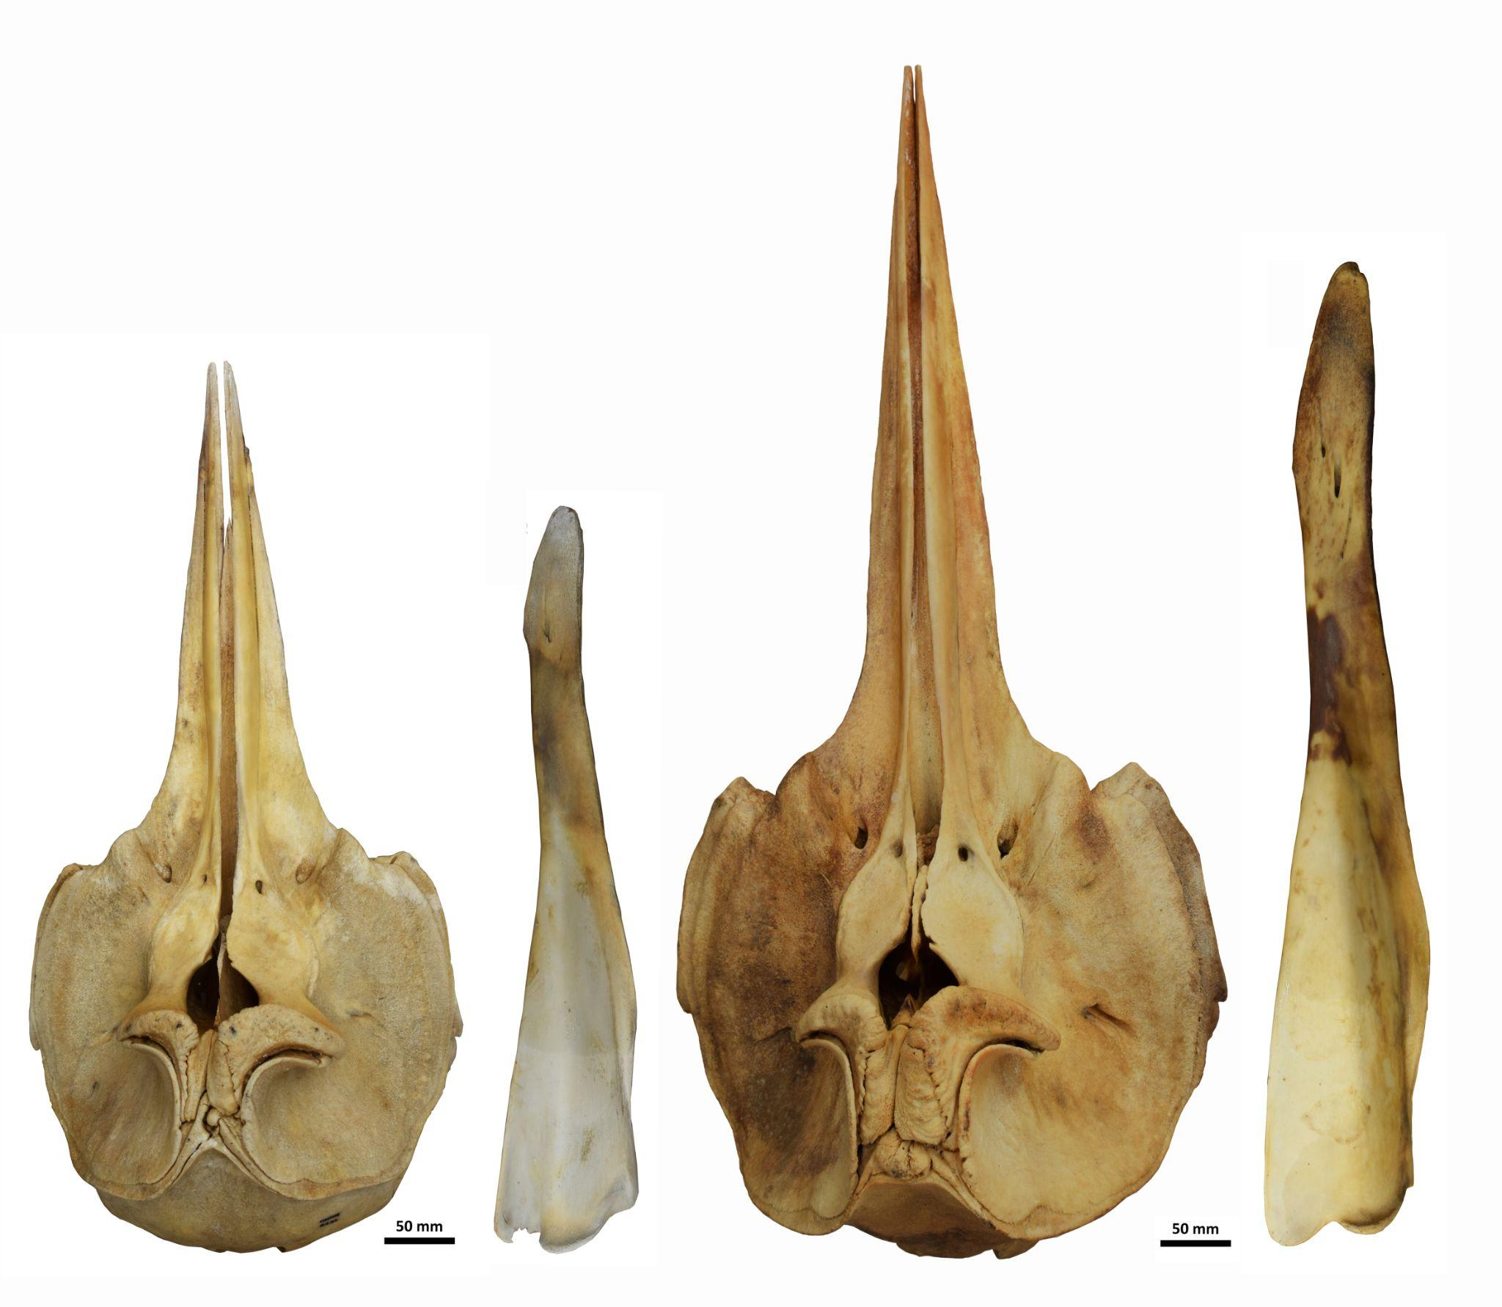
Figure S1. Dorsal view of skulls and lateral view of left mandible of the M. eueu stranded in Uruguay (left MNHN 8211, right MNHN 8212).

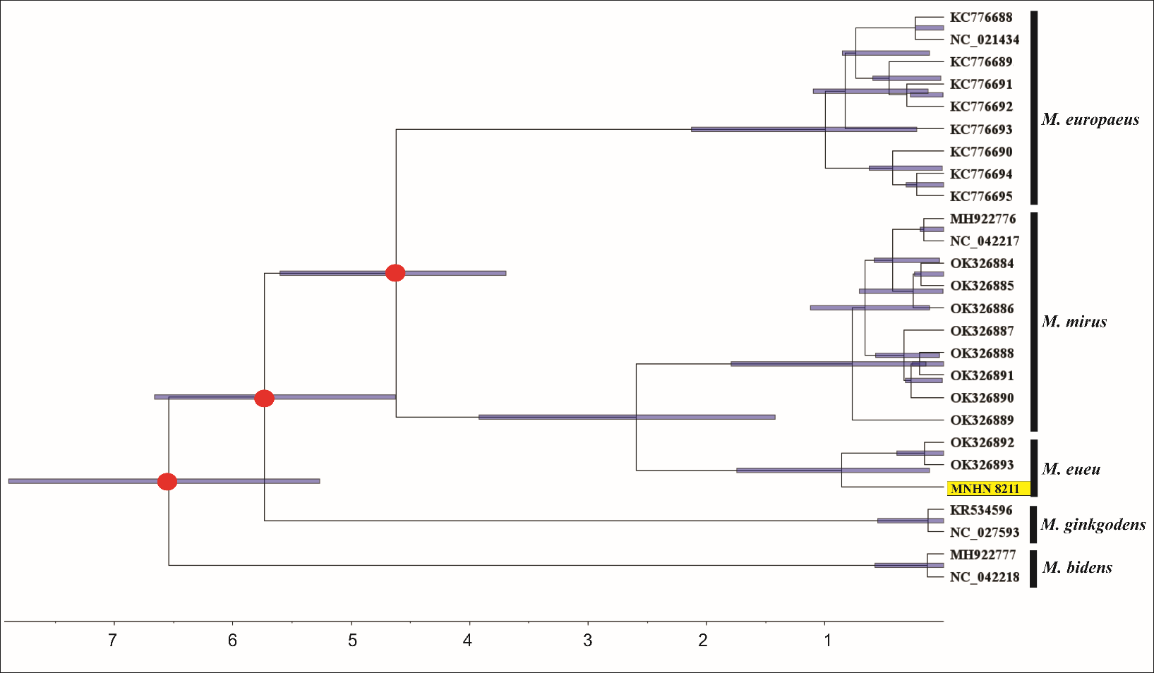
Figure S2. Mitogenome coalescence tree analysis of BEAST v.2.6.7 (Bouckaert et al. 2014). Red circles mark calibration nodes (Table S4). Purple boxes in nodes show 95% HPD (highest posterior density). The bottom bar shows millions of years before present. Bars on the left indicate the Mesoplodon species.

