Supplementary figures
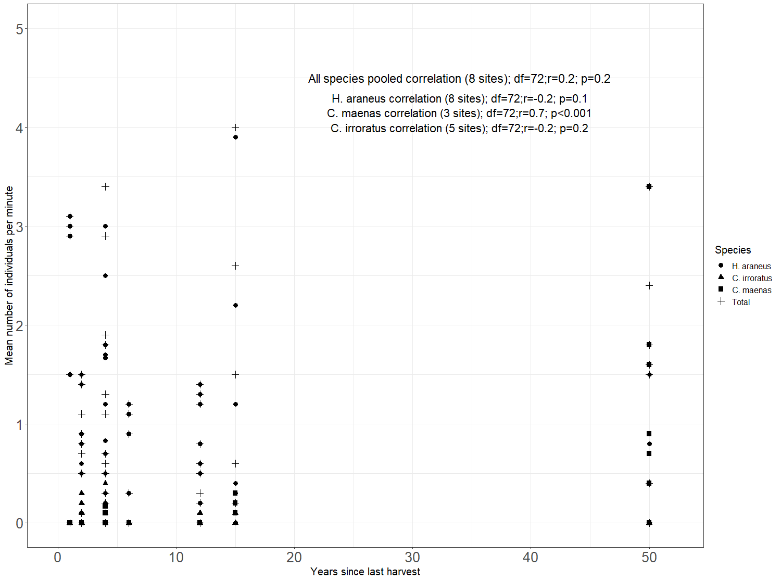
Supplementary figure S1. Correlation between square root CPUE for each search at each site in Breiðafjörður and years since last harvest.

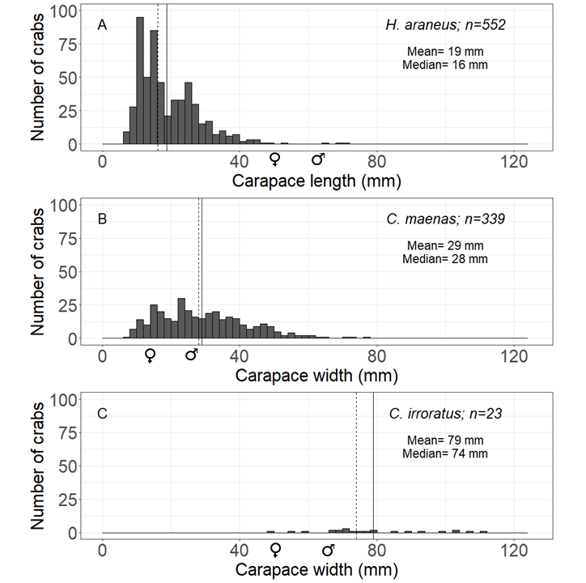
Supplementary figure S2. Size distribution of species from all sites pooled within 2 mm size classes. Maximum carapace dimension was used for each species (A = H. araneus [length], B = C. maenas [width], C = C. irroratus [width]). Data pooled for all sites (n=914). Solid line= mean; dotted line= median; rounded up to nearest mm. Sizes at sexual maturity are indicated with each of the sex symbols.

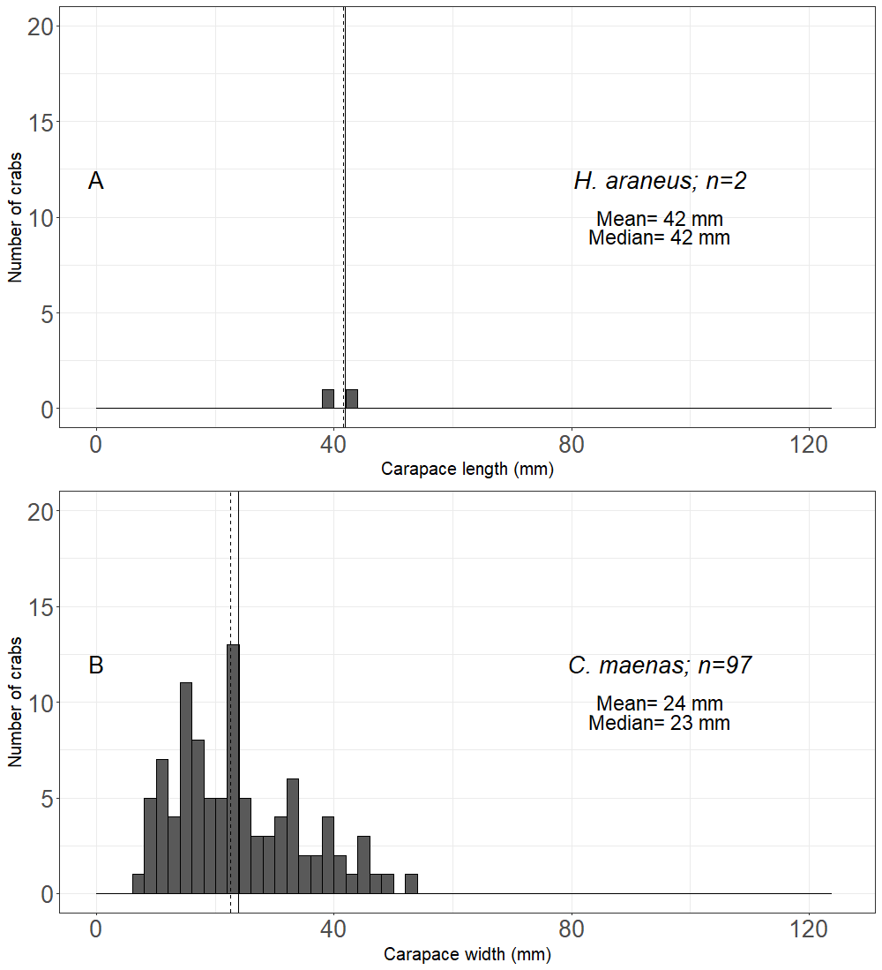
Supplementary figure S3. Size distribution of crabs within 2 mm size classes (A = H. araneus [length]; B = C. maenas [width]) in Sæbraut, location 1. Maximum carapace dimension was used for each species. Solid line= mean; dotted line= median; rounded up to nearest mm.
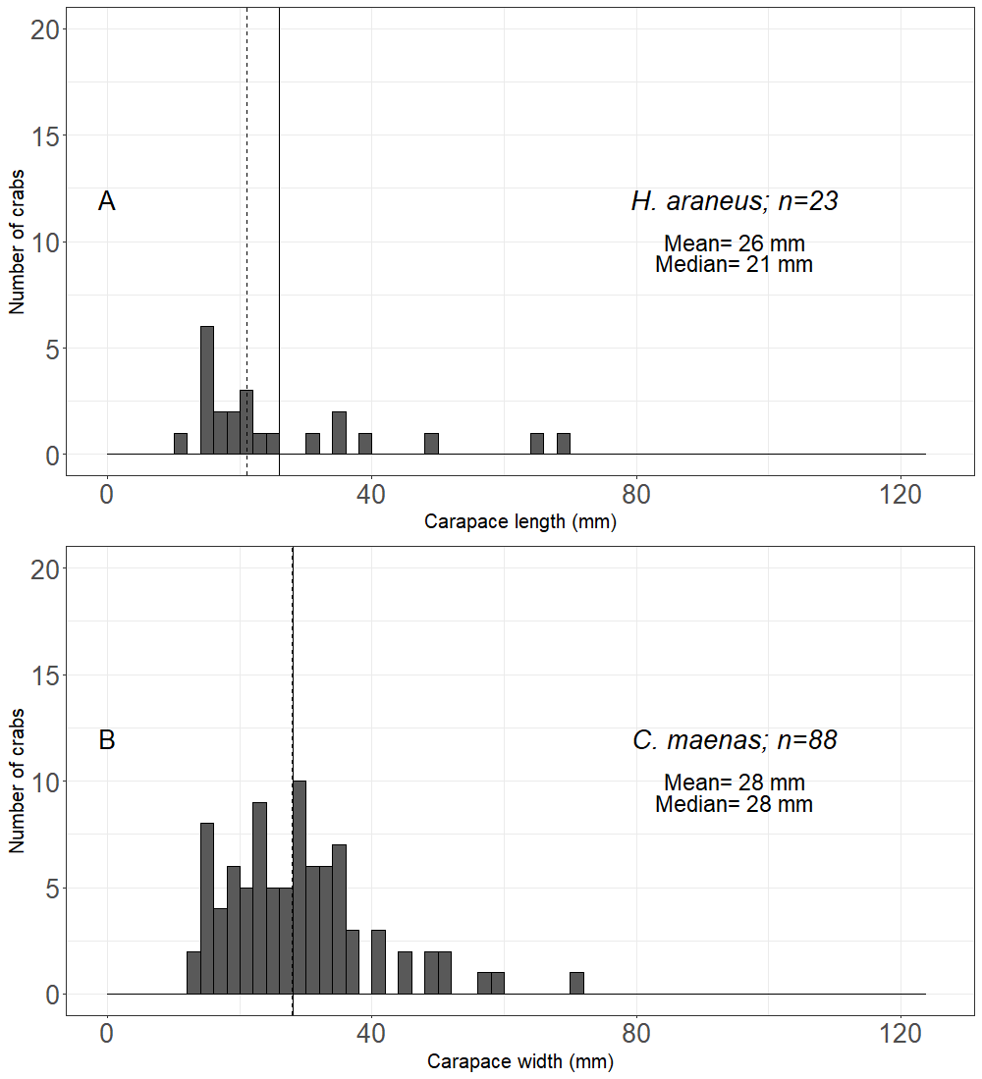
Supplementary figure S4. Size distribution of crabs within 2 mm size classes (A = H. araneus [length]; B = C. maenas [width]) in Maðkavík, location 3. Maximum carapace dimension was used for each species. Solid line= mean; dotted line= median; rounded up to nearest mm.

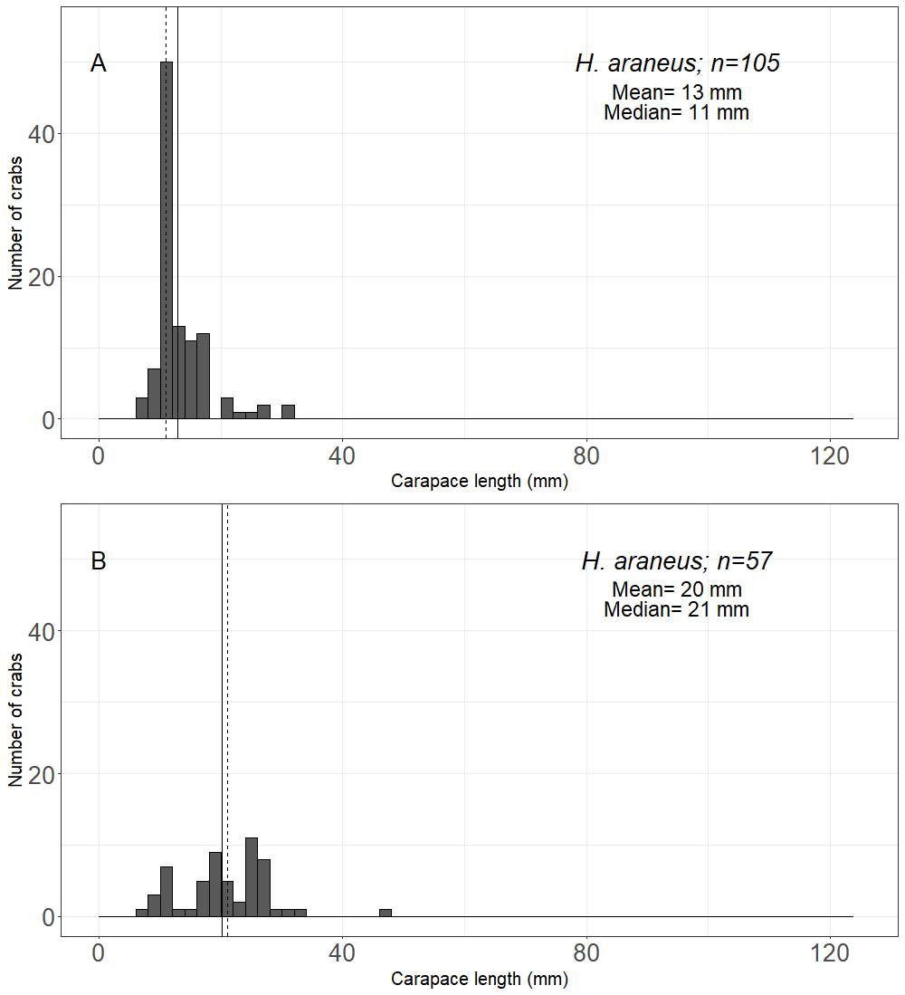
Supplementary figure S5. Size distribution of H. araneus (length) within 2 mm size classes in, Karlsey [7] (A) and Klauf [8] (B), where H. araneus was the only species found in the intertidal zone. Maximum carapace dimension was used. Solid line= mean; dotted line= median; rounded up to nearest mm.

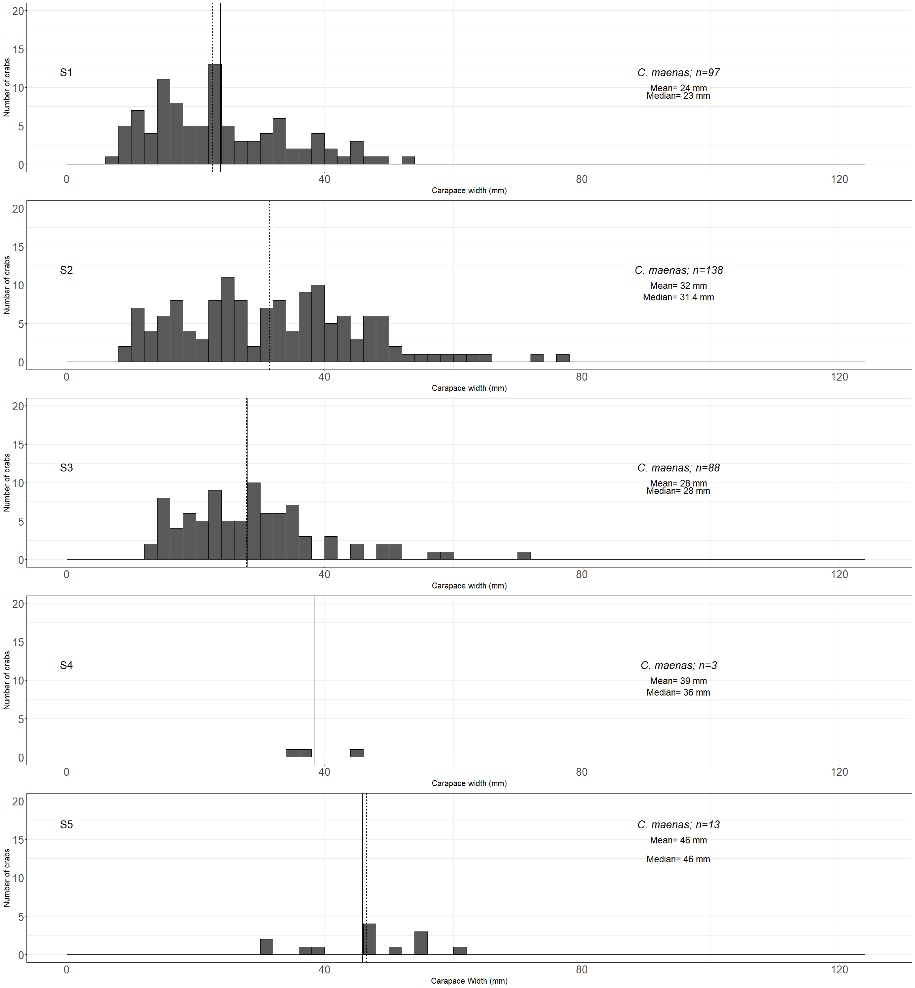
Supplementary figure S6. Size distribution C. maenas (width) within 2 mm size classes in all sites from most southern (S1) to most northern (S5). Solid line= mean; dotted line= median; rounded up to nearest mm.

