**Supplementary Material File S6.**

Genetic dissimilarity and geographic distances between continental individuals were computed to assess if isolation by distance could partly explain population partitioning found using de-novo clustering with DAPC. Datasets used to do this include the .vcf file used for phylogenomic analysis (6,697 snps) and a table with geographic coordinates for each continental sample. We used the function *diss.dist* from the R package “poppr” (Kamvar et al., 2014) to calculate pairwise allelic distances between individuals. For geographic distances, sample coordinates were tabulated and the function *distm* (fun = distGeo)from the R package “geosphere” (Hijmans, 2019) was used to calculate physical distance between these samples. This latter matrix was converted to a distance object with the R function *as.dist*. Statistical significance of the correlation between these two distance objects was assessed using a mantel test (function *mantel* in R package “vegan”(Oksanen et al., 2019)).

We found weak correlation between genetic dissimilarity and geographic distance between continental individuals (r=0.09). However, the association between these variables was found to be significant (p=0.001) (Fig S6).

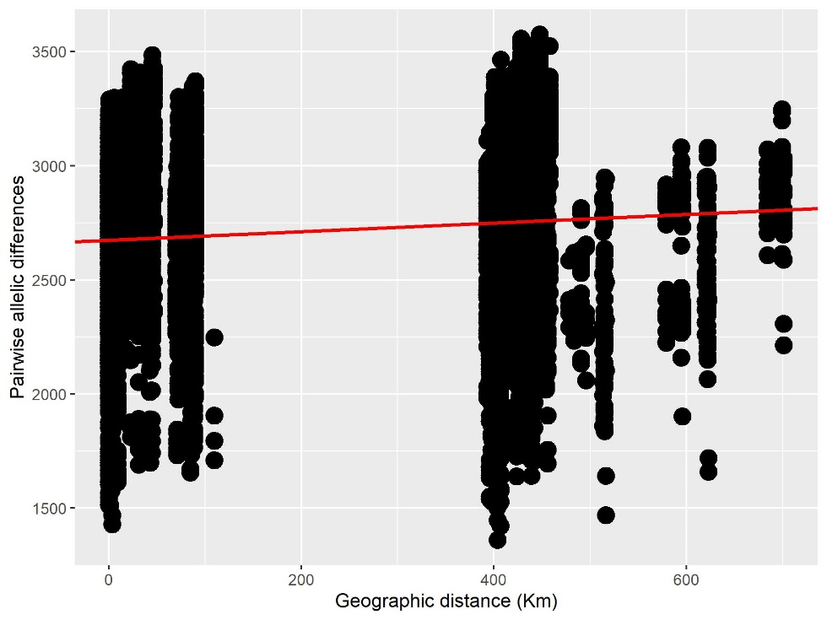

Fig S6. Correlation between geographic distance and genetic dissimilarity (as pairwise allelic differences) between continental individuals. The red line denotes the linear regression function.

**References**

Hijmans, R., 2019. geosphere: Spherical Trigonometry. R package version 1.5-10.

Kamvar, Z.N., Tabima, J.F., Gr̈unwald, N.J., 2014. Poppr: An R package for genetic analysis of populations with clonal, partially clonal, and/or sexual reproduction. PeerJ 2014, 1–14. https://doi.org/10.7717/peerj.281

Oksanen, A.J., Blanchet, F.G., Friendly, M., Kindt, R., Legendre, P., McGlinn, D., Minchin, R.B., O’Hara, R.B., Simpson, G.L., Solymos, P., Stevens, M.H.H., Szoecs, E., Wagner, H., 2019. vegan: Community Ecology Package. https://doi.org/ISBN 0-387-95457-0