**Supplementary Material File S5.** DAPC results for a-priori and de-novo clustering at K=3 and K=4

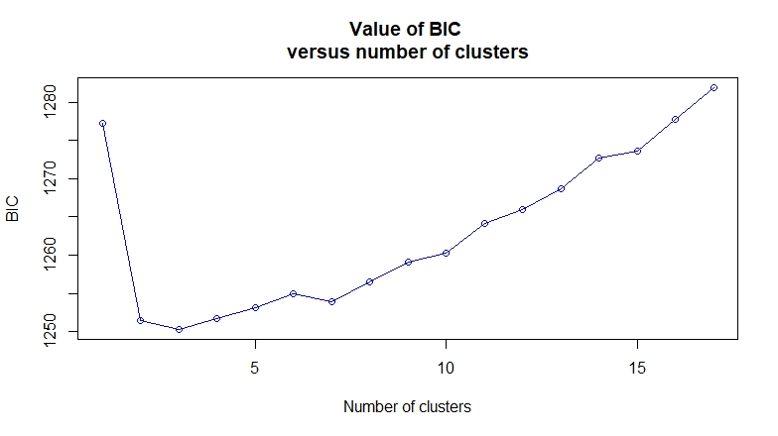

Figure S5.1. Plot for selecting the “best” number of populations (K) based on a Bayesian information criterion. Part of the function *find.clusters* (R package “adegenet”).

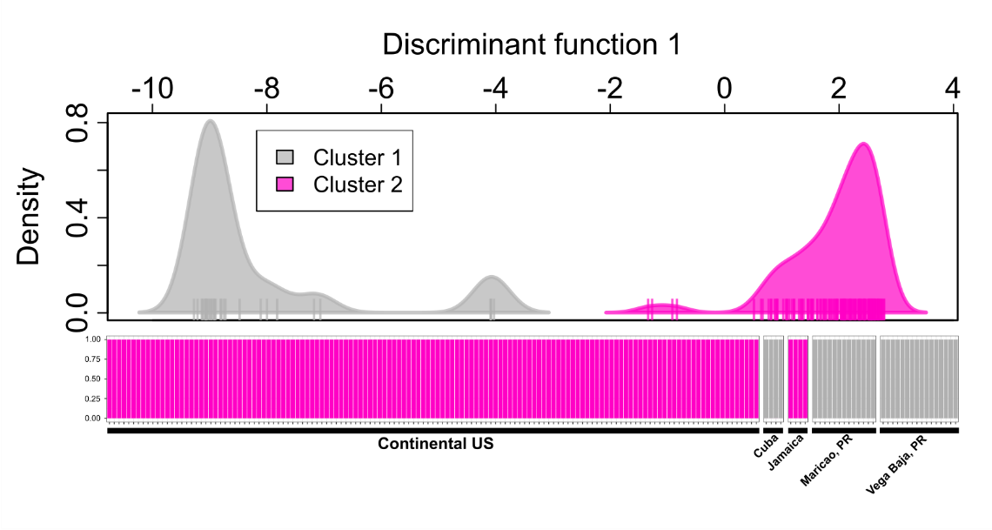

Figure S5.2. Results from de-novo clustering with DAPC at K = 2. Upper part shows scatterplot for with the single discriminant function recovered whereas the lower part show barplot with assigned membership probabilities. Each dot and bar represent an individual.

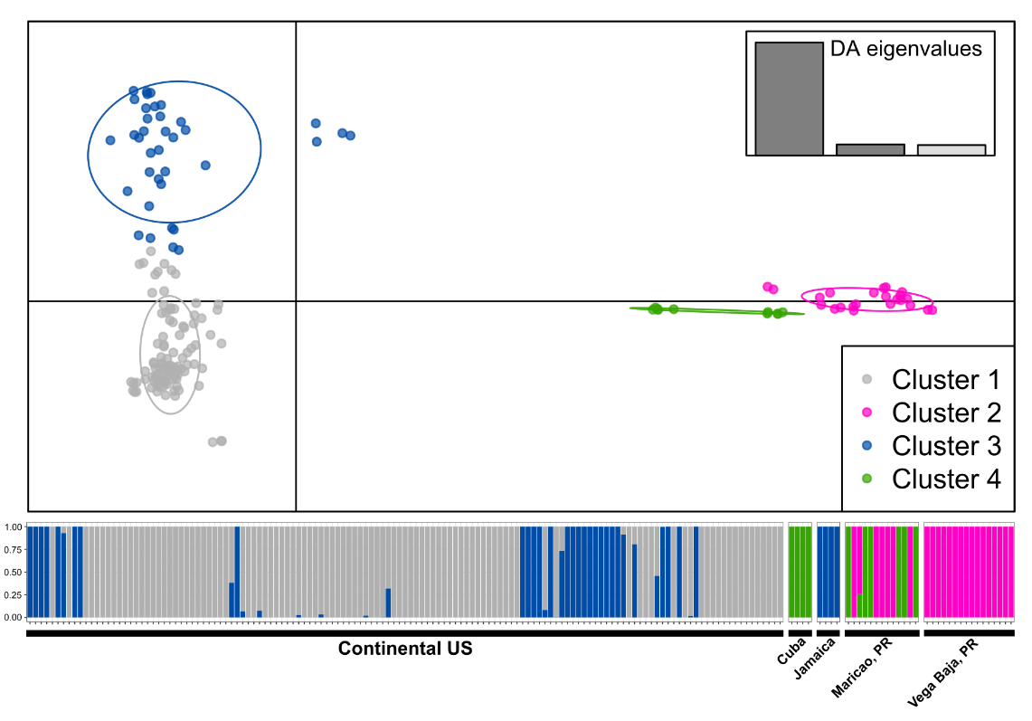

Figure S5.3. Results from de-novo clustering with DAPC at K = 4. Upper part shows scatterplot for discriminant functions whereas the lower part show barplot with assigned membership probabilities. Each dot and bar represent an individual.

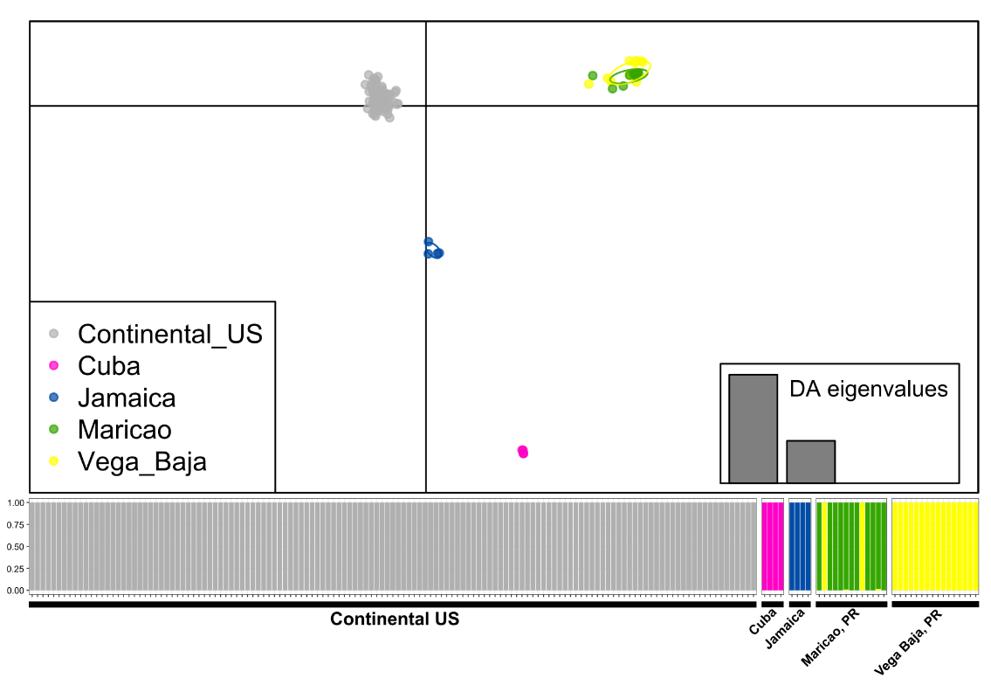

Figure S5.4. Results from a-priori clustering with DAPC. Upper part shows scatterplot for discriminant functions whereas the lower part shows barplot with assigned membership probabilities. Each dot and bar represent an individual.