Supplementary Material File S4. RADseq data processing statistics

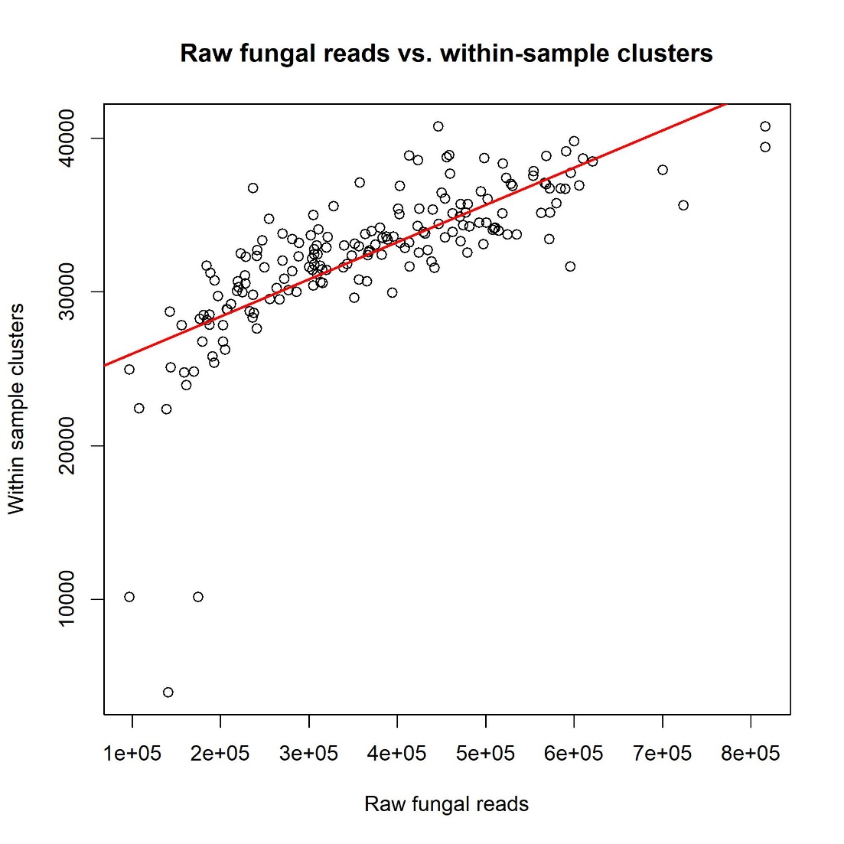
Call:
lm(formula = stats$Within.sample.clusters ~ stats$Reads.mapped.to.reference)

Residuals:
Min 1Q Median 3Q Max
-22978.1 -994.6 326.2 1482.5 7458.4

Coefficients:
Estimate Std. Error t value Pr(>|t|)
(Intercept) 2.355e+04 6.671e+02 35.30 <2e-16 ***
stats$Reads.mapped.to.reference 2.421e-02 1.687e-03 14.35 <2e-16 ***
---
Signif. codes: 0 ‘***’ 0.001 ‘**’ 0.01 ‘*’ 0.05 ‘.’ 0.1 ‘ ’ 1

Residual standard error: 3288 on 179 degrees of freedom
Multiple R-squared: 0.535, Adjusted R-squared: 0.5324
F-statistic: 206 on 1 and 179 DF, p-value: < 2.2e-16

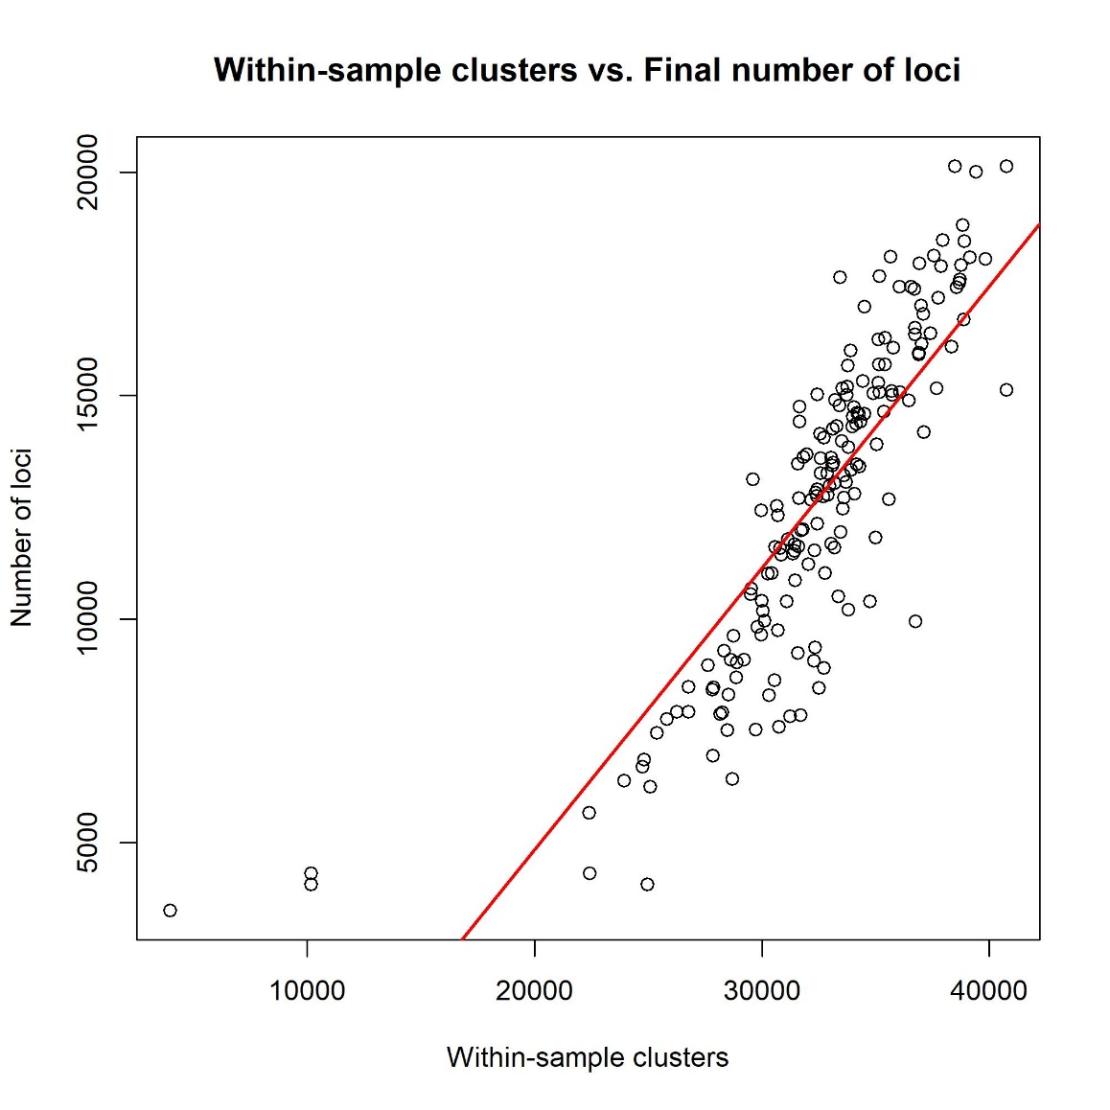
Call:
lm(formula = stats$Number.of.loci ~ stats$Within.sample.clusters)

Residuals:
Min 1Q Median 3Q Max
-5427.9 -1171.4 -20.9 1168.5 8759.2

Coefficients:
Estimate Std. Error t value Pr(>|t|)
(Intercept) -7.775e+03 1.006e+03 -7.726 7.66e-13 ***
stats$Within.sample.clusters 6.304e-01 3.068e-02 20.552 < 2e-16 ***
---
Signif. codes: 0 ‘***’ 0.001 ‘**’ 0.01 ‘*’ 0.05 ‘.’ 0.1 ‘ ’ 1

Residual standard error: 1979 on 179 degrees of freedom
Multiple R-squared: 0.7023, Adjusted R-squared: 0.7007
F-statistic: 422.4 on 1 and 179 DF, p-value: < 2.2e-16

