**Supplementary File S1**

Video (1:29) <https://youtu.be/RDy622zXNI8>

Visualizing usnic acid extracts, pure usnic acid and acetone extract from *Usnea scabrata*, using reagent AS (*p*-anisaldehyde in methanol, sulfuric acid, and acetic acid). Nearly colorless extracts can be strongly visualized with a three-stage treatment of the reagent, heating at 100°C, then reapplying the reagent.

Video (1:32) <https://youtu.be/PDn79S6kewM>

Chemical tests with *p*-anisaldehyde reagent A on crude acetone extracts from *Cladonia*. We sought good visualization of usnic acid reactions as well as any other substances that might react with the reagent.

Fig. S1. Post-treatment of TLC plate with the merochlorophaeic acid group (a combination of 4-*O*-methylcryptochlorophaeic, merochlorophaeic, and cryptochlorophaeic acids) from a specimen of *Cladonia* *albonigra*. Starting with a plate previously treated with sulfuric acid and heat, 3 µL spots of reagent AS were superimposed on specific spots, then reheated, then the cycle repeated once more. All three of these substances appear to intensify slightly more reddish to red with reagent AS. The reddish colors with these substances treated with reagent AS are similar, but somewhat more intense, than the reddish colors of those spots on TLC plates developed with the standard method of sulfuric acid then heat.

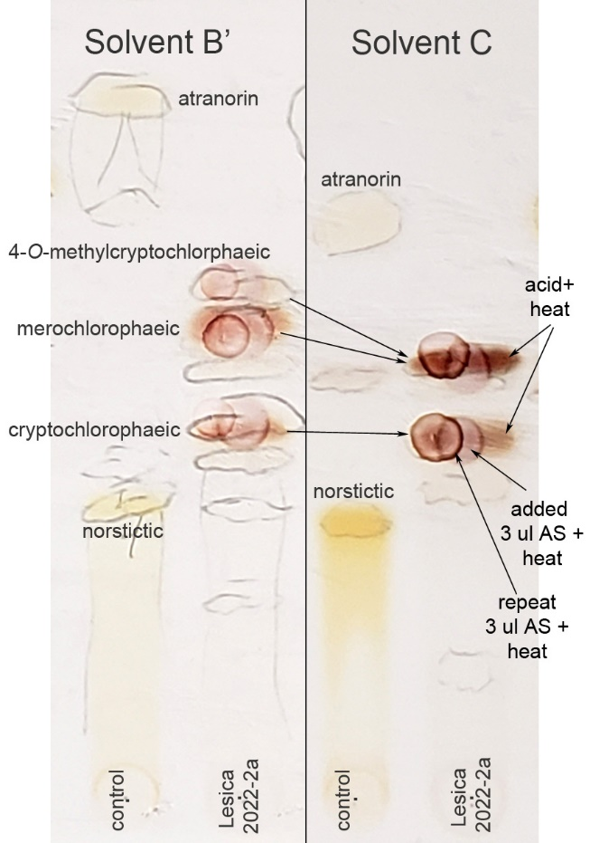

Figure S2. LCMS chromatogram, TIC (total ion chromatogram) of the reaction product of usnic acid and *p*-anisaldehyde (AS) reagent. The trace shown in black (background control) is excluded from the result analysis.

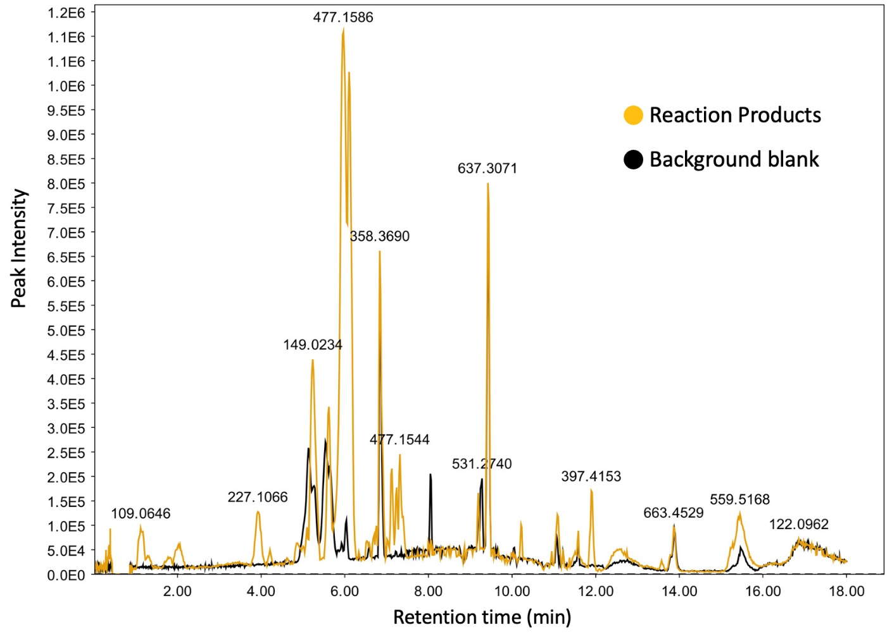

Figure S3. LCMS chromatogram, XIC (extracted ion chromatogram) of mass range *m/z* 463.1300-463.1400. The peaks detected within this range exhibited lower intensity compared to the *m/z* 477.1586 peak. This difference in peak intensity supports designation of the *m/z* 477.1586 ion as the main product.

