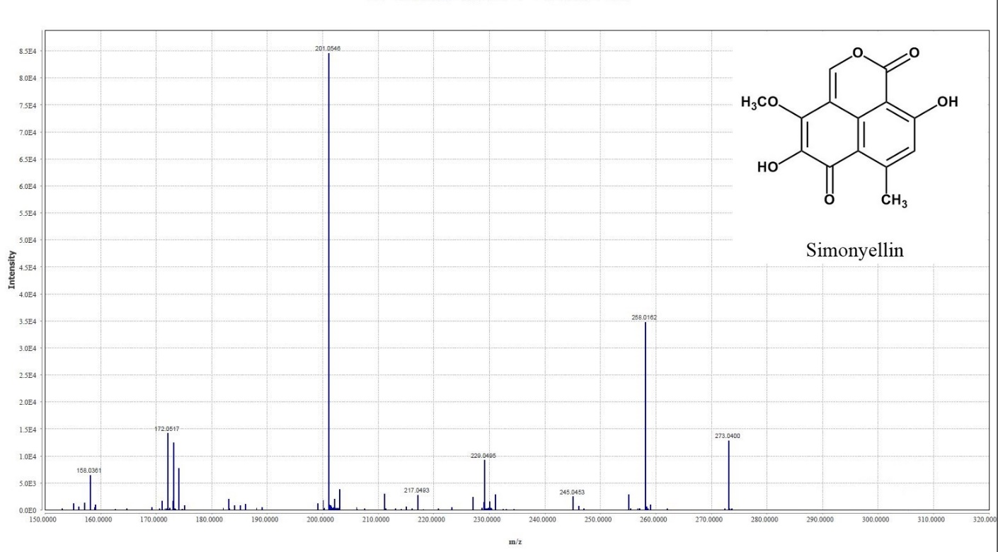
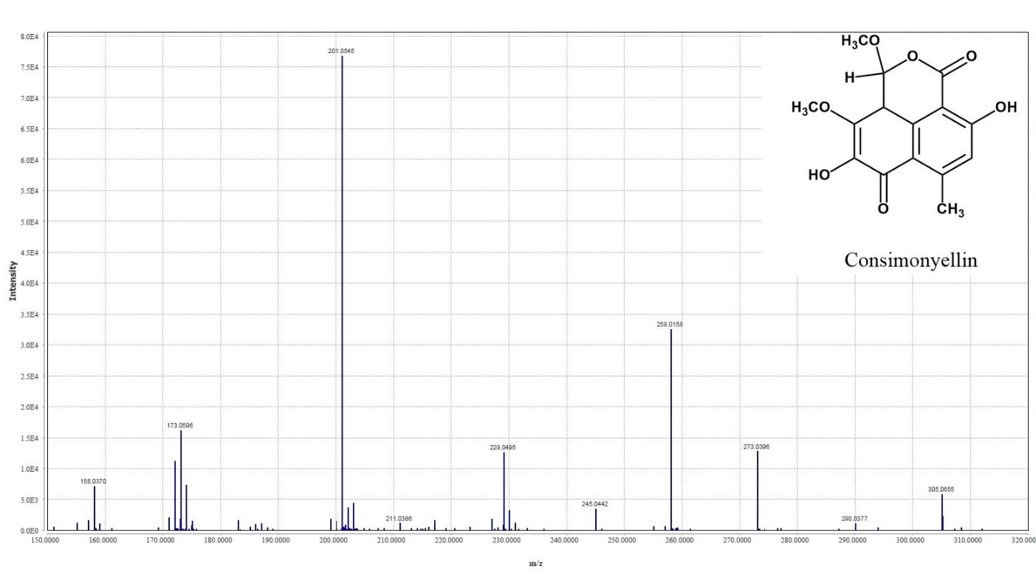

Supplementary Material Fig. S4. ESI-MS/MS spectra of simonyellin and consimonyellin in negative mode.

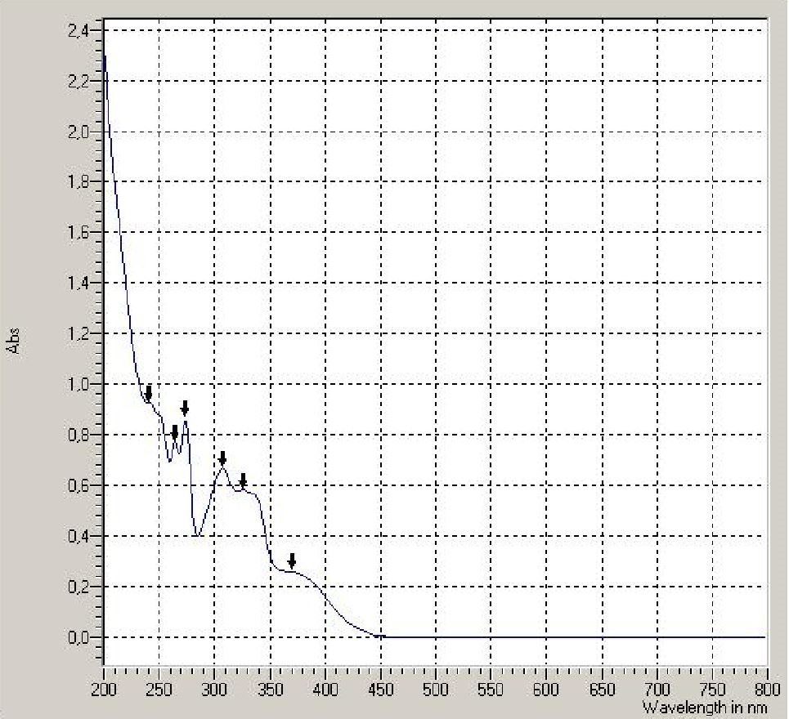
Supplementary Material Fig. S5. UV/Vis absorption spectrum of simonyellin.

