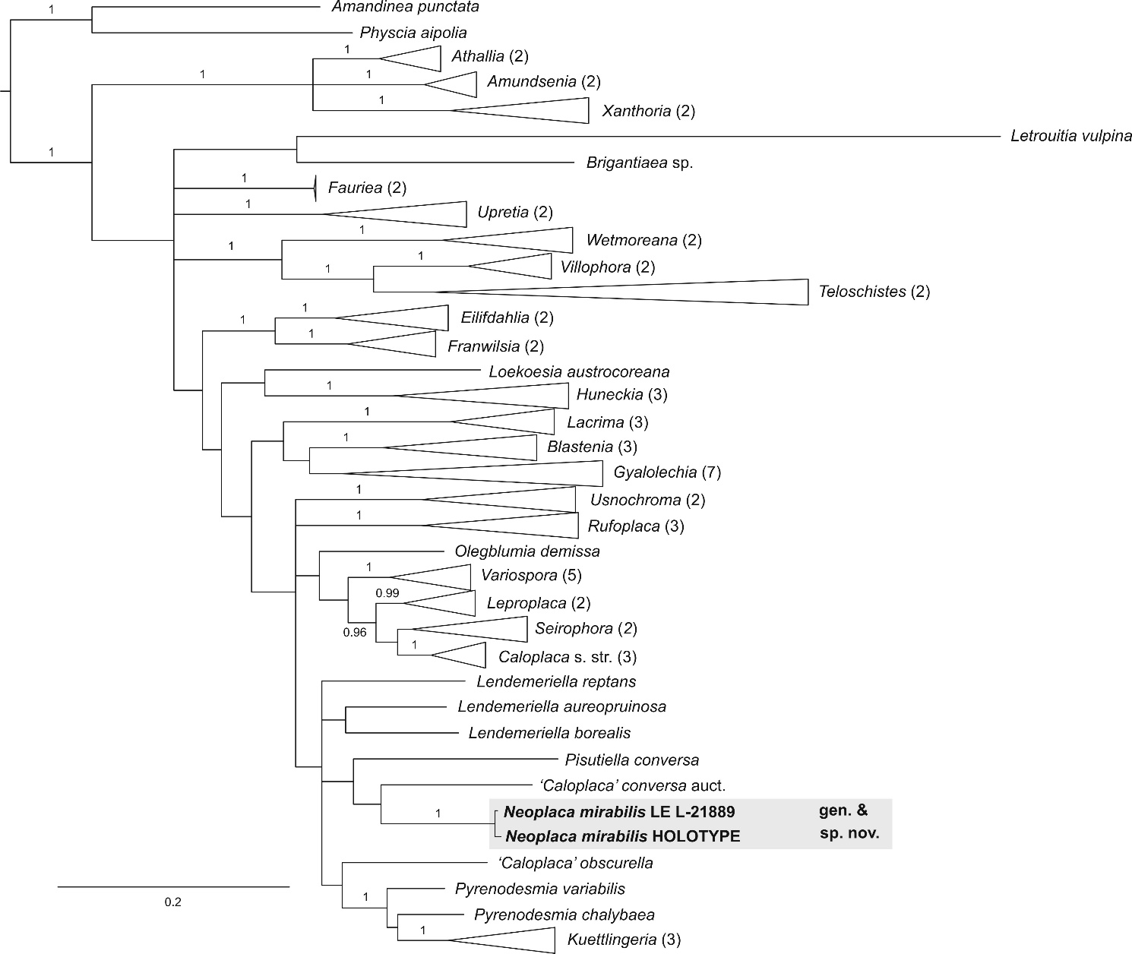

Supplementary Material Fig. S1. Phylogeny of the subfamily Caloplacoideae (Teloschistaceae) based on the Bayesian analysis of nrITS data. Genera are collapsed into single terminals. Numbers at branches represent posterior probability (PP) values ≥ 0.95. Numbers in parentheses correspond to the number of species of a genus used in the analysis.

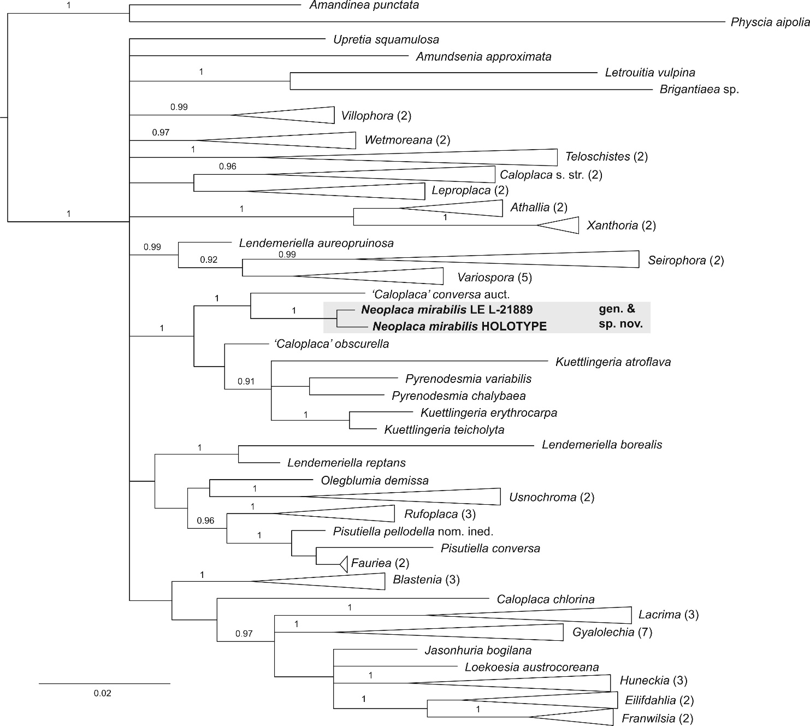
Supplementary Material Fig. S2. Phylogeny of the subfamily Caloplacoideae (Teloschistaceae) based on the Bayesian analysis of nrLSU data. Genera are collapsed into single terminals. Numbers at branches represent posterior probability (PP) values ≥ 0.95. Numbers in parentheses correspond to the number of species of a genus used in the analysis.

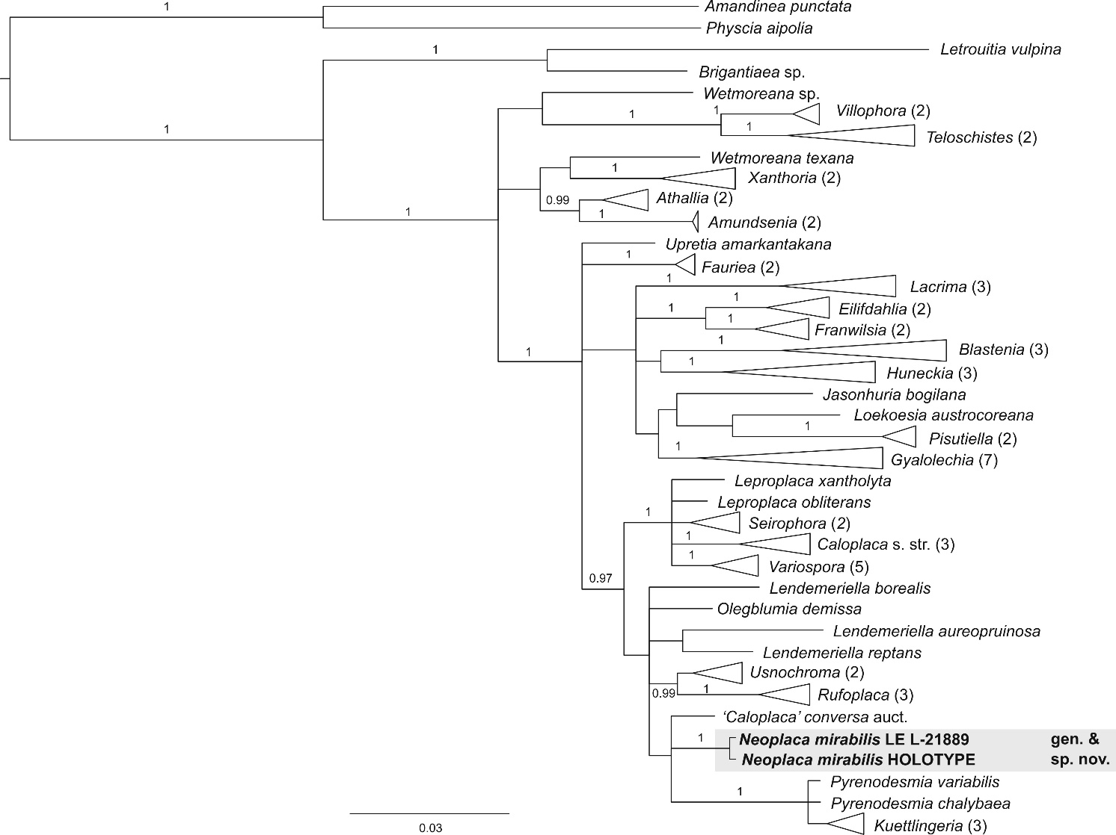
Supplementary Material Fig. S3. Phylogeny of the subfamily Caloplacoideae (Teloschistaceae) based on the Bayesian analysis of mtSSU data. Genera are collapsed into single terminals. Numbers at branches represent posterior probability (PP) values ≥ 0.95. Numbers in parentheses correspond to the number of species of a genus used in the analysis.

