Appendices

Appendix 1: Weights applied to the data analysis based on whether survey participants participated or not in the election of the members of the Constitutional Convention in 2021, by region.

Region | Participated | Did not participated
Tarapacá | 0.458294117647059 | 3.302250000000000
Antofagasta | 0.553350000000000 | 1.893300000000000
Atacama | 0.668833333333333 | 1.496750000000000
Coquimbo | 0.612393548387097 | 1.801053333333330
Valparaíso | 0.622955696202532 | 1.992883333333330
Libertador Bernardo O'Higgins | 0.589493333333333 | 2.679345454545450
Maule | 0.621226666666667 | 1.897094736842100
Biobío | 0.498978947368421 | 3.379850000000000
Araucanía | 0.624466666666667 | 1.643771428571430
Los Lagos | 0.595350000000000 | 1.917206666666670
Aysén | 0.516000000000000 | 2.936000000000000
Magallanes | 0.588900000000000 | 1.822200000000000
Metropolitana | 0.664132876712329 | 1.721126470588240
Los Ríos | 0.556464705882353 | 2.256683333333330
Arica y Parinacota | 0.597675000000000 | 1.643720000000000
Ñuble | 0.533375000000000 | 2.866500000000000

Appendix 2: Descriptive statistics of independent variables and control factors by scenario (responded have not experienced the hypothetical scenario – number of unweighted cases)
Variables |  | Scenario 1 | Scenario 2
Socioeconomic status (categorical variable) | ABC1ab | 14% | 13.3%
 | C2 | 18.8% | 18%
 | C3 | 21.5% | 20.8%
 | D | 31.8% | 32.3%
 | E | 13.9% | 15.6%
Socioeconomic status (binary variable) | ABC1ab | 14% | 13.3%
 | C2-C3 | 40.3% | 38.8%
 | D-E | 45.7% | 47.9%
Rights violation (% Yes) |  | 36.9% | 49.8%
Know my rights (% Know very well + Have some idea) |  | 64.4% | 61.9%
Know where to turn (% Know very well + Have some idea) |  | 58.7% | 54.4%
Expectation of just outcome (% Totally just + somewhat just) |  | 71.7% | 65.1%
Experience with courts (% Yes) |  | 35.7% | 32.5%
Experience with state institutions (% Yes) |  | 23.9% | 22.7%
Participation in informative sessions (% Yes) |  | 26.3% | 24.1%
Participation in protests (% Yes) |  | 17.5% | 15.1%
Gender (% Female) |  | 50.9% | 52.2%
Belong to indigenous group (% Yes) |  | 11.3% | 10.9%
Age | % 18-29 years old | 10.5% | 9.8%
 | % 30-59 years old | 63.6% | 61.4%
 | % 60 years old and older | 25.9% | 28.8%

Appendix 3: Predicted probabilities (and 95% Confidence Interval) based on models shown in Table 3

Predictive margins: Discrimination at a public hospital
 |  | Model 1: SES as 3 categories |  |  | Model 2: SES as 5 categories
 |  | Margin | 95% CI |  | Margin | 95% CI
Know where to turn | Little idea/don´t know | 0.19 | 0.14 | 0.25 | 0.19 | 0.14 | 0.25
 | Some idea/know very well | 0.29 | 0.23 | 0.34 | 0.29 | 0.23 | 0.34
Expectation of outcome | Totally/somehow unjust | 0.31 | 0.24 | 0.38 | 0.31 | 0.24 | 0.38
 | Totally/somehow just | 0.22 | 0.18 | 0.26 | 0.22 | 0.18 | 0.26
Participation in protests | No | 0.23 | 0.19 | 0.27 | 0.23 | 0.19 | 0.27
 | Yes | 0.36 | 0.27 | 0.46 | 0.36 | 0.27 | 0.46
Participation in informative sessions | No | 0.27 | 0.23 | 0.31 | 0.27 | 0.23 | 0.31
 | Yes | 0.18 | 0.13 | 0.24 | 0.18 | 0.13 | 0.24
Age | 18-29 | 0.32 | 0.19 | 0.43 | 0.32 | 0.20 | 0.43
 | 30-59 | 0.26 | 0.22 | 0.30 | 0.26 | 0.22 | 0.30
 | 60 and older | 0.18 | 0.11 | 0.24 | 0.18 | 0.12 | 0.24
SES (3 categories) | E-D | 0.26 | 0.20 | 0.31
 | C2-C3 | 0.23 | 0.17 | 0.28
 | ABC1ab | 0.29 | 0.20 | 0.39
SES (5 categories) | E |  |  |  | 0.27 | 0.17 | 0.37
 | D |  |  |  | 0.25 | 0.19 | 0.31
 | C3 |  |  |  | 0.18 | 0.11 | 0.25
 | C2 |  |  |  | 0.28 | 0.19 | 0.36
 | ABC1ab |  |  |  | 0.30 | 0.21 | 0.39

Appendix 4: Predicted probabilities (and 95% Confidence Interval) by socioeconomic level in model 1 and 2

Appendix 5
Predicted probabilities (and 95% Confidence Interval) by participation in protests over socioeconomic level in model 1
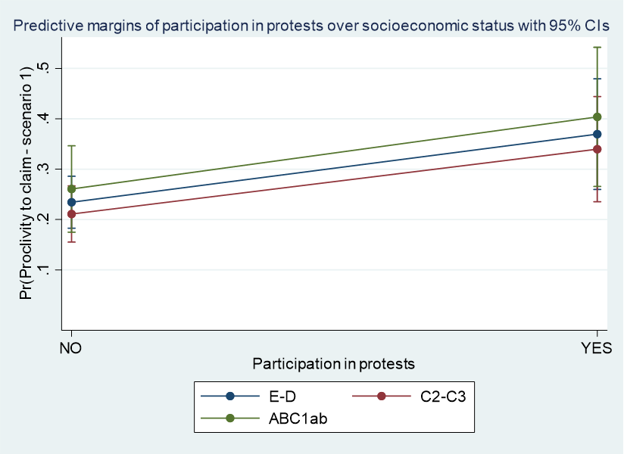
Predicted probabilities (and 95% Confidence Interval) by self-reported knowledge of where to turn over socioeconomic level in model 1
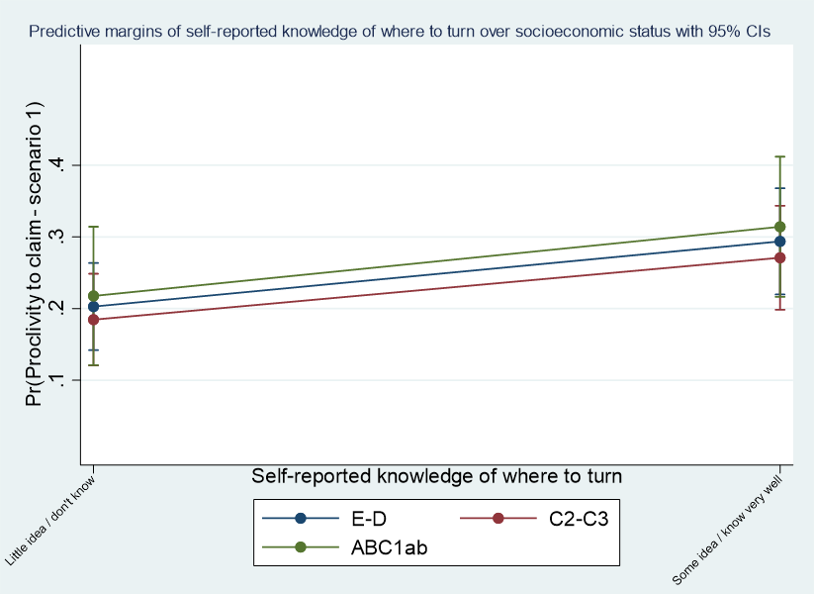

Predicted probabilities (and 95% Confidence Interval) by participation in protests over socioeconomic level in model 2

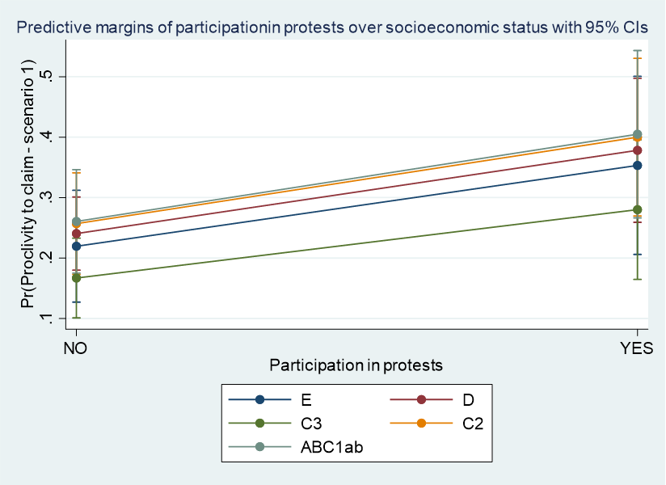

Predicted probabilities (and 95% Confidence Interval) by participation in protests and self-reported knowledge of where to turn over socioeconomic level in model 2

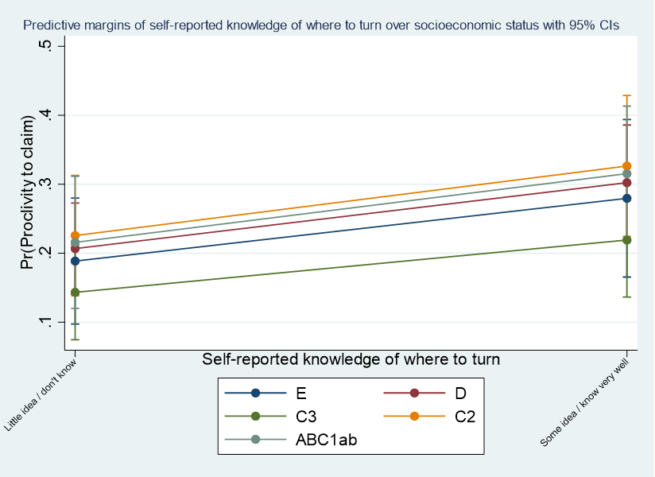

Appendix 6: Predicted probabilities (and 95% Confidence Interval) in models shown in Table 4

Predictive margins: Physical abuse by the police
 |  | Model 3: SES as 3 categories |  |  | Model 4: SES as 5 categories
 |  | Margin | 95% CI |  | Margin | 95% CI
Know where to turn | Little idea/don't know | 0.274 | 0.209 | 0.339 | 0.275 | 0.209 | 0.341
 | Some idea/know very well | 0.395 | 0.332 | 0.459 | 0.394 | 0.330 | 0.457
Participation in protests | No | 0.324 | 0.281 | 0.366 | 0.323 | 0.281 | 0.366
 | Yes | 0.453 | 0.347 | 0.558 | 0.454 | 0.348 | 0.559
SES (binary) | E-D | 0.355 | 0.295 | 0.415
 | C2-C3 | 0.310 | 0.249 | 0.371
 | ABC1ab | 0.374 | 0.267 | 0.482
SES II (5 categories) | E |  |  |  | 0.326 | 0.223 | 0.428
 | D |  |  |  | 0.369 | 0.296 | 0.443
 | C3 |  |  |  | 0.338 | 0.252 | 0.424
 | C2 |  |  |  | 0.282 | 0.197 | 0.367
 | ABC1ab |  |  |  | 0.374 | 0.267 | 0.481

Appendix 7: Predicted probabilities (and 95% Confidence Interval) by socioeconomic level in model 3 and 4

Appendix 8:
Predicted probabilities (and 95% Confidence Interval) by participation in protests over socioeconomic level in model 3
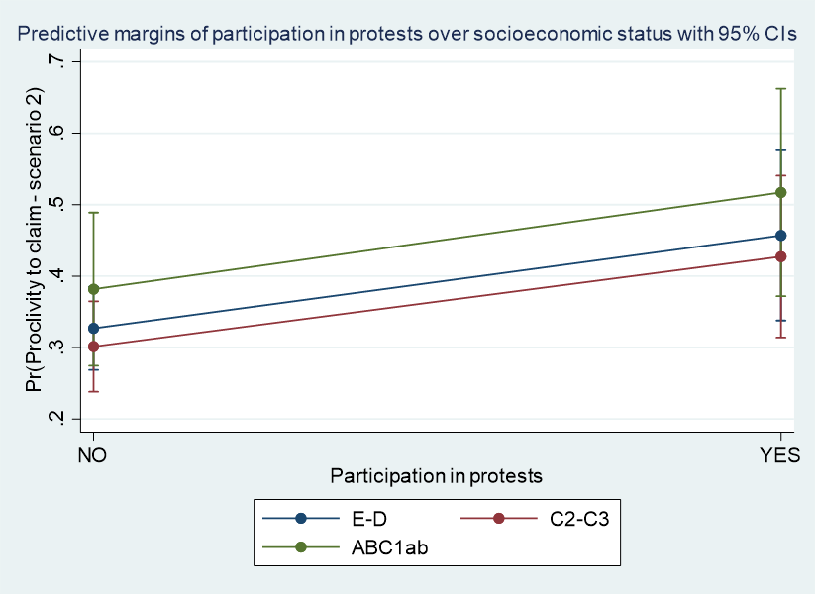
Predicted probabilities (and 95% Confidence Interval) by self-reported knowledge of where to turn over socioeconomic level in model 3

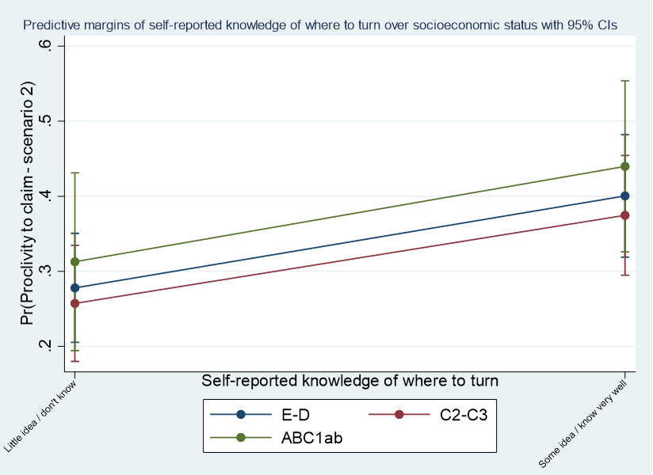

Predicted probabilities (and 95% Confidence Interval) by participation in protests over socioeconomic level in model 4

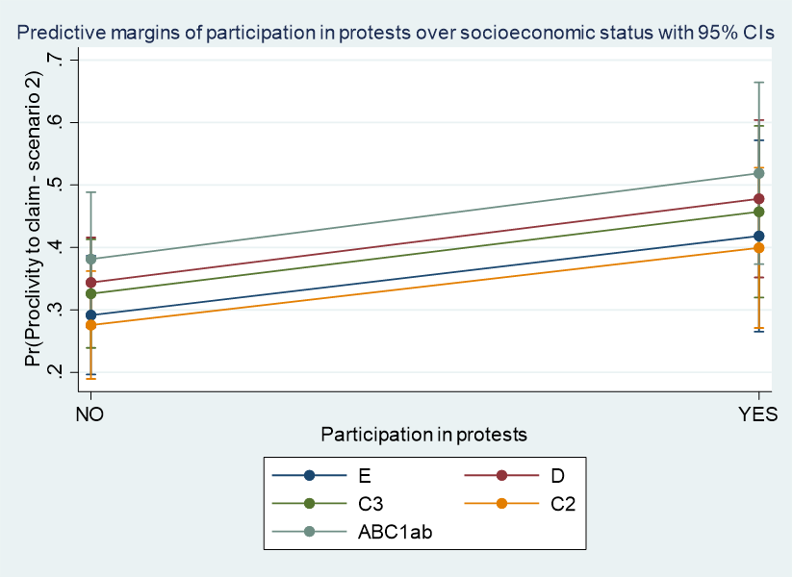
Predicted probabilities (and 95% Confidence Interval) by self-reported knowledge of where to turn over socioeconomic level in model 4

