**Supplementary file**

**Unusual electron temperature profile due to grain electrostatics in Planetary nebula cored dusty plasma**

Hemanga Jyoti Sarmah

*Department of Physics, Morigaon College, Morigaon-782015, Assam*

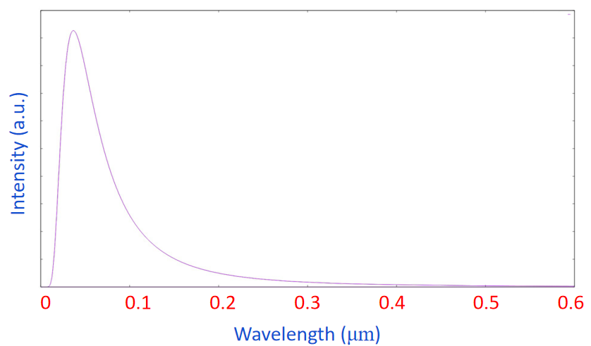

**Figure S1**: The incident spectrum as synthesized by CLOUDY in the inner face of the DP shell

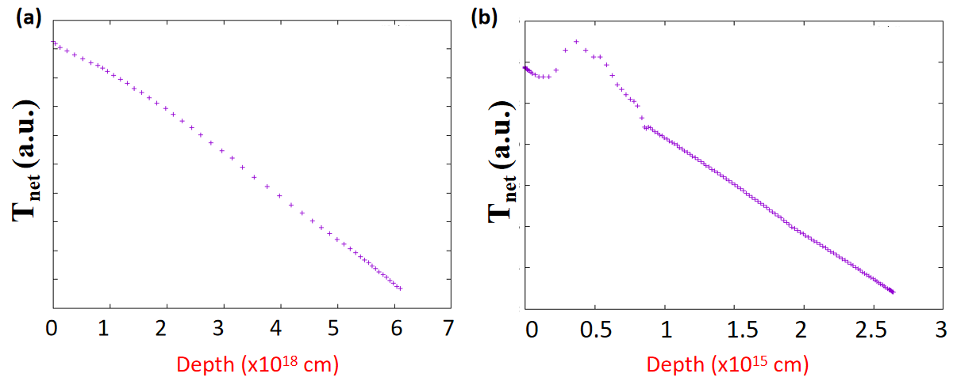

**Figure S2**: Temperature profile as per eqn. 3. (a) hydrogen density 10 cm-3 (b) hydrogen density 104 cm-3

**Note:** In order to solve eqn. 3., we consider

$$Incident energy hν ≈36 eV corresponding to peak of the incedent radiation$$

$$As the DP is mostly dominated by hydrogen ϕ_{th}=13.6 eV is used$$

α,β, γ *are constant and are varied until best fit.*

*Again, $d_{g}$* is considered 10-5 and 10-8 for nH= 104 cm-3 and nH=10 cm-3 respectively; which is consistent with the CLOUDY output.

$The values for Δn_{e}$*and $ϕ_{el}$* are employed from the CLOUDY output

rev2

**Figure S3**: Variation of grain temperature w.r.t. average grain charge. Note: An increasing trend has been witnessed. Average grain charge means the average over different charge state of a single type of grain.

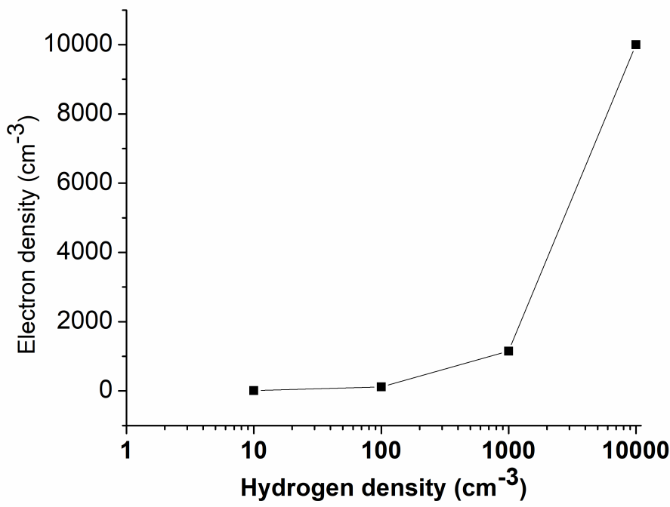

**Figure S4**: Electron density (at inner face of DP cloud) variation with hydrogen density

Link for *pah1_ab08_10.opc* file

<https://gitlab.nublado.org/cloudy/cloudy/-/blob/master/data/pah1_ab08_10.opc>