Figure A1: Sample Map of Original Baseline Survey

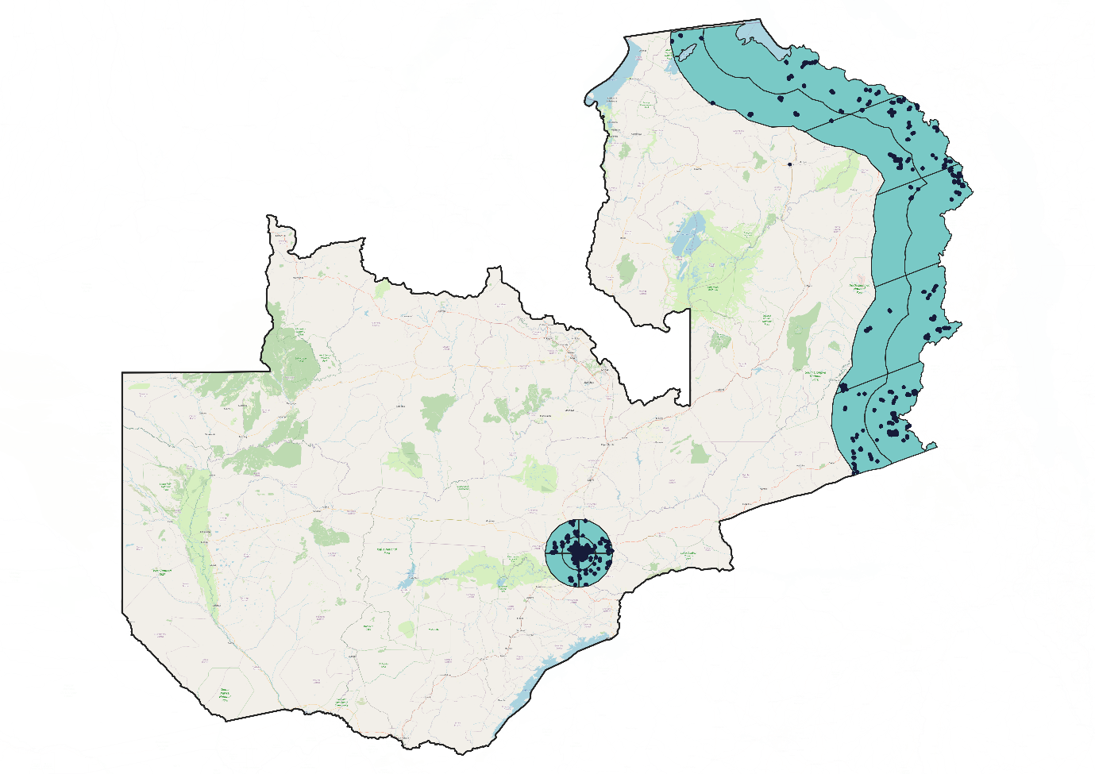

Note: Each dot represents a sample cluster. Reference omitted for review

Table A1: PF Vote Share by Province in 2016 and 2021 Elections

 | 2016 | 2021
Central | 44% | 36%
Copperbelt | 64% | 41%
Eastern | 80% | 56%
Luapula | 81% | 63%
Lusaka | 62% | 44%
Muchinga | 82% | 64%
Northern | 76% | 58%
North Western | 12% | 9%
Southern | 7% | 6%
Western | 17% | 14%

Source: Electoral Commission of Zambia (ECZ)

Table A2: Urban Constituencies (Population Denisty> 100 Inhabitants/km2

Bwana Mkubwa | Kanyama | Munali
Chawama | Kapiri Mposhi | Nchanga
Chililabombwe | Kasenengwa | Ndonla Central
Chimwemwe | Katuba | Nkana
Chingola | Livingstone | Roan
Kabushi | Lusaka Central | Wusakile
Kawata | Mandevu
Kafue | Mansa Central
Kafulafuta | Matero
Kalushi | Mkaika
Kamfinsa | Monze Central
Kankoyo | Mpongwe
Kantanshi | Mufulira

Table A3: Codebook

Variable | Survey Question | Response options | Operationalization
PF Vote | If the presidential elections  were held tomorrow, which  party’s candidate would you  vote for? | All parties with presidential candidates as well as “I don’t vote” “I don’t know” and “Refuse to answer” | Coded as 1 if responded “PF”
Urban | “What Constituency do you live in?” | All Zambian constituencies | Coded as urban if constituency has more than 100 inh/km2. For the four constituencies on the outskirts of Lusaka (Chilanga, Chongwe, Katuba, and Kafue) we code all respondents who do not respond “rural” to the question: “Is your current village/neighborhood, urban, rural, or peri-urban.” In cases where respondents do not know the name of their constituencies, we code respondents in Lusaka as urban if they characterize their area as urban or peri-urban.
Poverty | “I will read out a few  statements about your income.  Please tell me, which of the  following statement is closest  to your situation TODAY:” | 1. Our household income  covers the needs well - we can  save.  2. Our household income  covers the needs alright,  without much difficulty.  3. Our household income does  not cover the needs, there are  difficulties.  4. Our household income does  not cover the needs, there are  great difficulties.  5. Don’t Know/Refuse to | Coded as poor if responded option 4
Age | “How old are you?” | Respondent Age | Age enterer
Female | “Are you a man or a woman” | 1. Male  2. Female  3. Don’t Know/Refuse to  Answer | Coded as woman if responded option 2
Bemba-Ngoni | “What is your primary ethnic  community, cultural group, or  tribe?” | List of ethnic groups | Dummy variables coded in relation to what ethnic group stated by respondent
Lungu Economic Performance | “Since 2016 how well or badly  would you say that President  Lungu has . . . managed the  economy?” | 1. Badly  2. Well  3. Refused to answer | Coded as 1 is option 2
Lungu Corruption Performance | “Since 2016 how well or badly  would you say that President  Lungu has . . . reduced  corruption?” | 1. Badly  2. Well  3. Refused to answer | Coded as 1 is option 2
Lungu Infrastructure Performance | “Since 2016 how well or badly  would you say that President  Lungu has . . . improved and  maintained roads and other  infrastructure?” | 1. Badly  2. Well  3. Refused to answer | Coded as 1 is option 2
PF Rallies | “About how many of the PF rallies did you attend?” | - None  - One  - Two  - Three  - Four  - Five  - More than five  - Refuse to answer/Don’t know | Coded as 1 if option 2,3,5,6,7
UPND Rallies | “About how many of the UPND rallies did you attend?” | - None  - One  - Two  - Three  - Four  - Five  - More than five  - Refuse to answer/Don’t know | Coded as 1 if option 2,3,5,6,7
PF Contact | “During the campaign leading up to the August 12th elections, were you contacted by any political party?” | All parties | Coded as 1 if mentioned PF
UPND Contact | “During the campaign leading up to the August 12th elections, were you contacted by any political party?” | All parties | Coded as 1 if mentioned UPND
Ethnic: disapprove | “Do you think that if someone from your ethnic group  supported a candidate that others in your ethnic group  did not  like they would risk  Having others think poorly of them or  their household” | - Yes  - No  - Don't Know/Refuse to Answer | Coded 1 if response 1
Ethnic: harm | “Do you think that if a friend or  someone from your ethnic group  supported a candidate that others in your ethnic group  did not  like they would risk  Suffering material or physical  Damage” | - Yes  - No  - Don't Know/Refuse to Answer | Coded 1 if response 1
Family: disapprove | “Do you think that if a friend or  someone from your family openly  supported a candidate that other  friends or family members did not  like they would risk  Having others think poorly of them or  their household” | - Yes  - No  - Don't Know/Refuse to Answer | Coded 1 if response 1
Family: harm | “Do you think that if a friend or  someone from your family openly  supported a candidate that other  friends or family members did not  like they would risk  Suffering material or physical  Damage” | - Yes  - No  - Don't Know/Refuse to Answer | Coded 1 if response 1
Locality: disapprove | “Do you think that if a  someone in your village/neighborhood openly  supported  a candidate that other  living in your village/neighborhood did not  like they would risk  Having others think poorly of them or  their household” | - Yes  - No  - Don't Know/Refuse to Answer | Coded 1 if response 1
Locality: harm | “Do you think that if a  someone in your village/neighborhood openly  supported  a candidate that other  living in your village/neighborhood did not  like they would risk  Suffering material or physical  Damage” | - Yes  - No  - Don't Know/Refuse to Answer | Coded 1 if response 1

Table A4: OLS Regression of Constituency-level Change in PF Vote Share (High Urban Threshold)

 | Model 1 |  | Model 2
 | Change in PF Vote Share |  | Change in PF Vote Share
Urban | -.058**  (.015) |  | -.043*  (.014)
Share Bemba | - |  | . 065*  (.022)
Share Tonga  Share Nyanja | -  - |  | .017  (.024)  .038  (.026)
Share Lozi | - |  | .043*  (.015)
Ethnic Fractionalization  2016 PF Vote Share | -  -.240***  (.020) |  | -.030  (.042)  -.283  (.033)
N | 156 | 156
R² | .68 | .68

*** p<0.001, ** p<0.01, * p<0.05
Note: Entries are OLS regression coefficients with standard errors in parentheses. Standard errors clustered by province. Constituencies with a population density >250 inh/km2 are classified as urban.

Table A5: Stated Vote Choice across Survey Waves

 | 2019 Baseline | ZEPS R1 | ZEPS R2 | ZEPS R3
PF | 40.6 | 35.5 | 35.0 | 25.8
UPND | 14.0 | 27.1 | 26.6 | 60.6
Other | 5.5 | 1.4 | 6.3 | 3.3
Non-response, of which… | 39.9 | 36.0 | 32.1 | 9.0
Don’t feel close to a political party | 14.1 | 5.0 | 4.5 | 0.9
Don’t vote | 11.5 | 2.7 | 2.4 | 0.1
Don’t know | 7.2 | 4.9 | 3.8 | 0.3
Refuse to answer | 7.1 | 23.4 | 21.4 | 9.0

Table A6: Robustness test classifying respondents in Chipata Central as urban
 | (1) | (2)
 | Party Switching from PF 2019-2021 | Party Switching from PF 2019-2021 (only 2019 PF Voters)
Urban  Poverty | .035  (.195)  -.202  (.207) | .502  (.258)  -.439  (.260)
Age | -.000  (.007) | -.012  (.009)
Female  Bemba  Chewa  Tumbuka  Tonga  Ngoni | .112  (.190)  -.025  (.291)  .202  (.280)  .635  (.268)  -.922*  (.454)  -.401  (.372) | .275  (.251)  -.249  (.364)  .099  (.354)  .607  (.352)  .727  (.747)  -.306  (.450)
Observations | 826 | 300
Pseudo R2 | .023 | .036

*** p<0.001, ** p<0.01, * p<0.05
Note: Entries are logistic regression coefficients with standard errors in parentheses.

Table A7: Robustness test classifying respondents in Chipata Central as urban

 | (1) |  | (2) |  | (3)
 | Lungu Economic Performance |  | Lungu Corruption Performance |  | Lungu Infrastructure Performance
Urban  Poverty | -.534***  (.117)  .084  (.118) |  | -.601***  (.124)  .086  (.123) |  | .615***  (.138)  .051  (.135)
Age | .022***  (.004) |  | .003  (.005) |  | .001  (.005)
Female  Bemba  Chewa  Tumbuka  Tonga  Ngoni | -.048  (.113)  -.129  (.174)  -.398*  (.174)  -.109  (.173)  -1.136***  (.225)  .021  (.193) |  | .052  (.120)  -.276  (.188)  -.219  (.181)  -.002  (.178)  -1.013  (.246)  -.080  (.204) |  | .053  (.131)  .264  (.228)  -.482*  (.194)  -.531**  (.191)  -.264  (.232)  -.392  (.224)
N | 1,395 | 1,354 |  | 1,416
Pseudo R² | .048 | .032 |  | .031

*** p<0.001, ** p<0.01, * p<0.05
Note: Entries are logistic regression coefficients with standard errors in parentheses.

Table A8: Logistic Regression of Intention to vote for PF with Interaction Effects

 | (1)  Vote for PF | (2)  Vote for PF | (3)  Vote for PF
Lungu Economic Performance | 1.591***
 | (.155)
Lungu Corruption Performance |  | 1.358***
 |  | (0.154)
Lungu Infrastructure Performance |  |  | 1.482***
Urban | -.591**  (.179) | -.549***  (.155) | (0.184)  -.422  (.322)
Lungu Economic Performance *Urban | .234
 | (.243)
Lungu Corruption Performance *Urban |  | .196
 |  | (0.242)
Lungu Infrastructure Performance *Urban |  |  | -.443
 |  |  | (.345)
Observations  Pseudo R2 | 1,492  .13 | 1,444  .10 | 1,517  .06
*** p<0.001, ** p<0.01, * p<0.05
Note: Entries are logistic regression coefficients with standard errors in parentheses.

Table A9: Logistic Regression of Intention to vote for PF

 | (1)  PF Vote | (2)  PF Vote | (3)  PF Vote | (4)  PF Vote
PF Rallies | .573***
 | (.121)
UPND Rallies |  | -.482***
 |  | (.137)
PF Contact  UPND Contact |  |  | .197  (.147)
-.162
(.170)
Observations | 1,288 | 1,287 | 1,289 | 1,289
Pseudo R-squared | 0.013 | .008 | 0.01 | .001

*** p<0.001, ** p<0.01, * p<0.05
Note: Entries are logistic regression coefficients with standard errors in parentheses.

Table A10: Logistic Regression of Intention to vote for PF

 | (1) | (2) | (3) | (4) | (5) | (6)
Family: disapprove | -.024
 | (.132)
Family: harm |  | -.011
 |  | (.161)
Locality: disapprove |  |  | -.107
 |  |  | (.120)
Locality: harm |  |  |  | .027
 |  |  |  | (131)
Ethnic: disapprove |  |  |  |  | .036
 |  |  |  |  | (.141)
Ethnic: harm |  |  |  |  |  | .120
 |  |  |  |  |  | (.179)
Observations | 1,535 | 1,535 | 1,535 | 1.535 | 1,535 | 1,535
R-squared | .03 | .00 | .00 | .04 | .07 | .00

*** p<0.001, ** p<0.01, * p<0.05
Note: Entries are logistic regression coefficients with standard errors in parentheses.

