Judge, landlord, broker, watchman:
Assessing variation in chiefly duties and authority in the
Ghana-Togo Borderlands

SUPPLEMENTARY MATERIALS

Appendix A: Balance Statistics
Table A1: Balance Statistics
Village Pair | Population Estimate |  |  | Dist (km) to border |  |  | Chief Ethnicity
 | Ghana | Togo | Diff | Ghana | Togo | Diff | Ghana | Togo
1 | 839 | 865 | -26 | 0.83 | 1.94 | -1.11 | Bimoba | Bimoba
2 | 782 | 948 | -166 | 4.09 | 6.45 | -2.36 | Bimoba | Bimoba
3 | 918 | 739 | 179 | 1.62 | 0.76 | 0.86 | Bimoba | Bimoba
4 | 427 | 2331 | -1904 | 5.72 | 8.27 | -2.55 | Konkomba | Bimoba
5 | 2600 | 510 | 2090 | 2.49 | 4.35 | -1.86 | Bimoba | Bimoba
6 | 1294 | 1004 | 290 | 0.58 | 1.84 | -1.26 | Bimoba | Bimoba
7 | 431 | 186 | 680 | 0.23 | 2.37 | -2.14 | Ewe | Ewe
8 | 1578 | 1489 | 89 | 0.6 | 1.17 | -0.57 | Ewe | Ewe
9 | 469 | 422 | 47 | 0.74 | 0.21 | 0.53 | Ewe | Ewe
10 | 513 | 159 | 354 | 5.37 | 5.16 | 0.21 | Ewe | Ewe
11 | 689 | 2226 | -1537 | 3.32 | 3.95 | -0.63 | Ewe | Ewe
12 | 565 | 1374 | -809 | 16.6 | 5 | 11.6 | Ewe | Ewe
13 | 450 | 1277 | -827 | 4.1 | 6.42 | -2.32 | Ewe | Ewe
14 | 136 | 189 | -53 | 0.32 | 1.79 | -1.47 | Ewe | Ewe
15 | 720 | 2776 | -2056 | 8.46 | 10.24 | -1.78 | Ewe | Ewe
16 | 496 | 1351 | -855 | 7.24 | 6.37 | 0.87 | Ewe | Ewe
17 | 774 | 624 | 150 | 1.6 | 1.81 | -0.21 | Ewe | Ewe
18 | 382 | 1432 | -1050 | 1.19 | 1.21 | -0.02 | Ewe | Ewe
19 | 505 | 668 | -163 | 6.9 | 6.19 | 0.71 | Ewe | Ewe
20 | 150 | 179 | -29 | 1.76 | 2.66 | -0.9 | Bassar | Bassar
21 | 2035 | 1962 | 73 | 2.72 | 1.78 | 0.94 | Konkomba | Bassar
22 | 429 | 982 | -856 | 2.97 | 2.81 | 0.16 | Dagbani | Bassar
23 | 3861 | 1600 | 2261 | 15.4 | 3.86 | 11.54 | Dagbani | Bassar
24 | 793 | 487 | 306 | 2.26 | 2.13 | 0.13 | Konkomba | Bassar
25 | 475 | 516 | 571 | 2.36 | 4.06 | -1.7 | Konkomba | Konkomba
* In two cases, our villages have large differences in distance to the border. In the first, pair 12, the Ghanaian village was further away than maps had suggested. In the second, pair 23, the survey team went to an incorrect village on the Ghanaian side that had the same name. Because the surveyed village was still in proximity to the border, we include it here, but results are robust to omitting it.

Appendix B: Village-level results on chiefly duties, effectiveness, and authority
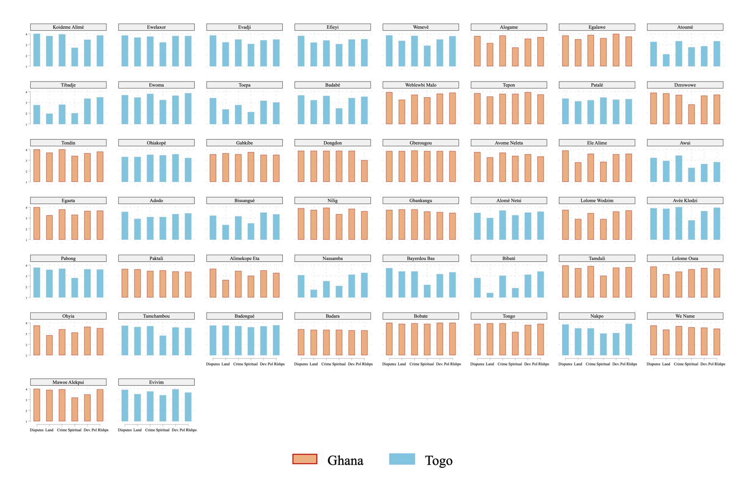
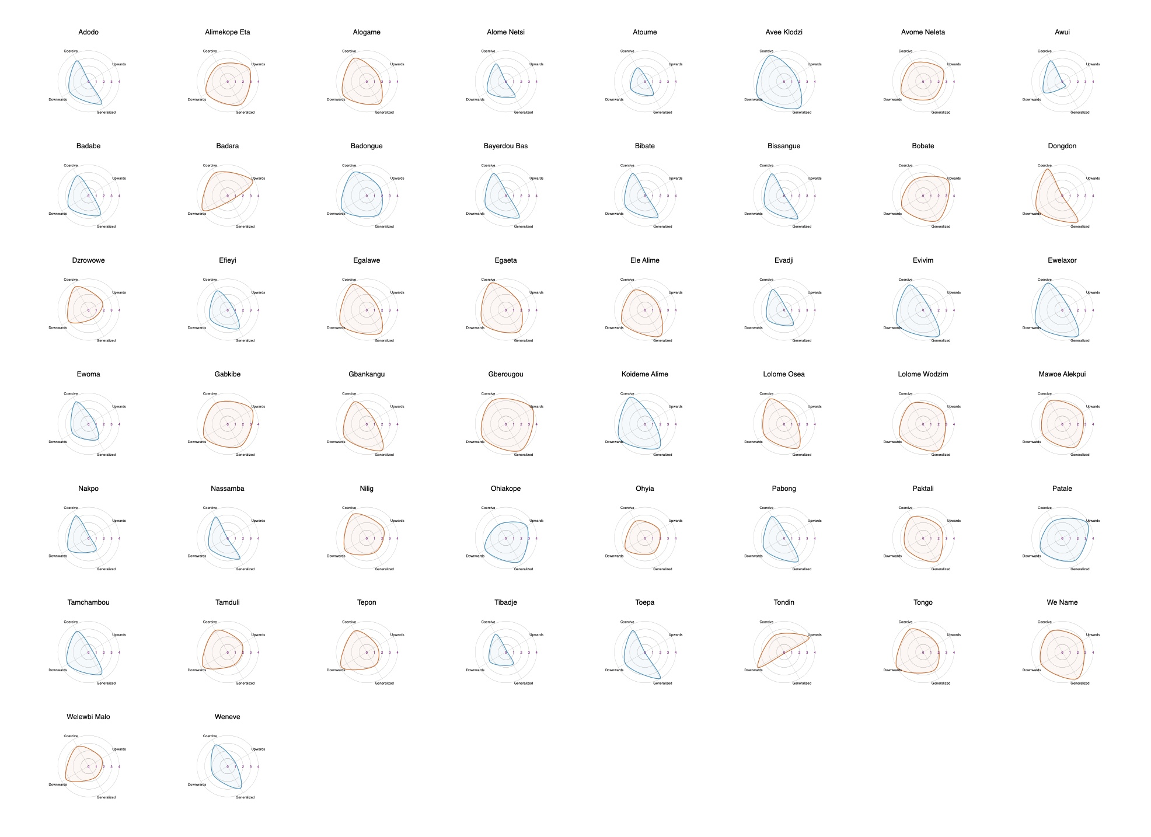
Appendix C: Descriptive statistics for explanatory variables.
FIGURE A1: Is managing this issue an important part of your chiefs job? Village averages with 95% confidence intervals. Issue areas on x-axis. Village names are pseudonyms.

FIGURE A2: Variation in the four dimensions of chiefly authority by village averages. Variables standardized to 0-4 (low to high) for purposes of comparison.

TABLE A2:
Descriptive Statistics
 |  | Sample Mean | Standard Deviation | N | Mean Ghana | Mean Togo
Togo |  | 0.51 | 0 | 1000 | 0 | 1
North |  | 0.48 | 0.49 | 1000 | 0.46 | 0.49
ln Distance District (km) |  | 3 | 0.62 | 1000 | 2.75 | 3.23
Strength of MP Relationship |  | 1.15 | 0.73 | 919 | 1.15 | 1.15
Openness of Chieftaincy Selection |  | 4.65 | 1.84 | 935 | 5.07 | 4.23

Appendix D: Question Specific Results (Disaggregated Replications of Figure 5)
Figure 5 presented average scores for chiefly duties and effectiveness. We replicate these models by each sub-question in Figures A3 (duties) and A4 (effectiveness) below. Two caveats to the findings from the averaged measure stand out. First, there is no statistically significant difference between Togolese and Ghanaian chiefs in their responsibility for land management/allocation or building political relations, though Ghanaian chiefs are perceived to be more effective at the latter. Second, Togolese chiefs are seen as less effective at two of the most important chiefly duties: resolving disputes and addressing crime.

The results in Figures A3 and A4 further support the general finding that an increased distance from the local state decreases the jobs a chief does (disputes, land management, crime, and building political relationships, the latter at the ten percent level). Effectiveness varies less on these dimensions, though chiefs who are farther from the local state are perceived as less effective on development. Importantly, Northern respondents were less likely to say that managing disputes or crime was an important part of their chiefs’ jobs, but there is no difference in effectiveness.

The disaggregated models offer two points of nuance to our conclusion that attributes of the chieftaincy itself do not track onto a chief’s expected duties or his effectiveness on the job. Chiefs selected through less open processes (e.g., shifting towards hereditary succession with a narrower body of selectors) increases the view that the chief is responsible for spiritual matters and that he is effective at building political relationships at the 10% level.

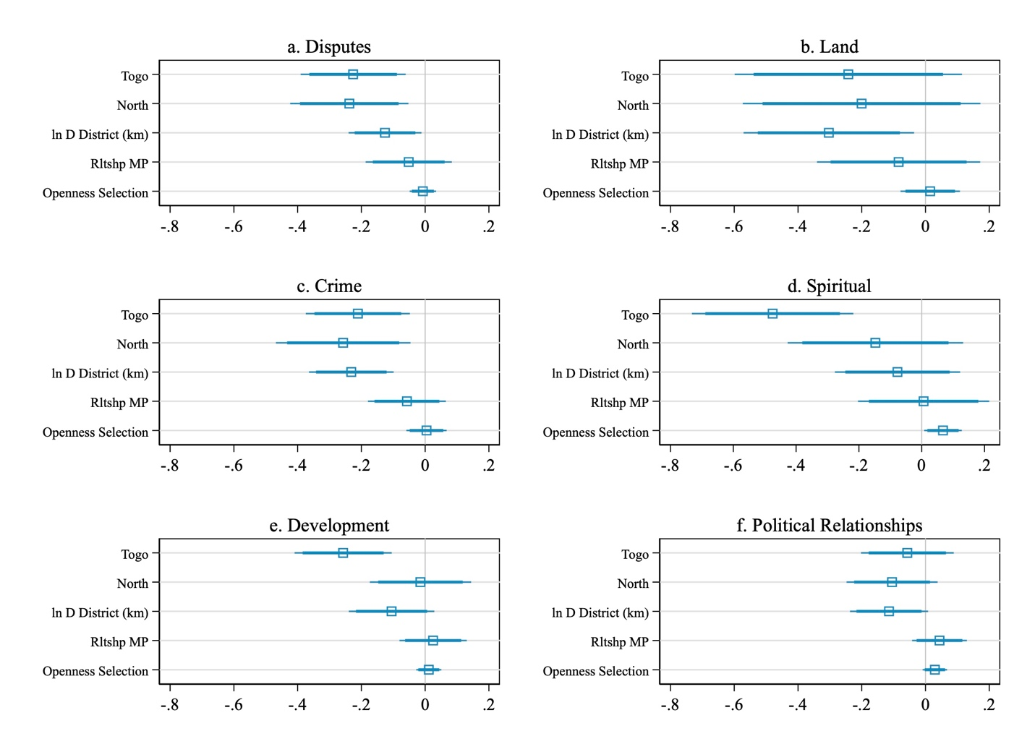
FIGURE A3: Disaggregated Results of Chiefly Duties (Figure 5 Extension) Dependent variable is how important a task the respondent views the following duties for their chief: managing disputes, allocating land, crime prevention, spiritual matters, development and building political relationships outside of the village. All responses on a four-point scale. Coefficients are from OLS models with standard errors clustered at the village. 90 and 95% confidence intervals reported.

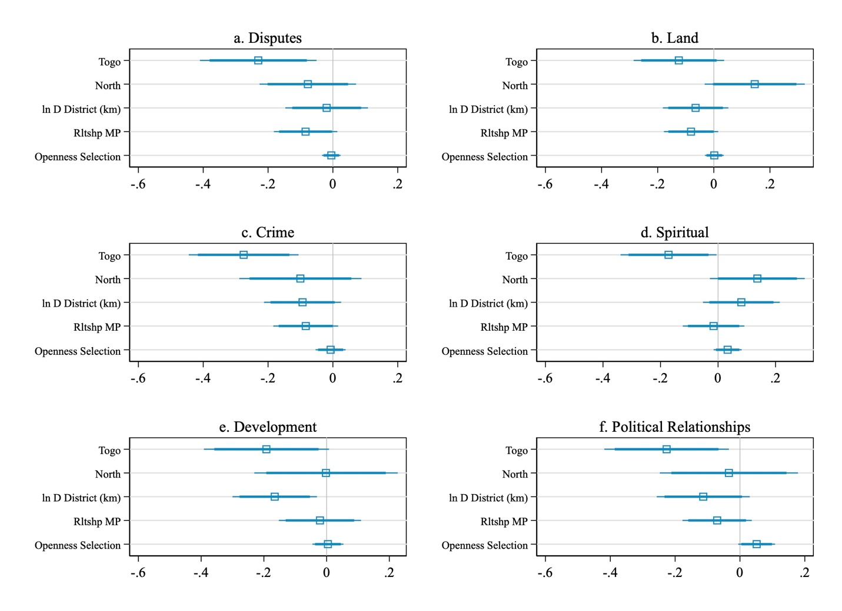
FIGURE A4: Disaggregated Results of Chiefly Effectiveness (Figure 5 Extension) Dependent variable is how effective the respondent perceives their chief to be at the following duties: managing disputes, allocating land, crime prevention, spiritual matters, development and building political relationships outside of the village. All responses on a four-point scale. Coefficients are from OLS models with standard errors clustered at the village. 90 and 95% confidence intervals reported.

Appendix E: Alternative Measures of Independent Variables (Figures 5 & 6)
Figure A5 replicates the findings in Figure 5 using two alternative measures. First, we show that there are consistent results if we use the logged distance to the national capital – located on the coast in both countries – in lieu of a dummy variable for North. This is arguably a better measure if what we are interested in is distance from the central state as opposed to a more blunt measure that assumes something distinct about the North in general. Secondly, we examine reported relationships with a more local political official: the District Chief Executive (DCE) in Ghana and the Préfet in Togo. Results are broadly consistent with all three sets of outcomes. Neither alternative variable significantly correlates with average duties, average effectiveness or any of our four measures of chiefly authority, though in Figure A6, Togo is no longer a significant predictor of the likelihood a respondent thinks their chief will listen at any level.

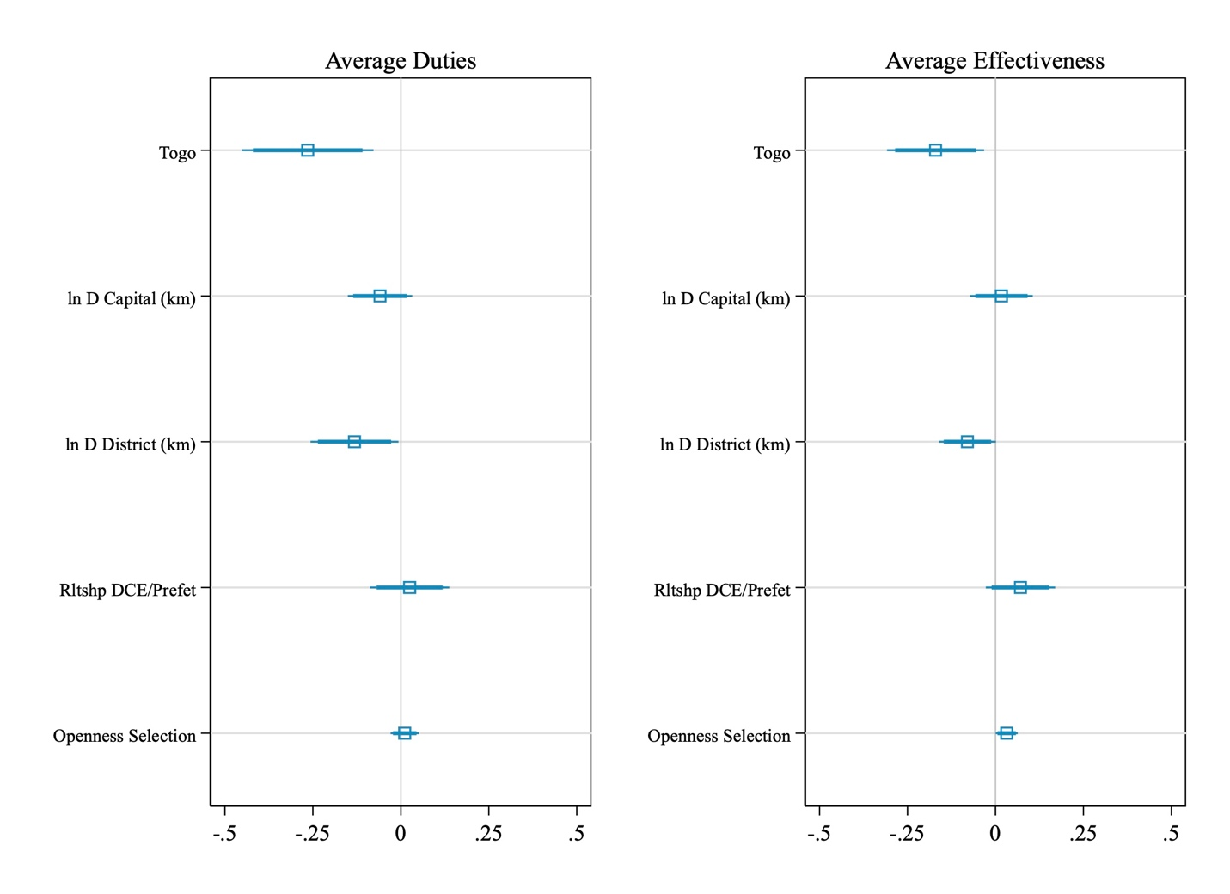
FIGURE A5: Explanations for variation in the average importance of duties ascribed to a chief (left panel) and his average effectiveness at those tasks (right panel) with Alternative IVs. Dependent variable is average score for how important the following are for the respondent’s chief’s duties/how effective the chief is at it: managing disputes, allocating land, crime prevention, spiritual matters, development and building political relationships outside of the village. All responses on a four-point scale. Coefficients are from OLS models with standard errors clustered at the village. 90 and 95% confidence intervals reported.

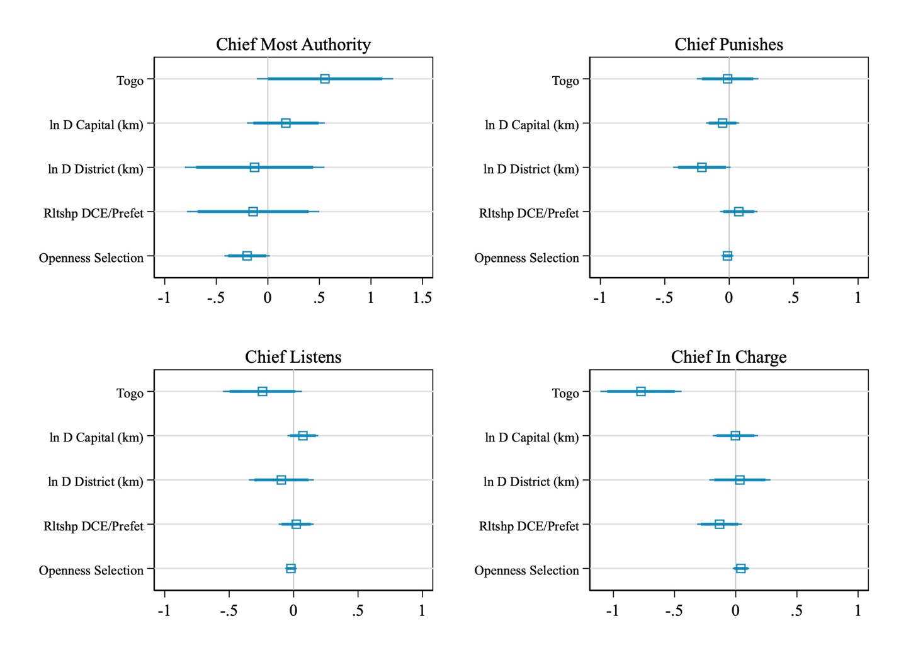
FIGURE A6: Perceptions of a Chief’s Authority in the Village with Alternative IV measures. Results from logit (Chief most authority) and OLS (all others) regressions, grouped by dependent variable, with 90 and 95 percent confidence intervals. Standard errors clustered at the village. 90 and 95% confidence intervals reported.
Appendix F: Alternative measures of chiefly authority: vote choice and trust
Two common metrics for assessing chiefly authority are not reported in the main text: the extent to which a respondent reports trusting their chief (e.g. Zimbalist 2021; Chlouba 2020) and whether or not their chief influences their vote choice (e.g. Baldwin 2013). We asked both questions in our survey and report the results descriptively below but choose not to report them in the main text given their particular potential to induce desirability bias. Although all of our survey questions likely induce some desirability bias, we feel it is particularly acute with these questions. Figure A7 shows the distribution of responses for both questions across countries. The vast majority of villages report trusting their chiefs.

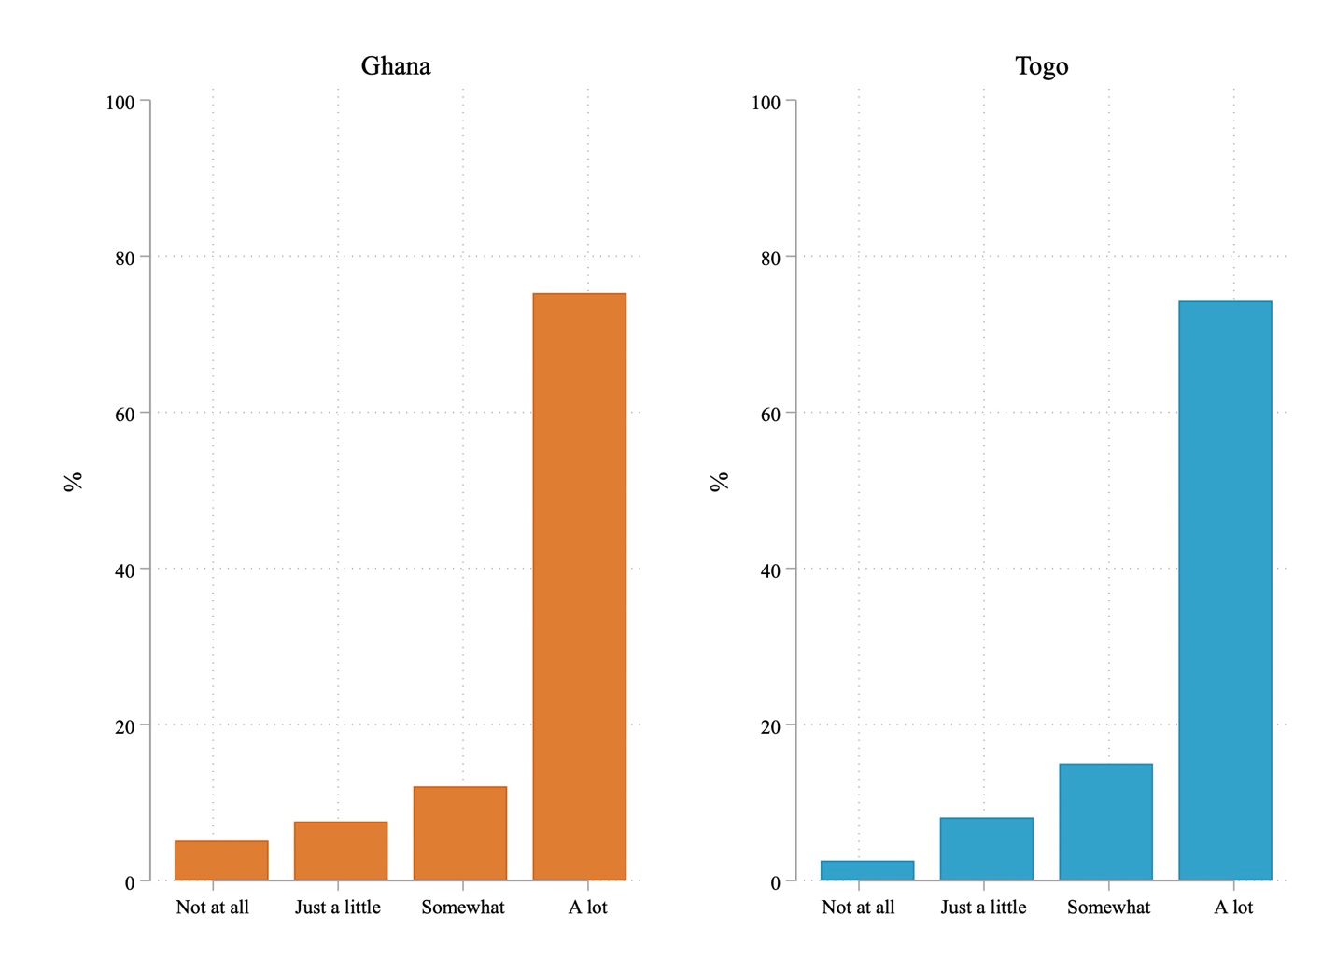
FIGURE A7: Distribution of Responses by Country to ‘How much do you trust your chief?’

Figure A8 shows the distribution for respondents’ evaluations about the influence of their chief on their vote choice. The left-side of the distributions look approximate to the extent that majority of respondents in both countries report that their chief has no influence on their vote choice (50.5% in Ghana versus 52.8% in Togo). The right hand of both distributions does diverge, however. Nearly double the number of Ghanaian respondents (22.8%) report that their chief is very influential in their vote choice compared to Togolese (11.5%).

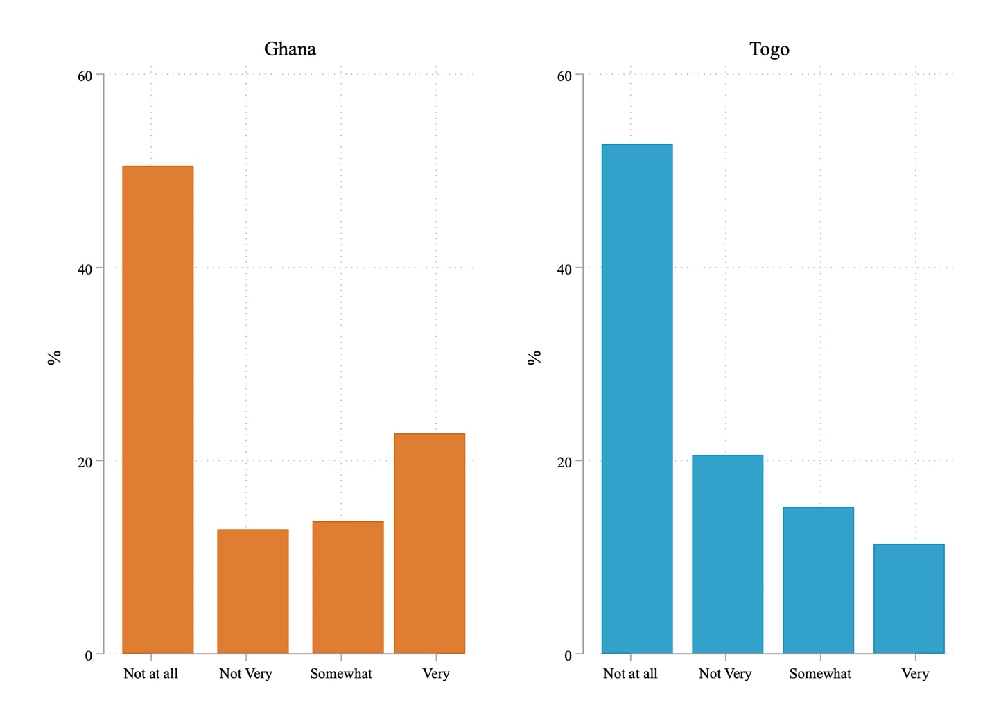
FIGURE A8: Distribution of responses by country to ‘When thinking about which party to vote for during elections, do you take into account the beliefs or opinions of your village chief?’

We rerun our authority models (Figure 6) using these two alternative dependent variables in Figure A9. Similar to our main results in Figure 6, we don’t find strong evidence that a chief’s downward authority (Chief important to vote) varies along any of our expectations. Trust in chief, which can be thought about as a more generalized measure does see significant variation on two dimensions: chiefs in our northern clusters see higher trust from survey respondents while, conversely, those who report stronger relationships with their MPs/Deputés see a decline in trust (significant at the ten percent level).
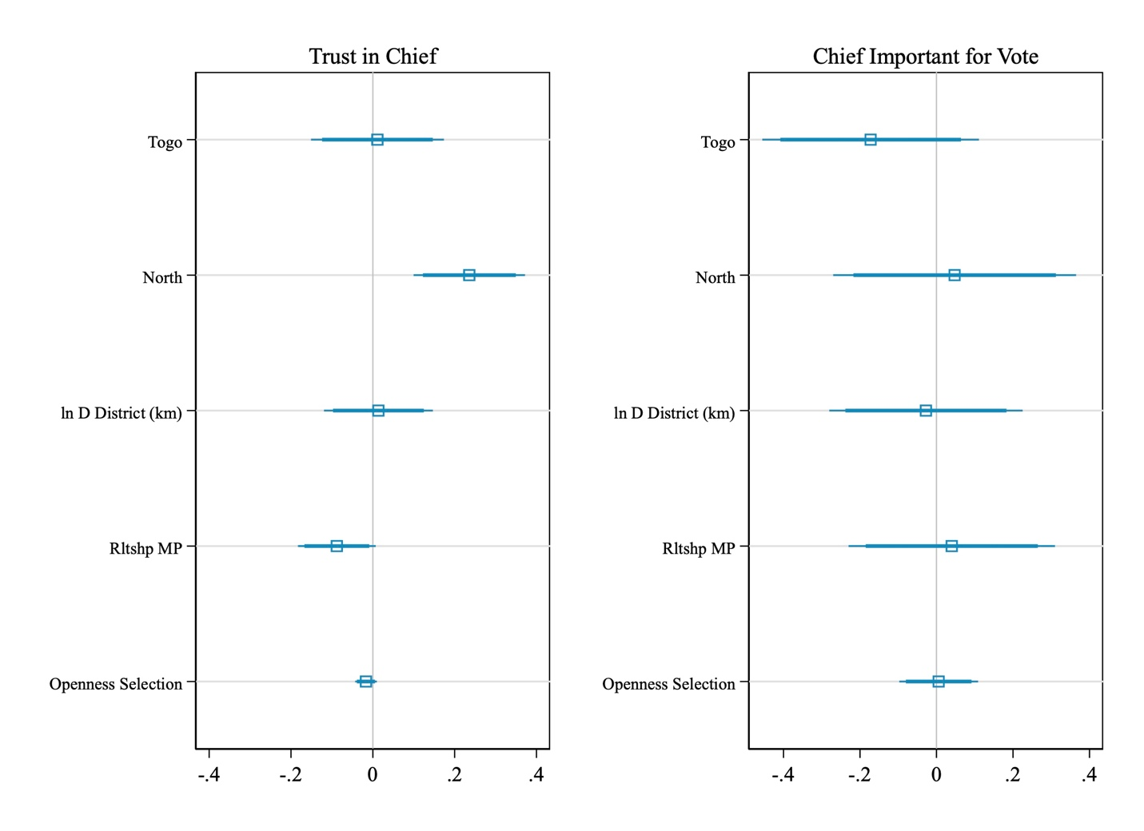
FIGURE A9: Alternative measures of perceptions of a chief’s authority in the village. Results from logit (Chief most authority) and OLS (all others) regressions, grouped by dependent variable, with 90 and 95 percent confidence intervals. Standard errors clustered at the village. 90 and 95% confidence intervals reported.

Works Cited

Baldwin, K., 2013, ‘Why Vote with the Chief? Political Connections and Public Goods Provision in Zambia’, American Journal of Political Science, 57(4), 794–809.
Chlouba, V., 2020, ‘Traditional Authority and State Legitimacy: Evidence From Namibia’, The Journal of the Middle East and Africa, 11(3), 251–272.
Zimbalist, Z., 2021, ‘Explaining Variation in Levels of Public (Dis)trust in Traditional Leaders: Colonial Ruling Strategies and Contemporary Roles in Governance’, Government and Opposition, 56(4), 661–682.

