Online supplement to Bjork-James, ‘When does Lethal Repression Fail? Unarmed Militancy and Backfire in Bolivia, 1982–2021,’ Journal of Latin American Studies.

Data and Methodology

R Code and Calculations
All calculations and data tables referenced in this article are compiled in RMarkdown file WLRF-Tables.Rmd in the Ultimate Consequences package on GitHub, using the database as constituted on May 12, 2022. A copy of the database on that date is archived for reproducibility of the analysis. Access is currently available to researchers on request and will be incorporated into the forthcoming public release of the dataset. The queries, data tables, and code used to create them are published online at https://ultimateconsequences.github.io/ ultimate-consequences/WLRF-Tables.html.

The Ultimate Consequences database
The Ultimate Consequences database enumerates individual deaths in Bolivian political conflict since October 1982, the end of military rule in the country. The research team is led by Carwil Bjork-James and has included Emma Banks, Chelsey Dyer, and Nathan Frisch. These researchers compiled data from multiple sources, including media reports, governmental, intergovernmental, and private human rights reports, and research literature on political conflict. The dataset now includes nearly all of the deaths identified by a Permanent Assembly of Human Rights-Bolivia (APDHB) study of deaths from 1988 to 2003, and a study of the coca conflict from 1982 to 2005 (Navarro Miranda 2006; Llorenti 2009; Salazar Ortuño 2008). Unlike prior compilations by human rights organizations, however, this database includes a variety of qualitative variables designed to understand how and why the deaths occurred and what policies and patterns underpin them.
The database is designed to both catalog the lethal consequences of participation in social movements and political activism, and to assess responsibility, accountability, and impunity for violent deaths. All deaths are significant as signs of the price that has been paid to seek social change. Some deaths are also significant as elements of repression or violence for which someone might ultimately be held accountable. Rather than begin by asking, “Is this death someone’s fault?,” the database codes each death according to multiple factors that enable us to extract different subsets of the overall database for different purposes. We estimate there were 580 to 600 deaths associated with Bolivian political conflict from October 1982 through December 2019. As of June 2020, the project had identified 578 of these deaths, including those of 540 named individuals. The database is maintained as a Google Docs spreadsheet, which can be queried by R scripts. Reports can be generated internally or exported for further manual coding, as done here for all events with three or more deaths.
The scale of the dataset for this period is both large enough to identify significant patterns and small enough (unlike the situation in some other Latin American countries) to permit the construction of a database that includes detailed information about every death. Precisely because its coverage is nearly comprehensive, the database offers a systematic sample of cases for quantitative and/or qualitative analysis, untainted by selection bias.
The situations described in the dataset principally involve the following:
- Deaths from repression or confrontations with security forces during protest
- Deaths from security force incursions into politically active communities that are related to their activism
- Deaths from inter-movement and intra-movement confrontations
- Deaths of all kinds related to guerrilla or paramilitary activity
- Deaths of all kinds related to the conflict over coca growing
- Political assassinations of all kinds, including public officials, political activists, and journalists
- Deaths of social movement participants while in police custody for their activism
- Deaths from the hardships of protests and acts of self-sacrifice such as hunger strikes, long-distance marches etc.
- Acts of suicide as a form of protest
- All deaths related to land conflicts that involve a collective/social movement organization on at least one side.
Each death record includes identifying information about the person who died, the individual or group who caused the death, the place and time of the death, the cause and circumstances of the death, whether the death appears to be deliberate or intended, the geographic location, the death’s connection to social movements and social movement campaigns, sources of information available about the death, types of investigation that have been performed, accountability processes, and relationship to the Bolivian state. Analytical variables used so far include: political assassination (a binary yes/no category); protest domain (aggregating all protest campaigns into a small number of topics such as “labor” and “municipal governance”); and denial (a binary yes/no category indicating whether the perpetrator denied responsibility for the death). In creating database entries, we create brief narrative descriptions of the events involved and/or quote such descriptions directly from sources of reporting. We also are collecting textual segments of reporting and testimonial narrative relevant to each death.

Deaths excluded from this analysis
At the beginning of this analysis, I excluded deaths classified as “collateral”, defined as indirect consequences of intentional but nonviolent acts upon non-participants. (Our codebook refers to “weapons, arson, or assault” rather than “violence.”) I also excluded non-conflict-related accidents (e.g., car crashes outside confrontational scenarios) and health incidents (e.g., heart attacks of marchers) that occurred during conflicts. The database also handles the situation where a report of an uncertain number of deaths (e.g., three to five) was recorded by tagging the excess deaths as “unconfirmed.” For the remainder of this article, I refer to deaths not filtered in any of these ways as “confirmed deaths.”
There were 180 events in the dataset before these filters, and 170 after excluding them. The 10 excluded events include 11 deaths; 0 have 3 or more deaths. In addition, there were 5 events that would meet the three-event threshold for consideration in this article if this filter were not applied: three in which most or all deaths were incidental, and two in which some deaths were unconfirmed. The 2011 TIPNIS march, where deaths are incidental, is mentioned briefly under Quadrant 4.

Selection of events
The analysis in this article uses events rather than individual deaths as its cases. Every death is associated with precisely one event, and each event is coded as part of a “protest domain,” one of 18 general areas of political contention, and a more specific “protest campaign.” Every death is coded as to whether it was committed by a member of the state security forces (i.e., the police and military), a “state perpetrator” death; and as to whether it had a member of these forces or national government officials as the victim, a “state victim” death. The first step in the data analysis then is to compile the total number of deaths, of state perpetrator deaths, and of state victim deaths for all events, something the database is configured to do automatically.
Before performing the event analysis, deaths were filtered as described above. There were 182 events in the dataset before these filters, and 172 after excluding them. The 10 excluded events include 11 deaths; none have 3 or more deaths.
For each of these events, I surveyed news reports and academic writings on the conflicts involved and described the results of the protest event from the point of view of the protesting group. In the tables these are colored as a binary success by movement (green; up arrow and grey in print version) or the state (red; down arrow and black in print version), while the text describes the outcome. Several were coded as movement successes but I note a “(Partial) agreement” by the government. One case, the June 1988 cocalero protests—described here as the “Villa Tunari Massacre” due to deadly repression on June 27—had a definitively split outcome: the government reversed its plans to spray herbicides to eradicate coca crops, as the protesters demanded, but nonetheless passed Law 1008, which criminalized all coca growing in the Chapare.

Clustering deaths into events; robustness of choices regarding 2019 crisis
In classifying deaths into events, there are inevitable questions of whether to lump individual deaths into smaller numbers of events, and whether to combine events over a prolonged social movement effort into a single event. In the service of evaluating the success or failure of periods of social mobilization, I opted to consolidate events across time when there was a sustained process of mobilization, and to consolidate events across geography making common demands. However, when a clear outcome occurred in response to just part of a wider or longer period of sustained mobilization, I categorized the event as if it ended with that outcome.
Following this logic, the 1996 mining uprising, the 2003 Tarifazo protests (with deaths in Cochabamba and La Paz), 2003 Gas War (with deaths in rural and urban La Paz department), the 2019 electoral fraud protests (events prior to Evo Morales’ ouster) are consolidated across geographic locations. The 2006 Huanuni mine clashes resulted in government concessions, but shortly afterward a security force member was killed; for purposes of categorization, I disregard this final death and include the event in Quadrant 4. Similarly, the 2008 Porvenir massacre—an act perpetrated by the departmental governor and allied non-state actors—precipitated a national government response to impose a state of emergency in Pando and arrest the governor; I treat this latter effort as a separate event.
The 2019 crisis remains open to multiple clusterings. Evo Morales’ resignation on November 10 provides a natural break between events, but there is uncertainty about how to group the deaths afterwards. I considered three alternatives: grouping all deaths after Morales’ ouster as a single “Combined 2019 post-resignation protests”; grouping events by region, which qualifies “Metro Cochabamba post-resignation” and “Metro La Paz post-resignation” as events with 3 or more deaths; and keeping a separation between the Sacaba and Senkata massacres and prior events. Since these massacres are two of the five largest one-sided killings in the dataset, and neither produced backfire, I think including them in the Quadrant 1 analysis is highly informative. However, I have also re-calculated comparative analysis tables on the basis of treating all post-resignation deaths as a single event; they are included in Tables S5 and S6. As can be seen, the overall outcome in S6 is robust to different ways of dividing 2019 into smaller events.

Table S1. All cases analyzed in this study, arranged chronologically.
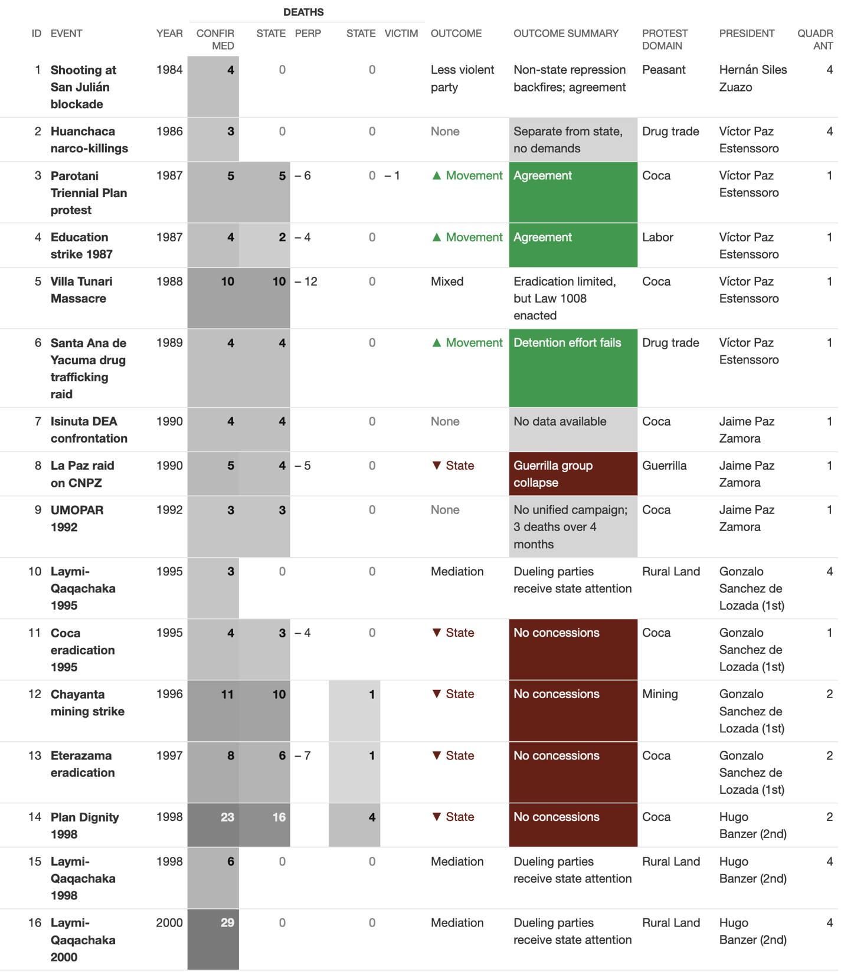
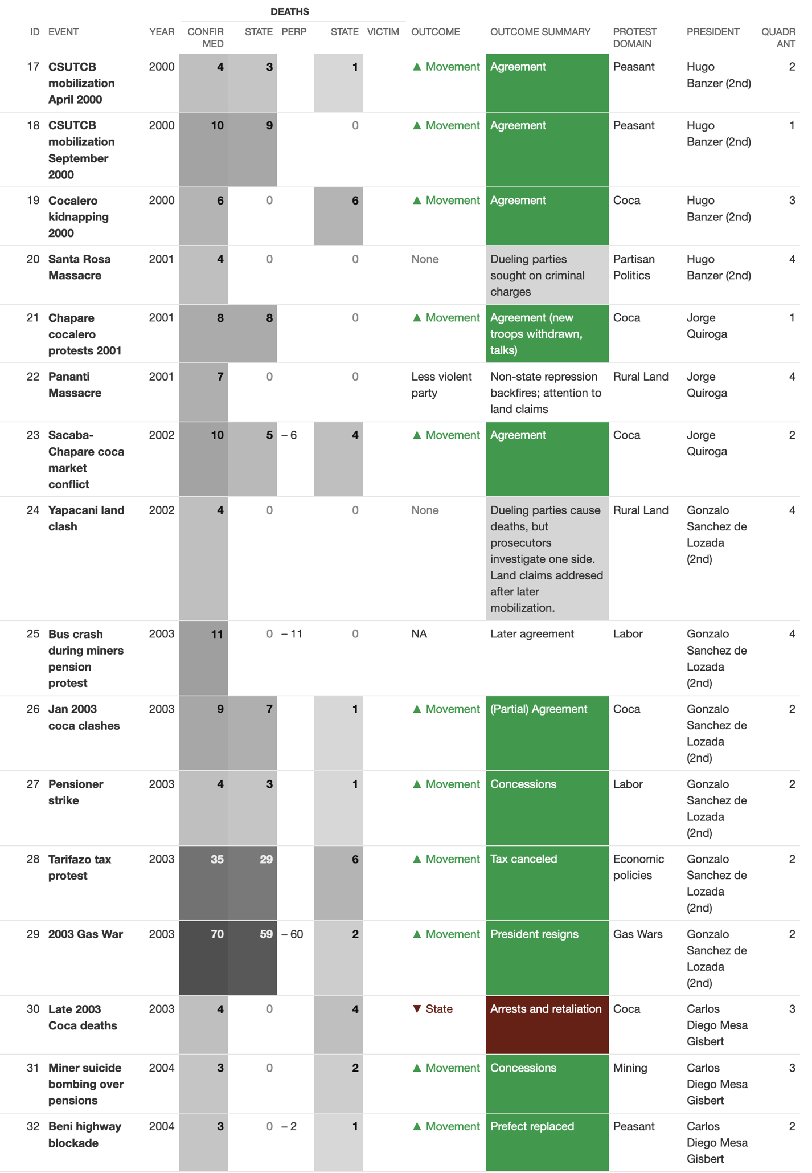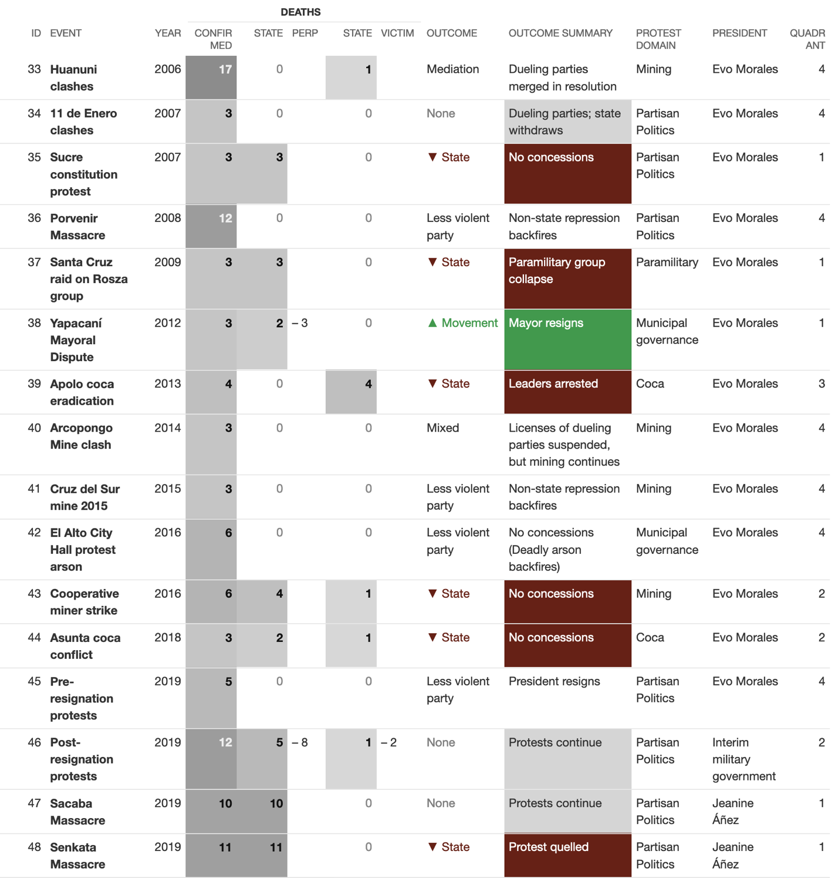

Table S2. Full tables of outcomes for the four quadrants
Quadrant 1: Cases with deadly state repression and zero state victims
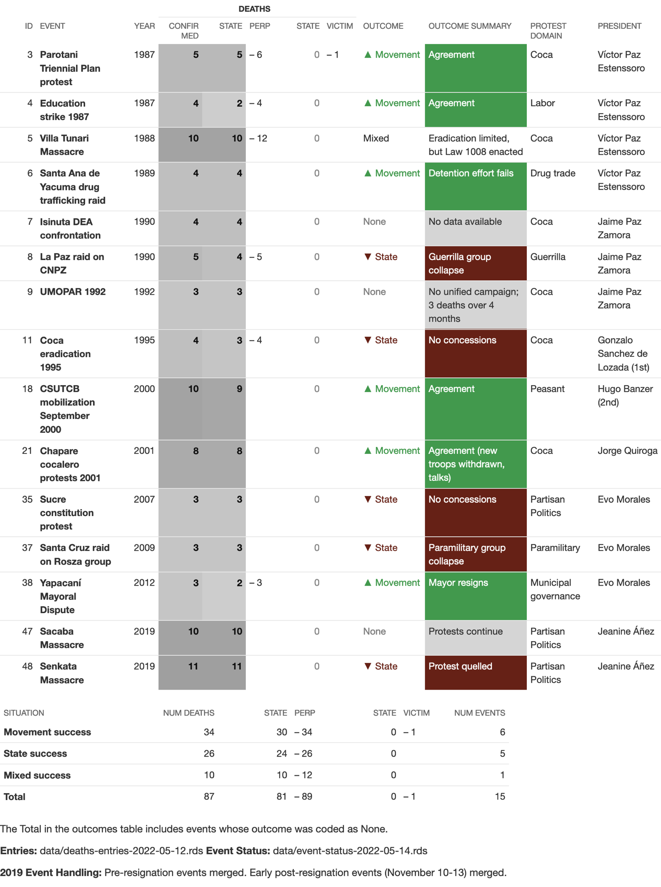
Quadrant 2: Cases with deadly state repression, but where state security forces were also killed
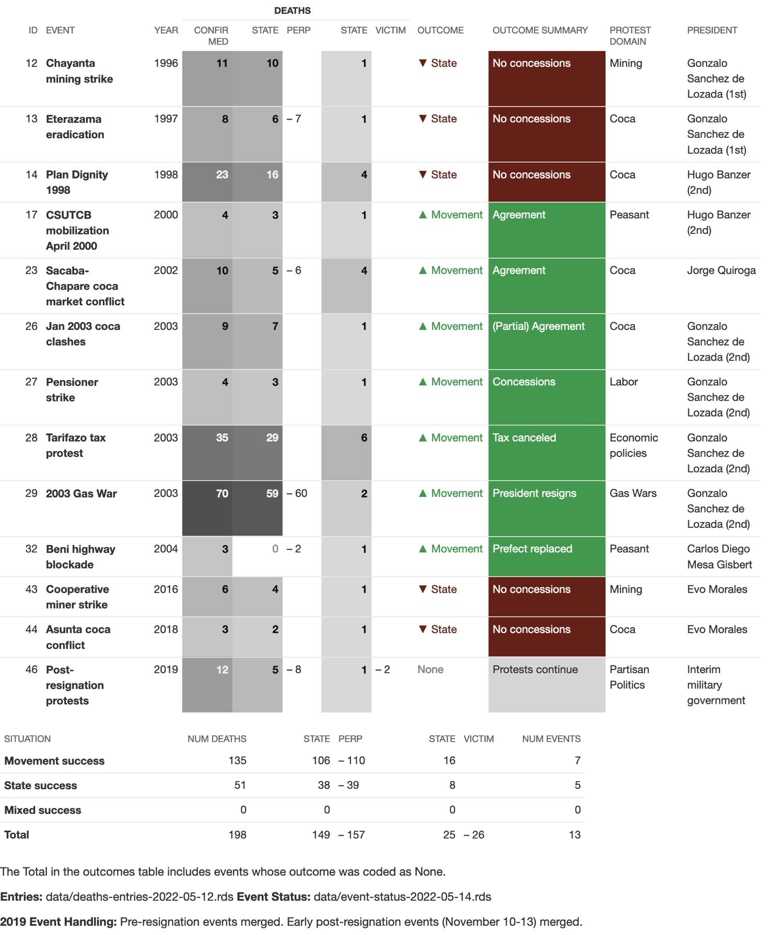

Quadrant 3: Cases with no deaths perpetrated by the state, but where state forces were killed
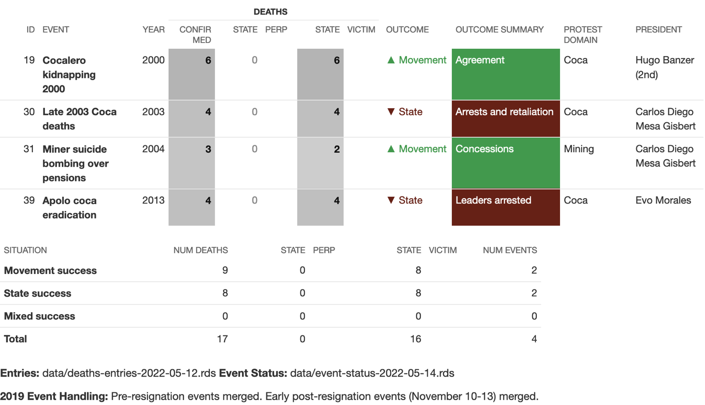

Quadrant 4: Outcomes of protest events in cases with no deaths involving the state
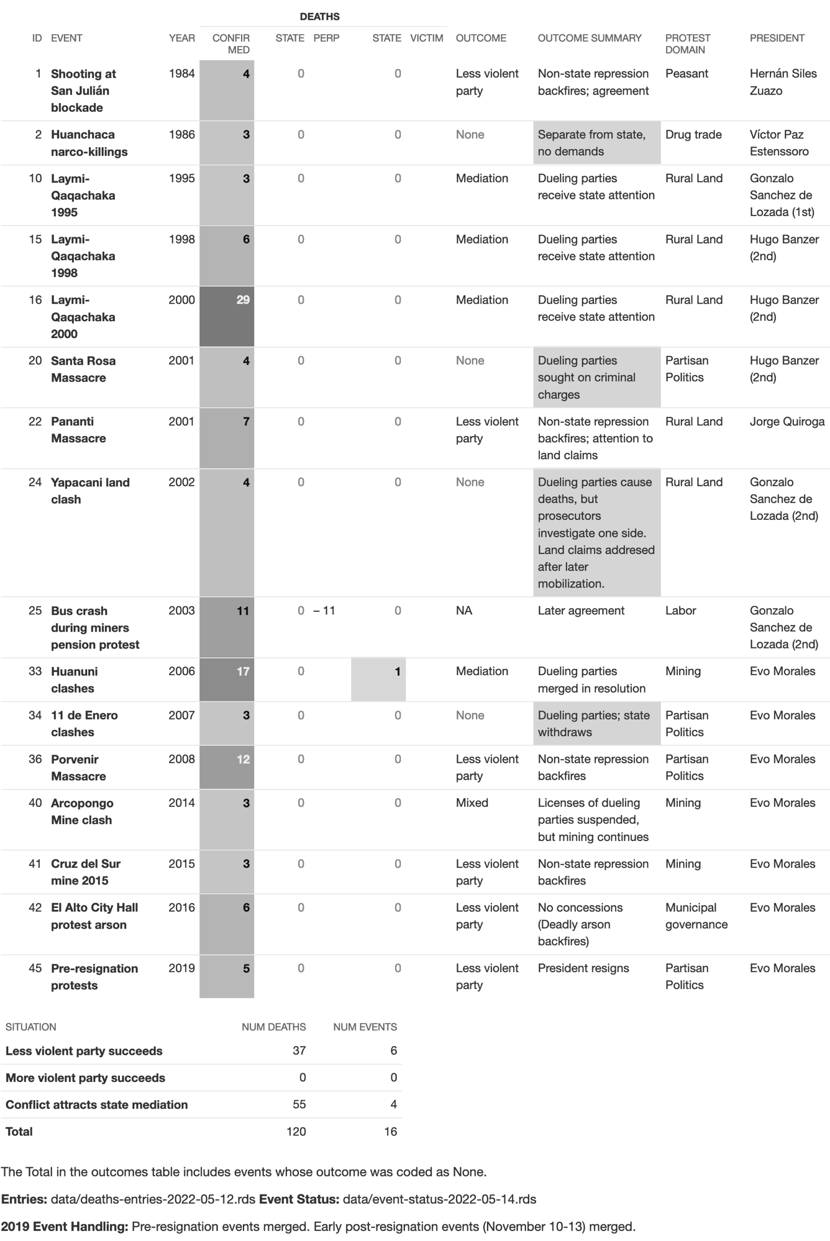
Table S3. Table of deaths by presidency and state responsibility
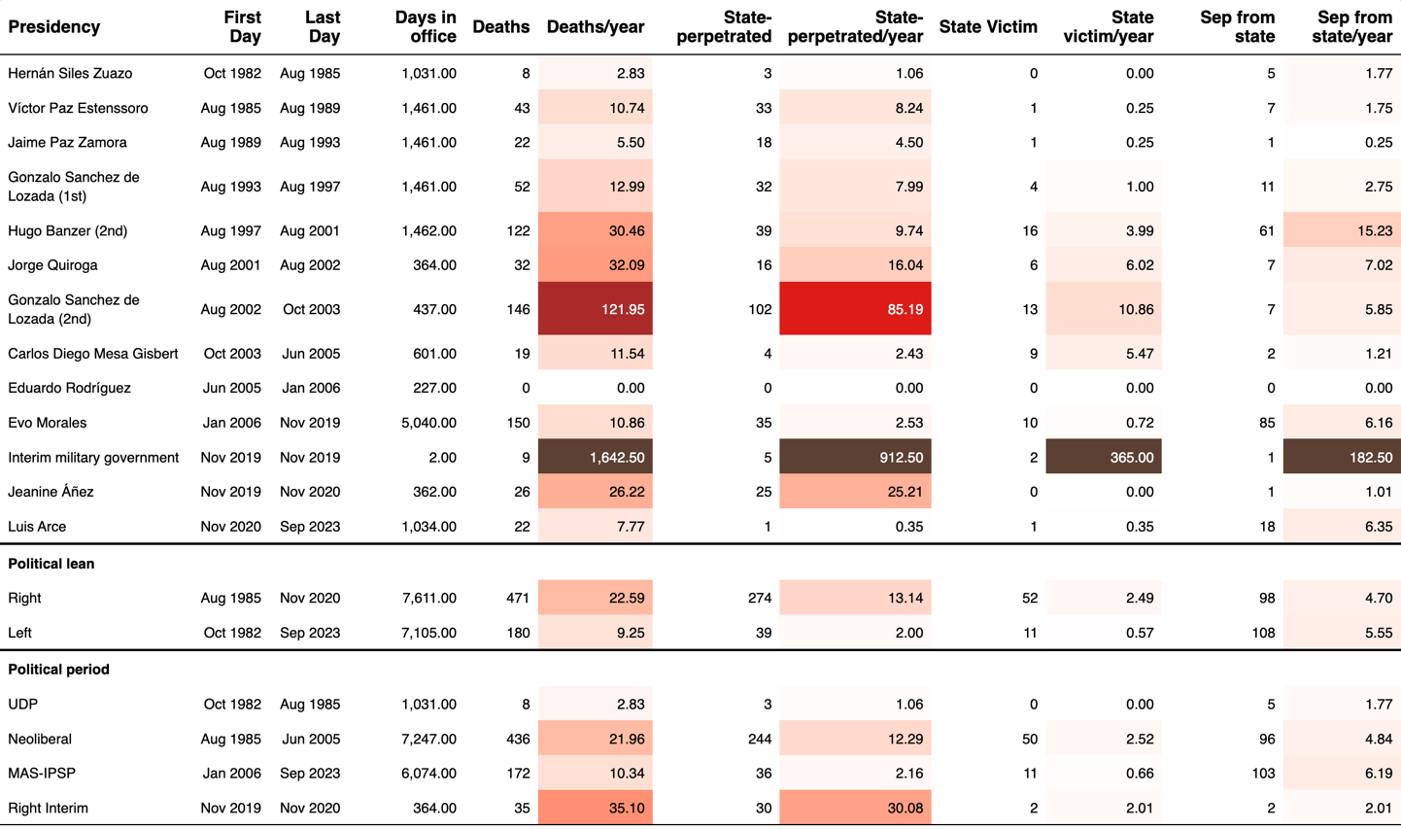

Table S4. Share of larger (n≥3) events by presidency
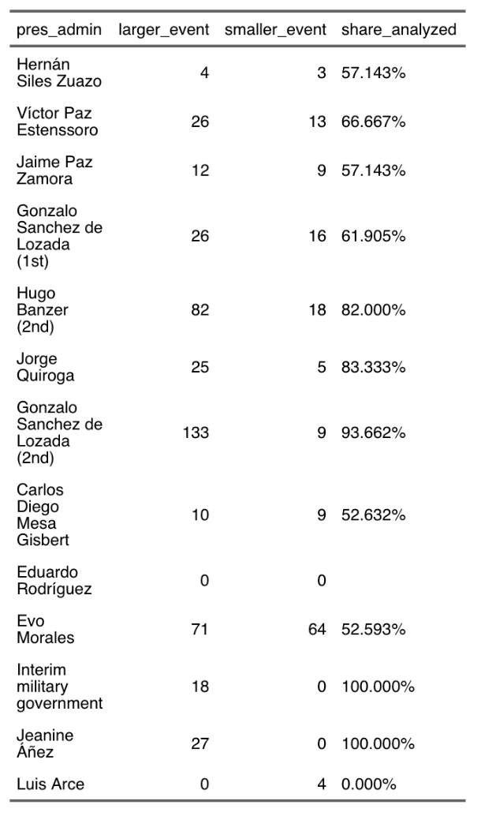

Table S5. Possible ways to cluster the deaths in the 2019 crisis
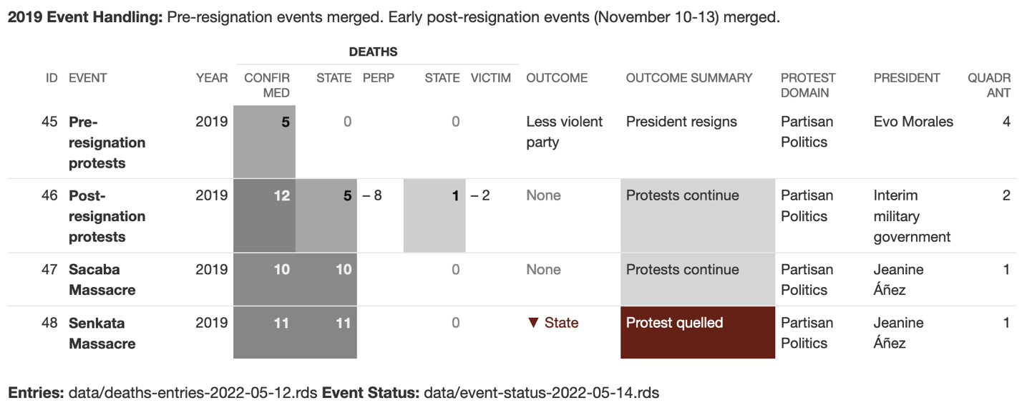

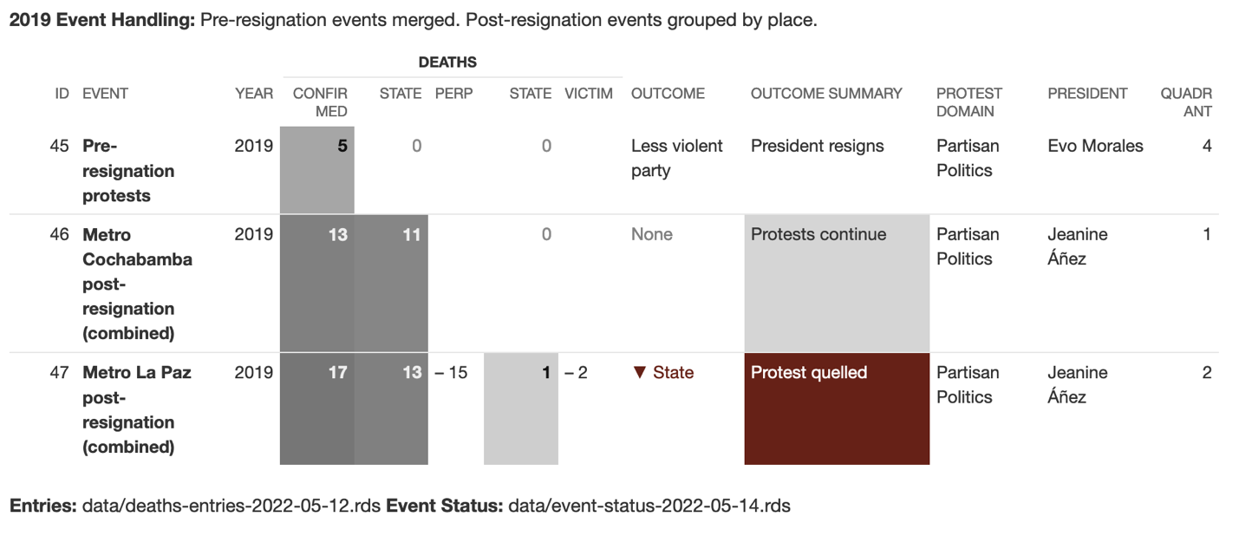

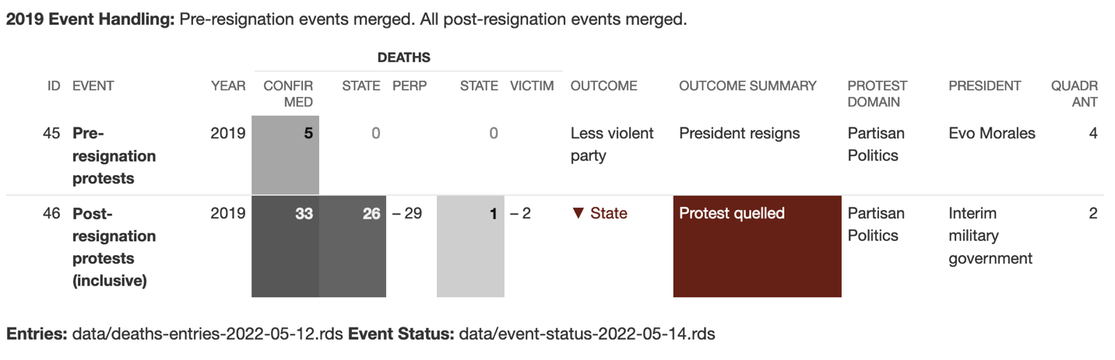

Table S6. Results of Qualitative Comparative Analysis under different clusterings of the 2019 crisis

 |  | Deadly Violence by State | Deadly Violence against State | Guerrilla or Paramilitaries | Coca Conflict | Dueling Partisan Mobilizations | Cases | Deaths | Deaths in Movement / Repression Success | Movement / Repression Success | Movement Success %
2019: Early post-resignation events (November 10–13) merged.  This grouping used in main article. | Deadly state repression (Quadrant 1 and 2) | + |  |  |  |  | 28 | 285 | 169 (+10 partial) / 77 | 13 (+1 partial) / 10 | 57–58%
 | Quadrant 1: Deadly state repression and zero state victims | + | - |  |  |  | 16 | 87 | 34 (+10 partial)  / 26 | 6 (+1 partial)  / 5 | 55–58%
 | Quadrant 2: Deadly state repression and violence against state | + | + |  |  |  | 13 | 198 | 135 / 51 | 7 / 5 | 58%
2019: Post-resignation events grouped by place  Metro Cochabamba includes Sacaba massacre.  Metro La Paz includes Senkata massacre. | Deadly state repression (Quadrant 1 and 2) | + |  |  |  |  | 28 | 285 | 169 (+10 partial) / 83 | 13 (+1 partial) / 10 | 57–58%
 | Quadrant 1: Deadly state repression and zero state victims | + | - |  |  |  | 16 | 87 | 34 (+10 partial)  / 15 | 6 (+1 partial)  / 4 | 60–64%
 | Quadrant 2: Deadly state repression and violence against state | + | + |  |  |  | 13 | 198 | 135 / 68 | 7 / 6 | 54%
2019: All post-resignation events (November 10–19) combined into a single event. | Deadly state repression (Quadrant 1 and 2) | + |  |  |  |  | 26 | 285 | 169 (+10 partial) / 99 | 13 (+1 partial) / 10 | 57–58%
 | Quadrant 1: Deadly state repression and zero state victims | + | - |  |  |  | 16 | 87 | 34 (+10 partial)  / 15 | 6 (+1 partial)  / 4 | 60–64%
 | Quadrant 2: Deadly state repression and violence against state | + | + |  |  |  | 13 | 198 | 135 / 84 | 7 / 6 | 54%

Cited Narratives of Cases Examined
Note: Narratives are only included for cases with a coded outcome or otherwise mentioned in the text.

Cases with deadly state repression and zero state victims (Quadrant 1)

(3) Parotani Triennial Plan protest: A joint military-police intervention against road blockades set up to protest the Triennial Plan to Fight Narcotrafficking resulted in at least five deaths in the towns of Parotani and La Angostura on May 28, 1987. After the plan was announced in January 1987, Chapare coca growers, the CSUTCB national peasant federation, and the COB national labor confederation publicly organized against it (Hoy 1987a). Following protests and unsuccessful negotiations, they erected blockades in Parotani, Angostura, and Chiñata. At Parotani, the violence began with an accidental self-inflicted gunshot by soldier Carlos Caballero Juárez. Two adult male coca growers were confirmed dead at Parotani, as was a two-month-old child who was beaten to death. Witnesses reported seeing another woman dead on a military truck, but this could not be confirmed by an investigation. Another peasant protester was killed at La Angostura. Protesters and the government agreed on the withdrawal of the Triennial Plan, the end of involuntary coca eradication, and the legalization of coca cultivation (Asociación de Familiares de Detenidos Desaparecidos y Mártires por la Liberación Nacional (Bolivia) 1987; Salazar Ortuño 2008, 119–30).
(4) Education Strike 1987: Rural and urban teachers mounted a 48-day strike campaign for higher wages in July and August 1987. The campaign attracted solidarity strikes and blockades from other sectors, including in rural La Paz department. There, in Huatajata, the military launched a deadly attack on protesters and carried out house-to-house raids, killing one teacher and two rural residents on August 13 (Hoy 1987c; Sucesos de Huatajata: Un Día Inolvidable, 13 de Agosto 1987 1987). A further teacher was killed by the consequences of tear gas in Sucre on August 15 (Hoy 1987b). The Catholic Church mediated an agreement on increased pay that was accepted by all parties by August 28 and signed on September 4 (Centro de Documentación e Información (CEDOIN) 1987a; 1987b)
(5) The June 1988 mobilization by Chapare coca growers against escalated government efforts to eradicate their crops culminated in the June 27 Villa Tunari massacre, in which nine civilians were killed and another three disappeared and are presumed dead. While the Villa Tunari crackdown was precipitated by an unarmed crowd’s attempt to occupy an eradication base, security forces simultaneously cracked down across the region (Centro de Documentación e Información (CEDOIN) 1988b; 1988a; Informe “R” 1988; Kawell 1989). Afterwards, the government proceeded to pass Law 1008, which prohibited coca growing in the region, although it did hold back from plans to use chemical defoliants as a method of eradication (Thoumi 2003; Malamud-Goti 1990; Andreas and Youngers 1989).
(6) Santa Ana de Yacuma drug trafficking raid: A joint UMOPAR–DEA raid targeting drug traffickers around a village uprising against in Santa Ana de Yacuma, Beni. Four villagers were killed during the ensuing confrontation, in which local Bolivian naval forces also fired on UMOPAR. The agents withdrew without capturing the target of the raid (Malamud-Goti 1990, 47; García-Sayán 1990, 166; Menzel 1997, 45).
(7) Isinuta DEA confrontation: During joint operations near Insinuta, DEA and UMOPAR agents engaged in aerial bombardment in an effort to destroy roadways and landing strips in the Chapare. On September 24, 1990, they were confronted by an apparently armed group of peasants and possibly drug traffickers along the Isiboro River near Isinuta. According to Jaime Malamud-Goti, “an hour long shoot-out ensued” during which a government helicopter “fired at the crowd, killing four campesinos” (Goti 1991, 127ff; Isikoff 1990). US officials confirmed one death as well as the wounding of a DEA agent. No information could be found about the continuation or ending of the policy of bombardment.
(8) La Paz raid on CNPZ: The Nestor Paz Zamora Commission, an urban guerrilla organization, kidnapped Coca-Cola tycoon Jorge Lonsdale and demanded millions for his release. During a police operation to find Lonsdale, he and several rebels were killed. Witness accounts dispute whether CNPZ members or the police killed the hostage, but witness and medical accounts confirm that the police killed four rebels, including one following his capture and torture. Two more may have been disarmed before their deaths. Despite this, the police raid resulted in the collapse of the organization (Agencia de Noticias Fides 2017; Reuters 1990).
(9) UMOPAR 1992: No unified campaign; 3 deaths over 4 months (Petterson, Mackay, and Andean Information Network 2005; Human Rights Watch/Americas 1996).
(11) Coca eradication 1995: The Bolivian government conducted intensified eradication of coca crops in the Chapare in coordination with the United States. In April 1995, the government issued a six-month state of siege under which there were numerous confrontations between cocaleros and security forces. Confrontations led to the deaths of four or five cocaleros between July and September. The deaths came during an explosive attack on an UMOPAR truck transporting detainees, attempts at forced eradication, resistance efforts, or other militarized operations denoted as “anti-narcotics raids” (Salazar Ortuño 2008, 254–68; Human Rights Watch/Americas 1996; Ledebur 2002). The eradication campaign and violence prompted a national march by the cocalero federations, “Marcha por la Vida, la Coca y Ia Soberanía Nacional,” which began in Villa Tunari on September 2. Marchers endured repression and arrived in La Paz on September 19. There they worked out an agreement, but this was immediately discarded by the government (Navarro Miranda 2006, 84–88).
(18) CSUTCB mobilization September 2000: In September 2000, allied movements led “the most tenacious Andean rural road blockades in modern history” (Healy 2004, 28). A teachers’ union strike included a march from Oruro to La Paz, while the CSUTCB peasant confederation mobilized nationwide roadblocks and the Six Federations of coca growers demanded the government break its commitment to coca eradication and the construction of three new US-funded bases in the Chapare (Kohl and Farthing 2006, 168). The blockades lasted from September 11 to October 7. As the mobilization extended, there was a shift from mere blockades to mass gatherings preparing to advance on La Paz, 50,000 in Achacachi alone. Blockades caused food to grow scarce in La Paz and El Alto, and Alteño housewives mobilized in solidarity. The state was obliged to concede certain demands, including the cancellation of three planned military installations around the coca-growing Chapare region (Ledebur 2002) and lengthy agreements with teachers’ and peasant unions (García Linera, Chávez León, Marxa, and Costas Monje, Patricia 2010, 123).
(21) Chapare cocalero protests 2001: Early in the presidency of Jorge Quiroga, cocalero protests against the militarization of the Chapare were reactivated. Three cocaleros were killed amid protests on September 27 and October 17. In November, state violence escalated and the government admitted the presence of the Expeditionary Task Force, a US-funded antinarcotics unit that had been denounced as mercenaries by human rights observers and even senior military officers (Faiola 2002; Los Tiempos 2001a). Three more cocaleros were killed on November 15, and a further cocalero was fatally wounded November 20. On November 21, the Minister of Government and cocalero leader Evo Morales agreed to de-escalate mobilization, withdraw troops, and open a “Summit on Coca and Alternative Development” (Los Tiempos 2001c). Backfire is suggested by the government’s felt obligation to seek to de-escalate violence and the moral divisions in the security force leadership (Los Tiempos 2001d; Los Tiempos 2001b). Despite this truce, a soldier would kill local cocalero leader Casimiro Huanca on December 6 and the conflict would re-ignite in early 2002.
(35) Sucre constitution protest: As the Constituent Assembly moved to approve a draft constitution in November 2007, Sucre’s civic movement and protesters from eastern departments attempted to block its sessions, held at the Liceo Militar. In the city center, a civic movement meeting declared the Constituent Assembly “illegal,” promised not to adhere to the constitution it produced, and called for Chuquisaca’s autonomy from the national government (Defensoría del Pueblo 2010, 15). Soon after, the day-and-a-half-long push by the civic movement protesters to reach the Liceo began, a battle of stones, burning tires, tear gas, and rubber bullets in the neighborhood of La Calancha. During running street confrontations, two civic movement protesters were shot dead (likely by security forces), while some 200 people were wounded on November 24 (Correo Del Sur 2008a). Overnight, frustrated right-wing crowds burned down many of the city’s police stations as well as the home of MAS-affiliated Prefect David Sánchez Heredia, who fled the country (Correo Del Sur 2007). During a confrontation over the police Transit Unit, officers killed a third protester but lost control of the building, with many escaping only after being beaten by the crowd (Correo Del Sur 2008b; Correo Del Sur 2008c; Carasco Alurralde and Albó 2008). With the constitutional text approved, both police and constituents abandoned the city of Sucre.
(37) Santa Cruz raid on Rosza group: Bolivian police raided the hotel room of five members of an apparent paramilitary group in April 2009. During the raid, three of the men were killed and two more were arrested. Accounts of the raid dispute whether the five men posed a deadly threat to officers or were victims of an extrajudicial execution. The raid disarticulated the group and investigations into their alleged terrorist activities and connections to mainstream right-wing activists dragged on for years afterwards. (Romero 2009; Kennard 2013; Sivak 2010, 224)
(38) Yapacaní Mayoral Dispute: Local protesters demanding the resignation of MAS-IPSP Mayor David Carvajal, who was indicted for corruption, attempted to block his return to City Hall. Hundreds of National Police were deployed. During clashes, they shot dead two protesters, while a third was electrocuted during a crowd attack on the police barracks. That night, Carvajal pledged to resign, and was succeeded by another member of his party. The government agreed to investigate the incident and release all detained protesters. (Página Siete 2012; Erbol Digital 2012; Seminario Uno 2012; La Información 2012)
(47) Sacaba Massacre: After the November 10 ouster of Evo Morales, nationwide protests were held against the new government. Two of these protests, a march of cocaleros to the city of Cochabamba and a prolonged blockade at the Senkata oil and gas facility in El Alto, became the targets for the military crackdown. Following negotiations and a four-hour standoff, the police deployed teargas upon the marchers at 4pm, touching off a prolonged confrontation. Then soldiers with guns replaced police at the frontlines and started shooting (Opinión 2019a; Opinión 2019b). They pursued demonstrators as they fled, killing ten and wounding at least 98. Eight of those killed were struck at such a high velocity the bullets passed through them. One survived nearly seven months with a bullet in his skull before succumbing to his injuries in June 2020 (GIEI Bolivia 2021, 194–214; Melgarejo 2019; International Human Rights Clinic. Harvard Law School and University Network for Human Rights 2020; Centro de Estudios Legales y Sociales (CELS) et al. 2020, 3–10).
(48) Senkata Massacre: A road blockade outside the Senkata YPFB gas installation was part of a general strike across La Paz department mounted by El Alto neighborhood councils and the La Paz campesino federation. Protesters blockaded the road outside the Senkata YPFB gas installation beginning November 10, and began to seriously disrupt gas supplies in La Paz by November 14 (GIEI Bolivia 2021, 228). On the morning of November 19, a convoy of dozens of tankers and trucks carrying LPG gas canisters departed peacefully under a military escort. Within the next hour, however, protesters re-established their blockade. Around noon, protesters toppled part of an exterior wall to the complex and military troops fired live ammunition as well as tear gas at the protesting crowd. The repression lasted over six hours and reached demonstrators 4km away. Eleven people were killed, 31 suffered bullet or projectile wounds, and at least 78 were injured (GIEI Bolivia 2021, 228–54; International Human Rights Clinic. Harvard Law School and University Network for Human Rights 2020; Centro de Estudios Legales y Sociales (CELS) et al. 2020, 10–20).
Despite the dispersal of the Senkata blockade, protesters mounted blockades in increasing numbers, interrupting traffic at 102 points across all nine departments on November 20 (Opinión 2019c). However, the massacres accompanied the demobilization of the protests. Preliminary talks between the Áñez government and pro-MAS social movements began on November 16. The MAS-IPSP-controlled legislature passed a law to convene new elections without Morales, which Áñez signed into law on November 24. The Chapare coca growers lifted the last blockades on November 26. The civil society–government agreement that followed is one of the few such agreements that do not advance major movement demands.

Cases with deadly state repression and state victims (Quadrant 2)

(12) Chayanta mining strike 1996: A simmering labor conflict at the Capacirca mine began in August, after new foreign owners of the Capacirca mine proposed closing it for modernization. In protest, miners occupied it and took over production. In November, they clashed with police. Miners took control of the Amayampa mine on December 17th to protest poor working conditions and the foreign control of the mine. They were supported by surrounding community members of the Juk’umani, Layme, Chayantaka, Puraka, and Phanakachi communities. On December 19, military and police entered the town to retake the mine. Over three days, confrontations took place between the military and miners and their supporters in three towns. Four miners and six other civilians were killed as was one soldier; forty were wounded. Brief talks led to the return of the mines to their owners, withdrawal of troops, and public disarmament of the miners (Aillón 1998; Ch. 2008; García Linera, Chávez León, Marxa, and Costas Monje, Patricia 2010, 94–95; Inter-American Commision on Human Rights 1997; Agencia de Noticias Fides 1999).
(13) Eterazama eradication 1997: As part of intensified governmental coca eradication efforts in the Chapare, Bolivian security forces including UMOPAR, the ecological police, DIRECO and DINACO conducted an operation to forcibly eradicate coca in Eterazama. Following Law 1008 security forces could eradicate new seedlings and plants, but old plantations and coca deemed excessive had to be voluntarily eradicated with compensation (Cridland et al. 1997). Community members in Eterazama contended that they had no new coca. As troops began eradication efforts community members tried to stop them, blocking their path and begging them to stop. Dissenters included 53-year-old Albertina Orellana Garcia who pleaded on bended knee against the eradication of her fields. When security forces shot and killed unarmed Albertina in the head the community erupted in protest (Salazar Ortuño 2008, 347). Community members went to the town center to destroy the DIRECO building. In efforts to quell dissension, security forces shot tear gas, beat, and shot resisters. As confrontations escalated, additional ground troops arrived as did helicopters. During the confrontation 7 people were killed. Five cocaleros were shot and killed by security forces, one security force member was killed, and a 1.5-year-old asphyxiated on tear gas (Salazar Ortuño 2008, 347). In addition, between 20 and 30 people were wounded and about 163 people were detained (Cridland et al. 1997). The government contended that the confrontation was against narco-traffickers. A human rights commission led by lawyers Juan del Granado and Waldo Albarracín soon arrived to begin an investigation (Salazar Ortuño 2008, 348).
(14) Plan Dignity 1998: Following historic pressure from the US to intensify coca eradication efforts President Hugo Banzer enacted the Dignity Plan in February 1998. Crafted alongside the US, the Dignity Plan was a five year plan whose goals were to eradicate all coca deemed illegal by law 1008 in the Chapare by 2002 and invest in coca growing families to provide alternative subsistence models (Salazar Ortuño 2008, 182). However, in practice the plan focused on militarized eradication while economic support to growers and alternative subsistence models received little to no focus (Ledebur 2002). The plan sparked widespread protests and resistance amongst coca growers.
The deadliest period throughout the Dignity Plan was April and May of 1998. During confrontations between security forces on coca eradication missions and coca growers trying to protect their crops, 12 people were killed in April 9 in May, and two in August. These tactics drew intense resistance across the region. Coca growers established blockades to prevent troops from entering and would try and stop eradication efforts. Security forces used force—tear gas, smoke grenades, and live ammunition—to break up blockades and quell attempts at resistance. For example, in April an overnight anti-eradication vigil on the Chimoré–Santa Cruz highway was hit with a vehicle presumed to be operated by security forces. Two were killed in this incident (Salazar Ortuño 2008, 430).
After ongoing strikes, blockades, and marches the government entered into a negotiation process with cocaleros in September. Preliminary negotiations took place with representatives from COB and ADEPCOCA in October, though leaders such as Evo Morales expressed dissatisfaction with the government’s lack of focus on demilitarization and compensation for those whose crops had been eradicated (Salazar Ortuño 2008, 458).
(17) CSUTCB mobilization April 2000: From April 5, rural unions put up road blockades across the country in support of multiple agrarian demands. Mass meetings and direct cooperation united labor and campesino organizations. The government declared a state of siege and imprisoned movement leaders. Following the emergency declaration, the riot police themselves went on strike, demonstrating before the National Palace on April 8 (Patzi 2003, 207–10). Confrontations flared in Achacachi, during which two demonstrators were shot dead on April 9. Enraged by the deaths, crowds looted state offices, opened the jail, and attacked officials and officers while urging indigenous soldiers to desert. One soldier was beaten to death. A further protester, a teacher, was shot dead in Patacamaya on the opposite side of La Paz department (Mamani Ramírez 2012, 94–100; Bolivia. Cámara de Diputados 2001, 19, 21). Escalating further, the government invaded the Achacachi region with some 2,000 soldiers, who leveled homes and tortured local residents (Mamani Ramírez 2004, 44; Patzi 2003, 210–12). Nonetheless, the government and CSUTCB reached a broad agreement by April 14, meeting demands on regulation of water and land rights, rural development investment, care for those wounded and killed, and respect for unions’ rights to protest (Gutiérrez Aguilar 2008, 124–28).
(23) Sacaba-Chapare coca market conflict 2002: From January 14, cocaleros mounted protests in the Chapare and in Sacaba in protest of Supreme Decree 26415, which criminalized sale of their coca in public coca markets, the largest of which was in Sacaba. Open fighting over the Coca Storage Center and market in Sacaba led to the deaths of five coca growers, three soldiers, and one police officer on January 16 and 17. After police raids on the cocalero leadership, protests widened in space and participation: urban protesters and the national peasants union CSUTCB mobilized in solidarity on January 25. Protesters were killed in blockades in Shinahota (in the Chapare) on January 29 and Challapata (Oruro) on February 4, and a previously wounded cocalero died on February 5. On February 9, the government and cocaleros reached agreement, suspending the decree, freeing those detained, and compensating families of those killed. However, Evo Morales, removed from legislature, was not restored to his office (Gutiérrez Aguilar 2014, 211–14; García Linera, Chávez León, Marxa, and Costas Monje, Patricia 2010, 410–11).
(27) January Coca Clashes, Pensioner strike 2003: Amidst increasing economic precarity in Oruro numerous social sectors—retirees, miners, students, and cocaleros—united demanding the government address their economic concerns. On January 13th representative of the Central Obrera Departmental, Pedro Montes declared an indefinite general strike (La Patria 2003c). Protesters constructed blockades at strategic points throughout the department. On January 13th about 15,000 retirees began a march from Patacamaya to La Paz demanding that the government annul the law that supports the continuation of “la Unidad de Fomento a La Vivienda (UFV),” Law 2434 (La Patria 2003a). Under the law, retirees’ pensions were devalued as it did not account for cost of living increases in comparison with the value of the US dollar. Along the march, in Calamarca the retirees began blockading the Oruro-La Paz highway while protesters constructed symbolic crucifixions, mounting themselves on crosses. Soon after the formation of the blockade, police arrived and asked the protesters to leave. The blockade ended peacefully, though the crucifixions continued. In the evening the retirees began the blockade once more by positioning themselves in the road with lit torches (La Patria 2003b).
They reached the San Francisco Plaza on January 17th and were met with police repression, including tear gas and firing at close range (La Patria 2003d). Following the protests, the government agreed to enter into a negotiation process (La Patria 2003g). On January 22nd the government and the Retiree Confederation of Bolivia reached an accord. The agreement stipulated the retirees’ pensions for the year would remain the same as before the implementation of law 2434, accounting for the flux in valuation of the US dollar (La Patria 2003h). The President of the Retiree Association of Oruro expressed his satisfaction with the agreement (La Patria 2003i).
However, protests, blockades, and police repression of cocalero resistance continued throughout the region. Two soldiers were killed in confrontations on January 21st and 25th and ten other cocaleros and civilians were killed throughout the confrontations (OMCT Network 2003).
(28) Tarifazo 2003: The second deadliest case is the February 2003 protest against a suddenly announced tax (known as the tarifazo). In this case, police in a number of high-profile units staged a mutiny in solidarity with the protests and wound up confronting the military in downtown La Paz (Agencia de Noticias Fides 2003b). Ten police officers and five soldiers were killed in clashes between these two security forces near the presidential palace in the capital’s central square (La Razón 2003). Funerals held for the police hailed them as heroes of the movement. The death toll in these protests was unequivocally split towards deadly violence on the government’s side: twenty-nine deaths from state repression, five deaths targeting state security forces loyal to the president, and one killing of a protester committed either by security forces or a private security guard.
(29) 2003 Gas War: The Gas War was an intensified period of protests and state repression from mid-September to mid-October. Mobilizations organized against gas privatisation and for greater Indigenous rights. During his last three months in office, Sánchez de Lozada’s government attempted to prohibit, to police, and to militarily repress road blockades, only to have this repression dramatically backfire, leading him to resign from office. Soldiers deployed to break up road blockades shot five civilians in rural La Paz department on September 20 and killed fifty-three civilians (largely in the cities of El Alto and La Paz) between October 9 and 16, 2003. Undeterred, protesters rebuilt and expanded their blockades day after day. The killings prompted Vice President Carlos Mesa to publicly distance himself from the government and Human Rights Ombudswoman Ana María Romero de Campero to lead a nationwide hunger strike campaign calling for the president’s resignation. Over fifteen hundred people swore off food at 83 different sites. Sánchez de Lozada yielded to massive crowds demanding his resignation and fled the country late on October 17 (Gutiérrez Aguilar 2008; 2014; Hylton and Thomson 2005; 2007).
(32) Beni Highway blockade: Responsibility for the deaths at a June 2004 road blockade by peasant colonists outside Trinidad is totally disputed. Peasant leaders and allied Congress members blamed security forces for the deaths of two protesters, while President Carlos Mesa attributes those deaths and that of a soldier to armed civilians sent by urban ultraconservative opponents of the protesters (Mesa Gisbert 2008, 178). In either case, president Carlos Mesa fulfilled protesters’ demands to remove the prefect of Beni from office.
(43) Cooperative miner strike 2016: In August 2016 the National Federation of Cooperative Miners (Fencomin) organized protests contesting national mining policies. Protesters had 10 key demands which included increased mining concessions in indigenous territory, contesting the government’s decision to allow workers to unionize, and reduced environmental restrictions among others (Achtenberg and Rebel Currents 2016). Protesters constructed a blockade across one of Bolivia’s highways, impeding the flow of goods and people across the country on the La Paz–Oruro highway. Police were dispatched to dismantle the blockades and deadly confrontations between miners and security forces ensued. Two miners were shot and killed along the Oruro–Cochabamba highway in Sayari. Two more miners died in Panduro, one from a gunshot wound and another as a result of a dynamite explosion (Mendoza 2016b). A fifth miner was killed after being shot in the head (Opinión Bolivia 2016).
On the second day of attempts to remove the blockades Deputy Vice Minister Rodolfo Illanes arrived in Panduro on August 25th to arrange a national negotiation process with protesters (BBC News 2016). Illanes was responsible for directing security forces. However, upon his arrival he was kidnapped and beaten to death over the course of six or seven hours by members of Federation of Cooperative Miners (Fencomin) (BBC News 2016). After being beaten his body was left on the side of the highway. Throughout the protests six were killed, five miners and one State official.
The miners’ protests were unsuccessful. In fact, a day after these confrontations the Morales government issued a series of decrees decreasing the power of cooperative miners (Achtenberg and Rebel Currents 2016). The decrees included more stringent regulations of mining cooperatives such as annual audits, increased labor concessions, as well as the reversal of some land concessions previously given to cooperative miners (NODAL 2016).
(44) Asunta coca conflict 2018: In the La Paz Yungas, the municipality of Asunta became the leading site for coca cultivation, around one-quarter of which exceeded the authorized area for cultivation, according to government officials (Página Siete 2018). During eradication operations by the national government, Police Lieutenant Daynor Sandoval was killed on August 24, and seven others wounded, in what official sources called an ambush (Los Tiempos 2018; La Razón 2018). Franklin Gutiérrez, leader of the La Paz Departmental Coca Association (Adepcoca) was charged with the murder and “instigation of delinquency” on August 29 (La Razón 2018), but the government did not name him as a material author of the killing (Agencia de Noticias Fides 2019). The same day, a new deadly outbreak of violence in Asunta led to the deaths of two coca growers, and the wounding of a third. Police and coca growers each accused the other of leading an armed ambush this day (Los Tiempos 2018). Despite major mobilizations by coca growers, including a protest march in La Paz (infobae 2018), coca eradication continued in La Asunta and was largely completed in early September (Opinión Bolivia 2018).

Cases without deadly state repression and with state victims (Quadrant 3)

Concessions granted to protesters despite their responsibility for deaths
(19) Cocalero kidnapping 2000 The Chapare coca growers’ movement launched road blockades across the region, adding demands against coca eradication to the simultaneous peasant protests (CSUTCB September 2000 protests) (Pinto Ocampo 2003, 17–18). Simultaneously, a series of armed actions by coca growers targeted security forces for kidnapping as part of resistance to eradication. Five soldiers including David Andrade were captured as well as his wife Graciela Alfaro de Andrade. All were later found shot dead following torture, and in Graciela’s case, sexual assault. Even though these acts resulted in the deaths of five members of the security forces and an officer’s wife, the government and coca growers concluded an agreement on October 15, 2000 to prohibit the construction of new military bases in the region (Youngers and Rosin 2005, 201).
(31) Miner suicide bombing over pensions: In March 2004, Eustaquio Picachuri, a retired miner who had spent years pressing a claim for his pension, strapped dynamite around his waist and entered the National Congress building in La Paz. He committed suicide by detonating the explosives, killing two soldiers in the process (Andrade 2004). Pichachuri’s frustration lay in the backlog of pension claims. Pension claims were backdated from between three and 25 years and some were dying before being able to access their funds. Both administrative disorganization and financial precarity were blamed for government failure (Andrade 2004). Following Pichachuri’s death, other miners vowed to take similar actions. This led the government to open negotiations and concede a more open system for accessing pensions (Andrade 2004; “Ex mineros conquistan jubilación a fuerza de dinamita” 2004; Mesa Gisbert 2008, 177; Azcui 2004).
No concessions granted; nonlethal repression in the wake of deadly incidents
(30) Late 2003 coca deaths: Over six weeks in October to December 2003, coca growers were responsible for at least three deadly attacks on soldiers and police officers using improvised explosive devices, wounding fifteen others. An armed ambush claimed a fourth death among the security forces, though this death has also been blamed on drug traffickers. No concessions were made, and security forces apparently retaliated by burning at least 25 homes and torturing three detainees (Farthing and Ledebur 2007; Mesa Gisbert 2008, 175).
(39) Apolo Coca Eradication: In October 2013, troops of the Joint Task Force for coca eradication were deployed to remove coca crops in Apolo, where community members violently repelled them, ultimately killing three soldiers and one government physician (Opinión 2013; Farfán 2013; Opinión Bolivia 2012). (The crops involved were permitted even under the restrictive 1988 coca law as part of the area of traditional cultivation.) Soldiers deployed to the region soon resumed their eradication efforts. A single community leader was arrested for the murders, was severely tortured, and remained in pre-trial detention in 2022 (Agencia de Noticias Fides 2020; Página Siete 2022).

Cases without deadly state repression or state victims (Quadrant 4)

Deadly nonstate violence led to a favorable outcome for the less violent party
(1) Shooting at San Julián blockade Local landowner Jorge Tomelic commandeered a tractor and led an armed attack on agrarian colonists’ blockade at San Julián in 1984. Two of the latter were killed and 11 others suffered bullet wounds before Tomelic ran out of bullets and the crowd seized and killed him and the driver of the tractor. Shortly thereafter the government began negotiations with the blockading colonists’ union and agreed to a wide-ranging set of demands (García Taboada 2008, 25–27; Gianotten 2006, 146–47).
(22) Panantí Massacre: Paid by large landowners, hired assassins attacked farmers affiliated with the Landless Workers’ Movement at Los Sotos, and burned their homes. Six landless farmers were killed, over 120 people were injured, and the farmers killed one of the intruders in response (Fabricant 2012, 40–42; Escalante F. 2017). INRA, the subprefect of Gran Choco, the Prefect of Tarija, the National Police, and the minister of Government were all warned of an impending massacre, but did nothing. Following the raid on the land occupation at Panantí, in which seven people were killed, the government negotiated with the movement and gave landless workers titles to 7600 hectares of land among other demands (Agencia de Noticias Fides 2001).
(25) Bus crash during miners pension protest (the January 2003 pensioners’ protest). Prior to the blockades mentioned above (27/Quadrant 2), the Sánchez de Lozada / Mesa government forcibly interrupted the pensioners’ march to the capital, forcing hundreds of protesters to take buses back to their point of origin. One of the buses involved crashed, leading to the deaths of 11 people including retired miners and at least four non-protesters; sixty were wounded (Agencia de Noticias Fides 2003a; La Patria 2003f; La Patria 2003e; Pereira and Sangüeza 2003). The tragedy contributed to the eventual favorable resolution of the matter at hand (García Linera, Chávez León, Marxa, and Costas Monje, Patricia 2010, 88).
(36) The September 2008 Porvenir massacre, in which right-wing allies of the departmental government attacked marchers supporting the national government of Evo Morales, killing at least 11 of them. An armed pro-government protester had shot dead an anti-government protester earlier that day. This local repression failed and contributed to the unraveling of a separatist political project in the four eastern departments of the country. The government’s response to the El Porvenir Massacre—sending soldiers to arrest Pando’s governor for organizing the massacre—resulted in two further deaths (one on each side) in a clash with armed civilians. After the Porvenir massacre, the Union of South American Nations (UNASUR) took a decisive stand on the side of the Morales government. UNASUR sent investigators to Pando and a support team to Cochabamba to help mediate a left–right dialogue, which began on September 18. While the opposition prefects and civic movements began a climb-down and returned custody of government offices to the national government, left grassroots sectors remained mobilized (Brie 2012; 2014; Soruco Sologuren 2011; André 2015; Erbol Digital 2017).
(–) 2011 TIPNIS March: Three protesters on the 2011 National Indigenous March in defense of the Isiboro-Sécure National Park and Indigenous Territory died during the course of the arduous march. (The deaths were due to a stomach infection, a fall from a vehicle, and plane crash.) The sympathy towards these losses compounded the outrage over the numerous injuries, but no deaths, suffered during a September 25 police raid, when the government tried and failed to forcibly return the marchers to their point of origin. Ultimately the marchers’ suffering from the nationally broadcast attack on their protest camp led to a major political crisis—two ministers and two vice ministers resigned and the president publicly apologized—and the concessions of protesters’ demands (Ortiz 2012; Albó 2012; Contreras Baspineiro 2012; La Jornada 2011).
(41) Cruz del Sur mining protest: Clashes erupted between community members and mine cooperatives over who had rights to the Cruz del Sur mine. Two were killed in these confrontations as a result of bullet wounds, a community member and a cooperative member (Fundación Nueva Democracia 2015). Days later, when police were conducting a search they found a third victim also killed as a result of gunfire (Agencia de Noticias Fides 2015). Following the clashes the Minister of the Interior, Carlos Ramero, called for a dialogue between the groups. However, after this call, clashes continued.
(42) El Alto City Hall: A fire set by a protesting parents’ group at the El Alto City Hall in 2016 caused the deaths of six municipal workers. Protesters arrived outside of the City Hall building at 9am February 17th advocating for better learning facilities for their children (DW News 2016). Following their arrival protesters began trying to break into the building using rocks and kicking at the door. Upon entering City Hall, protesters seized files and computers, and set fire to the rooms, focusing heavily on the Investigating Unit offices (Oficina Sumariante) (La Razón 2016). The head of the Investigating Unit alleged that protesters were potentially trying to counter investigations concerning allegations of corruption amongst MAS party members (Mendoza 2016a). Though the Mayor requested more police support, and a police command was only two blocks away, troops did not arrive on scene until an hour after the requests. By the time they arrived, six municipal workers who hid in a back room in city hall had died from asphyxiation due to smoke inhalation (teleSUR 2016). In response to their deaths, the local government passed a resolution creating positions in the municipal government for first degree blood relatives of the victims and ensuring that children had access to their deceased parents’ pensions (El Diario 2016).
Deadly nonstate violence led to the state stepping in as a mediator
(16) Laymi–Qaqachaka 2000 As part of a long-running boundary conflict among communities of the Laymi, Puraka, Qaqachaka, and Jukumani ayllus on the Potosí–Oruro border, a new outburst of violence occurred in January 2000. Qaqachaka community leader Gregorio Titi Tola was shot in the face by Laymi attackers. The Qaqachaka assaulted people and property in the Laymi settelments of Sora Sora and Maruqu Marka, killing 17 and wounding a hundred (Fernández Osco 2004, 288). This was the largest in an ongoing series of violent attacks between the ayllus, often with ritual dimensions in the violence itself (Fernández Osco 2004, 291–95). In response the state deployed military and police forces and proposed a series of peace plans among the communities (Fernández Osco 2004, 288; La Patria 2000; Agencia de Noticias Fides 2000).
(33) In the 2006 Huanuni mining clashes, fratricidal violence over the right to work in the lucrative Posokoni mine claimed the lives of seven cooperative miners, four unionized miners, two unemployed persons recently granted the right to work in the mine, two transport workers, one vendor, and one miner whose affiliation is reported differently by different sources (Castillo, n.d.; Howard and Dangl 2006; Agencia de Noticias Fides 2006). The parties involved were salaried miners employed by COMIBOL and cooperative miners working parts of the mine closer to the surface. Dueling protests and multiple rounds of negotiation preceded the clash. On October 5, cooperativists advanced on the disputed Posokoni hill, attacking offices, a radio station, church, and the houses of salaried miners. Fighting between the two groups involved dynamite and other mining explosives and gunfire, as well as less destructive combat. Hundreds of police deployed to the region did not intervene during two brutal days of conflict, but the Defensor del Pueblo brokered a resolution to the conflict after the sixteen October deaths. Four mining cooperatives were incorporated into the workforce of the state-owned mining company COMIBOL. In this unique case, the very parties to the original conflict were liquidated by its resolution. Cooperative miners who held out from accepting this agreement took part in the November 12 clash that led to the death of police officer Juan Carlos Quenallata on November 12 (“Murió El Policía, al Que Atacaron Cooperativistas” 2006; Ávila 2015).
(45) Pre-Resignation Protests 2019 There was significant private violence during the 2019 protests alleging fraud during the re-election of President Evo Morales. In the small city of Montero, Santa Cruz, confrontations between supporters and opponents of the president escalated to two incidents of gunfire on October 30. MAS supporters were wounded in a daytime confrontation, while two members of the anti-MAS Santa Cruz civic movement were shot dead in the evening (GIEI Bolivia 2021, 34–52, 387–89). On November 6, a Resistencia Juvenil Cochala-affiliated student died amid intense clashes. While he was widely believed to have been beaten by MAS supporters, forensic and testimonial investigation found that he was wounded by an accidental impact from a projectile explosive launched by himself or one of his comrades (GIEI Bolivia 2021, 66–73). These deaths, as well as the existence of pro-Morales snipers targeting anti-Morales protests on November 8 and 9 (GIEI Bolivia 2021, 138–68), strengthened protests against the president and contributed to a police mutiny against his rule. (Two further beatings, one committed by Morales’ allies and another by his opponents, were committed before the resignation, but both victims died some days afterwards.)
Mixed outcome
(40) Arcopongo mine conflict: In a dispute over gold mining between Arcopongo community members and the Ullakaya Condori and Palma Flor mining cooperatives, three were killed (Opinión 2014). Tensions erupted after the Palma Flor cooperative received permission to mine after a shortened process whereas it had taken the Ullakaya Condori cooperative a year to receive approval (Página Siete 2014a; Página Siete 2014b). Following the conflict, through resolution 5768 Comibol declared the cessation of all mining activities in the area (Paredes 2015; “Oro En Bolivia: Arcopongo Destapó Falencias Legales Sobre Avasallamiento En Áreas Mineras” 2014). Despite these declarations, reports note that mining in the area did not stop and La Paz governor César Cocarico called on Comibol to do more to end confrontations in the area (BNamericas.Com 2014).
(34) 11 de Enero Clashes: Right-wing civic movements calling for departmental autonomy and left-grassroots movements repudiating them and backing the ongoing Constituent Assembly engaged in a pattern of competitive mobilization from mid-December 2006 to mid-January 2007 in the Cochabamba city center, culminating in deadly physical confrontations on January 11–12, 2007 (Hernández 2012; Asamblea Permanente de Derechos Humanos de Cochabamba 2008; Alem Rojo and Rocha Monroy 2008).
This began on December 14, when Prefect Manfred Reyes Villa convened and addressed a rally/cabildo on the Prado that called for departmental autonomy, refused to recognized the constitution then being drafted in Sucre, and—alongside four other cabildos held in eastern departments the next day—endorsed the formation of a “Junta Autonómica Democrática de Bolivia” (Los Tiempos 2007a). Perhaps inadvertently, Reyes Villa’s speech called for independence rather than autonomy of the departments.
In response, urban and rural protesters from the left called for Reyes Villa’s resignation and rallied in support of the Constituent Assembly and the MAS-led government. They held protests in the Plaza 14 de Septiembre, with larger gatherings on December 19 and January 4, and then began a sustained pressure campaign including plaza protests and highway blockades.
On January 11, right-wing protesters gathered north of the Rocha River while the left continued its occupation of the Plaza de las Banderas. At 3:30pm, police between them stood down and a melee began. Juan Ticacolque Machaca, a 48-year-old coca farmer, was shot dead on the plaza in the first half-hour (Opinión Bolivia 2007b; Opinión Bolivia 2007a; Los Tiempos 2011); he was one of seven people who hit by live firearms. Just meters away, campesino Luciano Colque Anagua, 41, was beaten until his skull fractured; he never recovered and died in a hospital on February 25 (Los Tiempos 2007b). Around 5pm, Christian Daniel Urresti Ferrel, a seventeen-year-old youth on the civic movement side, was beaten to death in a street brawl with campesinos . Hundreds were wounded on both sides.
In the wake of the deaths, urban left grassroots protesters intensified protests calling for Reyes Villa’s resignation, but the rural protesters heeded national government calls to demobilize. Reyes Villa was eventually recalled by referendum in mid-2008.

References

Achtenberg, Emily and Rebel Currents. 2016. “What’s Behind Bolivia’s Cooperative Mining Wars?” NACLA. November 22, 2016. https://nacla.org/blog/2016/11/23/what%E2%80%99s-behind-bolivia%E2%80%99s-cooperative-mining-wars.
Agencia de Noticias Fides. 1999. “Caso de Amayapampa y Capasirca,” May 10, 1999. http://www.noticiasfides.com/nacional/politica/caso-de-amayapampa-y-capasirca-78287.
———. 2000. “FF.AA. buscan tregua entre laimes y qaqachacas,” July 13, 2000. http://www.noticiasfides.com/nacional/sociedad/ffaa-buscan-tregua-entre-laimes-y-qaqachacas-181640.
———. 2001. “Gobierno y Movimiento sin Tierra firmaron acta de entendimiento.,” November 20, 2001. http://www.noticiasfides.com/nacional/politica/gobierno-y-movimiento-sin-tierra-firmaron-acta-de-entendimiento-35709.
———. 2003a. “Jubilados demostraron valor y sacrificio, culminaron marcha por su,” January 17, 2003. http://www.noticiasfides.com/nacional/sociedad/jubilados-demostraron-valor-y-sacrificio-culminaron-marcha-por-su-dignidad-196643.
———. 2003b. “‘Febrero Negro’: Fiscalía acusa a policías y militares por homicidio,” August 23, 2003. http://www.noticiasfides.com/nacional/sociedad/febrero-negro-fiscalia-acusa-a-policias-y-militares-por-homicidio-258180.
———. 2006. “Policía confirma 16 muertos y 61 heridos en Huanuni.,” October 6, 2006. http://www.noticiasfides.com/nacional/politica/policia-confirma-16-muertos-y-61-heridos-en-huanuni-71020.
———. 2015. “Gobierno confirma tercer muerto en avasallamiento a mina en Coripata,” October 28, 2015. http://www.noticiasfides.com/nacional/sociedad/gobierno-confirma-tercer-muerto-en-avasallamiento-a-mina-en-coripata-358709-358660.
———. 2017. “¿Quién mató a Jorge Lonsdale?,” November 13, 2017. http://www.noticiasfides.com/nacional/politica/sshshshshshsh-383399.
———. 2019. “En las investigaciones sobre la ‘emboscada’ en La Asunta, nada apunta a Franclin Gutiérrez,” April 24, 2019. http://www.noticiasfides.com/nacional/politica/en-las-investigaciones-sobre-la-34emboscada-34-en-la-asunta-nada-apunta-a-franclin-gutierrez-396963.
———. 2020. “Caso Apolo: Juan Bascopé, seis años detenido preventivo y sin justicia,” August 25, 2020. http://www.noticiasfides.com/nacional/seguridad/caso-apolo-juan-bascope-seis-anos-detenido-preventivo-y-sin-justicia--406044.
Aillón, Lorgio Orellana. 1998. “La «Masacre de Navidad». Un Fragmento de La Violencia Estatal y Resistencia Popular En Bolivia.” Nueva Sociedad 153: 104–19.
Albó, Xavier. 2012. “Una mirada profunda del TIPNIS.” In Coraje, Memorias de la Octava Marcha Indígena por la Defensa del TIPNIS, by Alex Contreras Baspineiro, 12–48. Cochabamba, Bolivia: Industria Gráfica “J.V.” Editora. http://www.plataformademocratica.org/Publicacoes/21580.pdf.
Alem Rojo, Roberto, and Ramón Rocha Monroy. 2008. ¡Nunca más!: a un año del 11 de enero. Santa Cruz de la Sierra [Bolivia]: Editorial El País.
Andrade, Ricardo. 2004. “Analysis: Bolivian President and the Miners.” UPI, April 15, 2004. https://www.upi.com/Archives/2004/04/15/Analysis-Bolivian-president-and-the-miners/8591082001600/.
André, Christopher. 2015. “Seis Preguntas Para Entender El Caso Porvenir.” El Deber, August 10, 2015. http://www.eldeber.com.bo/bolivia/seis-preguntas-entender-caso-porvenir.html.
Andreas, Peter, and Coletta Youngers. 1989. “U. S. Drug Policy and the Andean Cocaine Industry.” World Policy Journal 6 (3): 529–62.
Asamblea Permanente de Derechos Humanos de Cochabamba. 2008. El 11 de enero: Desde la visión de los derechos humanos. Cochabamba: UNITAS : Editorial Verbo Divino.
Asociación de Familiares de Detenidos Desaparecidos y Mártires por la Liberación Nacional (Bolivia). 1987. Parotani: informe sobre la represión a los campesinos: mayo de 1987. La Paz: ASOFAMD.
Ávila, Enrique Bachinelo. 2015. Crónicas de La Vida: Columnas, Ensayos y Comentarios 2004-2013. Xlibris Corporation.
Azcui, Mabel. 2004. “Un minero mata a dos policías y se suicida con una bomba en el Congreso boliviano.” El País, March 31, 2004, sec. Internacional. https://elpais.com/diario/2004/03/31/internacional/1080684019_850215.html.
BBC News. 2016. “Bolivia Minister Killed by Protesting Miners.” BBC News, August 26, 2016, sec. Latin America & Caribbean. https://www.bbc.com/news/world-latin-america-37192790.
BNamericas.Com. 2014. “Bolivia Illegal Mining Operations Spreading – Official,” September 2, 2014. https://www.bnamericas.com/en/news/bolivia-illegal-mining-operations-spreading-official.
Bolivia. Cámara de Diputados. 2001. Informed de Actividades, Comisión de Derechos Humanos, Legislatura 2000–2001. La Paz, Bolivia: Cámara de Diputados.
Brie, César. 2012. “La Masacre de Pando.” Nueva Crónica y Buen Gobierno, no. 2da quincena de septiembre.
———. 2014. “Apuntes sobre la masacre de Porvenir y los periodistas.” Nueva Crónica y Buen Gobierno, October 2014. safar.
Carasco Alurralde, Inés Valeria, and Xavier Albó. 2008. “Cronología de La Asamblea Constituyente.” T’inkazos: Revista Boliviana de Ciencias Sociales 23–24: 101–23.
Castillo, Abenor Alfaro. n.d. “6 de Octubre: Hace 10 Años Atrás 13 Muertos En Enfrentamientos.” PIO XII BOLIVIA. Accessed November 3, 2017. http://www.radiopio12.com.bo/index.php/en-la-mira/1778-6-de-octubre-hace-10-a%C3%B1os-atr%C3%A1s-13-muertos-en-enfrentamientos.
Centro de Documentación e Información (CEDOIN). 1987a. “Maestros: ¿Un Conflicto de 48 Días?” Informe “R,” September 1987.
———. 1987b. “Maestros: Y… Volvieron a Clases.” Informe “R,” September 1987.
———. 1988a. “Villa Tunari: Dos Versiones Sobre Un Mismo Hecho.” Informe “R,” 1988.
———. 1988b. “Represión En Villa Tunari: Cuidado Con La Guerra de La Coca.” Informe “R,” July 1988.
Centro de Estudios Legales y Sociales (CELS), Andean Information Network, Asociación Pro Derechos Humanos Bolivia, University Network for Human Rights, and Centro Europa Tercer Mundo (CETIM). 2020. “Report to the United Nations Special Rapporteur on Extrajudicial, Summary or Arbitrary Executions.” https://www.cels.org.ar/web/wp-content/uploads/2021/05/Massacre-Report-CELS-CETIM-FPDH-AIN-UNHR-final.docx.pdf.
Ch., Nadia. 2008. “La «Masacre de Navidad» (1996).” Rebelion (blog). December 28, 2008. https://rebelion.org/la-masacre-de-navidad-1996/.
Contreras Baspineiro, Alex. 2012. Coraje, Memorias de la Octava Marcha Indígena por la Defensa del TIPNIS. Cochabamba, Bolivia: Industria Gráfica “J.V.” Editora. http://www.plataformademocratica.org/Publicacoes/21580.pdf.
Correo Del Sur. 2007. “Sánchez Renuncia, Se Asila En Perú y Chuquisaca Ya Piensa En Elección,” December 18, 2007.
———. 2008a. “La Nueva Constitución Se Aprobó Con El Sado de Un Muerto,” May 25, 2008, sec. Especial Noviembre Negro.
———. 2008b. “Suman Las Muertes y Huyen Los Policías,” May 25, 2008, sec. Especial Noviembre Negro.
———. 2008c. “Trabas y Recusaciones Marcan El Avance de La Investigación,” May 25, 2008, sec. Especial Noviembre Negro.
Cridland, Lee, Veronica Ramos, Andean Information Network, Washington Office on Latin America, Coletta Youngers, and Amy Nahley. 1997. “Update on Human Rights and Antinarcotics Efforts in the Bolivian Chapare.” Memorandom.
Defensoría del Pueblo. 2010. Informe Defensorial: 24 de Mayo de 2008, Sucre.
DW News, Deutsche. 2016. “Bolivian Protest Turns Deadly after Crowd Sets Fire to City Hall | DW | 18.02.2016.” DW.COM, February 18, 2016. https://www.dw.com/en/bolivian-protest-turns-deadly-after-crowd-sets-fire-to-city-hall/a-19055036.
El Diario. 2016. “Familiares de Víctimas Trabajarán En La Alcaldía.” El Diario, February 29, 2016. http://www.eldiario.net/noticias/2016/2016_02/nt160229/nacional.php?n=43&.
Erbol Digital. 2012. “Alcalde de Yapacaní Renuncia Tras Violento Enfrentamiento Que Causó Un Muerto,” January 11, 2012. http://www.erbol.com.bo/noticia.php?identificador=2147483954141.
———. 2017. “Leopoldo es sentenciado a 15 años de cárcel caso Porvenir,” March 10, 2017. http://www.erbol.com.bo/noticia/seguridad/10032017/leopoldo_es_sentenciado_15_anos_de_carcel_caso_porvenir.
Escalante F., Yenny. 2017. “Pananti, paz y producción a 16 años de la matanza.” El País, December 10, 2017. https://elpaisonline.com/index.php/2013-01-15-14-16-26/sociedad/item/275790-pananti-paz-y-produccion-a-16-anos-de-la-matanza.
“Ex mineros conquistan jubilación a fuerza de dinamita.” 2004. IPS Agencia de Noticias (blog). April 30, 2004. https://ipsnoticias.net/2004/04/1-de-mayo-bolivia-ex-mineros-conquistan-jubilacion-a-fuerza-de-dinamita/.
Fabricant, Nicole. 2012. Mobilizing Bolivia’s Displaced: Indigenous Politics & the Struggle over Land. First Peoples. Chapel Hill: University of North Carolina Press.
Faiola, Anthony. 2002. “U.S. Role in Coca War Draws Fire.” Washington Post, June 23, 2002. https://www.washingtonpost.com/archive/politics/2002/06/23/us-role-in-coca-war-draws-fire/fb4b10ec-9f4b-434a-88e6-9b97420553fd/.
Farfán, Williams. 2013. “Gobierno Afirma La Existencia de Extranjeros En Hechos de Apolo.” La Razón, October 21, 2013. https://www.la-razon.com/lr-article/gobierno-afirma-la-existencia-de-extranjeros-en-hechos-de-apolo/.
Farthing, Linda, and Kathryn Ledebur. 2007. “The Beat Goes on: The U.S. War on Coca.” NACLA, September 25, 2007. https://nacla.org/article/beat-goes-us-war-coca.
Fernández Osco, Marcelo. 2004. La ley del ayllu: práctica de jach’a justicia y jisk’a justicia (justicia mayor y justicia menor) en la comunidades aymaras. La Paz: Programa de Investigación Estratégica en Bolivia.
Fundación nueva democracia, observatorio derechos humanos. 2015. “Reporte Anual de violaciones a los derechos humanos sucedidas en Bolivia.”
García Linera, Alvaro, Chávez León, Marxa, and Costas Monje, Patricia. 2010. Sociología de Los Movimientos Sociales En Bolivia: Estructuras de Movilización, Repertorios Culturales y Acción Política. 4th ed. La Paz: Plural.
García Taboada, Mariano. 2008. San Julián, la colonización y su fortaleza. La Paz: Fondo Editorial de los Diputados.
García-Sayán, Diego. 1990. Coca, cocaína y narcotráfico: laberinto en los Andes. Lima: Comisión Andina de Juristas.
Gianotten, Vera. 2006. CIPCA y Poder Campesino Indígena: 35 Años de Historia. La Paz, Bolivia: CIPCA.
GIEI Bolivia. 2021. Informe Final Sobre Los Hechos de Violencia y Vulneración de Los Derechos Humanos Ocurridos Entre El 1 de Septiembre y El 31 de Diciembre de 2019.
Goti, Jaime Malamud. 1991. “Who Wants to Bring the Good Old Military into the War on Drugs in Bolivia.” Pace YB Int’l L. 3: 123.
Gutiérrez Aguilar, Raquel. 2008. Los Ritmos Del Pachakuti: Movimiento y Levantamiento Indígena-Popular En Bolivia. La Paz, Bolivia: Ediciones Yachaywasi.
———. 2014. Rhythms of the Pachakuti: Indigenous Uprising and State Power in Bolivia. Translated by Stacey Alba D. Skar. New Ecologies for the Twenty-First Century. Durham, NC: Duke University Press.
Healy, Kevin. 2004. “Towards an Andean Rural Development Paradigm?” NACLA Report on the Americas 38 (3): 28–33.
Hernández, Andrew. 2012. “‘Todo Pasado Es Presente’: Racismo Abierto y Confrontación Violenta En Cochabamba El 11 de Enero de 2007.” Independent Study Project (ISP) Collection, April. https://digitalcollections.sit.edu/isp_collection/1340.
Howard, April, and Ben Dangl. 2006. “Tin War in Bolivia: Conflict Between Miners Leaves 17 Dead.” Toward Freedom, October 11, 2006. https://towardfreedom.org/story/archives/americas/tin-war-in-bolivia-conflict-between-miners-leaves-17-dead/.
Hoy. 1987a. “Campesino Radicalizarán Bloqueos En El Territorio,” May 28, 1987.
———. 1987b. “Un Muerto Fue Saldo de Violencia En Sucre,” August 15, 1987.
———. 1987c. “Vecinos Relataron Hechos Luctuosos de Huatajata,” August 15, 1987.
Human Rights Watch/Americas. 1996. “BOLIVIA UNDER PRESSURE: Human Rights Violations and Coca Eradication.” Human Rights Watch. https://www.hrw.org/reports/1996/Bolivia.htm.
Hylton, Forrest, and Sinclair Thomson. 2005. “The Chequered Rainbow.” New Left Review 35.
———. 2007. Revolutionary Horizons: Past and Present in Bolivian Politics. London: Verso.
infobae. 2018. “Masiva marcha opositora de cocaleros en Bolivia: ‘Evo, nos están matando y es tu culpa,’” September 3, 2018. https://www.infobae.com/america/america-latina/2018/09/03/masiva-marcha-opositora-de-cocaleros-en-bolivia-evo-nos-estan-matando-y-es-tu-culpa/.
Informe “R.” 1988. “Comisión Investigadora Multisectorial,” 1988.
Inter-American Commision on Human Rights. 1997. “Report on the Situation of Human Rights in Amayapampa, Llallagua and Capasirca, Northern Potosi, Bolivia, December 1996.” OEA/Ser.L/V/II. Washington, DC: Inter-American Commision on Human Rights. http://www.cidh.org/countryrep/bolivia-eng/Index-%20Bolivia.htm.
International Human Rights Clinic. Harvard Law School and University Network for Human Rights. 2020. “They Shot Us Like Animals”: Black November & Bolivia’s Interim Government. http://hrp.law.harvard.edu/wp-content/uploads/2020/07/Black-November-English-Final_Accessible.pdf.
Isikoff, Michael. 1990. “DEA AGENT SHOT IN BOLIVIA.” Washington Post, September 28, 1990. https://www.washingtonpost.com/archive/politics/1990/09/28/dea-agent-shot-in-bolivia/55c50fe9-ba99-4d6b-a610-06a203ce3d8f/.
Kawell, Jo Ann. 1989. “Under the Flag of Law Enforcement.” NACLA Report on the Americas 22 (6): 25–40.
Kennard, Matt. 2013. “Bolivian Democracy vs the United States.” openDemocracy, June 3, 2013. https://www.opendemocracy.net/en/bolivian-democracy-vs-united-states/.
Kohl, Benjamin H., and Linda C. Farthing. 2006. Impasse in Bolivia: Neoliberal Hegemony and Popular Resistance. London: Zed Books.
La Información. 2012. “Firman convenio para pacificar poblado boliviano donde murieron tres personas,” January 18, 2012, sec. Sociedad. https://www.lainformacion.com/asuntos-sociales/firman-convenio-para-pacificar-poblado-boliviano-donde-murieron-tres-personas_IOC5abG44mmrdj0VXuKVD4/.
La Jornada. 2011. “El Gobierno Selló Acuerdo Con 16 Comunidades Del TIPNIS Por Carretera,” September 26, 2011. http://www.jornadanet.com/n.php?a=68235-1.
La Patria. 2000. “Inician Tareas de Pacificación Entre Laimes y Qaqachacas,” January 29, 2000.
———. 2003a. “Rentistas Bloquearon Carretera En Calamarca.” La Patria, January 13, 2003, 20 edition.
———. 2003b. “Gobierno: No habrá diálogo si no levantan los bloqueos.” La Patria, January 14, 2003, 20 edition.
———. 2003c. “Huelgas, bloqueos y marchas aumentan la convulsión social.” La Patria, January 14, 2003, 20 edition.
———. 2003d. “Militares y policías reprimieron sin contemplación y con excesos.” La Patria, January 16, 2003.
———. 2003e. “Choque de Buses En Panduro Dejó a Tres Niños Huérfanos,” January 17, 2003.
———. 2003f. “Llanto y Dolor En El Cementerio En Funerales de Los Accidentados,” January 17, 2003.
———. 2003g. “Marcha de Miles de Ancianos Recibe Solidarida de La Paz,” January 18, 2003.
———. 2003h. “Jubilados y Gobierno Firmaron Acuerdo Que Pone Fin al Conflicto.” La Patria, January 21, 2003.
———. 2003i. “Rentistas satisfechos por último acuerdo con gobierno.” La Patria, January 21, 2003.
La Razón. 2003. “Heridos En Santa Rosa y Muertos En Otros Conflictos.” July 23, 2003. https://www.bolivia.com/noticias/AutoNoticias/DetalleNoticia14863.asp.
———. 2016. “Seis Funcionarios Ediles Mueren En Ataque e Incendio a La Alcaldía.” La Razón, February 18, 2016. http://www.la-razon.com/suplementos/Reportajes/funcionarios-ediles-mueren-incendio-Alcaldia_0_2438756119.html.
———. 2018. “Envían a La Cárcel de San Pedro a Franklin Gutiérrez Por La Muerte de Efectivo Policial En La Asunta,” August 29, 2018. https://www.la-razon.com/nacional/2018/08/29/envian-a-la-carcel-de-san-pedro-a-franklin-gutierrez-por-la-muerte-de-efectivo-policial-en-la-asunta/.
Ledebur, Kathryn. 2002. “Coca and Conflict in the Chapare.” WOLA Drug War Monitor, July 2002.
Llorenti, Sacha. 2009. La democracia traicionada: derechos humanos, crímenes de lesa humanidad e impunidad. Bolivia 1982-2005. La Paz (Bolivia): Cervantes.
Los Tiempos. 2001a. “Sí Hay Sicarios En Chapare; Las FF.AA. Los Llama ‘Reservistas,’” November 15, 2001.
———. 2001b. “La Nueva Fuerza Hace El Trabajo Sucio En Chapare,” November 22, 2001.
———. 2001c. “Tregua En Conflicto Chapare; Viene La Cumbre de La Coca,” November 22, 2001.
———. 2001d. “La Embajada de EE.UU. Se Opuso Hasta El Final al Pacto de Chapare,” November 24, 2001.
———. 2007a. “Historia de Una Pugna Por El Poder Que Derivó En Un Trágico Saldo Para Cochabamba: Pugna Entre Manfred y Evo Enciende Chispa,” January 14, 2007.
———. 2007b. “Muere El Cocalero Luciano Colque,” February 26, 2007. http://www.lostiempos.com/diario/actualidad/local/20070226/muere-el-cocalero-luciano-colque_4398_4752.html.
———. 2011. “Confirman sentencia de 14 años para Álex Rosales,” September 20, 2011. https://www.lostiempos.com/actualidad/local/20110920/confirman-sentencia-14-anos-alex-rosales.
———. 2018. “Conflicto se agrava en Yungas tras muerte de 2 cocaleros en La Asunta,” August 30, 2018. https://www.lostiempos.com/actualidad/pais/20180830/conflicto-se-agrava-yungas-muerte-2-cocaleros-asunta.
Malamud-Goti, Jaime. 1990. “Soldiers, Peasants, Politicians and the War on Drugs in Bolivia Recent Developments Articles.” American University Journal of International Law and Policy 6 (1): 35–56.
Mamani Ramírez, Pablo. 2004. El Rugir de Las Multitudes: La Fuerza de Los Levantamientos Indígenas En Bolivia/Qullasuyu. La Paz: Aruwiyiri.
———. 2012. Wiphalas y fusiles: poder comunal y el levantamiento Aymara de Achakachi-Omasuyus (2000-2001). La Paz: Revista Willka [etc.
Melgarejo, Angélica. 2019. “Sube a 9 El Número de Muertos En Sacaba Tras Violento Conflicto; Hay 115 Heridos.” La Razón, November 16, 2019. http://www.la-razon.com/nacional/Sube-muertos-Sacaba-violento-conflicto-cocaleros-bolivia_0_3258874103.html.
Mendoza, Luz. 2016a. “El Alto. Vándalos fueron a la Alcaldía con un objetivo: destruir documentos que comprometen a Patana.” eju.tv (blog). February 2, 2016. https://eju.tv/2016/02/alto-vandalos-fueron-la-alcaldia-objetivo-destruir-documentos-comprometen-patana/.
———. 2016b. “Gobierno boliviano: Mineros carapintadas y dopados tendieron emboscada para masacrar policías.” eju.tv (blog). August 28, 2016. https://eju.tv/2016/08/gobierno-boliviano-mineros-carapintadas-y-dopados-tendieron-emboscada-para-masacrar-policias/.
Menzel, Sewall H. 1997. Fire in the Andes: U. S. Foreign Policy and Cocaine Politics in Bolivia and Peru. University Press of America.
Mesa Gisbert, Carlos. 2008. Presidencia Sitiada: Memorias de Mi Gobierno. La Paz, Bolivia: Fundación Comunidad/Plural Editores.
“Murió El Policía, al Que Atacaron Cooperativistas.” 2006. November 14, 2006. https://www.bolivia.com/noticias/autonoticias/DetalleNoticia33916.asp.
Navarro Miranda, César. 2006. Crímenes de la democracia neoliberal y movimientos sociales: desde la masacre de Villa Tunari a El Alto. La Paz: Fondo Editorial de los Diputados. http://catalog.hathitrust.org/api/volumes/oclc/132692880.html.
NODAL. 2016. “El gobierno fija nuevas reglas para las cooperativas y prohíbe el uso de dinamita en protestas.” NODAL, September 2, 2016. https://www.nodal.am/2016/09/el-gobierno-fija-nuevas-reglas-para-las-cooperativas-y-prohibe-el-uso-de-dinamita-en-protestas/.
OMCT Network. 2003. “Bolivia: Continued Violence Surrounding Social Protests.” OMCT. January 29, 2003. https://www.omct.org/en/resources/urgent-interventions/bolivia-continued-violence-surrounding-social-protests.
Opinión. 2013. “El Gobierno Confirma La Muerte de Dos Personas Más En Apolo; Suman Cuatro Fallecidos,” October 21, 2013. http://www.opinion.com.bo/opinion/articulos/2013/1021/noticias.php?id=109455.
———. 2014. “Confirman tres muertos y el uso de ametralladoras en Arcopongo,” May 24, 2014. https://www.opinion.com.bo/articulo/economi%C2%ADa/confirman-muertos-uso-ametralladoras-arcopongo/20140524014800489144.html.
———. 2019a. “‘Fuego cruzado’ entre cocaleros, Policía y FFAA deja 8 muertos,” November 16, 2019. https://www.opinion.com.bo/articulo/cochabamba/fuego-cruzado-cocaleros-policia-ffaa-deja-8-muertos/20191116042130737145.html.
———. 2019b. “Violencia: Sube a 9 Los Muertos Por Disparo de Arma de Fuego,” November 17, 2019. https://www.opinion.com.bo/articulo/cochabamba/violencia-%E2%80%88sube-9-muertos-disparo-arma-fuego/20191117023157737276.html.
———. 2019c. “Hay 102 puntos de bloqueo en el país y 7 regiones sin alimentos,” November 20, 2019. https://www.opinion.com.bo/articulo/pais/102-puntos-bloqueo-pais-7-regiones-alimentos/20191120203159737750.html.
Opinión Bolivia. 2007a. “Contradicciones en reconstrucción de la muerte de Juan Tica Colque,” March 15, 2007. https://www.opinion.com.bo/articulo/policial/contradicciones-reconstruccion-muerte-juan-tica-colque/20070315221741266503.html.
———. 2007b. “Condenan a Alex Rosales a 14 años de cárcel por la muerte de Juan Ticacolque,” November 11, 2007. https://www.opinion.com.bo/articulo/tendencias/condenan-alex-rosales-14-anos-carcel-muerte-juan-ticacolque/20071111195808275531.html.
———. 2012. “Duelo por Michael Olivares,” October 22, 2012. https://www.opinion.com.bo/articulo/cochabamba/duelo-michael-olivares/20131023013000451795.html.
———. 2016. “Autopsia confirma muerte de un minero por impacto de bala,” August 24, 2016. https://www.opinion.com.bo/articulo/el-pais/autopsia-confirma-muerte-minero-impacto-bala/20160825000100558426.html.
———. 2018. “Viceministro dice que resta erradicar 166 hectáreas de hoja de coca ilegal en La Asunta,” September 5, 2018. https://www.opinion.com.bo/articulo/policial/viceministro-dice-resta-erradicar-166-hect-aacute-reas-hoja-coca-ilegal-asunta/20180905124800625263.html.
“Oro En Bolivia: Arcopongo Destapó Falencias Legales Sobre Avasallamiento En Áreas Mineras.” 2014. Oro En Bolivia (blog). May 30, 2014. http://orobolivia.blogspot.com/2014/05/arcopongo-destapo-falencias-legales.html.
Ortiz, Pablo. 2012. “Indígenas lloran a sus mártires en Chaparina; esperan a Evo para dialogar.” El Deber, May 26, 2012. http://eju.tv/2012/05/indgenas-lloran-a-sus-mrtires-en-chaparina-esperan-a-evo-para-dialogar/.
Página Siete. 2012. “Suben a Tres Las Muertes En Yapacaní,” January 11, 2012. http://www.paginasiete.bo/2012-01-11/Nacional/NoticiaPrincipal/3muertos.aspx.
———. 2014a. “Denuncian que una cooperativa obtuvo personería en dos días,” May 22, 2014. https://www.paginasiete.bo/economia/2014/5/23/denuncian-cooperativa-obtuvo-personeria-dias-22234.html.
———. 2014b. “Arcopongo, el paradigma del conflicto minero en Bolivia,” May 30, 2014. https://www.paginasiete.bo/ideas/2014/6/1/arcopongo-paradigma-conflicto-minero-bolivia-22904.html.
———. 2018. “La Asunta tiene el 41% de cultivos de coca de los Yungas,” August 29, 2018. https://www.paginasiete.bo/seguridad/2018/8/29/la-asunta-tiene-el-41-de-cultivos-de-coca-de-los-yungas-192107.html.
———. 2022. “Juan Bascopé: luto y un encierro de siete años sin sentencia ni pruebas,” January 9, 2022. https://www.paginasiete.bo/seguridad/2022/1/9/juan-bascope-luto-un-encierro-de-siete-anos-sin-sentencia-ni-pruebas-320228.html.
Paredes, Jimena. 2015. “Sigue La Explotación Ilegal En Arcopongo.” La Razón, January 2, 2015. https://www.la-razon.com/economia/2015/01/02/sigue-la-explotacion-ilegal-en-arcopongo/.
Patzi, Felix. 2003. “Rebelión Indígena Contra La Colonialidad y La Transnacionalización de La Economía: Triunfos y Vicisitudes Del Movimiento Indígena Desde 2000 a 2003.” In Ya Es Otro Tiempo El Presente: Cuatro Momentos de Insurgencia Indígena, 199–279. La Paz, Bolivia: Muela del Diablo Editores.
Pereira, Iver, and José Sangüeza. 2003. “Calamarca, En Un Nuevo Episodio Histórico.” La Patria, January 19, 2003.
Petterson, Bjorn, Lesley Mackay, and Andean Information Network. 2005. “Human rights violations stemming from the ‘War on Drugs’ in Bolivia.” Http://web.archive.org/web/20200614131247/https://www.tni.org/es/node/12035. Internet Archive WayBack Machine. https://www.tni.org/es/node/12035.
Pinto Ocampo, Maria Teresa. 2003. Entre La Represión y La Concertación: Los Cocaleros En El Chapare y En El Putumayo. Buenos Aires: Consejo Latinoamericano de Ciencias Sociales. http://biblioteca.clacso.edu.ar/clacso/becas/20110127090256/pinto.pdf.
Reuters. 1990. “Kidnapped Executive Slain by Bolivia Rebels.” The New York Times, December 6, 1990, sec. World. https://www.nytimes.com/1990/12/06/world/kidnapped-executive-slain-by-bolivia-rebels.html.
Romero, Simon. 2009. “Plot Foiled? In Bolivia, Truth Is Elusive.” The New York Times, April 28, 2009, sec. World. https://www.nytimes.com/2009/04/28/world/americas/28bolivia.html.
Salazar Ortuño, Fernando. 2008. Kawsachun coca. Cochabamba? UMSS, IESE, Instituto de Estudios Sociales y Económicos : UDESTRO, Unidad de Desarrollo Económico y Social de Trópico.
Seminario Uno. 2012. “Yapacaní, Soloquedan Cenizas,” February 10, 2012.
Sivak, Martín. 2010. Evo Morales: The Extraordinary Rise of the First Indigenous President of Bolivia. New York: Palgrave Macmillan.
Soruco Sologuren, Ximena. 2011. “El Porvenir, the Future That Is No Longer Possible: Conquest and Autonomy in the Bolivian Oriente.” In Remapping Bolivia: Resources, Territory, and Indigeneity in a Plurinational State, edited by Nicole Fabricant and Bret Gustafson. School for Advanced Research Global Indigenous Politics Series. Santa Fe: School for Advanced Research Press.
Sucesos de Huatajata: Un Día Inolvidable, 13 de Agosto 1987. 1987. Asamblea Permanente de Derechos Humanos de Bolivia.
teleSUR. 2016. “6 Dead in Bolivia After Workers Locked Inside During Protest,” February 18, 2016. https://www.telesurenglish.net//news/6-Dead-in-Bolivia-After-Workers-Locked-Inside-During-Protest-20160218-0002.html.
Thoumi, Francisco E. 2003. Illegal Drugs, Economy and Society in the Andes. Woodrow Wilson Center Press.
Youngers, Coletta, and Eileen Rosin. 2005. Drogas y democracia en América Latina: el impacto de la política de Estados Unidos. Editorial Biblos.

