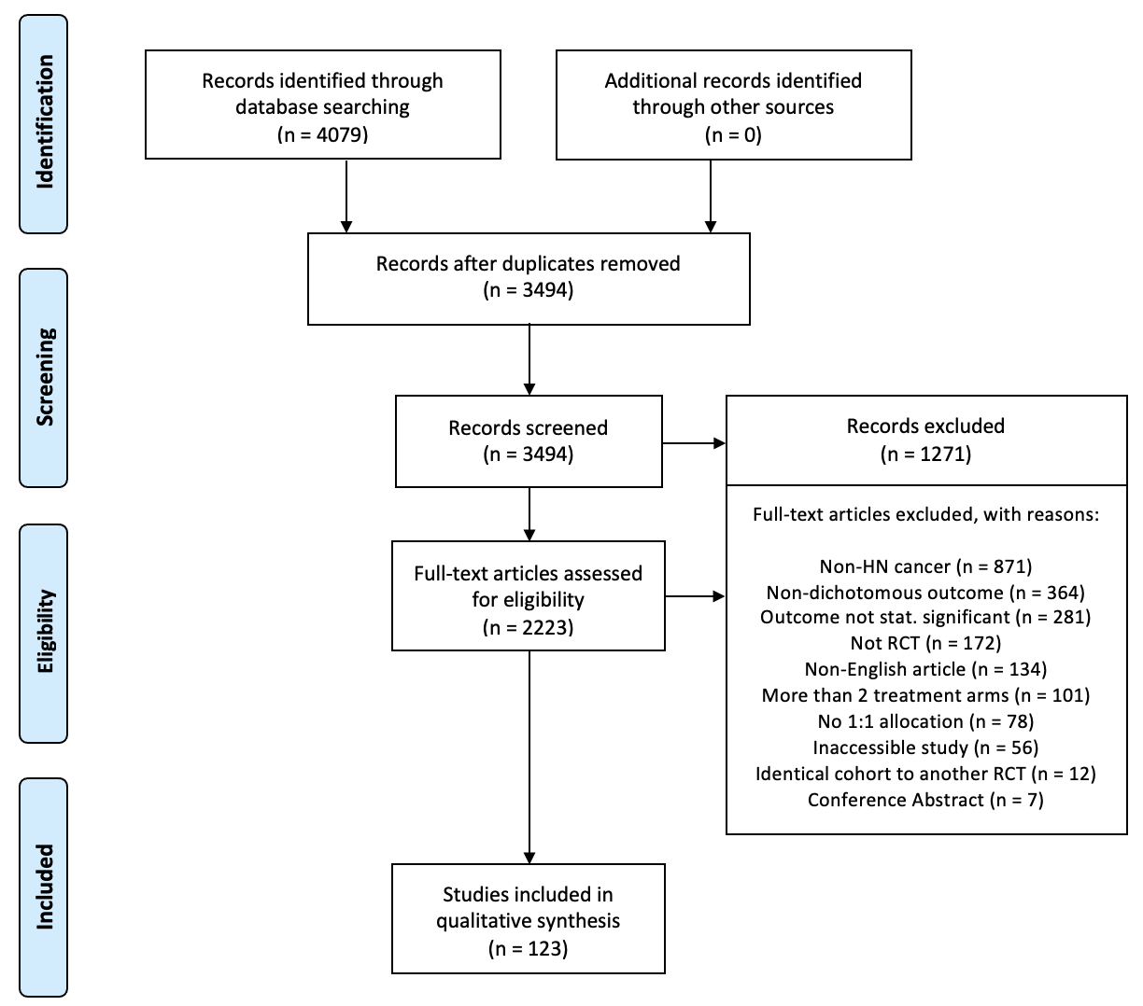**Supplemental Figure 1.**

Records excluded  
(n = 1271)

Studies included in qualitative synthesis  
(n = 123)

Additional records identified through other sources  
(n = 0)

Full-text articles assessed for eligibility  
(n = 2223)

Records screened  
(n = 3494)

Records after duplicates removed  
(n = 3494)

## Identification

## Eligibility

## Included

## Screening

Records identified through database searching  
(n = 4079)

Full-text articles excluded, with reasons:

Non-HN cancer (n = 871)

Non-dichotomous outcome (n = 364)

Outcome not stat. significant (n = 281)

Not RCT (n = 172)

Non-English article (n = 134)

More than 2 treatment arms (n = 101)

No 1:1 allocation (n = 78)

Inaccessible study (n = 56)

Identical cohort to another RCT (n = 12)

Conference Abstract (n = 7)