**Journal of Helminthology**

**Diversity of trematodes (Platyhelminthes) in Mexico with an assessment of the availability of genetic data for their conservation**

**Yanet Velázquez-Urrieta1**, **Verónica Mendoza-Portillo1, and Francisco Javier García-De León**\***1**

**Supplementary Figure S1**. Pearson’s correlation plot among number of Trematodes’ species or families (for records and genetic data) with biogeographic (provinces and regions) and main rivers (hydrography) in Mexico. The colors represent the intensity of positive (blue) or negative (red) correlations.

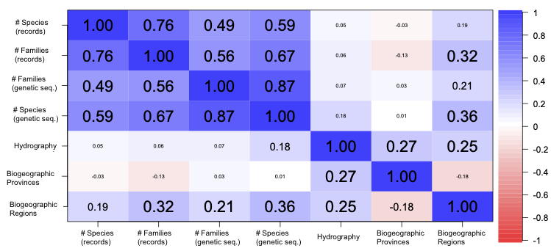

**Supplementary Figure S2**. Linear regression among number of species occurrence records with genetic sequences (a), with Biogeographic (provinces: b, regions: c), or main rivers (d) variables as predictors.

