

**Predicted conserved domains of rSs 22.6 protein**

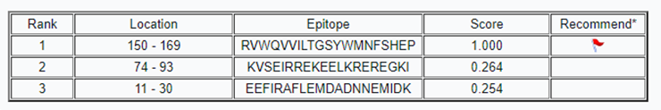

**Predicted epitopes of rSs 22.6 protein**