**Supplementary material**

**Table S1:**Post hoc pairwise comparisons between the eight groups of *Asellus aquaticus* defined by ecomorph, infestation status, and sex for movement activity, shelter-seeking, and response to light.Beta regression models were fitted for all three behaviors first. All estimates are shown on the response scale, i.e., in proportion of time moving, proportion of time spent at the unsheltered Petri dish half, or proportion of time spent at the illuminated Petri dish half, respectively. In the last four pairwise comparisons ‘alteration’ refers to a difference between uninfested and infested isopods. Statistically significant differences are bolded.

|  |  |  |  |  |  |  |  |  |  |
| --- | --- | --- | --- | --- | --- | --- | --- | --- | --- |
| **Pairwise comparisons** | **MOVEMENT ACTIVITY** | | | **SHELTER-SEEKING** | | | **RESPONSE TO LIGHT** | | |
| **Ecomorph – Infestation_status (Sex)** | **estimate [95% CI]** | ***z*-statistics** | ***p*-value** | **estimate [95% CI]** | ***z*-statistics** | ***p*-value** | **estimate [95% CI]** | ***z*-statistics** | ***p*-value** |
| surface uninfested (F) – cave uninfested (F) | **0.270 [0.164, 0.377]** | **7.288** | **<.0001** | 0.020 [-0.100, 0.139] | 0.469 | 0.681 | **0.138 [0.026, 0.249]** | **3.532** | **0.001** |
| surface uninfested (M) – cave uninfested (M) | **0.243 [0.144, 0.343]** | **6.997** | **<.0001** | -0.027 [-0.147, 0.092] | -0.648 | 0.636 | **0.128 [0.020, 0.235]** | **3.412** | **0.001** |
| surface infested (F) – cave infested (F) | **0.280 [0.192, 0.368]** | **9.105** | **<.0001** | -0.021 [-0.143, 0.100] | -0.498 | 0.682 | **0.124 [-0.003, 0.251]** | **2.796** | **0.008** |
| surface infested (M) – cave infested (M) | **0.260 [0.160, 0.360]** | **7.477** | **<.0001** | **-0.139 [-0.270, -0.008]** | **-3.034** | **0.008** | **0.159 [0.062, 0.255]** | **4.721** | **<.0001** |
| surface uninfested (F) – surface infested (F) | 0.008 [-0.110, 0.127] | 0.203 | 0.916 | **-0.082 [0.157, -0.008]** | **-3.161** | **0.008** | **-0.157 [-0.230, -0.084]** | **-6.150** | **<.0001** |
| surface uninfested (M) – surface infested (M) | -0.05 [-0.175, 0.074] | -1.164 | 0.419 | **-0.112 [-0.199, -0.025]** | **-3.697** | **0.002** | **-0.237 [-0.325, -0.150]** | **-7.758** | **<.0001** |
| cave uninfested (F) – cave infested (F) | 0.018 [-0.053, 0.088] | 0.724 | 0.625 | **-0.123 [-0.257, 0.011]** | **-2.625** | **0.023** | **-0.171 [-0.319, -0.022]** | **-3.288** | **0.001** |
| cave uninfested (M) – cave infested (M) | -0.034 [-0.100, 0.032] | -1.470 | 0.283 | **-0.224 [-0.360, -0.089]** | **-4.743** | **<.0001** | **-0.206 [-0.314, -0.098]** | **-5.449** | **<.0001** |
| surface uninfested (F) – surface uninfested (M) | 0.026 [-0.102, 0.155] | 0.587 | 0.669 | -0.005 [-0.091, 0.081] | -0.172 | 0.864 | 0.019 [-0.070, 0.109] | 0.610 | 0.636 |
| cave uninfested (F) – cave uninfested (M) | -0.001 [-0.069, 0.067] | -0.042 | 0.966 | -0.052 [-0.178, 0.074] | -1.178 | 0.382 | 0.009 [-0.114, 0.133] | 0.214 | 0.831 |
| surface infested (F) – surface infested (M) | -0.033 [-0.146, 0.081] | -0.819 | 0.620 | -0.035 [-0.111, 0.041] | -1.331 | 0.326 | **-0.061 [-0.128, 0.007]** | **-2.589** | **0.013** |
| cave infested (F) – cave infested (M) | -0.053 [-0.121, 0.016] | -2.200 | 0.067 | **-0.153 [-0.296, -0.010]** | **-3.064** | **0.008** | -0.026 [-0.162, 0.110] | -0.549 | 0.636 |
| surface alteration (F) – cave alteration (F) |  |  |  | 0.041 [-0.117, 0.199] | 0.762 | 0.607 | 0.014 [-0.157, 0.184] | 0.234 | 0.831 |
| surface alteration (M) – cave alteration (M) |  |  |  | 0.112 [-0.054, 0.278] | 1.995 | 0.105 | -0.031 [-0.176, 0.114] | -0.636 | 0.667 |
| surface alteration (F) – surface alteration (M) |  |  |  | 0.030 [-0.089, 0.149] | 0.747 | 0.607 | 0.080 [-0.037, 0.197] | 2.021 | 0.069 |
| cave alteration (F) – cave alteration (M) |  |  |  | 0.101 [-0.095, 0.298] | 1.522 | 0.256 | 0.035 [-0.154, 0.225] | 0.550 | 0.666 |



**Table S2:**Spearman rank correlation between traits altered by parasite infestation in surface and cave ecomorphs of *Asellus aquaticus*.Upper and lower diagonals show values for uninfested and infested individuals, respectively. Statistically significant correlations (*p*-value < 0.05) are bolded. F – female, M – male, *ρ* – Spearman rank correlation coefficient, *p* – *p*-value.

|  |  |  |  |  |
| --- | --- | --- | --- | --- |
| **Ecomorph** | **Trait** | shelter-seeking | response to light |  |
| surface | shelter-seeking | / | F: *ρ* =-0.37, *p* = 0.300 |  |
|  |  | **M: *ρ* =0.61, *p* = 0.008** |  |
|  | response to light | F: *ρ* =0.20, *p* = 0.601 | / |  |
|  |  | M: *ρ* =0.05, *p* = 0.857 |  |
|  |  |  |  |  |
|  |  |  |  |
|  |  |  |  |
|  |  |  |  |  |
| cave | shelter-seeking | / | F: *ρ* =-0.03, *p* = 0.857 |  |
|  |  | M: *ρ* = 0.14, *p* = 0.805 |
|  | response to light | F: *ρ* =0.11, *p* = 0.805 | / |  |
|  |  | M: *ρ* = *-*0.08, *p* = 0.805 |

**Table S3:** Intraclass Correlation Coefficient (ICC) analysis for consistency (repeatability at the individual level) across eight groups of *Asellus aquaticus* defined by ecomorph, infestation status, and sex. Statistically significant differences are bolded.

|  |  |  |  |  |  |  |
| --- | --- | --- | --- | --- | --- | --- |
|  | **MOVEMENT ACTIVITY** | | **SHELTER-SEEKING** | | **RESPONSE TO LIGHT** | |
|  | **ICC** | **p-value** | **ICC** | **p-value** | **ICC** | **p-value** |
| surface uninfested (F) | 0.30 | 0.160 | 0.33 | 0.414 | -0.63 | 0.999 |
| surface uninfested (M) | 0.23 | 0.189 | 0.09 | 0.888 | 0.39 | 0.068 |
| surface infested (F) | 0.22 | 0.160 | -0.07 | 0.893 | 0.28 | 0.068 |
| surface infested (M) | 0.04 | 0.407 | 0.20 | 0.570 | -0.22 | 0.999 |
| cave uninfested (F) | 0.18 | 0.195 | -0.25 | 0.918 | 0.35 | 0.068 |
| cave uninfested (M) | 0.04 | 0.407 | -0.05 | 0.893 | 0.40 | 0.063 |
| cave infested (F) | **0.61** | **0.001** | -0.23 | 0.918 | 0.29 | 0.091 |
| cave infested (M) | 0.29 | 0.088 | -0.04 | 0.892 | 0.06 | 0.443 |

**Figure S1:** Movement activity (expressed as total path) in the eight groups of Asellus aquaticus defined by ecomorph (surface, cave), infestation status (infested, uninfested), and sex (females, males). Infested and uninfested isopods are represented with grey and white boxplots, respectively. The y-axis is shown on the log scale but with original labels.

**Figure S2:** Movement activity (expressed as average speed) in the eight groups of Asellus aquaticus defined by ecomorph (surface, cave), infestation status (infested, uninfested), and sex (females, males). Infested and uninfested isopods are represented with grey and white boxplots, respectively.

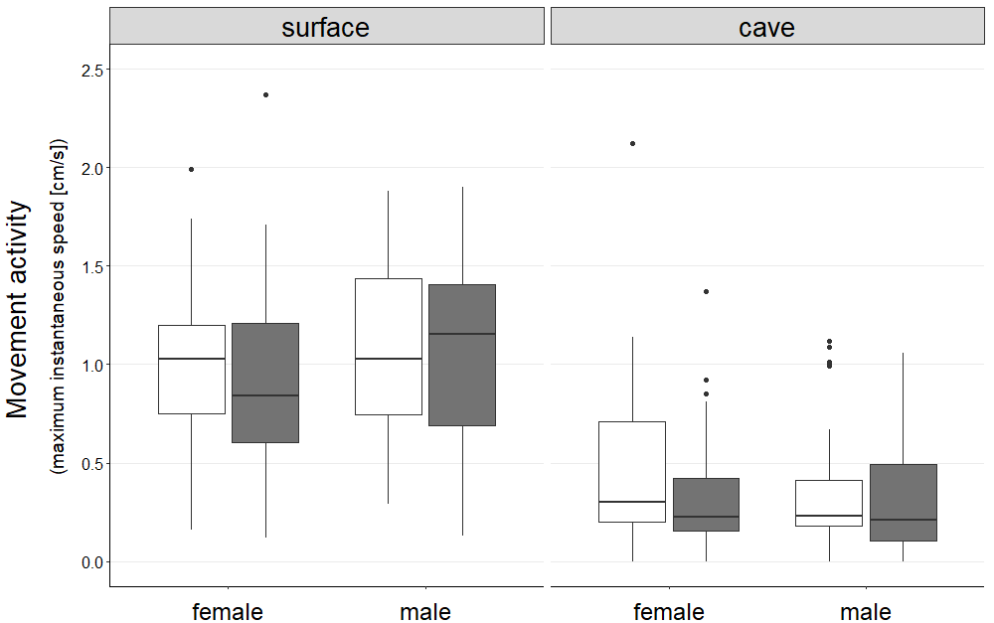

**Figure S3:** Movement activity (expressed as maximum instantaneous speed) in the eight groups of Asellus aquaticus defined by ecomorph (surface, cave), infestation status (infested, uninfested), and sex (females, males). Infested and uninfested isopods are represented with grey and white boxplots, respectively.

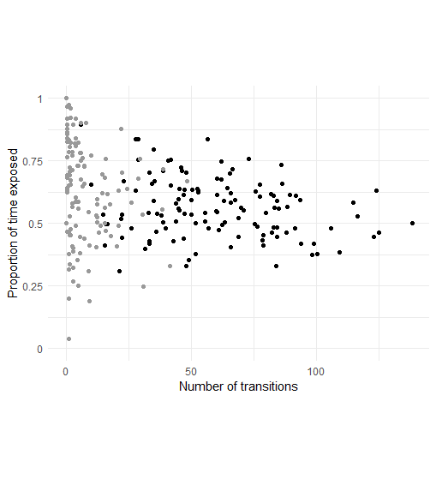

**Figure S4:** Correlation between the proportion of time spent at the exposed Petri dish half and the number of transitions between the Petri dish halves (a proxy for movement activity) in shelter-seeking behavior. Surface and cave isopods are represented with black and grey points, respectively.

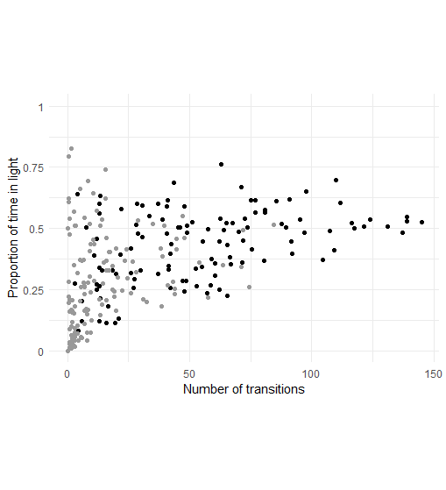

**Figure S5:** Correlation between the proportion of time spent at the illuminated Petri dish half and the number of transitions between the Petri dish halves (a proxy for movement activity) in response to light. Surface and cave isopods are represented with black and grey points, respectively.