Supplementary material
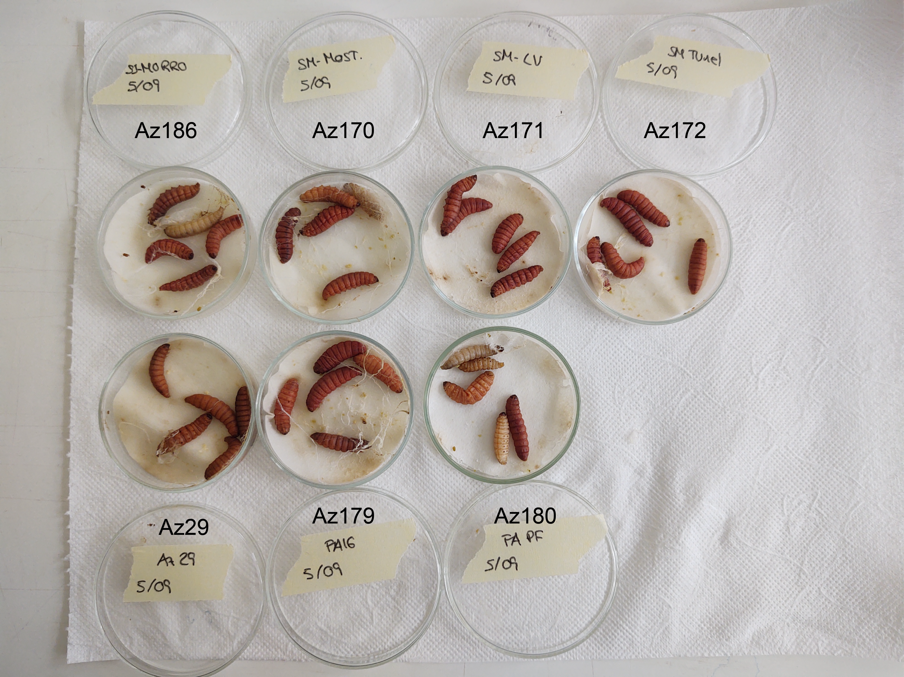
Fig. S1 Infection in G. mellonella of the EPN strains isolated from the Azorean Islands in which the reddish colour can be observed after 3 days of infection. Previous strain names were written on the labels sided by the final strain code.

