Rationale:
Rossanigo & Gruner (1996) presented a figure (their Fig. 1) suggesting apparent interactions between temperature and moisture on the length of L3 larvae. Here, the data (provided in their Table 2) was reanalysed to specifically test for an interaction between temperature and moisture, which they had not formally done in their paper.
Methods:
Rossangio & Gruner (1996) had fitted linear regression lines in their original plots but closer inspection of the data shows that for both Trichostrongylus circumcincta and Ostertagia leptospicularis the change in length as moisture (FMC) increased was better described by a sigmoidal relationship at most temperatures. Therefore, for these two species, we used the Fit Curve procedure in Genstat. v22 (VSNi). This first fits a common sigmoidal curve using four parameters A + C/(1 + EXP(-B*(X - M))), where A and C are the upper and lower asymptotes, respectively, B is the slope and M the turning point on the x-axis. Then the procedure interprets if fitting this common curve to each of the three different temperature regimes (18, 23 & 28ºC) under which the experiment was conducted show significant differences in the turning point (M), which is essentially the same as the comparison of intercepts in linear regression. The next step interprets if the three sigmoidal curves have significantly different slopes – the interaction: i.e., the rate of change in length as moisture (FMC) increases differs between the three experimental temperatures. Finally, the procedure asks if all the parameters should be separate by considering different lower and upper asymptotes for each of the three curves. In some cases, a linear regression fits better and is more parsimonious than a sigmoidal curve. This was the case for T. circumcincta at 28ºC (top left-hand panel in Figure S1, below). For T. colubriformis and O. ostertagi all relationships are linear, and significance of interactions are tested in a standard linear regression framework.
Results: In each of the four nematode species (T. circumcincta, T. colubriformis, O. leptospicularis, O. ostertagi), there was a significant interaction between faecal moisture content (FMC) and temperature at which the experiment was conducted on the length of L3 larvae (Figure S1) . T. circumcincta – slopes: F _{2,22} = 3.83, P = 0.038, asymptotes F _{4,22} = 1.44, P = 0.255; O. leptospicularis – slopes: F _{2,21} = 30.83, P<.001, asymptotes F _{4,21} = 3.52, P = 0.024). T. colubriformis – slopes: F _{2,21} = 6.82, P = 0.005; O. ostertagi – slopes: F _{2,21} = 3.70, P = 0.042). However, the impacts of changing temperature and FMC on L3 larvae lengths were not consistent across species. For both T. circumcincta and O. leptospicularis L3 larvae lengths were shortest at the lowest temperature (18°C) at low FMC and longest at higher FMC, than either at 23°C or 28°C. Whereas, for T. colubriformis the increase in L3 larvae length as FMC increased was fastest at the lowest temperature (18°C), the increase in L3 larvae length at this temperature in O. ostertagi was slowest. These results suggest that the impact of climate change is likely to be very variable with different species responses.

References:
Rossanigo, C.E. & Gruner, L. (1996) The length of strongylid nematode infective larvae as a reflection of developmental conditions in faeces and consequences on their viability. Parasitology Research 82, 304–311.

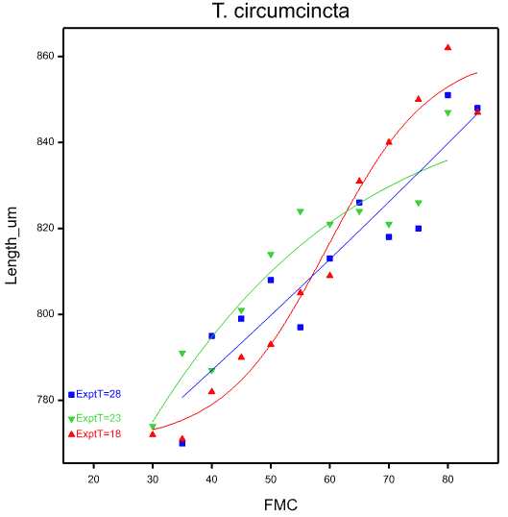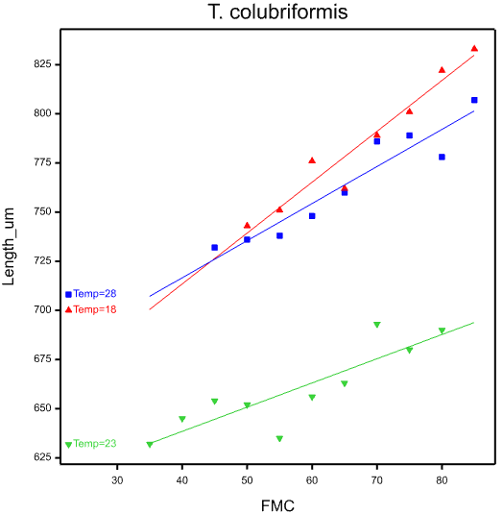
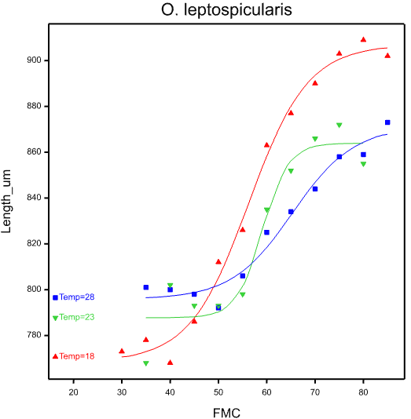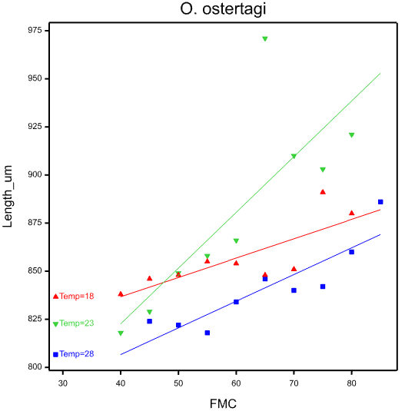
Figure. S1. The effect of faecal moisture content (FMC) on the length of L3 larvae at three different temperatures (18 °C, 23 °C and 28 °C) in four nematode species (data from Rossanigo & Gruner 1996) . The best fit models for T. circumcincta and O. leptospicularis were logistic regression curves with differing slopes and asymptotes (see left-hand pair of panels above). For T. colubriformis and O. ostertagi the best model is one fitting simple linear regressions which have significantly different slopes (see right-hand pair of panels above

