**Developing Digital Image Processing (DIP) methods to quantify internal and interfacial convection in the Hele-Shaw cell, with applications to the laboratory ice-ocean boundary layer**

S. Moos1, M. Vichi2,3, F. Fripiat4, J.-L. Tison4, A. De Wit5 and T. Rampai1,3

*1 Department of Chemical Engineering, University of Cape Town, Rondebosch, Cape Town, 7712*

*2 Department of Oceanography, University of Cape Town, Rondebosch, Cape Town, 7712*

*3Marine and Antarctic Research centre for Innovation and Sustainability (MARIS), University of Cape Town, Rondebosch, Cape Town, 7712*

*4 Université libre de Bruxelles (ULB), Laboratoire de glaciologie, 1050 Bruxelles, Belgium*

*5 Université libre de Bruxelles (ULB), Nonlinear Physical Chemistry Unit, CP231, 1050 Bruxelles, Belgium*

This document provides an outline of the supporting DIP figures, and a description of the data collected and processed during the Schlieren optical experiments performed in the Laboratoire de Glaciologie (GLACIOL) at the Université Libre de Bruxelles (ULB).

**Contents**

1. Supplementary Figures 2

1.1. Supporting DIP images 2

1.2. Supporting graphs 4

2. Image files: 6

3. Video files: 7

4. Publications 7

5. Supporting DIP scripts 7

# Supplementary Figures

## Supporting DIP images

The following figures accompany the manuscript to outline the decision-making process of DIP steps. The images outline the isolation of the ice interface (Fig. S1 and section 3.2.1 of the manuscript), the boundary extraction method (Fig. S2 below and section 3.2.1 of the manuscript), and the effect of increasing the Sobel operators kernel size (Fig. S3 below and section 3.2.1 of the manuscript).

|  |  |  |  |  |
| --- | --- | --- | --- | --- |
| (a) Pre-processed image | (b) Smoothing | (c) $σ$ = 30 | (d) $σ$ = 60 | (e) = 120 |
|  |  |  |  |  |

**Fig. S1** (a) Pre-processed image, (b) image showing the result of applying a smoothing filter to blend the expulsions into the background, (c), (d) and (e) Images showing the application of a binary threshold at sigma values of 30, 60 and 120 respectively for isolation of the ice interface. The orange boxes show the interference of the background if the sigma value is too low, and the red boxes show an over-estimation in the ice thickness if the sigma value is too high.

|  |  |  |
| --- | --- | --- |
|  |  |  |

**Fig. S2** Comparison of (a) binary Schlieren image; (b) contouring; (c) length extraction algorithm with the different colours indicating individual extracted lengths. The orange boxes highlight the removal on the noisy interferences in the contour image, while the blue boxes show the neglection of the finger expulsions after the length extraction algorithm. The green boxes and blue arrows show the breakages in the streamers described in the text.

|  |  |  |
| --- | --- | --- |
| (a) | (b) | (c) |
|  |  |  |

**Fig. S3** Images segmented using the Sobel operator using a kernel size of (a) three, (b) five and (c) seven respectively. The orange boxes show the discontinuities in the fingers and the red arrows indicate the discontinuity at the tip of the expulsions. Both types of discontinuity are further seen to decrease with an increase in the kernel size

## Supporting graphs

The following figures accompany the manuscript to outline the justification of using 20 mm as a representative length for fingers (see Fig. S4 below and section 3.3.2 of manuscript). Figure S5 outlines the temporal change in average length of fingers and streamers (See section 3.3.2.2 of manuscript). Figure S6 outlines the average mass flux ratio of fingers and streamers prior to binning (See section 3.3.2.3 of manuscript)

|  |  |  |
| --- | --- | --- |
| (a) | (b) | (c) |
|  |  |  |
| (d) | (e) | (f) |
|  |  |  |
|  |  |  |

**Fig. S4** (a) – (c) Probability density histograms for experiments one, two and three and (d) – (f) cumulative probability distribution for the lengths of the expulsions (fingers and streamers) in experiments one, two and three during the 15-hour experiment.

(a)

(c)

(d)

(b)

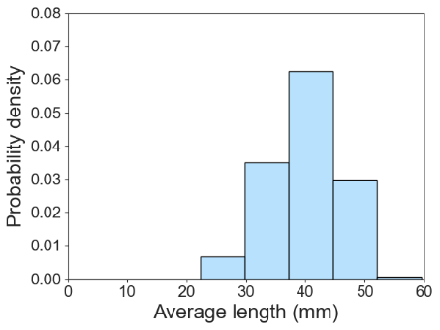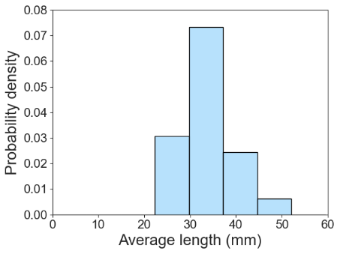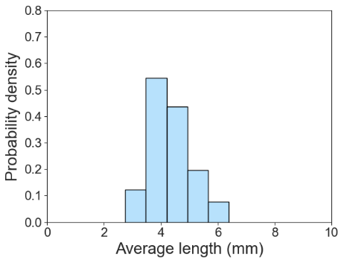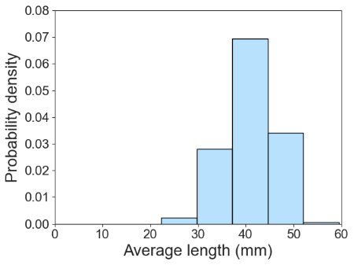

Fingers: 0 – 15 hours

Streamers: 0 – 15 hours

Streamers: 0 – 5 hours

Streamers: 5 – 15 hours

**Fig. S5** Probability density histogram of (a) the average finger lengths, compared with (b) the average streamer lengths over the 15-hour period. To analyse the temporal evolution of the average streamer lengths, the PDF was plotted (c) before five hours and (d) after five hours into the experiment.

**Fig. S6** A scatter plot of the average mass flux ratio as a function of ice thickness in eq. (5) compared to the manually calculated mass flux ratio based on the descent speed eq. (2) using the DIP streamer tracking algorithm (blue triangle) and Middleton and others (2022) (grey square) as a function of ice thickness

# Image files:

The raw images and processed images of the Schlieren experiment 3 are included. The description of each folder is outlined below:

|  |  |
| --- | --- |
| Folder Name | Description |
| Raw Images Exp 3.zip | Unprocessed images obtained from Schlieren experiment 3 |
| ProcessedImages.zip. | Pre-processed, segmented and final processed images of experiment 3 |

# Video files:

The raw and processed videos of the Schlieren experiment 3 are included. The description of each video is outlined below:

|  |  |
| --- | --- |
| Video Name | Description |
| Video1 | Unprocessed video of experiment 3 with timestamp and scale border |
| Video2 | Final processed video (after application of DIP steps) of experiment 3 with timestamp and scale border |
| Video3 | Segmented ice interface of experiment 3 with scale border |

# Publications

The publication associated with the data presented in the manuscript:

Middleton, C. A., Gopalakrishnan, S. S., Berenstein, I., Knaepen, B., Tison, J. L., and De Wit, A. (2022). Relative role of short interfacial fingers and long internally driven streamers in convective flows below growing sea ice. *Physical Review Fluids*, *7*(4), 1–18. <https://doi.org/10.1103/PhysRevFluids.7.043503>

# Supporting DIP scripts

The supporting script may be accessed via github: <https://github.com/safiyyah97/Developing-Digital-Image-Processing-methods-for-Schlieren-Images>