**Supplemental material for “Retreat and Frontal Ablation Rates for Alaska’s Lake-Terminating Glaciers: Investigating Potential Physical Controls with Implications for Future Stability” by Noah Caldwell, William Armstrong, Robert McNabb, Ellyn Enderlin, Daniel McGrath, Brianna Rick, Jacob Hanson, and L. Baker Perry**

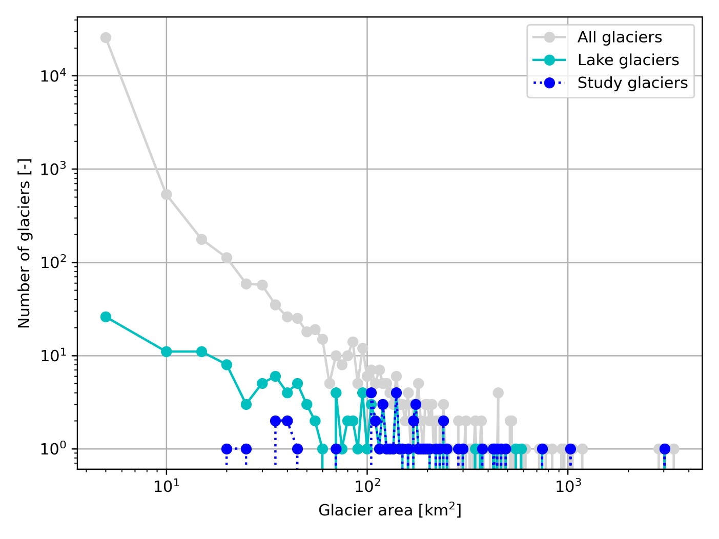

**Figure S1.** Distribution of glacier area for the study glaciers (dark blue dashed line) compared with all Region 01 lake-terminating glaciers as defined by the RGI Version 6 (cyan solid line) and all Region 01 glaciers regardless of terminus type (gray).

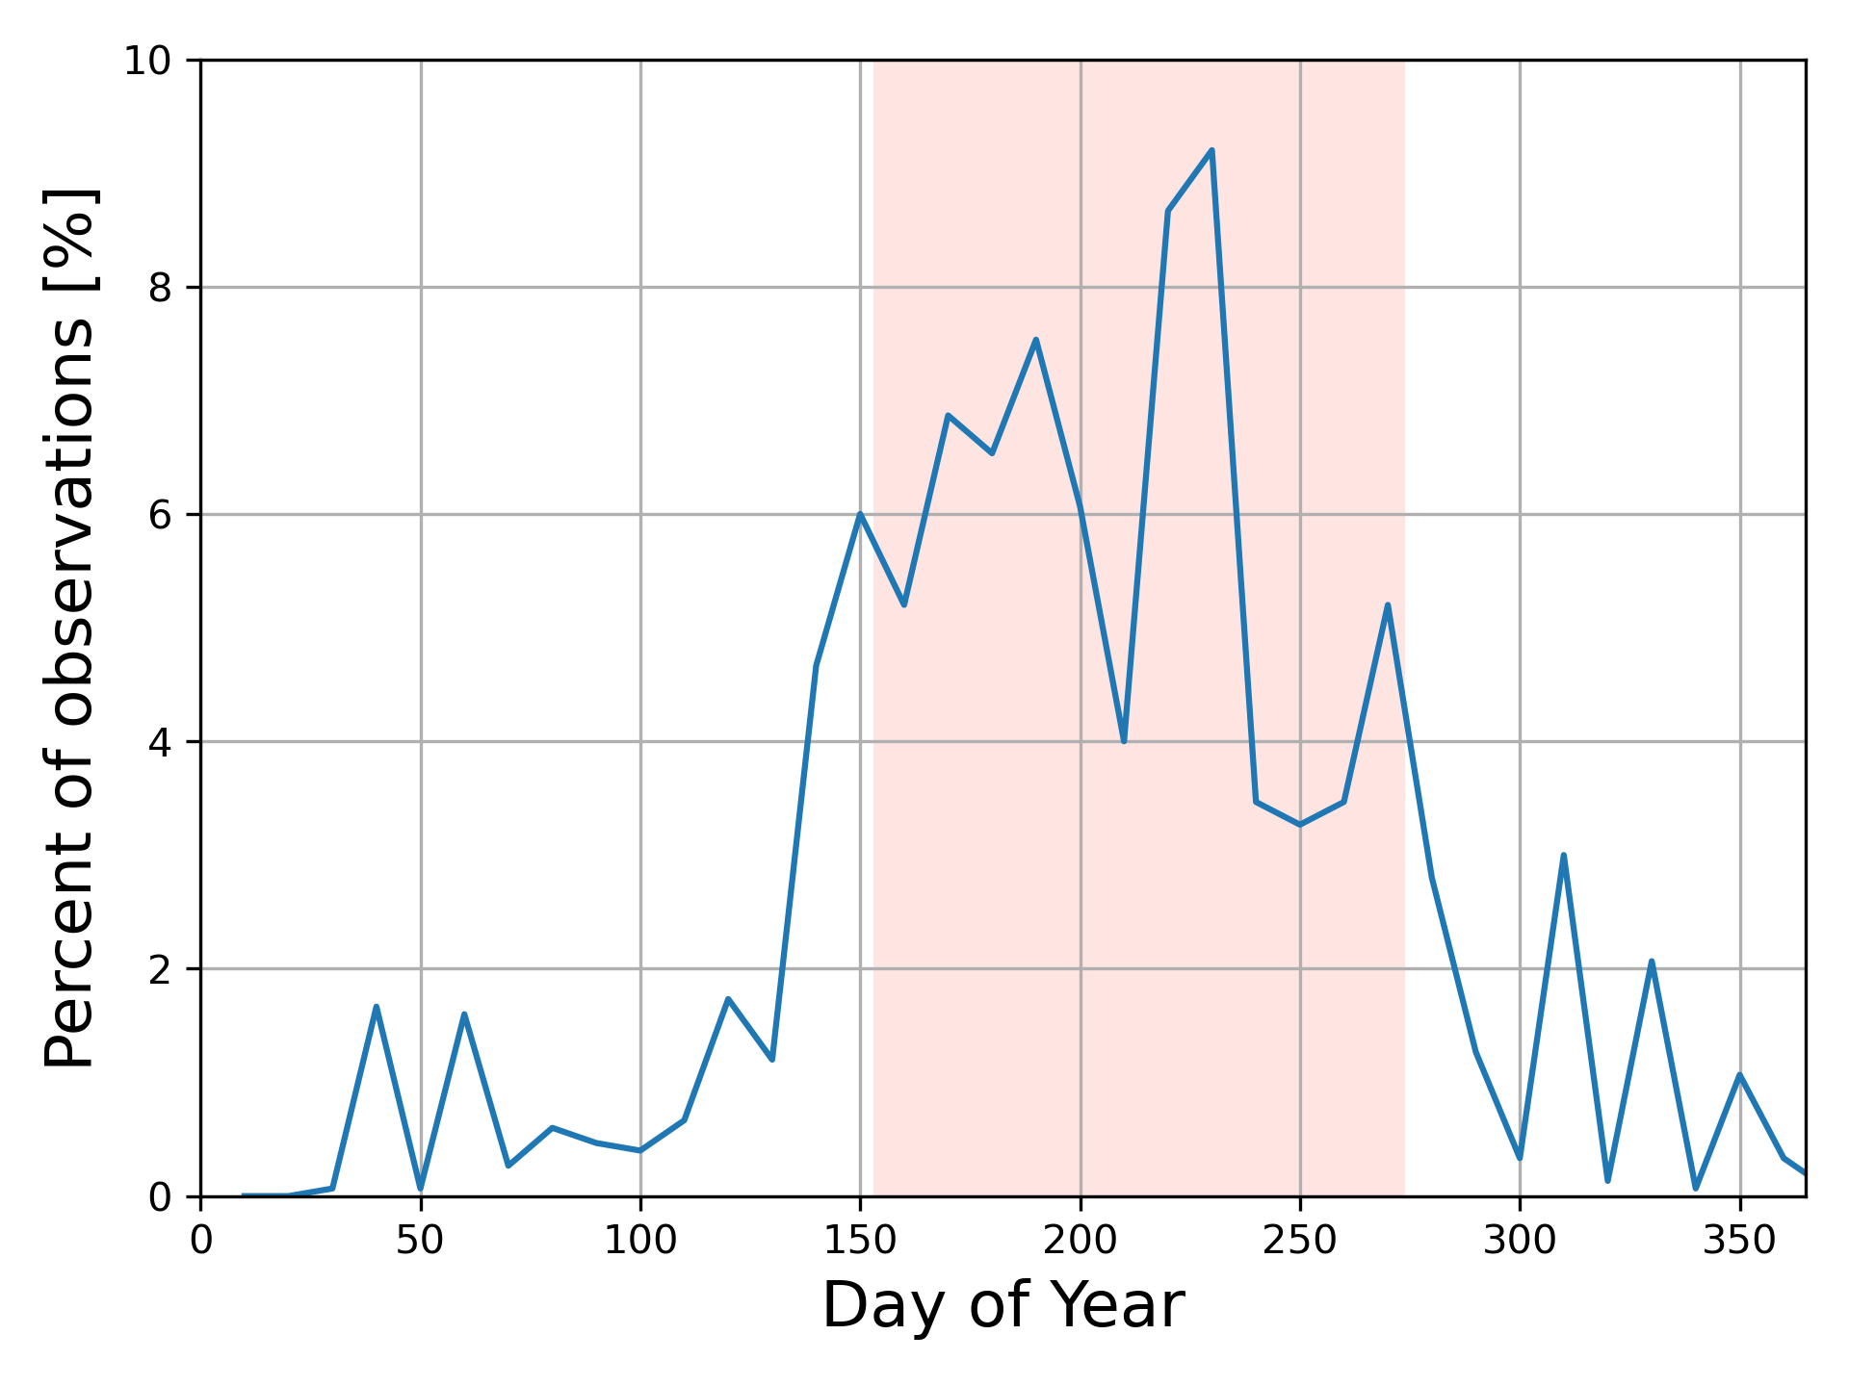

**Figure S2.** Histogram of the timing of images used for terminus delineation. The red fill highlights the period from May 1 - September 30.

**Figure S3.** Difference in estimated frontal ablation rates using the full study period (1984 – 2021) retreat rates (x-axis) compared to the primary result reported in the study which uses the more recent 2009 – 2018 retreat rates that better overlap with other input datasets. Marker colors indicate glaciers that retreated faster (red) or slower (blue) over 2009 – 2018 compared with 1984 – 2021. The dashed line shows 1:1, and solid black lines separate positive from negative frontal ablation values. Negative *F* values imply non-physical mass gain through frontal ablation (ice accretion), which we discuss in the text is more likely related to temporal mismatch between input datasets, particularly on surging glaciers, as well as overestimation of surface melt below the flux gate.

**Figure S4.** The difference in frontal ablation estimates using different assumptions for the mass balance below the flux gate. The x-axis shows the frontal ablation rate used in the main text, where m a-1 is applied over the glacier surface area below the flux gate (colors). The y-axis shows the difference in frontal ablation estimates if m a-1 is used instead, where negative values indicate lower frontal ablation rates using m a-1. On average, *F* estimates are 10% higher using m a-1.

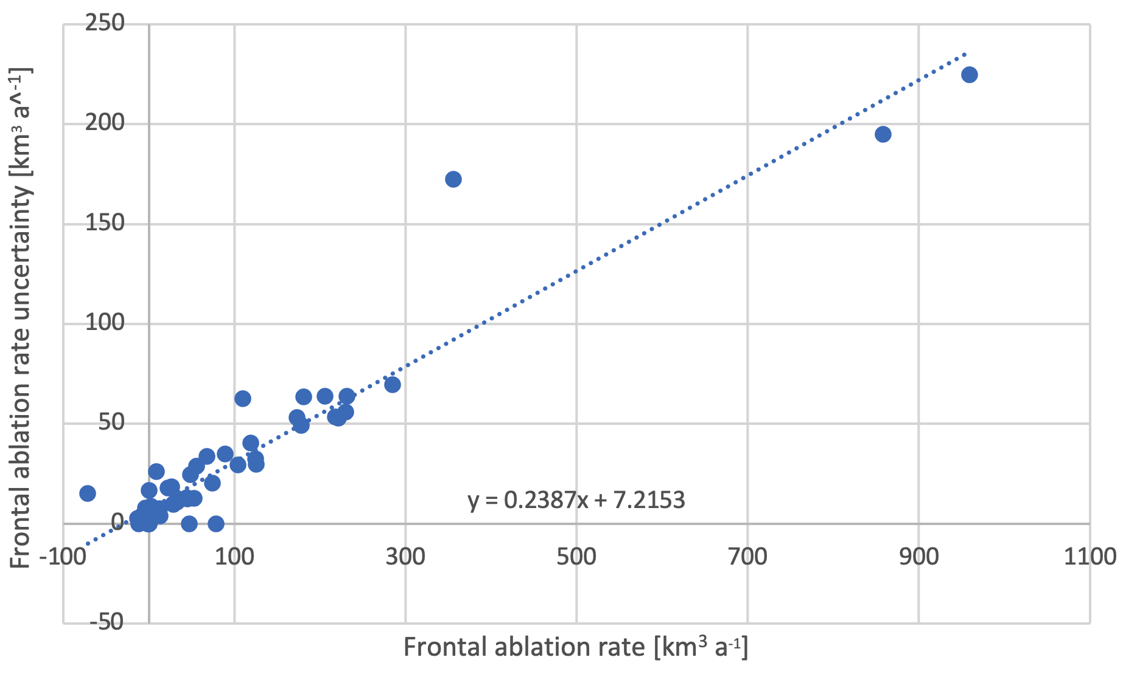

**Figure S5.** Uncertainty in frontal ablation as a function of frontal ablation magnitude.

**Figure S6.** Maps of (a) retreat rate over the full 1984 – 2021 study period as well as (b) frontal ablation estimated using the full study period retreat rate. This figure presents very similar data to Fig. 5 in the main text, but uses a different time period for estimating retreat and frontal ablation rates.

**Figure S7.** Summary of changes in retreat rates between the 1984 – 1999 (early), 1999 – 2009 (middle), and 2009 – 2018 (late) periods. Glaciers that retreated fastest in the early period and slowest in the late period are denoted as “consistently slowing” and drawn in dark blue. Glaciers that retreated slowest in the early period, fastest in the middle period, and slowest in the late period as labelled “accelerating/slowing” and drawn in light blue. The other two classes are similarly defined. Numbers indicate percent of study glaciers falling into that style of retreat rate change.

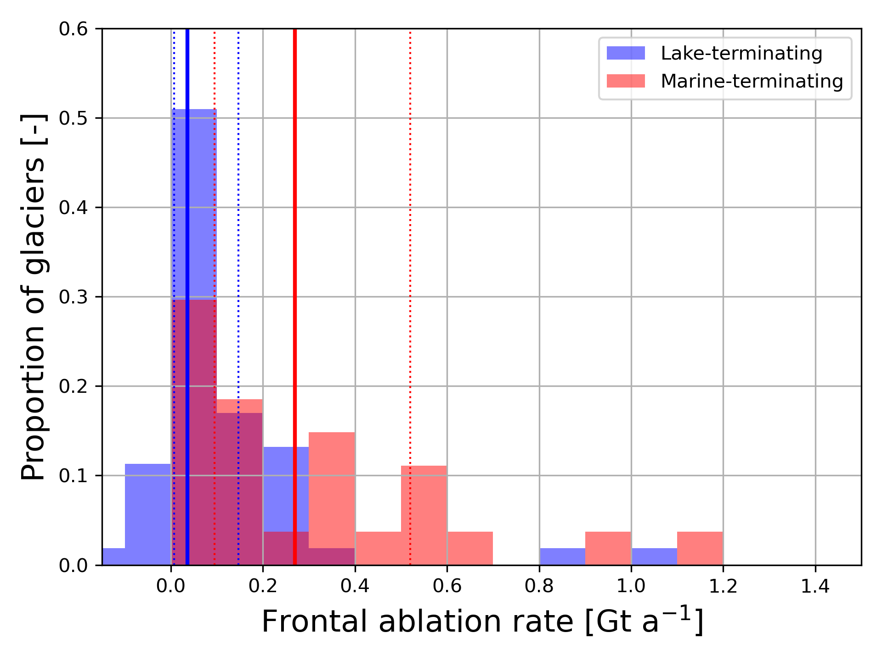

**Figure S8.** Distributions of lake-terminating (blue) and marine-terminating (red) frontal ablation rates. The vertical lines show the median (solid line) and interquartile range (dashed lines) for each class. Marine-terminating glaciers with outlying frontal ablation rates (Columbia Glacier, F = 3.7 Gt a-1; Hubbard Glacier, F = 3.6 Gt a-1) and the lake-terminating Bering Glacier (F = -0.56 Gt a-1; negative value discussed in text) are not shown for clarity.

**Table S1**. Definitions of variables used for calculating frontal ablation rates and flotation fraction as described in sections 2.3 and 2.6. “-” Indicates a value that varies between individual glaciers.

|  |  |  |  |  |  |  |  |
| --- | --- | --- | --- | --- | --- | --- | --- |
| Retreat rate by percentile [m/a] | | | | | | | |
| Percentile / Time period | 5% | 25% | 50% | 75% | 95% | IQR  25–5% | Span  5 – 95% |
| 1986 - 1999 | 208 | 75 | 30 | 10 | -11 | 66 | 218 |
| 1999 - 2009 | 218 | 88 | 44 | 21 | -7 | 67 | 225 |
| 2009 - 2018 | 314 | 126 | 67 | 36 | -3 | 90 | 317 |
| 1986 - 2018 | 152 | 79 | 59 | 34 | 9 | 45 | 143 |

**Table S2.** Summary statistics of rates of glacier length change for each ~decadal period. The rightmost two columns are indicators of the variability within the sample. Negative numbers indicate advance.