*Supplement of*

A Geophysical and Glaciological Survey of the Highest Tropical Mountain glaciers (Mt. Huascarán, Andes)

Stanislav KUTUZOV1,2, Lonnie G. THOMPSON1,2, John F. BOLZAN1, Ivan LAVRENTIEV3, Gleb CHERNYAKOV3, Forrest SCHOESSOW1

1*Byrd Polar and Climate Research Center, Ohio State University, Columbus OH, USA.*

2*School of Earth Sciences, The Ohio State University, Columbus, OH, USA.*

3*Institute of Geography RAS, Moscow, Russia.*

*Correspondence: Stanislav Kutuzov (*[*kutuzov.1@osu.edu*](mailto:kutuzov.1@osu.edu)*)*

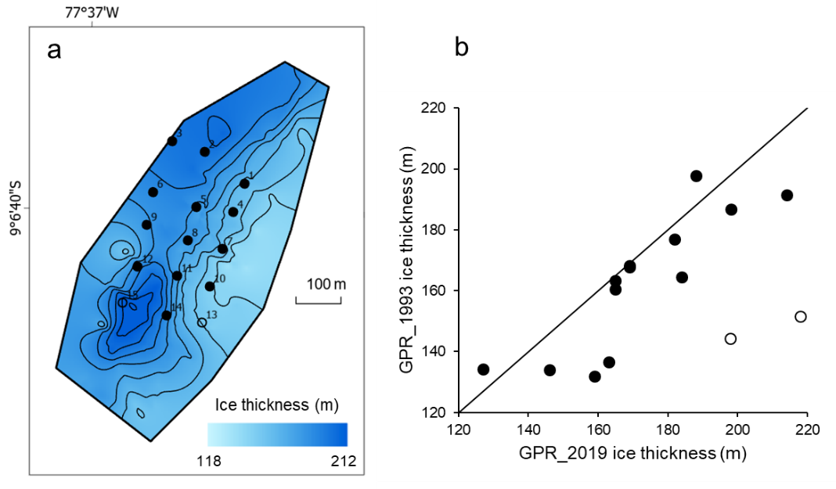

Figure S1. a) Ice thickness map based on 2019 GPR measurements. Point measurements locations in 1993 are shown in black circles; b) a comparison between 1993 and 2019 GPR ice thickness measurements at 15 locations measured in 1993. Black line indicates one-to-one (1:1) relationship. Empty circles represent two sites where ice thickness was likely underestimated in 1993 due either to positioning errors or misinterpretation of the sidewall reflections.

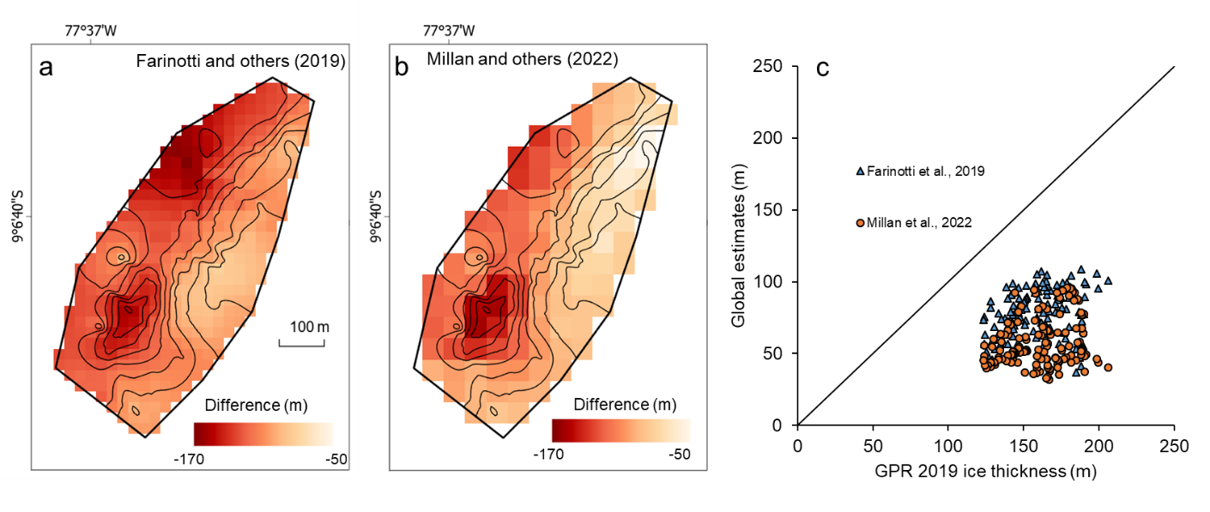

Figure S2. Differences between modeled ice thickness and 2019 GPR measurements. a) data from Farinotti and others (2019); b) data from Millan and others, 2022; c) a comparison between 2019 GPR ice thickness measurements and global estimates.