Supplementary materials for:
Experimental constraints on transient glacier slip with ice-bed separation
Nathan T. Stevens^{1,2,}*, Dougal D. Hansen^{1,}*, Lucas K. Zoet¹, Peter E. Sobol¹, Neal E. Lord¹
¹Department of Geoscience, University of Wisconsin—Madison, Madison, WI, USA
² Pacific Northwest Seismic Network, University of Washington, Seattle, WA, USA
*Corresponding author emails: ntsteven@uw.edu, ddhansen3@wisc.edu
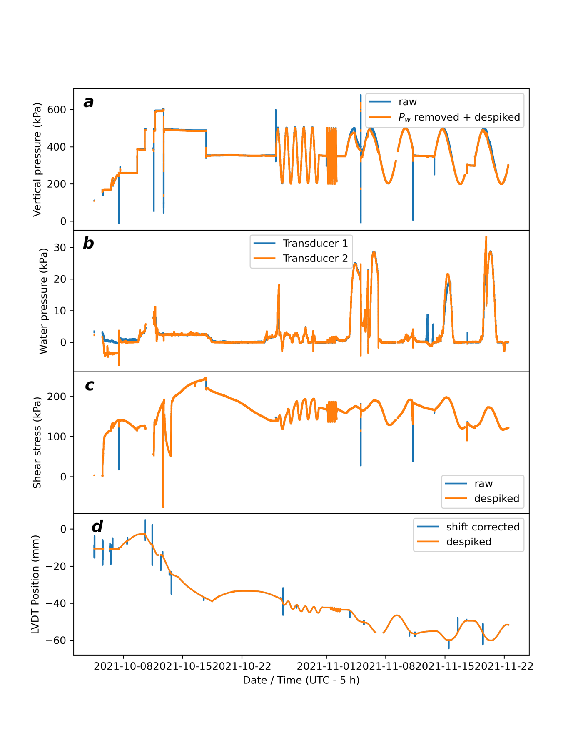
Fig. S1. Raw time series data for (a) vertical pressures, (b) water pressures for both pressure transducers (c) raw shear stress values (prior to mounting socket drag correction), and (d) LVDT position data (after stitching). Effective pressures are shown in (a) as the orange line (raw data minus average water pressure) after despiking. Despiked shear stresses and LVDT positions are also shown in (c) and (d), respectively (orange lines). Experiments T24, T06, and T96 are best identified in Fig. S1a as successive intervals with periodic pressure signals.

Time-lapse imaging conducted during Exp. T24 are composed of two sequences from camera #2 (Mov. S1 and Mov. S3) and one sequence from camera #4 (Mov. S2). This split between cameras was necessary due to a connection failure to camera #2 during the experiment. All movie files are hosted on YouTube as a playlist: https://youtube.com/playlist?list=PLhoXTpbFojM3Jtu6ZQeIwrGj3Px4wLHAh&si=GlPE6-1fW2AXrw-6

Movie S1. Time-lapse images captured by camera #2 (see Fig. 1b) between 2021-10-26 11:57:40 and 2021-10-28 11:33:12 (time zone: UTC – 5 hours). This captures the pre-Exp. T24 steady-state conditions through the 2nd minimum effective stress trough during Exp. T24. Nineteen frames were selected from this movie to extract contact areas given in Figs. 4 and 5. YouTube URL: https://youtu.be/bTlNULYZ5Bg
Movie S2. Time-lapse images captured by camera #4 (see Fig. 1c) between 2021-10-28 11:38:12 and 2021-10-30 08:08:07 (time zone: UTC – 5 hours). This captures experiment T24 during cycles 2—4. Twenty-one frames were selected from this movie to extract contact areas in Figs. 4 and 5. YouTube URL: https://youtu.be/FE2Q6l4V27U

Movie S3. Time-lapse images captured by camera #2 (see Fig. 1b) between 2021-10-30 12:57:53 and 2021-11-01 10:26:03 (time zone: UTC – 5 hours). This captures experiment T24 during cycles 4 and 5. Eleven frames were selected from this movie to extract contact areas given in Figs. 4 and 5. YouTube URL: https://youtu.be/wN0k7q9tZtE

