**Supplementary material**

**Glacier speed-up as a possible precursor to volcanic eruptions at Mount Veniaminof, Alaska**

Michael Dieter Martin1,2, Iestyn Barr1*, Benjamin Edwards2, Matteo Spagnolo3, Elias Symeonakis1, Joseph Mallalieu1,4, Kathryn Adamson1, Donal Mullan5, Maximillian Van Wyk de Vries6,7,8

1Department of Natural Sciences, Manchester Metropolitan University, Manchester, UK

2 Institute of Geo-Engineering, Clausthal University of Technology, Clausthal-Zellerfeld, Germany

3Department of Earth Sciences, Dickinson College, Carlisle, PA 17013, USA

4School of Geosciences, University of Aberdeen, Aberdeen, UK

5School of Geography, Earth and Environmental Sciences, [University of Birmingham](https://scholar.google.co.uk/citations?view_op=view_org&hl=en&org=2124538389813752374), Birmingham, UK

6School of Natural and Built Environment, Queen’s University Belfast, Belfast, Northern Ireland, UK

7School of Geography and the Environment, University of Oxford, Oxford, OX1 3QY, UK

8Department of Geography, University of Cambridge, Cambridge CB2 3EL, UK

9Department of Earth Sciences, University of Cambridge, Cambridge CB3 0EZ, UK

*Corresponding author: [i.barr@mmu.ac.uk](mailto:i.barr@mmu.ac.uk)

Figure S1. Velocity standard deviation (SD) as a percentage of the mean velocity for each pixel for Cone Glacier. The background is a Sentinel-2 true colour satellite image from 25 March 2017.

Figure S2. Time-series of monthly velocity and air temperature for 10 points along a profile line (approximating the centreline) extending from the terminus of Cone Glacier, over the icefall, and into the accumulation zone (see point locations in Fig. 1c). Greyed areas reflect eruptions at Mount Veniaminof in 2018 and 2021. R2 values are based on plots in Figure S3.

Figure S3. Correlation between velocity and air temperature for multiple points (labelled 1–10) on the surface of Cone Glacier (see point locations in Fig. 1c). The solid lines and white dots (and associated R2 values) show the relationships for the entire November 2017 to January 2022 period. The dashed lines and coloured dots (and associated R2 values) show the relationships for just for the period of presumed quiescence between the eruptions (i.e. April 2019 until December 2020).

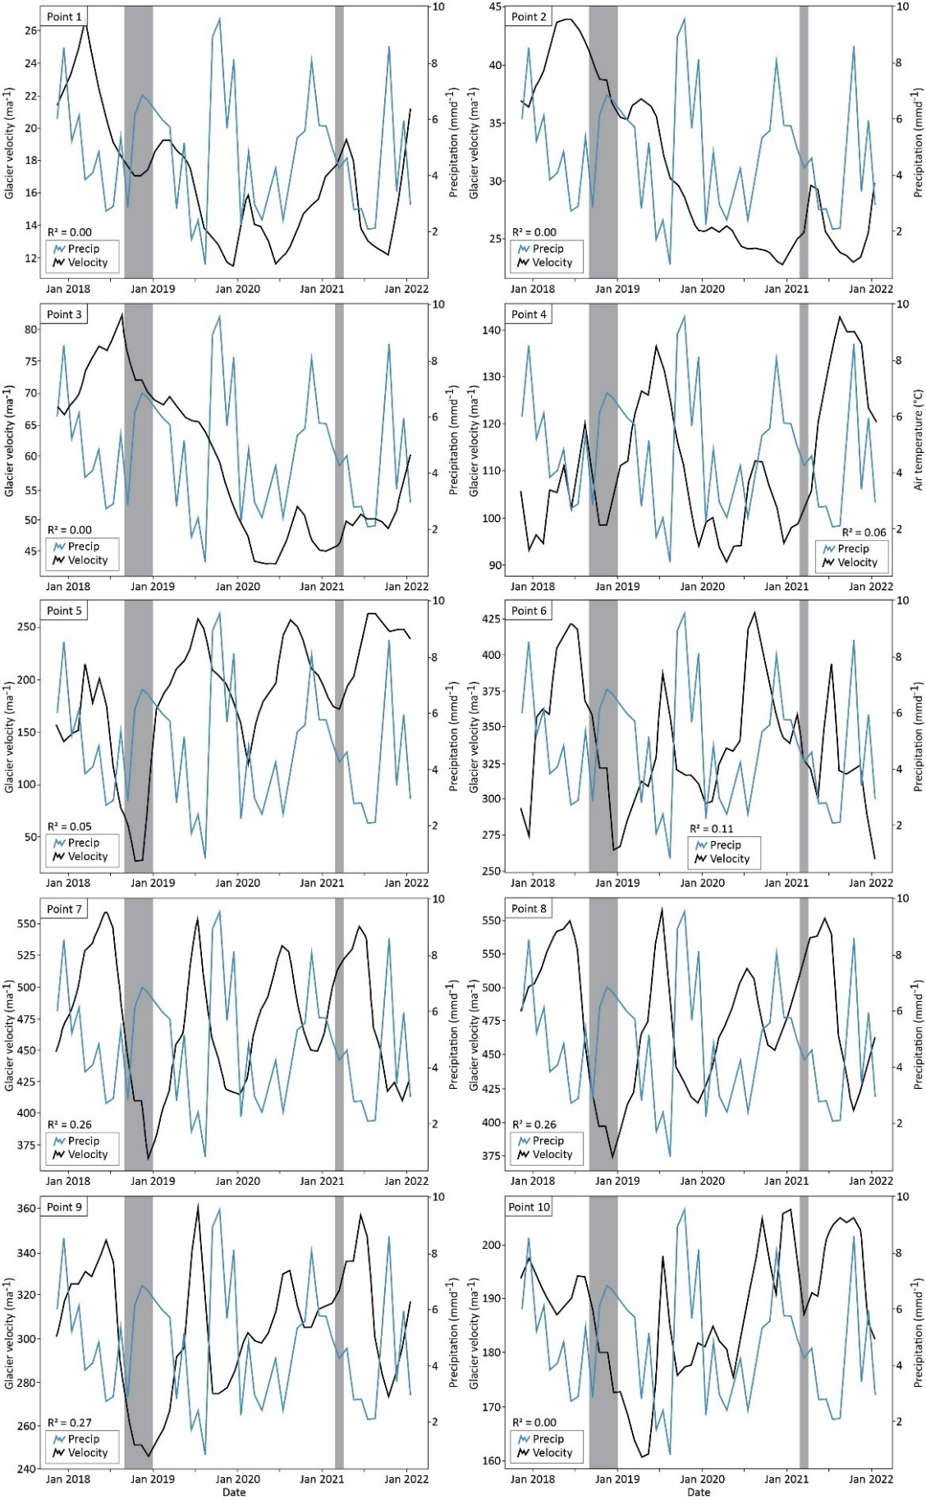

Figure S4. Time-series of monthly velocity and precipitation for 10 points along a profile line (approximating the centreline) extending from the terminus of Cone Glacier, over the icefall, and into the accumulation zone (see point locations in Fig. 1c). Greyed areas reflect eruptions at Mount Veniaminof in 2018 and 2021. R2 values are based on plots in Figure S5.

Figure S5. Correlation between velocity and precipitation for multiple points (labelled 1–10) on the surface of Cone Glacier (see point locations in Fig. 1c). The solid lines and white dots (and associated R2 values) show the relationships for the entire November 2017 to January 2022 period. The dashed lines and coloured dots (and associated R2 values) show the relationships just for the period of presumed quiescence between the eruptions (i.e. April 2019 until December 2020).