# **Supplemental Information**

**AMIGOS-3 multi-sensor stations and the climate, ice, and ocean conditions at Thwaites Eastern Ice Shelf during 2020-2022**

**T. A. Scambos**1**, T. White**2**, B. Wallin**3**, M. Truffer**4**, G. Collao-Barrios**5**, C. Kratt**6**, S. Tyler**6**, E. Pettit**7**, C. Wild**7**, S. Arora**8**, S. Edwards**8**, R. Fotherby**8**, C. Meha**8**, J. Soltys**8**, E. Tomlinson**8**, R. Weatherby**8**, S. Orr**8**, R. Ross**9**, A. Wåhlin**10**, T. Dotto**11

1Earth Science Observation Center, CIRES, University of Colorado Boulder, Boulder, CO 80309 USA

2Tim White Engineering, Boulder CO 8030X

3National Snow and Ice Data Center, CIRES, University of Colorado Boulder, Boulder, CO 80309 USA

4Geophysical Institute, University of Alaska Fairbanks, Fairbanks AK

5Institut des Geosciences de l’Environnement, Université Grenoble Alpes, Grenoble FRANCE

6Center for Transformative Environmental Monitoring Programs, Reno, NV 89557 USA

7College of Earth, Ocean and Atmospheric Sciences, Oregon State University, Corvallis, OR 97331 USA

8Space Grant, Engineering Department, University of Colorado Boulder, Boulder CO 80309 USA

9Polar66 Engineering, Sydney, AUS

10 Department of Marine Sciencees, University of Gothenbourg, 413 90 Göteborg SWE

11 School of Environmental Sciences, University of East Anglia, Norwich, UK

We provide here additional information and images associated with the AMIGOS-2 and AMIGOS-3 systems installed on the Nansen Ice Shelf in 2017 and Thwaites Eastern Ice Shelf in 2020, respectively.

**Table S1. Components of the AMIGOS-3 station**

1. **Triton board (4-layer PCB, 11-20 v DC power, tested to -40°C):**

**CPU chip Operating System Memory Board Components**

Atmel ARM9 Jazelle Linux 2.6 64 MB SDRAM 1x 10/100Base T Ethernet

PXA255 w/ WebServer 64 MB Flash 3 x RS232 serial port

@200MHz FTP, Telnet, crontab 1 to 32 GB CF card 4-chan. 8-bit ADC

Temperature sensor

External HW watchdog

1. **Electronics box and power box components:**

Ethernet switch Hirschman SPIDER II 8TX

Router DCB Inc. IP6600/12VDC

Data Transfer NAL Research A3LA-R

Power System Seely Flexcharge NC25A12

Solar Panels Solartech 4 x SPM065P-F 65 w

Batteries Sunlyte 6 x 12-5000X 100 Ah

1. **Surface, atmosphere, and position science sensors:**

Weather Vaisala WXT530

GPS TopCon B110 and PG-S1 antenna

Albedo Apogee Scientific SP-212 (pair)

Snow Height Campbell Scientific SR50A-L

Firn Temp. Campbell Scientific CR-1000X and Pt-1000 temperature sensors

Camera CCTV Camera World 1080p Mini IP PTZ camera

1. **Sub-ice shelf ocean science sensors and ice temperature profile:**

CTD Seabird SBE-037 MicroCAT 2000m

Current direction Nortek Aquadopp 6000-m

Temperature profile Silixa XT-DTS

**Figure S1:**

**Assembly and installation photos of the AMIGOS-3 system on Thwaites Eastern Ice Shelf**

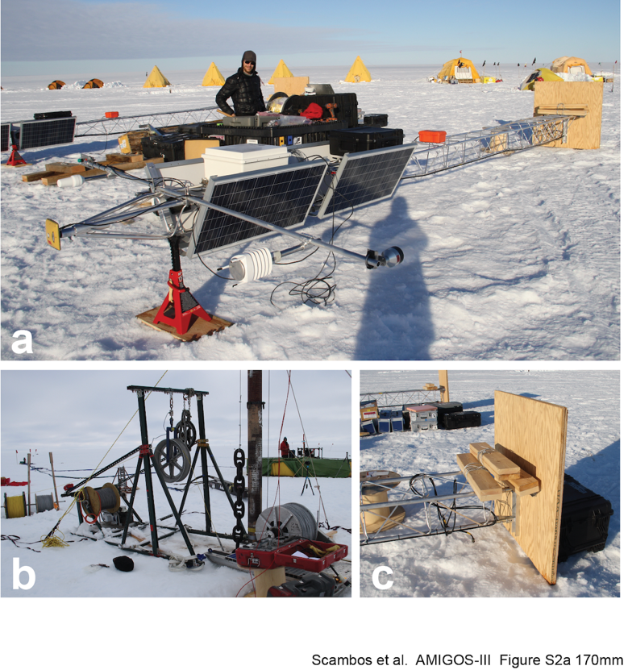

*Figure S1a. AMIGOS-3 assembly and installation of the ocean instrument cable on the Eastern Thwaites Ice Shelf in January 2020 (Cavity Camp site). a) Two 8-m towers under assembly; b) several winches were operated simultaneously as the ocean cable, with fiber-optical cable attached, was installed; c) base of the stations showing snow anchors (deadmen) and plywood platform for the battery box.*

*Figure S1b. AMIGOS-3 installation on the Eastern Thwaites Ice Shelf in January 2020 (Cavity Camp site). location 75.048°S, 105.584°W). (a) Tower as installed, with base set in 1.6m pit (refilled). (b) Upper section of the tower showing (left to right) snow height sensor, weather sensor, GPS antenna, camera, Iridium antenna, and albedometer, with main electronics box (white box) and distributed thermal sensing (DTS) controller (black box) set between solar panel pairs. (c) Lifting the tower into the snow pit. (d) Yale hitch rope harness holding steel cable with ocean instruments, DTS, and thermistor cable attached. (e) cable suspension block above borehole.*

## Figure S2 and text: Results from an AMIGOS-3 prototype installation

The prototype of the AMIGOS-3 systems, built in 2016, was installed on the Nansen Ice Shelf at 74.783°S, 163.525°E on February 12th 2017. Coincidentally this is very near Robert Scott’s Northern Party traverse campsites in early February, 1912, almost exactly 105 years earlier. Hot-water drilling penetrated the ice shelf at an estimated thickness of 398 m and the ocean string was installed successfully. Eleven days after installation (Feb 23rd), the main CPU failed during mild weather conditions, clear skies but dry air and high battery voltage. Electronic stations are very difficult to ground in Antarctica owing to dry snow and windy low-humidity conditions. During the nine-day record, temperatures ranged between -0.4°C and -18.9˚C, and wind speeds reached a maximum of 21 m s-1. Nearly all winds with speeds greater than 5 m s-1 came from the southwest, in a narrow range between bearing 245˚ and 250˚. Ocean conditions at two sub-ice-shelf depths, ~410(350) m and ~718(658) m below the surface (below sea level), indicated that the entire cavity was filled with water near the surface freezing point, -1.82 °C (350 m) to -1.76 °C (658 m), and therefore likely to be the ocean water type ‘high-salinity shelf water’ (as expected). However, the salinity measurements from the CTDs were invalid, likely due to the formation of fresh water ice crystals in the sensor intake as the device was lowered in the borehole. These did not clear in the period of data acquisition.

Despite the short observation time, the DTS recorded data useful for tracking the initial borehole freeze-up, and the DTS was restarted in November 2017 and collected further data independent of the rest of the station. This allowed an estimate of the minimum temperature of the center of the ice shelf (-23°C) at a depth of 205 m below the ice-shelf surface, and provided calibrated ocean profile data, and some estimate of basal melt rates (0 to 1 m/yr; Lee and others, 2019).

*Figure S2. AMIGOS-3 prototype as installed on the Nansen Ice Shelf, 12 February 2017. From the top of the tower, RMYoung wind sensor, Mobotix camera, sensor cross-arm with instrument (left to right) albedometer, TopCon GPS antenna, Vaisala weather station, Iridium antenna; 100* *w solar panels (2, facing opposite directions); main CPU enclosure, white; ocean inductive modem receiver, yellow. Eight 100 amp-hr batteries and a Sensornet DTS system were enclosed in battery boxes initially set at the surface. A vertical-axis wind power generator is installed to the left of the main tower. As noted in the main text, this station failed a few weeks later, probably due to static electricity effects in cold dry winds at the onset of austral autumn. The station was partially recovered in February 2018.*

**Figure S3: University of Colorado Boulder (UCB) Space Grant engineering team**

An undergraduate team from the UCB Space Grant program developed the initial sensor integration for the AMIGOS-3 units for the TEIS deployment, which included some new sensor systems that were not a part of the prototype AMIGOS-3 of 2016.

*Figure S3. Undergraduate team assembling the AMIGOS-3 unit for an outdoor test. The unit was moved to a building roof and tested for several months. From left to right, left-side image: Emily Tomlinson, Ryan Weatherbee, Raymie Fotherby, Sid Arora, Covi Meha; right-side image: Ryan Weatherbee, Ted Scambos, Emily Tomlinson, Skylar Edwards (kneeling), Covi Meha, Sid Arora (kneeling).*

**Figure S4: Data availability chart for the AMIGOS-3 units installed on Thwaites Eastern Ice Shelf**

*Figure S4. AMIGOS-3 data set availability with time. Data codes: WXT, weather; SNH, snow height; SOL, albedo; OCE, ocean data (both Seabird CTD and Nortek Aquadopp unless otherwise noted); GPS, global navigation satellite system; CAM, camera images; DTS, Silixa X1 Distributed Temperature Sensing system. Dotted sections indicate sporadic data retrievals due to low system power. GPS and albedo data for the Cavity AMIGOS-3a system continued intermittently through November 2022.*

**Figure S5:**

**Analysis of solar heating impact on air temperature measurement at low wind speeds**

As discussed in the text, there is some concern regarding the potential for solar heating of un-aspirated air temperature measurements using the Vaisala. In particular, a significant heating is seen for light winds and sunny conditions on the East Antarctic Plateau (Genthon and others, 2015).

To test the scale of this potential effect, we filtered the wind data for the two sunniest months, December and January of 2020-2021. We examined the mean, maximum, and minimum temperature in the data record for both stations, with the data selected for *minimum wind greater than a limit value* and *maximum wind less than a limit value*. Both are shown in Figure S5. The number of observations for each of the limiting conditions is shown next to the data point for the mean air temperature values.

In fact, the conditions at low wind speed are cooler than the average for the two-month period. For all values at all wind speeds, the average air temperature is -4.56°C at AMIGOS 3a Cavity site (1319 observations out of 1488 hours total) and -4.71°C (1344 observations) at AMIGOS 3c Channel site. The average of all air temperatures with wind speeds less than 2 ms-1, as an example, is -6.60°C (74 observations) at AMIGOS 3a Cavity, and -6.61°C at AMIGOS 3c Channel. With all observations greater than 2 ms-1, mean air temperature at AMIGOS 3a Cavity site is –4.44°C (1245 obs.), and at AMIGOS 3c Channel it is -4.64°C (1255 obs.). It is still possible that there is a heating effect, and that actual temperatures at low wind speed for the two sites are even lower. However, the effect on the overall mean air temperature is very small because of the very small proportion of measurements with low wind speeds. As noted in Figure 1, mean winds for the two sites are quite high, at 9.6 s ms-1 for AMIGOS 3a Cavity, and 9.9 ms-1 for AMIGOS 3c Channel.

*Figure S5. Temperature data for the two AMIGOS stations for December and January, 2020-2021 filtered by wind speed limits Square symbols indicate the temperature data are for all observations with wind speeds less than the limit (shown on the* x-*axis); round symbols indicate the temperature data for observations with wind speeds greater than the limit. AMIGOS 3a Cavity data are indicated by open symbols; AMIGOS 3c Channel data are indicated by filled symbols.*