Supporting Information for

**Antarctic ice-shelf meltwater outflows in satellite radar imagery: ground-truthing and basal channel observations**

Jakob S. Hamann1,2, Thomas Arney3,4, James D. Kirkham4, Paul Wachter5, Karsten Gohl1

1 Alfred Wegener Institute, Helmholtz Centre for Polar and Marine Research, Bremerhaven, Germany, 2 Department of Earth Sciences, Physical Geography, Freie Universität Berlin, Berlin, Germany, 3 School of Ocean and Earth Science, University of Southampton, UK, 4 British Antarctic Survey, Natural Environment Research Council, Cambridge, UK, 5 German Remote Sensing Data Center (DFD), German Aerospace Center (DLR), Wessling, Germany

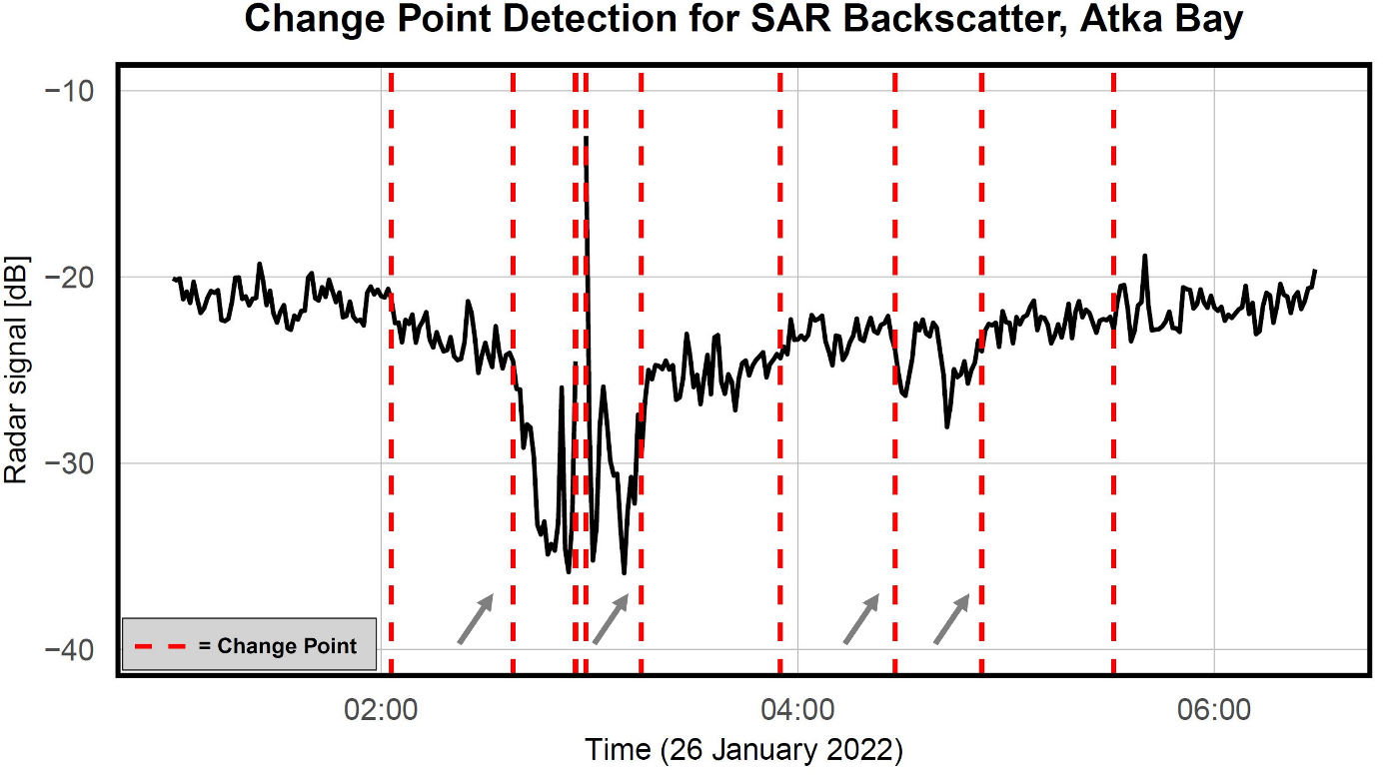

**Supplementary figure 1.** Change Points for SAR backscatter along the shiptrack from Atka Bay. The red dashed lines indicate the detected change points using the Pruned Exact Linear Time algorithm. The grey arrows mark change points coinciding with the broad low radar backscatter feature emanating from the Ekström Ice Shelf, displayed in Figure 2a of the main text. The third and fourth change points coincide with an iceberg.

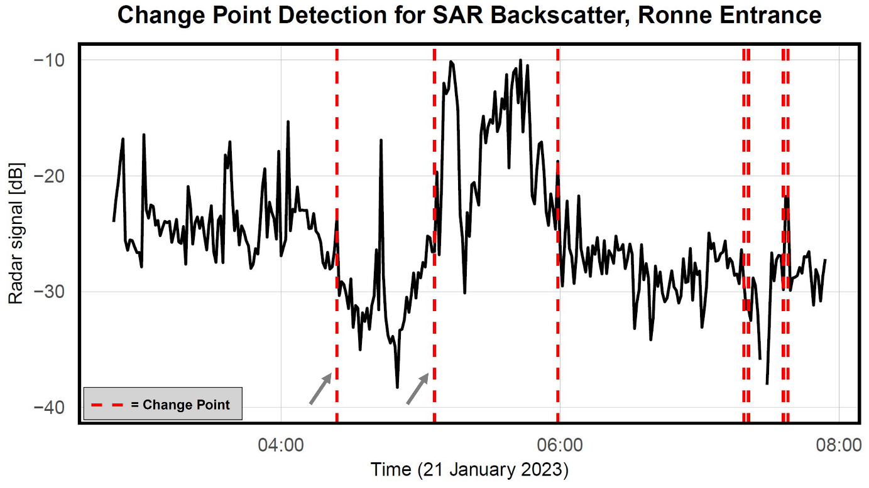

**Supplementary figure 2.** Change Points for SAR backscatter along the shiptrack from Ronne Entrance. The red dashed lines indicate the detected change points using the Pruned Exact Linear Time algorithm. The grey arrows mark change points coinciding with the broad low radar backscatter feature emanating from the George VI Ice Shelf, displayed in Figure 3d of the main text. The second and third change points coincide with a patch of sea ice. Four change points are detected in a very short interval, indicating a decrease and subsequent increase in radar backscatter values, not evident as a broad feature in the SAR image.

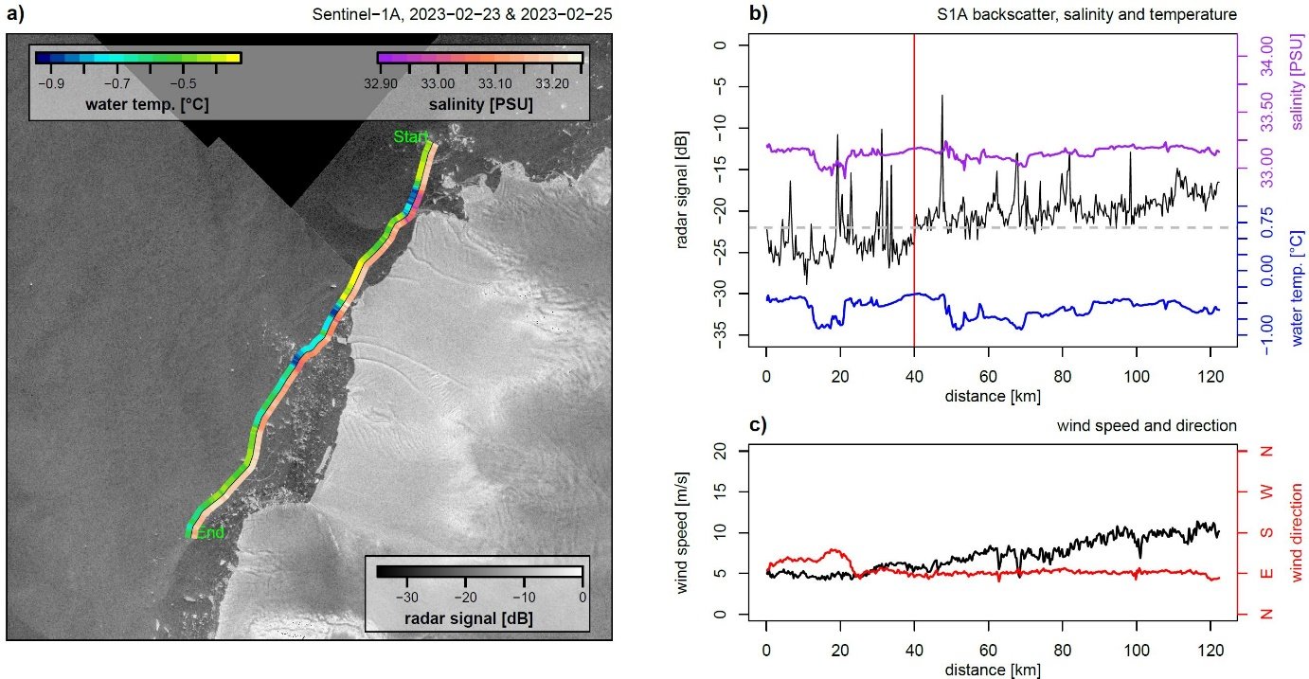**Supplementary figure 3.** SAR and in-situ data from Venable Ice Shelf. (a) Composite Sentinel-1A SAR imagery from 23 and 25 February 2023 of the Venable Ice Shelf, showing the ship's survey track (black line); water temperature data are represented to the right of the ship's track and salinity data to the left, relative to the ship’s heading. (b) Plots of radar backscatter, salinity, and water temperature along the survey track. The vertical red line at 40 km marks where the SAR image changes. (c) Wind data plotted against the survey track.

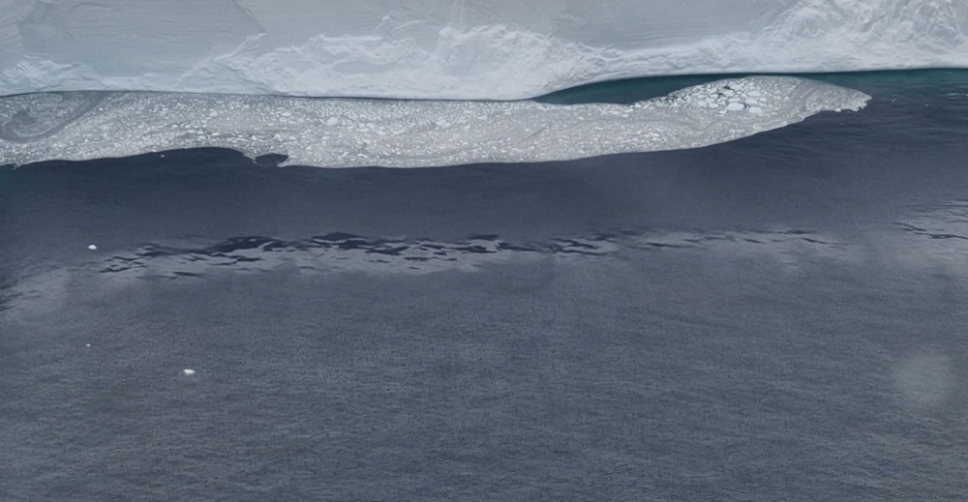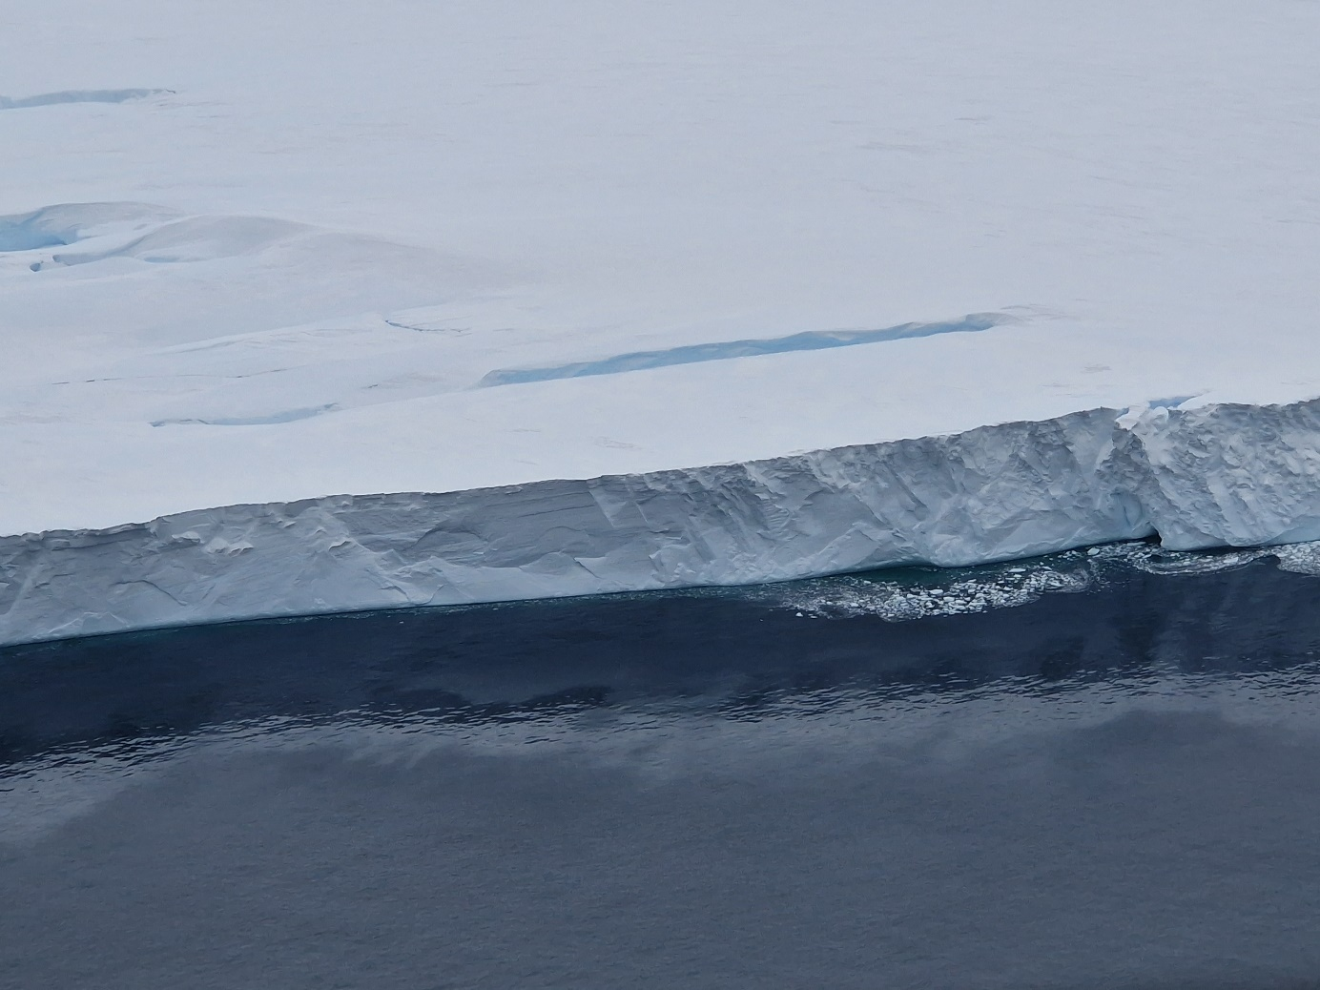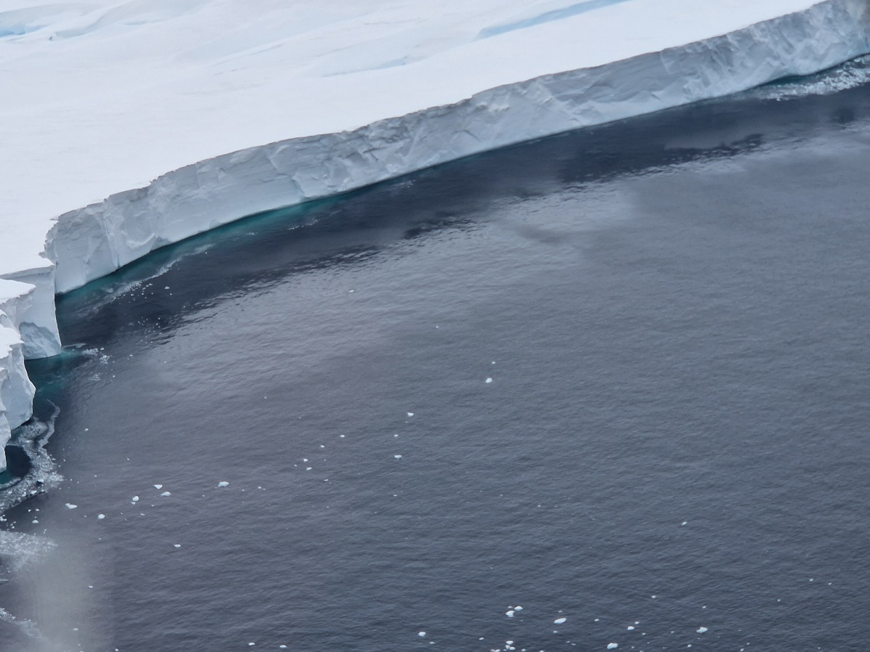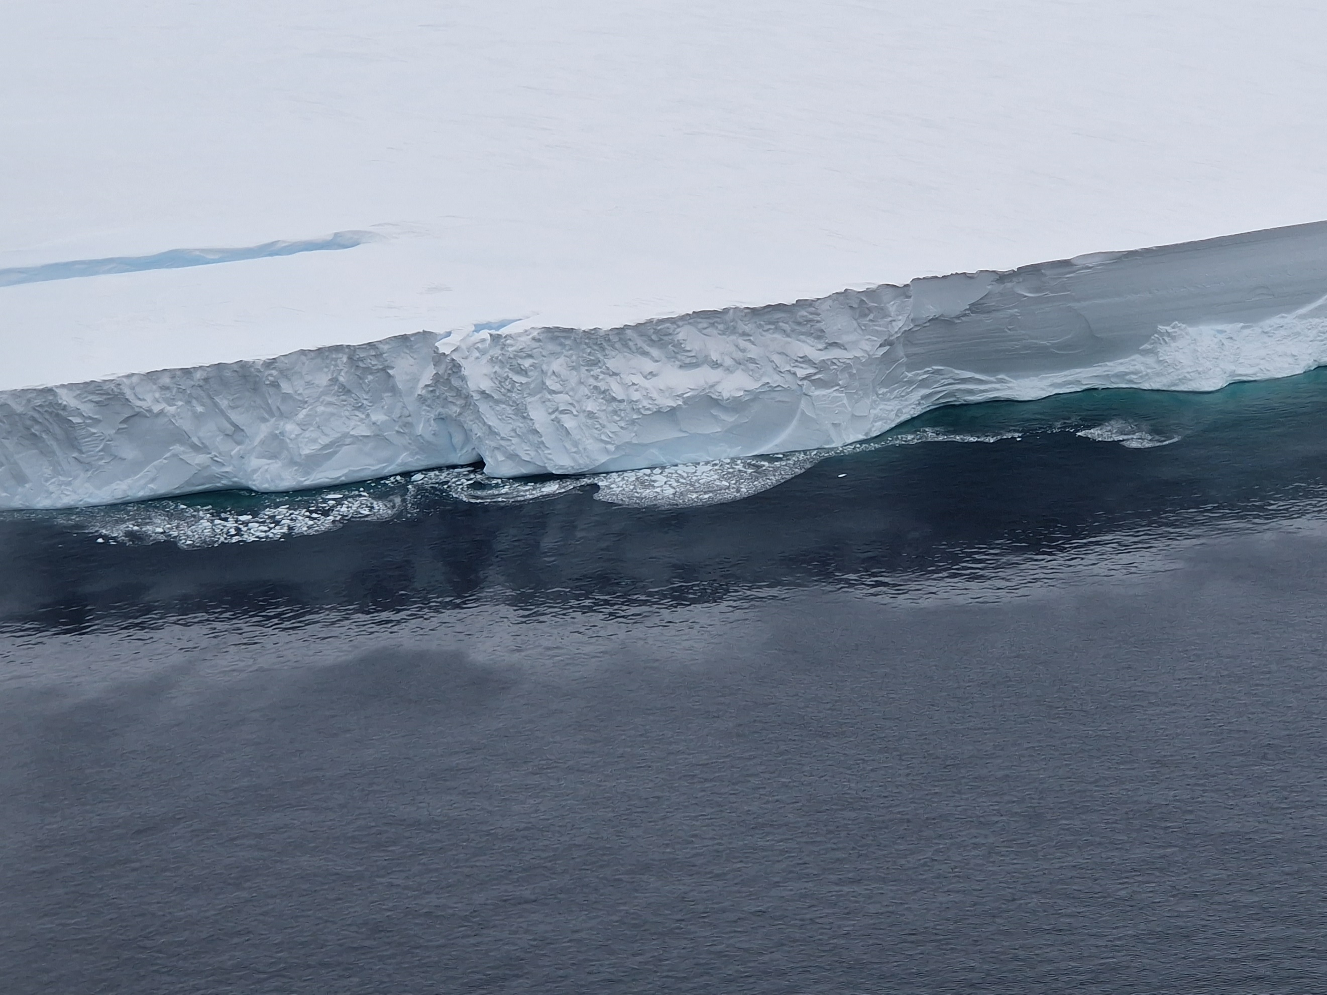

**Supplementary figure 4.** Pictures of glossy water ribbons by Venable Ice Shelf.