# SUPPLEMENTARY MATERIAL

**Rift Propagation Signals the Last Act of the Thwaites Eastern Ice Shelf**

**Despite Low Basal Melt Rates**

# by Wild et al., YYYY

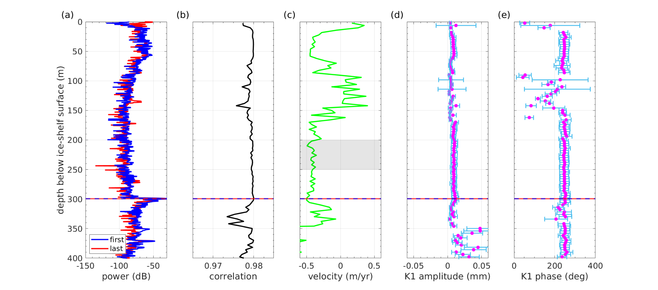

**Figure S1. Continuous ApRES Deployment at Cavity Camp**: (a) The initial and concluding ApRES bursts at January 11, 2022 and August, 5, 2022. (b) Cross-correlation average between internal reflectors over a 3-hour rolling window during bursts. (c) Profile of vertical velocity across the ice column, with the representative depth range (in gray) for computing the melt-free strain component. Panels (d) and (e) present the amplitude and phase of the internal layer displacement at the K1 tidal constituent derived from harmonic analysis. The dashed blue and red lines in all panels indicate the minimal shift of the ice base throughout the record. It's noteworthy that vertical velocities across the ice column are substantial compared to the minimal ice-base shift.

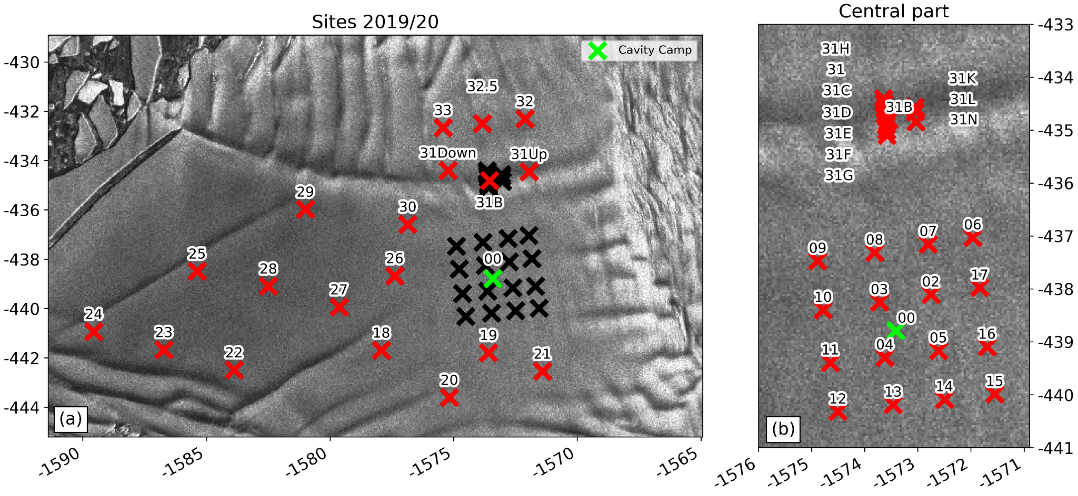

**Figure S2: Sites**. Locations of ApRES sites and their corresponding site names on the Thwaites Eastern Ice Shelf during the 2019/20 Antarctic field season. The background image is a Sentinel-1a SAR image captured in October 2019.

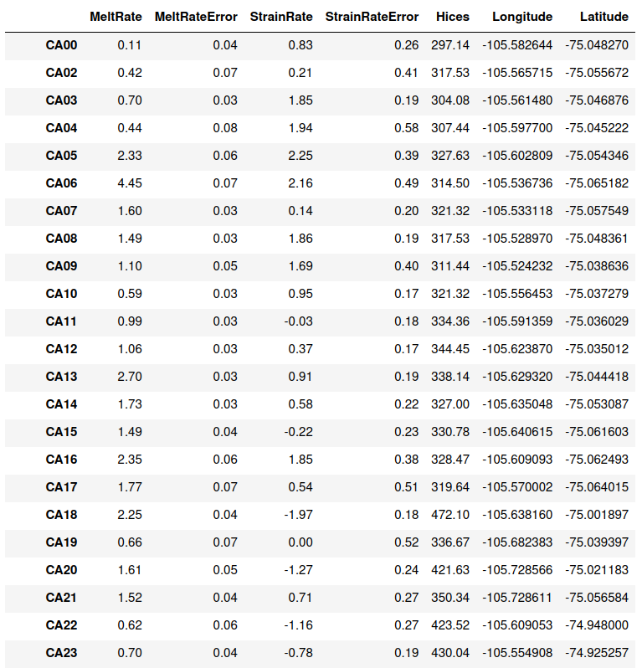

**Table S1: ApRES results.** Site names, basal melt rates (m yr⁻¹), vertical strain rates (milli-strain yr⁻¹) with associated errors, ice thickness, and coordinates for 46 ApRES sites between December 2019 and January 2020.

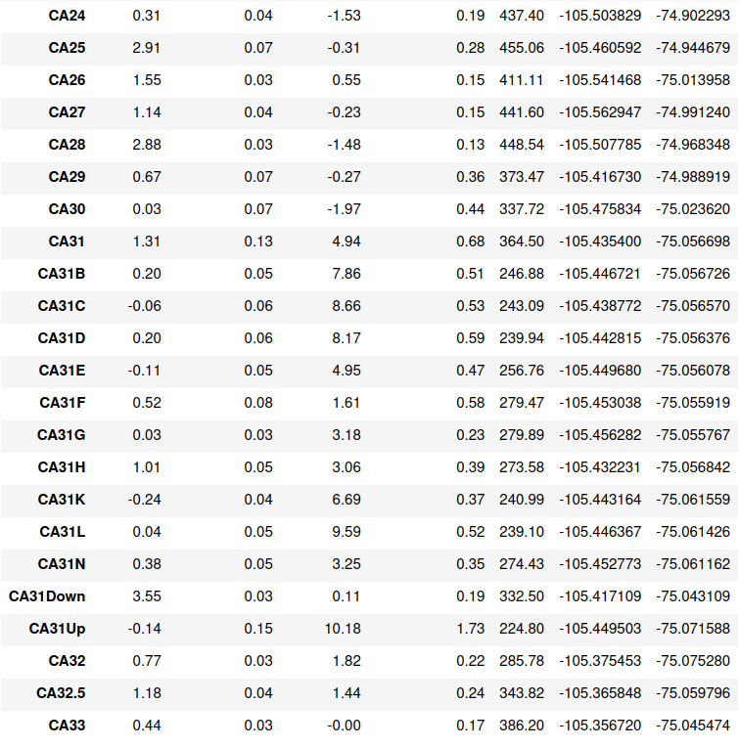

**Table S2:** continued Table S1.

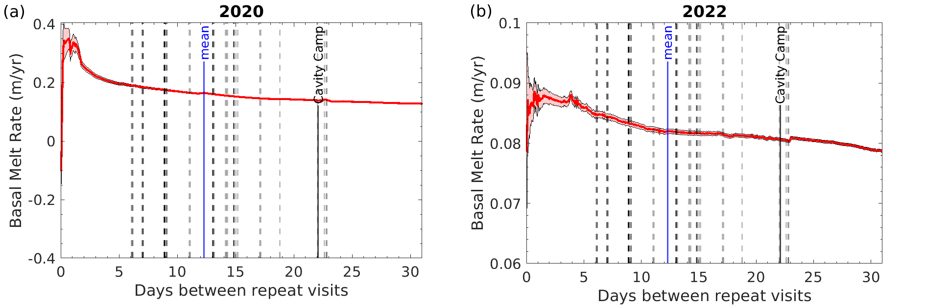

**Figure S3. ApRES Sensitivity.** The relationship between basal melt rate and the duration between repeat visits, as determined from the Cavity Camp records. The dashed lines correspond to the duration at each of the 46 ApRES sites between December 2019 and January 2020. It's important to note that durations below 3 days would significantly overestimate the basal melt rate compared to the long-term value. The mean duration of all 46 sites is approximately 12 days, ranging from a minimum of 6 days to a maximum of 23 days. The duration between repeat visits at Cavity Camp is 22 days and results in a basal melt rate of 0.11 m yr -1, confirming the actual repeat measurement at site 00 (Table S1).

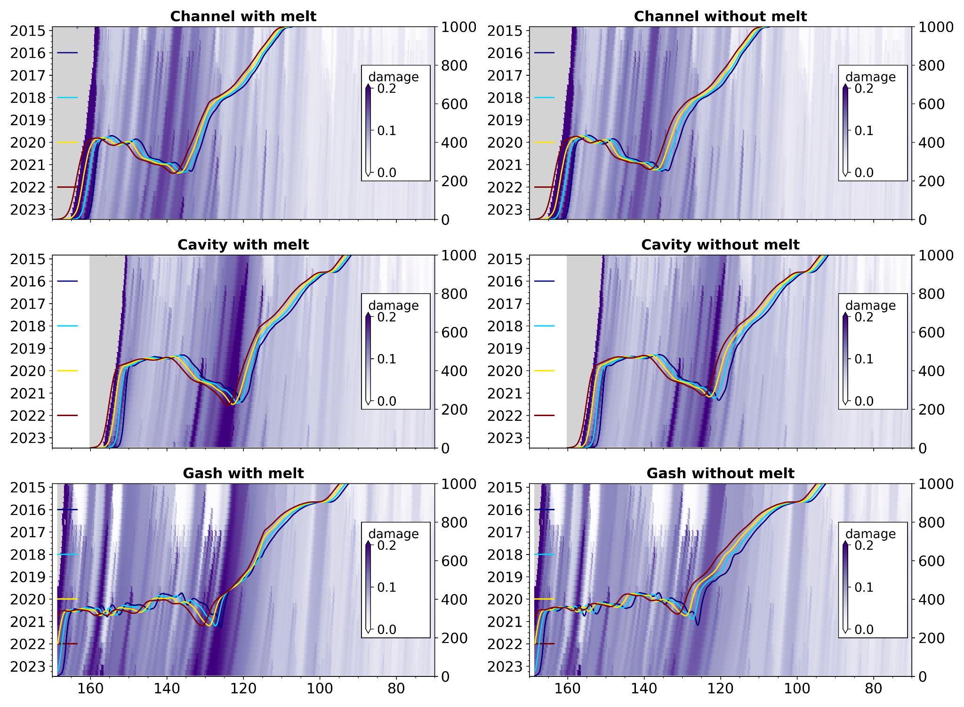

**Figure S4.** Model results depicting damage with basal melting (left column) and without basal melting (right column).