**Supplementary materials**

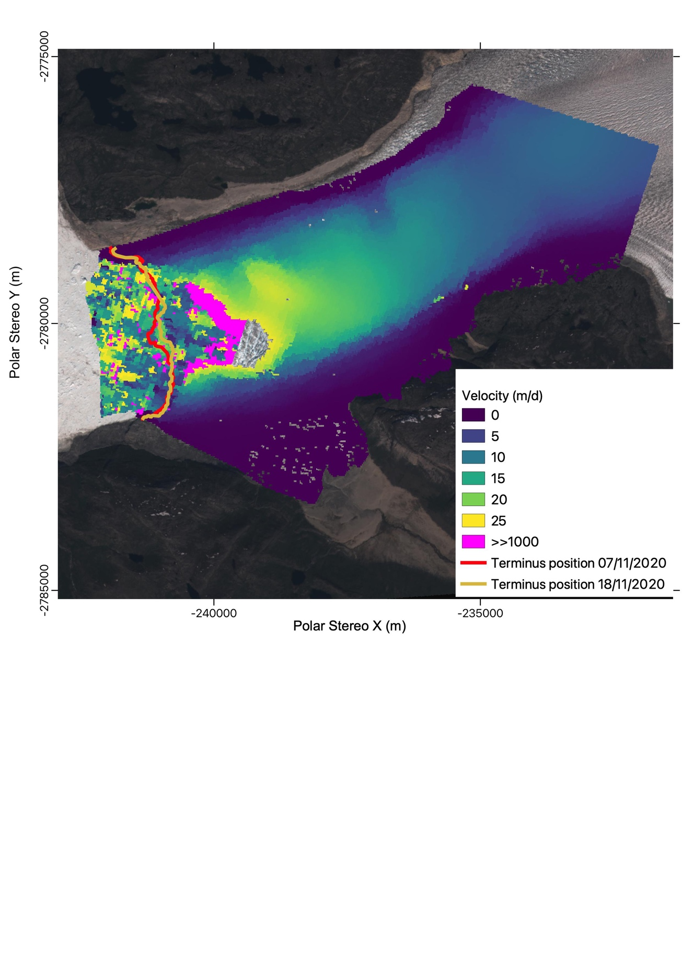

Figure S1: Example of noisy velocity data in front of the terminus and up to approximately 2 kilometres upstream with a data gap also being apparent upstream from the terminus. Velocity map from the image pair 7/11/2020 – 18/11/2020 with respective terminus positions. Basemap: European Space Agency Sentinel-2 RGB image from 09/07/2021.

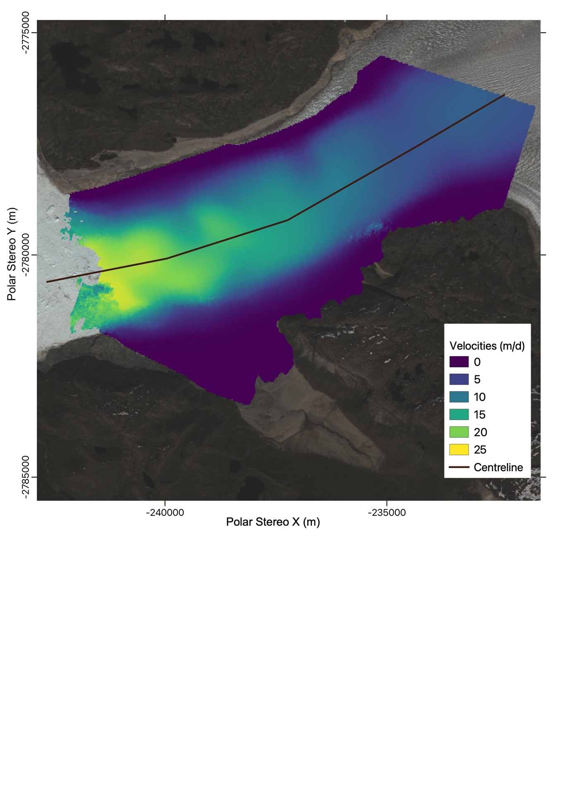

Figure S2: Map of stacked median velocity magnitude from PAZ SAR images for the Stage 1 (30/10/2019 – 12/04/2020. Black line shows centreline along which velocities have been extracted in Figure 4. Basemap shows an ESA Sentinel-2 RGB image acquired on 09/07/2021.

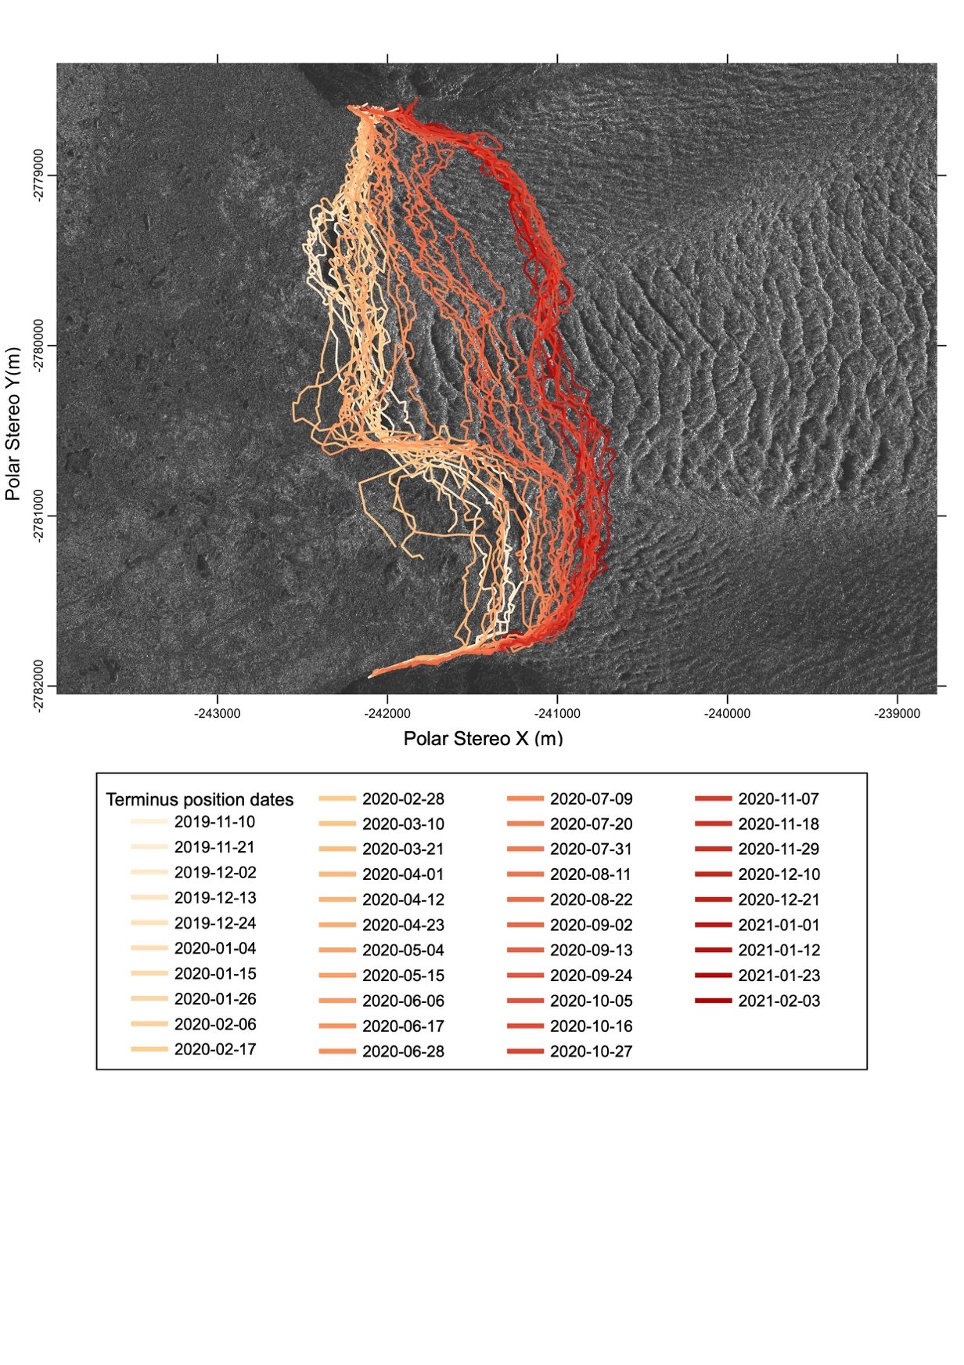

Figure S3: High-resolution PAZ SAR image from 10/11/2019 derived from geocoding and co-registering the image to the reference image (30/10/2019). Termini have been digitised in QGIS and are shown for the observation period without the reference image (10/11/2019 - 03/02/2021).

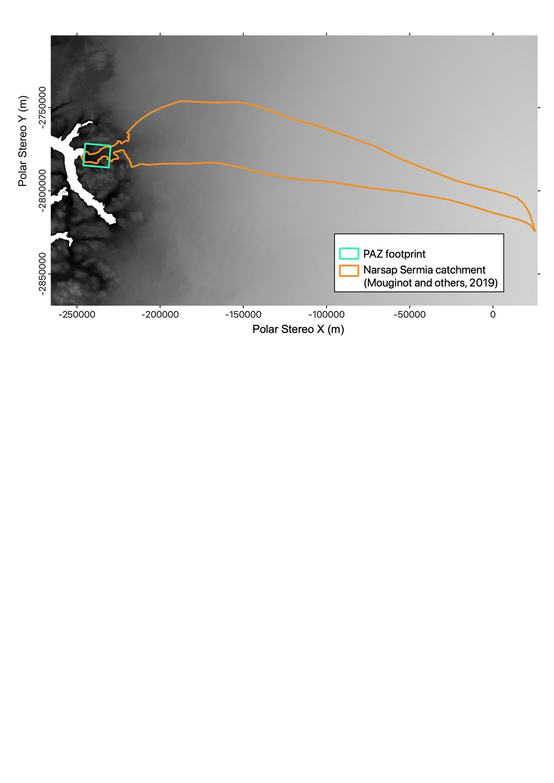

Figure S4: Catchment of Narsap Sermia used for the extraction of runoff from MAR v3.11.2 ((Fettweis and others, 2017; Mouginot and Rignot, 2019; Colosio and others, 2020) shown in orange. Footprint of used PAZ data shown in turquoise. Basemap is surface elevation from Bedmachine v4 (Morlighem and others, 2017,2021)

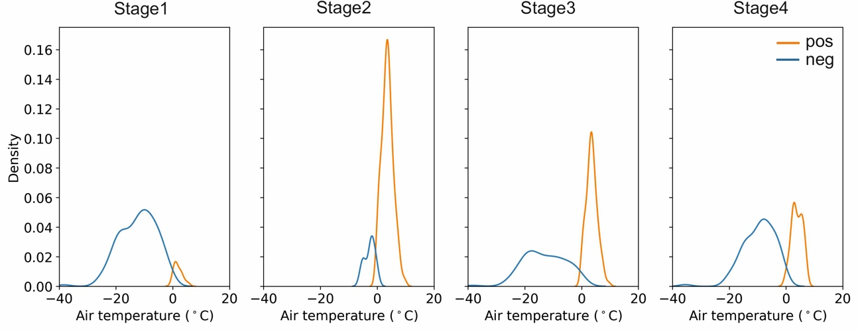

Figure S5: Kernel density estimation of positive (orange) and negative (blue) air temperatures (°C) from the weather station NUK_L for the four stages of velocities.

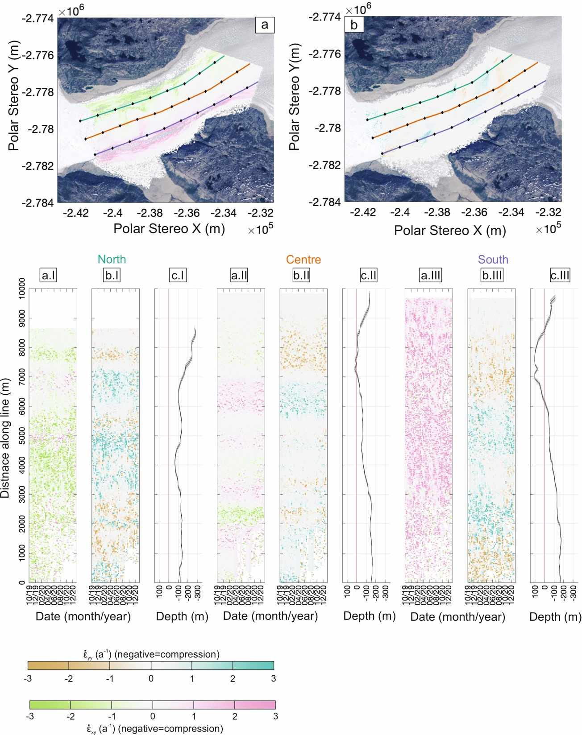

Figure S6: Stacked shear (a) and transverse strain rates (b) derived from PAZ data for the period 30/10/2019 – 03/02/2021 with lines along which strains were extracted in the north (green), centre (orange), and south (purple). **a.I - a.III**) Shear strain rate evolution. **b.I - b.III**) Transverse strain rate evolution**. c.I - c.III**) Bedrock topography with error (shaded) from Bedmachine v.4 (Morlighem et al., 2017, 2021). Basemap: European Space Agency Sentinel-2 RGB image acquired on 09/07/2021.

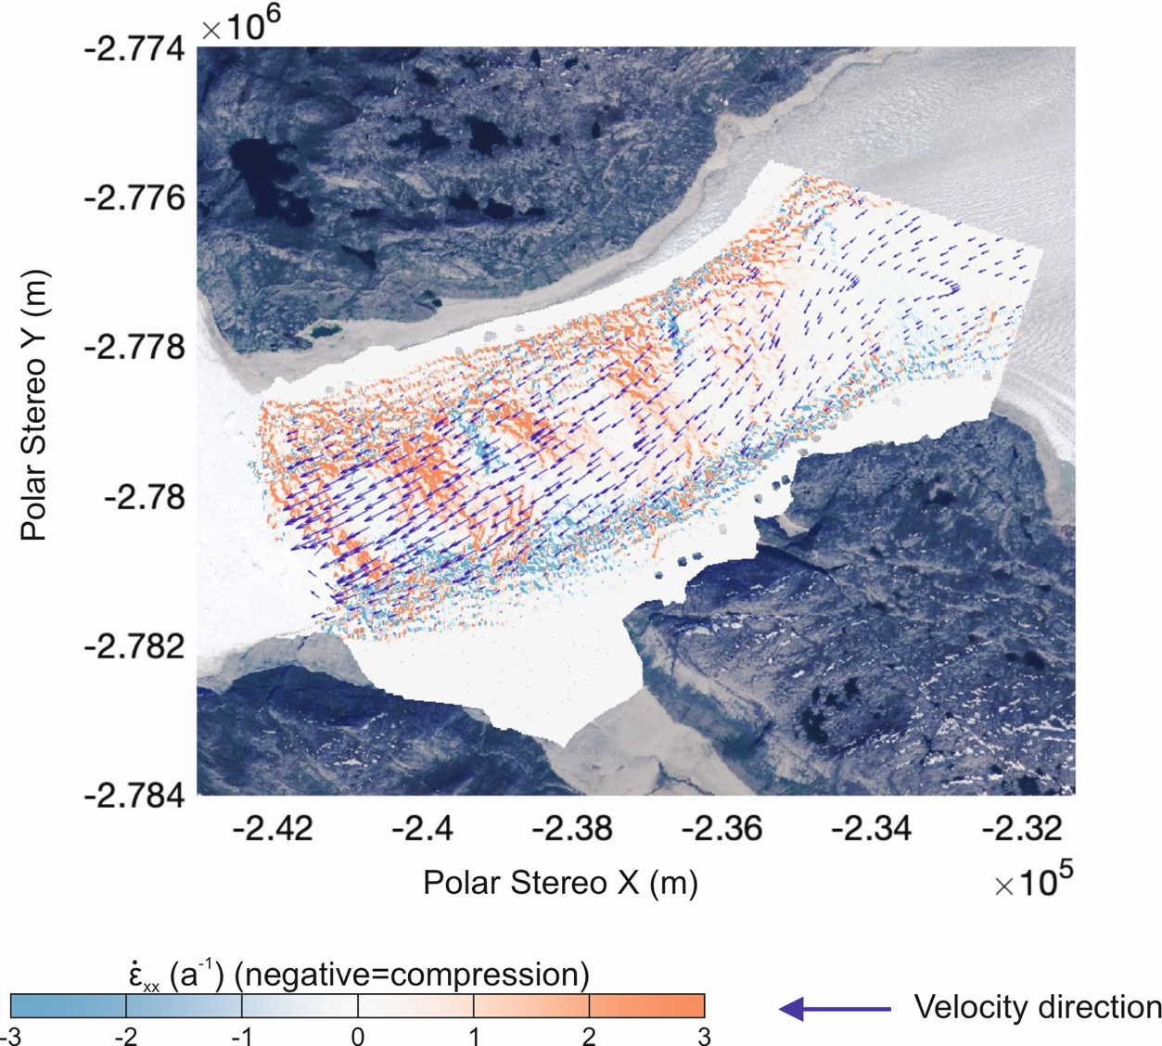

Figure S 7: Velocity directions are shown on top of longitudinal strain rates (both from image pair 30/10/2019-11/10/2019) highlighting that glacier flow is direction more towards the south-southwest whereas the fjord orientation is more southwest. The arrows only show every 100th velocity measurement to make changes in flow direction easier to see. Basemap showing an ESA Sentinel-2 RGB image, acquired on 09/07/2021.