**Supplementary Tables**

**Table S1:** List of data sources used in the study, including: the data set name, image date, spatial resolution, the bands and threshold used in the NDWI classification, and the source of the data.

|  |  |  |  |  |  |
| --- | --- | --- | --- | --- | --- |
| **Dataset** | **Image Dates** | **Spatial Resolution** | **NDWI bands** | **NDWI threshold** | **Source** |
| PlanetScope | 20/12/2020  09/12/2019  05/12/2018  13/12/2017 | 3 m | Band 2 – Green  0.50 - 0.59 µm  Band 4 – NIR  0.78 - 0.86 µm | 0.07 | Planet Education and Research Program (Planet Team, 2017). |
| RapidEye | 13/12/2017  05/12/2016  19/12/2015  03/12/2014  08/12/2013  10/12/2012 | 5 m | N/A | N/A – manually digitised. | Planet Education and Research Program (Planet Team, 2017). |
| Landsat 8 OLI/TIRS | 18/12/2020  14/11/2019  13/12/2018  10/12/2017  07/12/2016  19/11/2015  02/12/2014  29/11/2013 | 30 m | Band 3 – Green  0.525–0.600 µm  Band 5 – NIR  0.845–0.885 µm | 0.04  0.04  0.02  0.04  0.04  0.04  0.04  0.04  0.05 | USGS Earth Explorer Landsat Collection 2 Level 1 |
| Landsat 7 ETM+ | 20/12/2012  02/12/2011  23/12/2010  04/12/2009  17/12/2008  23/12/2007 | 30 m | Band 2 - Green  0.52 - 0.60 µm  Band 4 - NIR  0.77 - 0.90 µm | 0.045  0.045  0.04  0.04  0.04  0.04 |
| Landsat 4-5 TM | 04/12/2003  09/12/2002  22/12/2001  27/12/2000  25/12/1999  04/11/1998  01/11/1997  27/12/1994  24/12/1993  19/12/1991  14/11/1990  10/12/1988  08/12/1987 | 30 m | Band 2 - Green  0.52 - 0.60 µm  Band 4 - NIR  0.76 - 0.90 µm | 0.045  0.09  0.04  0.14  0.13  0.14  0.25  0.14  0.14  0.05  0.16  0.035  0.04 |
| Declassified KH-9 Lower Resolution Mapping | 07/01/1976  02/01/1974 | 20-30 feet |  |  | USGS Earth Explorer Declassified satellite imagery 2 |
| Declassified Corona KH-4 imagery | 15/11/1968  12/12/1967  12/11/1966  24/11/1962 | 6-25 feet |  |  | USGS Earth Explorer Declassified satellite imagery 1 |

.

**Table S2**. Comparison of pond metrics from PlanetScope and RapidEye data, including: number of ponds; total area of all ponds detected; area of the largest pond; mean area of all ponds detected; and percentage of the glacier covered by ponds. Absolute and percentage differences between PlanetScope and RapidEye data are given. Both images were acquired on 13th Dec 2017.

|  |  |  |  |  |  |  |
| --- | --- | --- | --- | --- | --- | --- |
| **Source** | **Date** | **No. of ponds** | **Total pond area (m2)** | **Largest pond area (m2)** | **Mean pond area (m2)** | **Pond cover (%)** |
| PlanetScope | 13/12/2017 | 40 | 153,545 | 34,778 | 3,839 | 1.02 |
| RapidEye | 13/12/2017 | 43 | 154,383 | 33,734 | 3,590 | 1.03 |
| **Percentage Difference** | N/A | 7.23% | 0.54% | 0.76% | 6.69% | 0.54% |

**Table S3**. Percentage difference in pond metrics between PlanetScope and Landsat data, including the percentage difference in: number of ponds; total area of all ponds detected; area of the largest pond; mean area of all ponds detected; and percentage of the glacier covered by ponds. Mean percentage difference was calculated for Platescope and Landsat images within 3 days of each other.

|  |  |  |  |  |  |  |
| --- | --- | --- | --- | --- | --- | --- |
| **PlanetScope dates** | **Landsat dates** | **No. of ponds** | **Total pond area (m2)** | **Largest pond area (m2)** | **Mean pond area (m2)** | **Pond cover (%)** |
| 20/12/2020  13/12/2017 | 18/12/2020  10/12/2017 | 41.13% | 0.94% | 4.63% | 42.02% | 0.94% |

**Table S4**. Percentage difference in pond metrics between RapidEye and Landsat data, including the percentage difference in: number of ponds; total area of all ponds detected; area of the largest pond; mean area of all ponds detected; and percentage of the glacier covered by ponds. Mean percentage difference was calculated for RapidEye and Landsat images within 3 days of each other.

|  |  |  |  |  |  |  |
| --- | --- | --- | --- | --- | --- | --- |
| **RapidEye dates** | **Landsat dates** | **No. of ponds** | **Total pond area (m2)** | **Largest pond area (m2)** | **Mean pond area (m2)** | **Pond cover (%)** |
| 13/12/2017  05/12/2016  03/12/2014 | 10/12/2017  07/12/2016  02/12/2014 | 29.65% | 14.95% | 10.63% | 44.09% | 14.95% |

**Table S5**. Area of ponds over 20,000 m2 on Tshojo Glacier between 1987 and 2020. Ponds are named by a letter and categorised by pond area, in bands of 10,000 m2, starting from 20,000 m2. Pond locations are given in Fig. 5B.

|  |  |  |  |
| --- | --- | --- | --- |
| **Year** | **Pond Name** | **Area (m2)** | **Size Category (k m2)** |
| 2008 | BD | 117000 | 50 |
| 2015 | BD | 116100 | 50 |
| 2013 | A | 100800 | 50 |
| 2010 | BD | 99900 | 50 |
| 2019 | A | 57600 | 50 |
| 2009 | V | 54000 | 50 |
| 2007 | BD | 50400 | 50 |
| 2020 | A | 48600 | 40 |
| 2018 | A | 46800 | 40 |
| 2019 | C | 38700 | 30 |
| 2010 | V | 38700 | 30 |
| 2017 | A | 36900 | 30 |
| 2016 | A | 35100 | 30 |
| 2011 | H | 34200 | 30 |
| 2013 | B | 33300 | 30 |
| 2014 | B | 32400 | 30 |
| 2008 | V | 31500 | 30 |
| 2011 | B | 30600 | 30 |
| 2014 | A | 28800 | 20 |
| 2007 | A | 28800 | 20 |
| 2009 | Y | 27900 | 20 |
| 2008 | Y | 27900 | 20 |
| 2007 | H | 27900 | 20 |
| 1994 | J | 27900 | 20 |
| 2015 | A | 27000 | 20 |
| 1993 | J | 25200 | 20 |
| 2018 | F | 24300 | 20 |
| 2014 | E | 24300 | 20 |
| 2020 | D | 23400 | 20 |
| 2008 | A | 23400 | 20 |
| 2007 | V | 23400 | 20 |
| 1990 | M | 23400 | 20 |
| 2012 | B | 22500 | 20 |
| 2007 | S | 22500 | 20 |
| 2010 | Y | 21600 | 20 |
| 1990 | A | 21600 | 20 |
| 2018 | C | 20700 | 20 |
| 2011 | Y | 20700 | 20 |

**Supplementary Figures**

**Figure S1**. Histogram of image acquisition date, by day of the year. Bars are coloured coded by imagery type. Numbers in brackets indicate the total number of images for that image type.

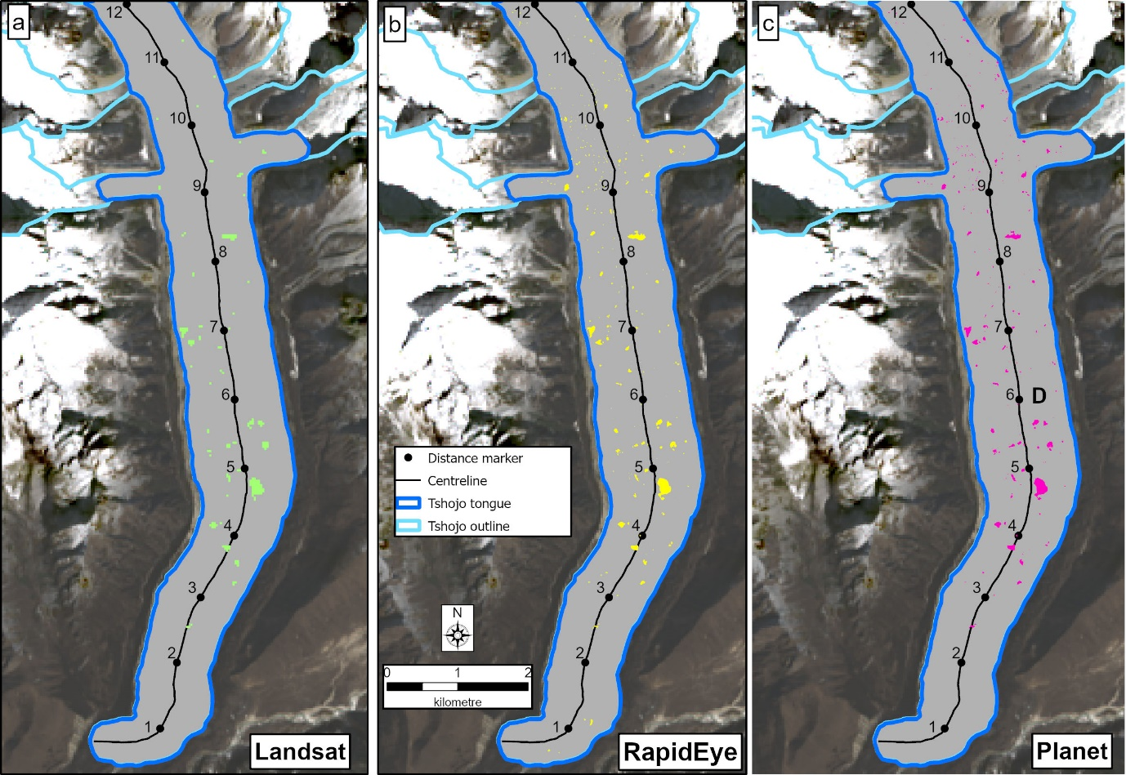

**Figure S2:** Spatial comparison of ponds detected using different imagery types, specifically: a) Landsat 8, 30 m spatial resolution, image acquired 10th Dec 2017. Ponds are shown in green; b) RapidEye, 5 m spatial resolution, image acquired 13th Dec 2017. Ponds are shown in yellow; C) PlanetScope, 5 m spatial resolution, image acquired 13th Dec 2017. . Ponds are shown in pink.

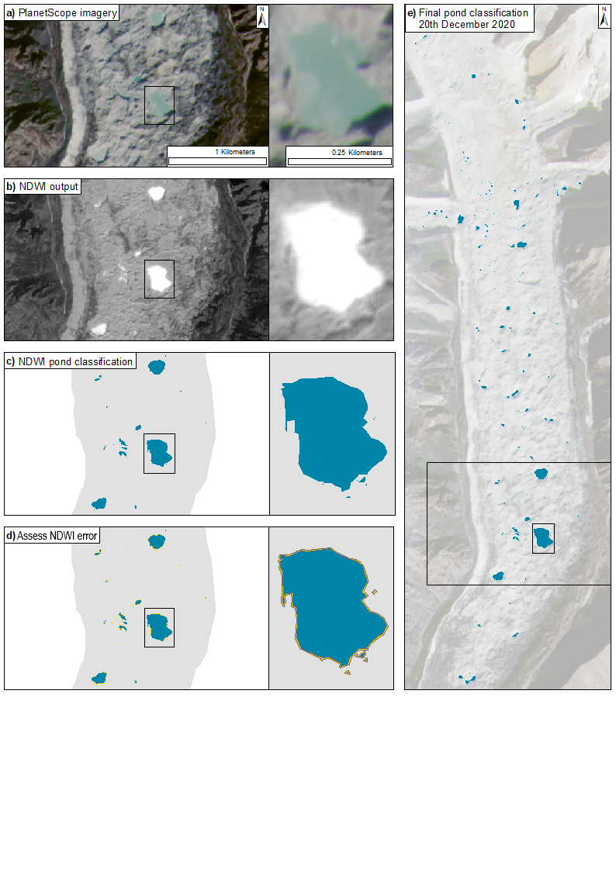 **Figure S3:** NDWI pond classification workflow. a) Supraglacial pond on PlanetScope imagery (3 m resolution). b) NDWI output raster, calculated using the green and near-infrared bands. c) Threshold is applied to NDWI raster to identify ponds and converted to polygons. d) Assess the NDWI error by calculating the difference in total pond area between NDWI classification and ponds manually digitised RapidEye. e) final pond classification example for 20th Dec 2020.

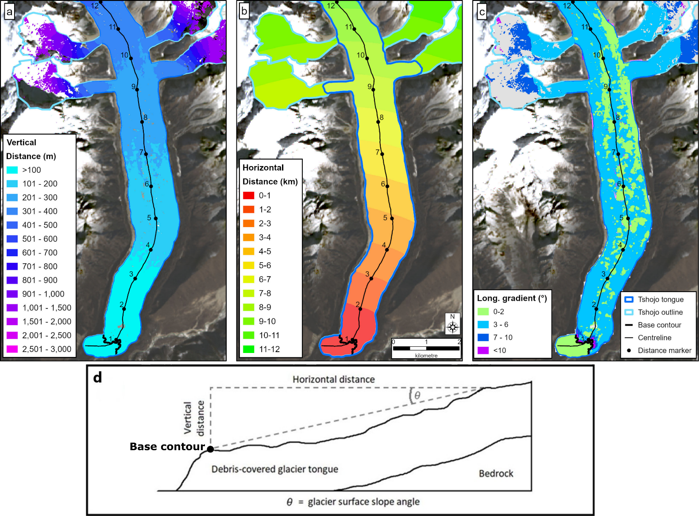

**Figure S4**. Approach for calculating the longitudinal gradient of the glacier surface for Tshojo Glaicer, using the High Mountain Asia 8 m DEM (Shean, 2017). a) Vertical height difference between each point on the glacier surface and the base contour (4,060 m; thick black line). b) Horiztonal distance from the base contour. c) Longitudinal gradient of the glacier surface in degrees. d) Diagram to illustrate vertical and horizontal distance and longitudinal gradient of the glacier surface, with the base contour marked by a black dot.

**Figure S5**. Pond locations at decadal internals during the study period: 1990, 2000, 2010 and 2020. Ponds larger than 10,000 m2 are symbolised by size and colour, according to pond area category. Ponds smaller than 10,000 m2 are symbolised by a cyan dot.

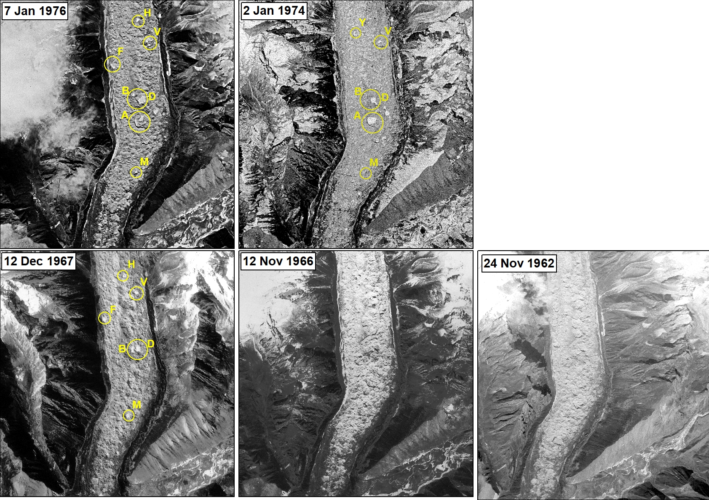

**Figure S6**. Ponds over 20,000 m2 identified on Tshojo Glacier (yellow circles) from spy satellite imagery, acquired between 1962 and 1976. Image dates are provided on each sub figure. Pond initials correspond to those in Figure 5.

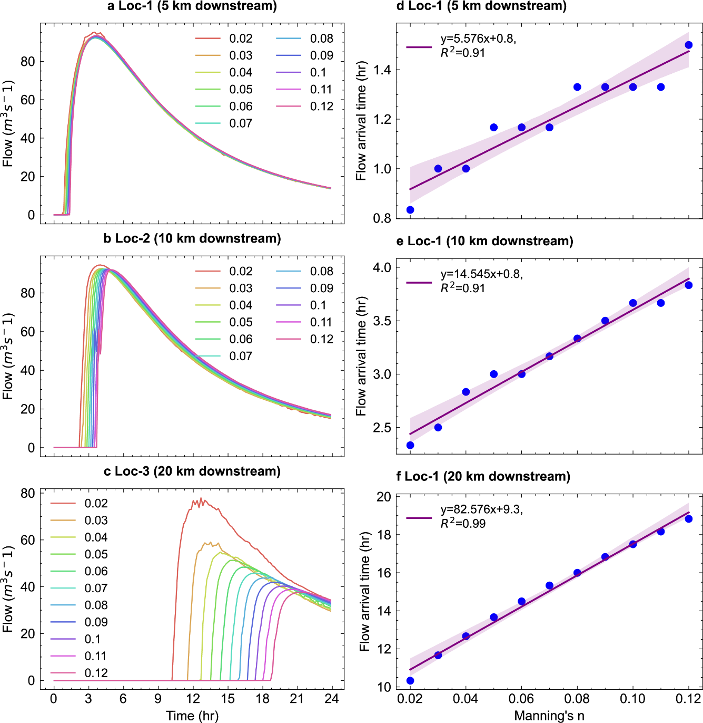

**Figure S7.** Effect of Manning's n variation on flow characteristics. (a) Flow rate at positions downstream of Tshojo Glacier due to variation in Manning's n. (b) Flow arrival time at the selected downstream locations due to variations in Manning's n.

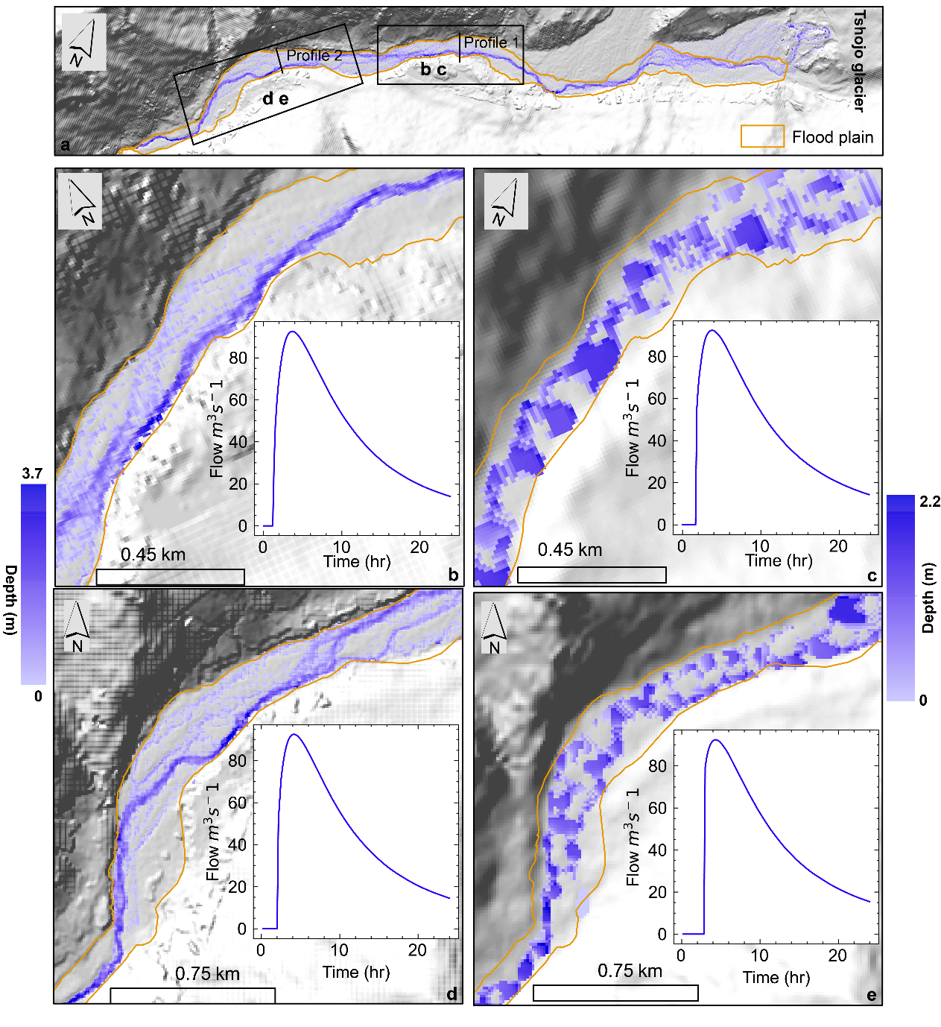

**Figure S8.** Comparison of the inundation map and hydrograph between pond outburst flood simulated using ALOS-PALSAR DEM and HMA 8m DEM. (a) Inundation extent and flood plain for the entire model domain used for comparing these two DEM datasets. Note that this is not the entire model domain, due to limited data in the HMA 8m DEM. Inundation map and hydrograph for the HMA 8m DEM (b) and ALOS-PALSAR (c) from the locations b and c, marked in map a. Inundation map and location at the location for HMA 8m DEM (d) and ALOS-PALSAR DEM (e) from the locations and e, marked in map a. The hydrograph insets are derived from profile-1 (b and c) and profile-2 (d and e). The flood plain extent was manually digitized from high-resolution Google Earth Imagery (date:27th Dec 2023) The background image is the hillshade produced from the respective DEM data.