Any use of trade, firm, or product names is for descriptive purposes only and does not imply endorsement by the U.S. Government.

Supplementary Material

GNSS reflectometry from low-cost sensors for continuous in-situ contemporaneous glacier mass balance and flux divergence

Albin Wells*, David Rounce, Louis Sass, Caitlyn Florentine, Adam Garbo, Emily Baker, and Christopher McNeil

* Correspondence: Albin Wells: awwells@cmu.edu

TABLE OF CONTENTS
1. Supplementary Text
- Supplemental text S1: Monitored banded ablation stake setup (Page 3)
- Supplemental text S2: Slope correction DEM comparison (Page 3)
- Supplemental text S3: Monitored banded ablation stake uncertainty (Page 3)
- Supplemental text S4: Comparison of GNSS processing workflow (Page 4)
- Supplemental text S5: GNSS positioning bias (Page 5)
- Supplemental text S6: GNSS-IR filtering azimuth range (Page 5)
- Supplemental text S7: Hydrological impacts on surface velocity (Page 6)
- Supplemental text S8: Bed separation scenarios (Page 7)

2. Supplementary Tables
- Table S1: Differences between kinematic processing with a base station and precise point positioning for fixed and floating GNSS systems (Page 8)

3. Supplementary Figures
- Figure S1: GNSS system setup at Gulkana Glacier site AB on 16 April 2023 (Page 8)
- Figure S2: GNSS system setup at Gulkana Glacier site AB on 23 August 2023 (Page 9)
- Figure S3: Examples of monitored banded ablation stake failures (Page 10)
- Figure S4: Gulkana Glacier site AB fixed GNSS-IR reflector height results (Page 10)
- Figure S5: Gulkana Glacier site AB floating GNSS-IR reflector height results (Page 11)
- Figure S6: Gulkana Glacier site AB weekly and cumulative slope-corrected uplift from fixed and GNSS systems (Page 11)
- Figure S7: Gulkana Glacier site AB fixed - floating GNSS climatic mass balance before and after applying corrections (Page 12)
- Figure S8: Gulkana Glacier GNSS system positions at site AB and site D (Page 12)

4. Supplementary Material References

1 SUPPLEMENTARY TEXT
Supplemental text S1: Monitored banded ablation stake setup
The monitored banded ablation stake used a Reconyx HyperFire 2 Professional Covert IR camera set in “Time-Lapse” mode that imaged the stake three times per day at 10:00, 12:00, 14:00 AKST to minimize issues with inadequate lighting and weather conditions. The quality of the three images each day were similar, so the 12:00 image was used for processing to maintain a 24-hour interval for each day. The camera was mounted on a rig looking downward toward the banded ablation stake at a 30-degree angle from a position approximately 40 cm above the surface and 70 cm horizontally from the stake. The rig featured one long (~90 cm) aluminum arm with a ring that wrapped loosely around the stake and three shorter arms for stability. This setup ensured the camera remained upright and faced the banded stake at the same distance, even if the camera rig tilted slightly in any direction.
The ablation stake consisted of three 10 ft (3.05 m) schedule 40 aluminum pipe sections of 1” nominal pipe size (1.315” OD, 0.133” thickness) connected by 1 ft (30.5 cm) aluminum rods with a retaining ring in the middle. Each pipe section was spray painted in 10 cm bands alternating unpainted bands with rotating black, red, and yellow colors. A short wood dowel was attached to the bottom of the stake to prevent heat conduction that could cause the stake to melt into the ice. The stake was drilled 8.1 m into the ice/snow surface, leaving ~1 m of the stake above the glacier surface, using a steam drill (Taylor Scientific Engineering).

Supplemental text S2: Slope correction DEM comparison
A slope correction is required to adjust fixed and floating system elevations, effectively converting observed GNSS position changes from a Eulerian to Lagrangian reference. We evaluated the effect of using a high-resolution (2 m) and lower-resolution (30 m) DEM, as well as the importance of using a smoothed DEM. We found that the choice of DEM used to apply the slope-based correction is not critical over most parts of a glacier considering the large scales of glacier surfaces relative to DEM resolutions and the generally gradual surface slopes. However, the slope correction must be derived from a smooth DEM that is not impacted by small-scale surface topography. DEM choice for the slope correction could be critical for older DEMs over rapidly thinning regions of the glacier with changing slope, either near the terminus or at thin areas where bed topography is expressed at the ice surface. On Gulkana Glacier at site AB, applying the slope correction from the ~2011 30 m Copernicus DEM (https://doi.org/10.5270/ESA-c5d3d65, last access: December 2023) yields comparable results to the newer 2 m USGS DEM.

Supplemental text S3: Monitored banded ablation stake uncertainty
The uncertainty in the monitored banded ablation stake mass balance can be partitioned into a detection error and a measurement uncertainty. Detection error captures flaws in manual delineation of the glacier surface, i.e., an error in incorrectly identifying the glacier surface on the ablation stake. Measurement uncertainty captures limitations associated with calculating the distance of a selection along the ablation stake. We assume both types of uncertainty to be random, i.e., they result from a limit on the method precision but do not correlate or increase over time.
For images where a full color band was clearly visible (83 of 129 days), we estimated measurement uncertainty by comparing the derived distance value to the known band length of 10 cm. We get a mean error of 0.07±0.53 cm over a 10 cm distance. However, this is a conservative estimate of the error for any of our readings, which are all less than 10 cm (usually within 5 cm) of the nearest visible color band. We also consider color band position uncertainty of 0.3 cm, which results from imperfect measuring and painting of the ablation stake. Thus, we expect our monitored banded ablation stake values to have random measurement uncertainty no greater than 0.9 cm for any single reading.
Detection uncertainty is more difficult to quantify, but we expect this uncertainty to be on a centimeter-scale. During the early summer, snow cover makes detection reliable as snow is relatively evenly distributed and often contacts the stake providing a clear marker for detection. Later in summer, detection is encumbered by surface irregularities, which is a limitation of ablation stake measurements in general (Krimmel 1999). In general, our camera rig setup sits on the ice and slides down the ablation stake, which gives a reference to the local glacier surface height and facilitates an effective banded stake reading. We assume our detection uncertainty does not contribute additional uncertainty compared to that which is inherent in glaciological measurements.
Our monitored banded ablation stake measurements have a combined measurement and detection uncertainty below 2 cm. Comparing the monitored banded ablation stake measurements at the end of the summer to glaciological measurements of the same stake, we obtain a difference of 0.5 cm. Our below 2 cm uncertainty estimate is consistent with a previous study that estimates 1.5 cm standard deviation for monitored banded ablation stake readings from manual detection (Landmann and others, 2021). While automated detection methods can obtain sub-centimeter accuracy (Cremona and others, 2023), these methods are susceptible to the banded stake color quality and not necessarily conducive to our spray-painted ablation stakes.

Supplemental text S4: Comparison of GNSS processing workflow
We compare our GNSS data processing workflow with a slightly modified process that incorporates the use of a base station for GPS positioning. We use the Emlid Studio desktop application (Emlid Tech Kft.) in kinematic processing mode with a base station, which relies on open-source RTKLIB tools (Takasu and Yasuda, 2009). In our case, both our rover and base stations are Cryologger systems located almost 1.2 km apart, logging for 6 hours daily, and equipped with the u-blox ZED F9P receiver and the SparkFun TOP106 antenna. Processing the data in kinematic mode with a base station using this setup is more precise than precise point positioning results as long as the base station position is prescribed. We observe a ~5x reduction in the standard deviation of position solutions (Table S1), indicating that the base station reduces vertical, northing, and easting position uncertainties associated with kinematic processing.
Thus, these results are close to the millimeter-level accuracy reported with similar GNSS hardware from Still and others (2023) using a similar processing pipeline; however, our results depend largely on the accuracy of the base station position. The base station position needs to be prescribed manually during kinematic processing to avoid daily changes in base station position that subsequently propagate to the kinematic processing with the base station. While the base station processing decreases the uncertainty in our results, partial system failures due to a bug in the ZED-F9P firmware (see Section 3.3) reduces the data from this processing pipeline to only those days with sufficient observations from both the base and rover GNSS systems. As a result, we opt to maintain the maximum data availability and use the precise point positioning results, especially as the accuracy is more than sufficient for the requirements of our study.

Supplemental text S5: GNSS positioning bias
We evaluate potential bias in our GNSS systems by comparing the mean position of our Cryologger GVT base system over the entire monitoring period to the known USGS Nunatak base station position. The difference of -0.16 cm in the vertical direction indicates no significant vertical bias in our positions, as this uncertainty is within the manual measurement required to measure the distance from measuring the mounted antenna phase center to the stable ground. Biases in the Easting and Northing direction are 3.8 and -3.6 cm, respectively. This bias may be introduced as a result of limitations in GNSS hardware, small time delays between satellite signal transmission and receiver signal reception, multipath interference from terrain, or satellite constellation geometry. The ~4 cm bias toward the south and east directions, of course, only plays a role when looking at absolute positions on a precise scale. Because we only use changes in GNSS position to apply slope corrections and calculate velocity, this bias does not impact our climatic mass balance ($\frac{{\dot{b}}_{clim}}{ρ}$), total elevation change ($\frac{dh}{dt}$), and flux divergence ($∇·q$) results which are based on relative position.

Supplemental text S6: GNSS-IR filtering azimuth range
GNSS-IR depends greatly on satellite pass azimuth and elevation angle. Specifically, azimuth and elevation angle determine the footprint of reflected GNSS signals, and thus influence the resulting signal to noise ratio data. However, filtering by smaller ranges of azimuths did not yield improved results at sites AB or D, especially considering the relatively small number of valid satellite observations for GNSS-IR at Gulkana Glacier (Fig. S4 and S5). Instead, limitations of the GNSS-IR method on Gulkana Glacier are driven by rough, uneven mountain glacier terrain that emerges in the ablation area in late summer as ice is exposed. Surface runoff channels and debris cause melt patterns that become progressively uneven throughout the late summer, disrupting the planar surfaces that are optimal for GNSS-IR. The late-summer increase from the floating GNSS system reflector height (Fig. 7) is not observed at site D, where the glacier surface remains snow-covered. While the surface at site D is not completely flat at the end of the study period, local surface undulations remain well below L-band wavelength (19 cm for L1, 24 cm for L2).

Supplemental text S7: Hydrological impacts on surface velocity
The observed onset of velocity speed-up was both profound and rapid. At site AB in the ablation area, we observe no notable change in velocity before velocity doubled over an 8-day period and quadrupled over a 16-day period. At site D, velocity increased by a modest 9.5% (5.1 m yr⁻¹) over a week before similarly increasing by nearly 50 m yr⁻¹ over an 11-day period. The onset of these drastic increases–June 3 at site AB and June 15 at site D–aligns with the melt signal and indicates the presence of surface melt that reaches the glacier bed and reduces the effective pressure (Rada and Schoof, 2018) as evident by changes in downstream discharge (Fig. 11A). The maximum velocity at site AB occurs on June 19, which is nearly identical to the onset of the increased daily melt signal which occurs on June 18 (Fig. 5). The velocity pattern at site AB is likely the result of mounting basal water pressure due to rapid surface melt influx combined with inefficient subglacial drainage. After nearly two weeks of mounting water pressure, the subglacial drainage system develops and basal water is discharged, leading to a rapid decline in surface velocity. A decrease in surface melt associated with low air temperatures (Fig. 5) likely accounts for the temporary decrease in velocity from June 12 to 14 (Fig. 8), where decreased velocity aligns with a decrease in discharge. The daily GNSS system position shows an even starker signal than the weekly velocity, as a decisive “jump” in site AB position is clear for both the fixed and floating GNSS system on June 18 (DOY 170) after which GNSS positions change little (i.e., low velocities) (Fig. S8). This sudden and substantial jump in GNSS position only occurs at site AB, showing the way in which the terminus readjusts its position and slides to account for changes in basal conditions. This is symptomatic of disconnected subglacial cavities acting as “sticky spots” that slow down the glacier following an increase in sliding (Iken and Truffer, 1997; Bartholomaus and others, 2011).
At site D in the accumulation area, we similarly expect basal water pressure to account for the rapid velocity speed-up. However, unlike in the ablation area, the high velocities at site D are maintained for three weeks (Fig. 8). This prolonged velocity increase reflects a distributed, disconnected drainage system in the accumulation area. Thus, some amount of basal water pressure is maintained to sustain the period of increased velocity at site D. This is a notable difference between site AB in the ablation zone, where the velocity decreased and speed-up was not maintained, implying that the subglacial drainage system switched to efficient channelization rapidly, reducing basal water pressure within days. The stark variability in observed velocity changes and inferred corresponding degree of channelization between site AB and site D is consistent with results from other glacier sites where detailed water pressure observations and analyses are available (Rada and Schoof, 2018).
By the end of the summer, weekly velocity at site AB in the ablation area remained slightly above the start of summer values while the opposite is true at site D in the accumulation area. This is a continuation of the combination of both ice flux being pushed down into the ablation area and the backstress against fluxes from the accumulation area. As the surface no longer melts and subglacial water is evacuated from the system in late August, we expect the site AB and D velocities to return to their respective April magnitudes.

Supplemental text S8: Bed separation scenarios
We consider four scenarios of bed separation during the drainage and efficiency phases (Section 4.5, Fig. 11). A minimum emergence is estimated by assuming all bed separation is compensated for during drainage, such that the efficiency phase uplift is solely a result of flux divergence. As such, emergence is 0.55 cm d⁻¹ (2.0 m yr⁻¹) after June 27 (Fig. 11 ‘Full decrease’); however, this emergence value can be taken as a minimum estimate (Flowers and others, 2016) as bed separation most likely does not return to zero during drainage. A maximum emergence is similarly estimated by assuming bed separation decreases at a constant rate between the drainage and efficiency phases. This yields a maximum estimate for emergence of 0.95 cm d⁻¹ (3.5 m yr⁻¹) after June 27 (Fig. 11 ‘Constant decrease’). Again, however, the stagnated uplift during the drainage phase would suggest this scenario is also not likely. More realistically, bed separation decreases at a higher rate during drainage than efficiency but does not decrease entirely. Assuming half of the bed separation is compensated for during drainage, we estimate emergence to be 0.77 cm d⁻¹ (2.8 m yr⁻¹) after June 27 (Fig. 11 ‘Partial decrease’). Finally, since the velocity at site AB remains higher in August than April, basal water pressure is likely still present and bed separation may not have returned to zero at the end of the study. Thus, we consider a fourth scenario in which we assume bed separation continues to decrease to zero over an additional 30 days beyond the study period. As such, we estimate an emergence of 0.69 cm d⁻¹ (2.5 m yr⁻¹) between June 27 and August 18 (Fig. 11 ‘Partial decrease, +30 day’).
We can also challenge the assumption of equal emergence during the spring and build-up phases during our interpretation. Instead, we can assume emergence is proportional to the increase in velocity between the spring and build-up phases. For this scenario, we estimate an absolute minimum emergence of 0.55 cm d⁻¹ (2.0 m yr⁻¹) after June 27 for the ‘Full decrease’ scenario and an absolute maximum estimate for emergence of 0.86 cm d⁻¹ (3.1 m yr⁻¹) after June 27 for the ‘Constant decrease’ scenario (Fig. 11). Our more realistic estimate, which again assumes half of the bed separation is compensated for during drainage, is 0.72 cm d⁻¹ (2.6 m yr⁻¹) after June 27 for the ‘Partial decrease’ scenario and 0.66 cm d⁻¹ (2.4 m yr⁻¹) after June 27 for the ‘Partial decrease, +30 day’ scenario (Fig. 11). Although not identical, these values fall well within the reported range of emergence values reported in this study (Section 5.2).
Our rationale for this framework is motivated by the complex relationship between horizontal velocity and bed separation. A hysteresis between horizontal velocity and bed separation is expected (Howat and others, 2008), but this relationship is difficult to quantify. After peak velocities, bed separation has been shown to decrease linearly after drainage (Bartholomaus and others, 2011 Fig. 9), stagnate after drainage (Howat and others, 2008 Fig. 8), or show an exponential decrease during and following drainage (Anderson and others, 2004). Nonetheless, our findings show a subseasonal change in flux divergence, which is consistent with some previous literature (Anderson and others, 2004), although results can largely depend on the spatial scale considered (Flowers and others, 2016; Armstrong and Anderson, 2020).

2 SUPPLEMENTARY TABLES
Table S1: Mean position difference and standard deviation for kinematic plus base station (KIN+BASE) and precise point positioning (PPP) results for fixed and floating GNSS systems in the elevation, northing, and easting directions.
System | Elevation |  |  | Northing |  |  | Easting
 | Difference (m) | PPP (m) | KIN + BASE (m) | Difference (m) | PPP (m) | KIN + BASE (m) | Difference (m) | PPP (m) | KIN + BASE (m)
Fixed | 0.02 | 0.132 | 0.017 | -0.04 | 0.075 | 0.014 | 0.00 | 0.063 | 0.012
Floating | 0.03 | 0.108 | 0.014 | -0.03 | 0.075 | 0.008 | 0.03 | 0.046 | 0.006

3 SUPPLEMENTARY FIGURES
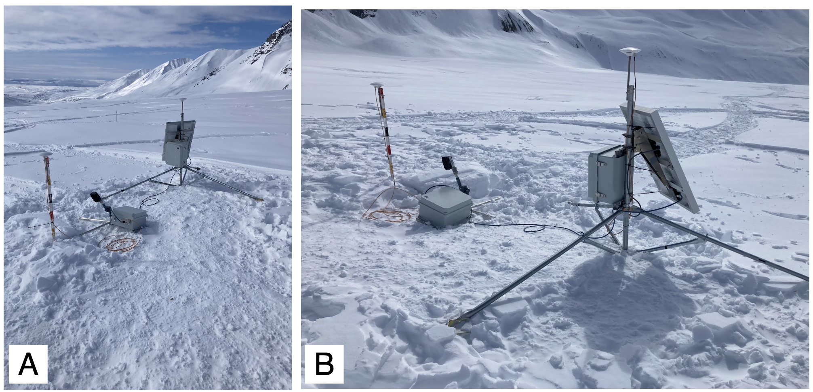
Fig. S1: System setup at Gulkana Glacier site AB on 16 April 2023. Panel A looks down glacier, roughly in the azimuth that supports GNSS-IR.

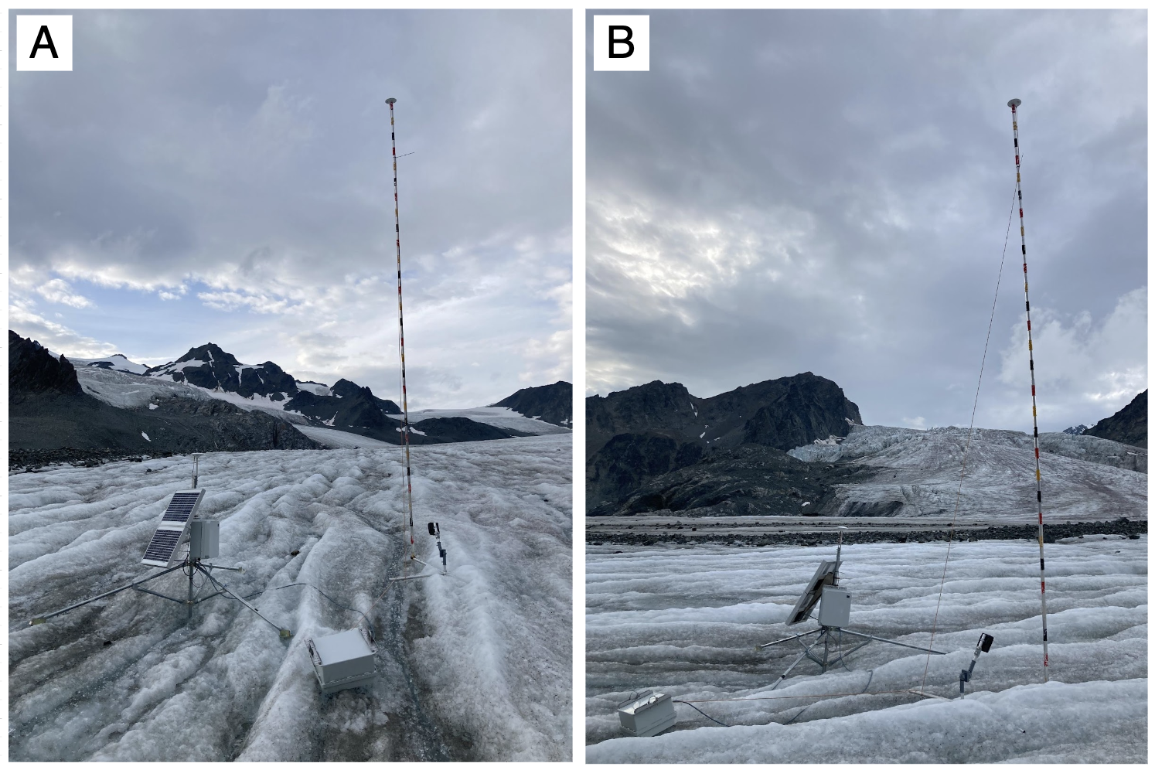
Fig. S2: System setup at Gulkana Glacier site AB on 23 August 2023.

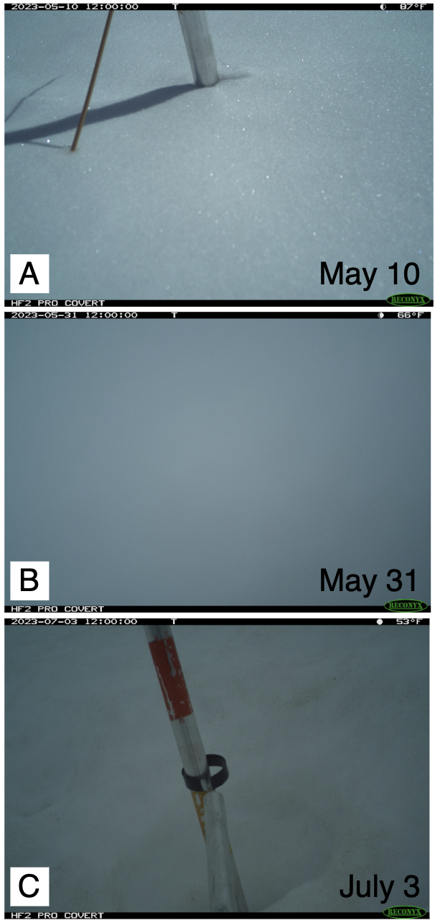
Fig. S3: Examples of monitored banded ablation stake failures: incomplete color band visible (A), camera burial (B), camera rig tilt (C).

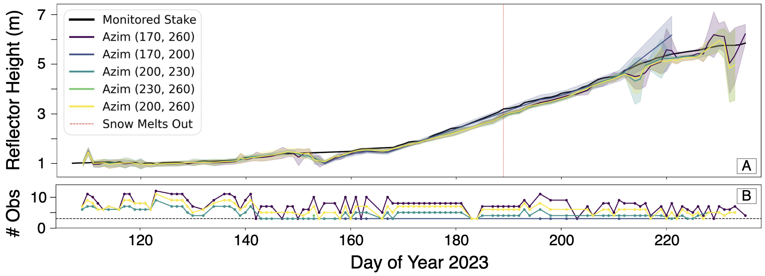
Fig. S4: Gulkana Glacier site AB fixed GNSS-IR reflector height results. Reflector heights partitioned by satellite signal azimuth (A) given at least three observations are available (B). No bias exists between reflectors from different azimuths, although uncertainties increase for azimuth ranges with fewer observations. Note that errors are solely based on the standard deviation of GNSS-IR reflector height locations within each day.

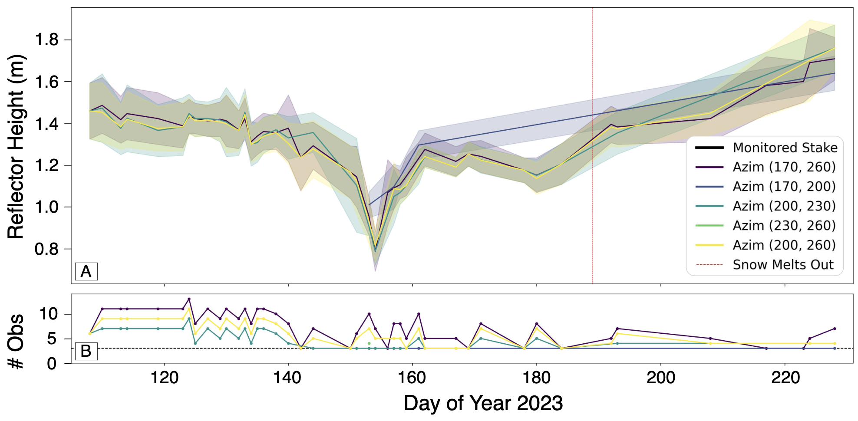
Fig. S5: Gulkana Glacier site AB floating GNSS-IR reflector height results. Same as Fig. S4 except results are shown for the floating system.

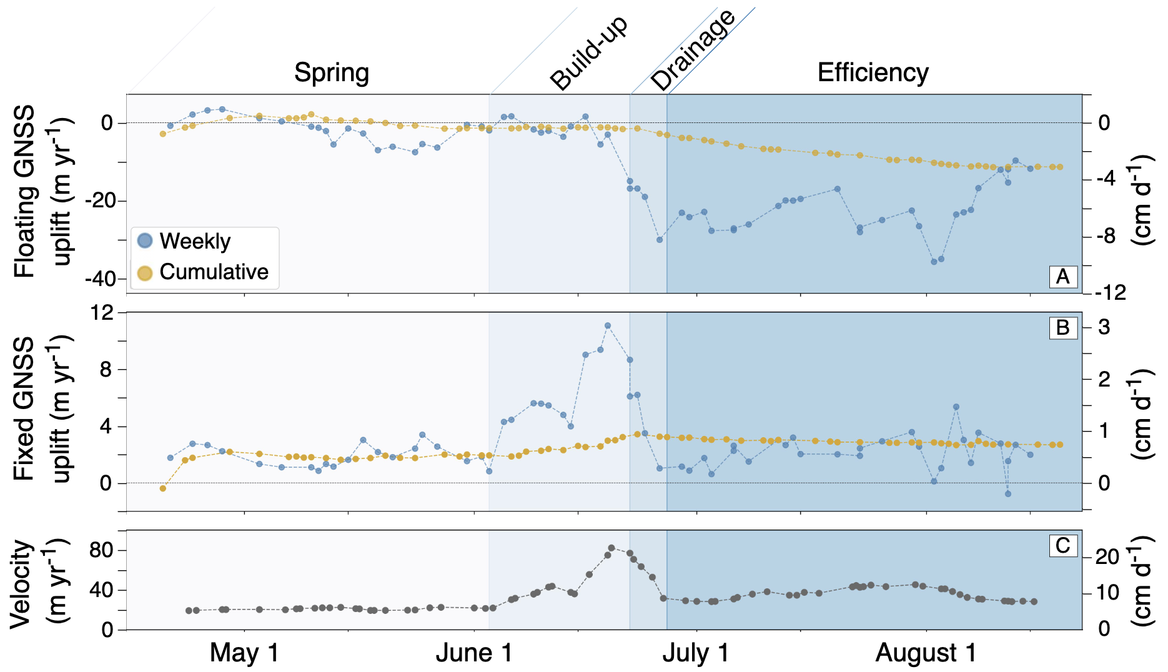
Fig. S6: Gulkana Glacier site AB weekly and cumulative slope-corrected uplift from floating GNSS (A) and fixed GNSS (B). Weekly velocity is also shown (C). Impact of bed separation is clear during build-up and drainage.

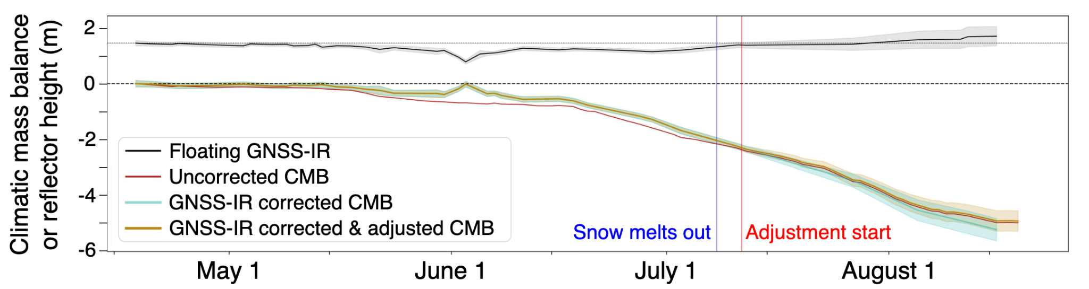
Fig. S7: Gulkana Glacier site AB fixed - floating GNSS climatic mass balance before and after applying a GNSS-IR based correction to account for floating GNSS sinkage into snow. Comparison before accounting for floating system reflector height (black) changes (“uncorrected”), accounting for reflector height changes (“GNSS-IR corrected”), and applying a late-season adjustment for limitations with GNSS-IR method (“GNSS-IR corrected & adjusted”). The adjustment is a constant reflector height in late summer after reflector height increases above its initial height. This avoids adding errors associated with limitations of GNSS-IR on heterogeneous surfaces into the climatic mass balance measurement.

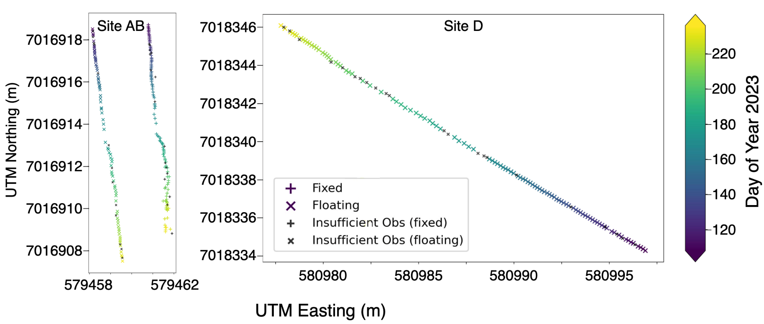
Fig. S8: Gulkana Glacier GNSS system positions at site AB (left) and site D (right). Site AB shows two sets of positions from the fixed GNSS system (right) and the floating GNSS system (left). The data are plotted on equal axes so there is no distortion in the northing or easting directions.

4 SUPPLEMENTARY MATERIAL REFERENCES
Harper JT, Humphrey NF, Pfeffer WT and Lazar B (2007) Two modes of accelerated glacier sliding related to water. Geophysical Research Letters 34(12). doi:10.1029/2007GL030233.
Hoffman AO, Maclennan M, Lenaerts J, Larson KM and Christiansen K (2023) Amundsen Sea Embayment accumulation variability measured with GNSS-IR. The Cryosphere Discussions, 1–28. doi:10.5194/tc-2023-114.
Iken A and Truffer M (1997) The relationship between subglacial water pressure and velocity of Findelengletscher, Switzerland, during its advance and retreat. Journal of Glaciology 43(144), 328–338. doi:10.3189/S0022143000003282.
Krimmel RM (1999) Analysis of Difference Between Direct and Geodetic Mass Balance Measurements at South Cascade Glacier, Washington. Geografiska Annaler: Series A, Physical Geography 81(4), 653–658. doi:10.1111/1468-0459.00093.
Rada C and Schoof C (2018) Channelized, distributed, and disconnected: subglacial drainage under a valley glacier in the Yukon. The Cryosphere 12(8), 2609–2636. doi:10.5194/tc-12-2609-2018.
Takasu T and Yasuda A (2009) Development of the low-cost RTK-GPS receiver with an open source program package RTKLIB. URL: https://www.rtklib.com/

