# Supporting information for “Thickness of Ruth Glacier, Alaska, and Depth of its Great Gorge from Ice-Penetrating Radar and Mass Conservation”

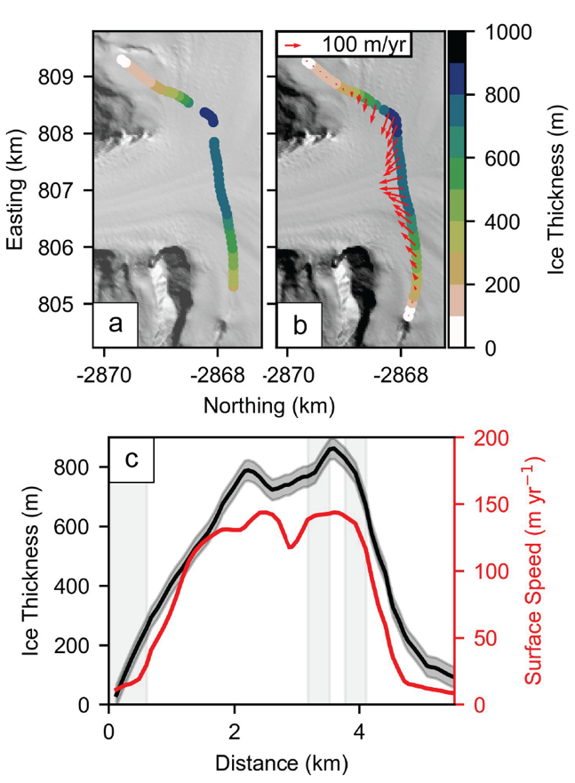

**Figure S1.** Groundhog radar-derived ice influx gate to Ruth Glacier’s Great Gorge. (a) Groundhog radar-derived measurements of ice thickness along a profile crossing the entrance to the gorge. (b) Ice thickness measurements along the same profile as in (a), with holes filled through cubic spline, and the tails extrapolated to zero-thickness at the glacier’s boundary. Glacier surface velocity vectors in red from ITS_LIVE. (c) Ice thickness and ITS_LIVE surface velocity along the Groundhog radar-derived gate shown in (a,b), providing ice influx to the gorge. Black shaded area surrounding ice thickness profile represents Groundhog ice thickness measurement uncertainty. Gray vertical shaded regions indicate positions along the influx gate where holes were filled.

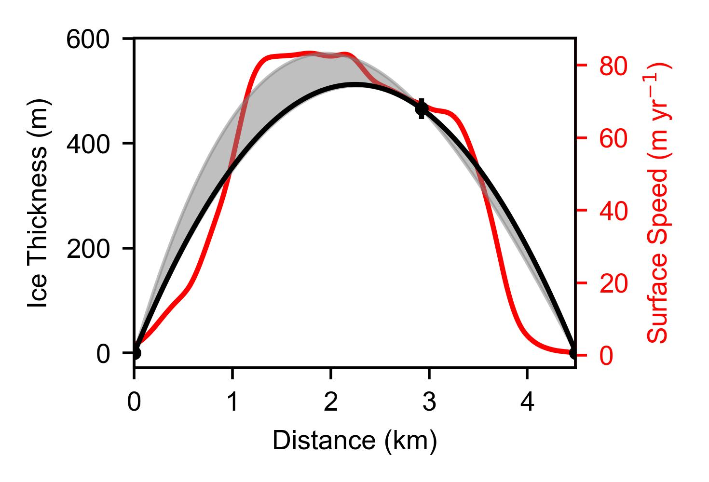

**Figure S2.** ARES radar-derived ice flux through a gate on the lower Ruth Glacier ~15 km up-glacier from the terminus. The ITS_LIVE surface speed profile (red) indicates the potential for an asymmetric cross-flow bed shape. Solid black line indicates symmetric ice thickness profile constrained by ARES radar-derived measurements along a near-centerline profile and the glacier valley edges (blue circles, with vertical error bars corresponding to radar measurement uncertainty). Gray shaded area represents uncertainty related to the potential for an asymmetric bed shape.

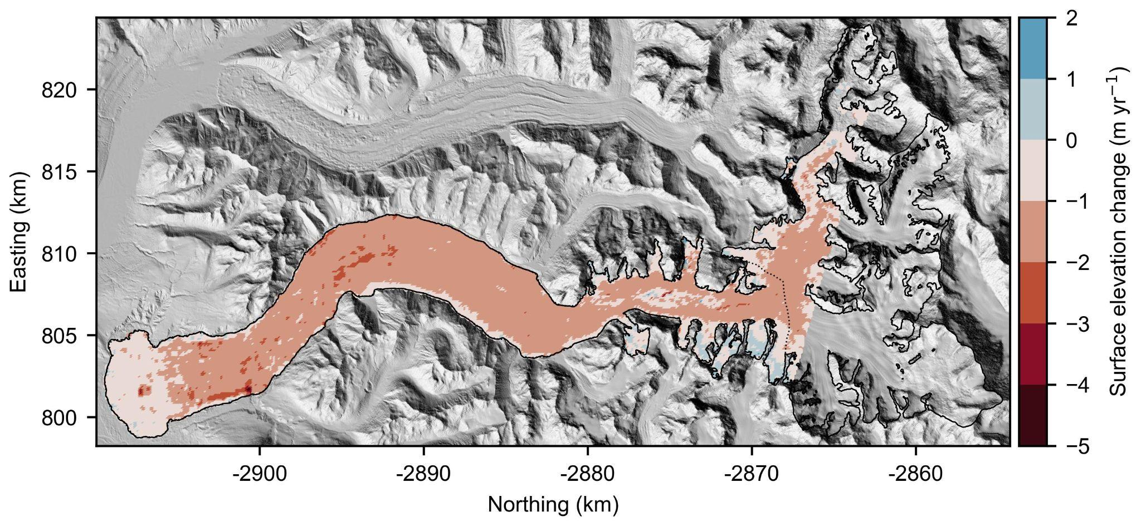

**Figure S3.** Ruth Glacier average rates of surface elevation change for the 2000–2019 period from [Hugonnet et al. (2021)](https://www.zotero.org/google-docs/?BXZoEk). Dashed line indicates the Groundhog profile used to constrain the ice influx to the Great Gorge (Figure S1) and thus the up-glacier extent of our model domain.

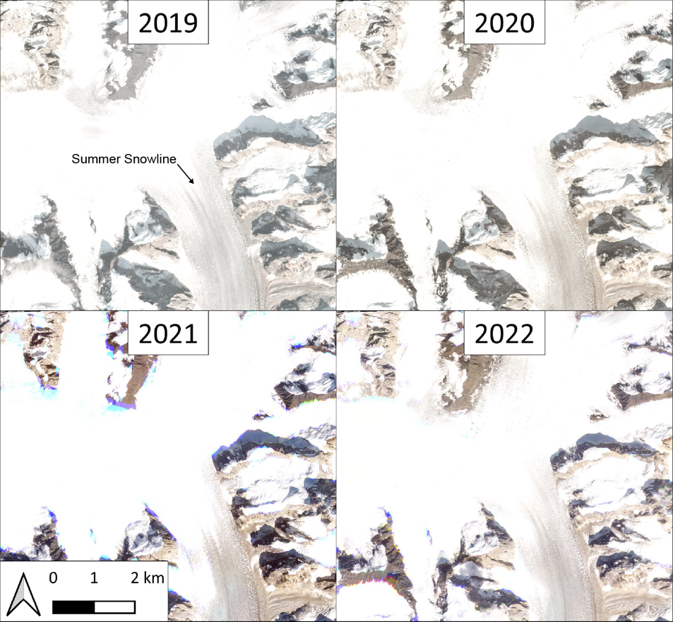

**Figure S4.** PlanetScope imagery from summer (top left) 2019, (top right) 2020, (lower left) 2021, and (lower right) 2022 illustrating the relatively stable snowline at approximately the entrance to the Great Gorge, corresponding to a surface elevation of ~1550 m in reference to the WGS 84 ellipsoid.

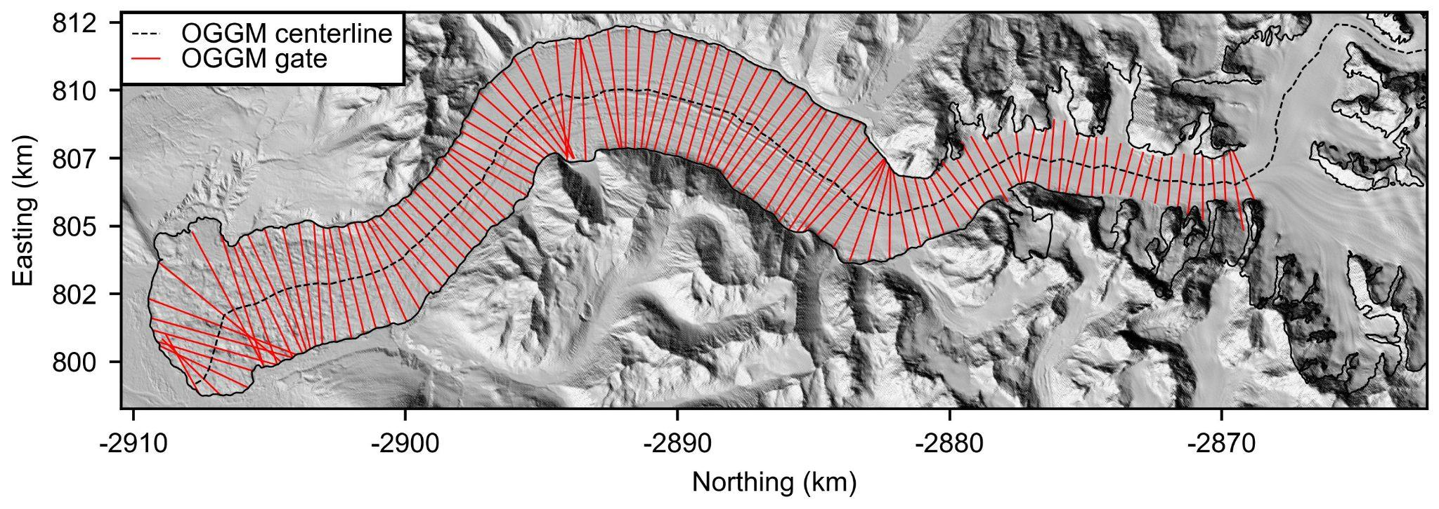**Figure S5.** Ruth Glacier main centerline (dashed black line) and cross-flow transects (red lines) provided by the Open Global Glacier Model (OGGGM; [Maussion et al., 2019)](https://www.zotero.org/google-docs/?WkIdmZ). Ice thickness was estimated across cross-flow transect between radar-constrained gates in the amphitheater and along lower Ruth Glacier.

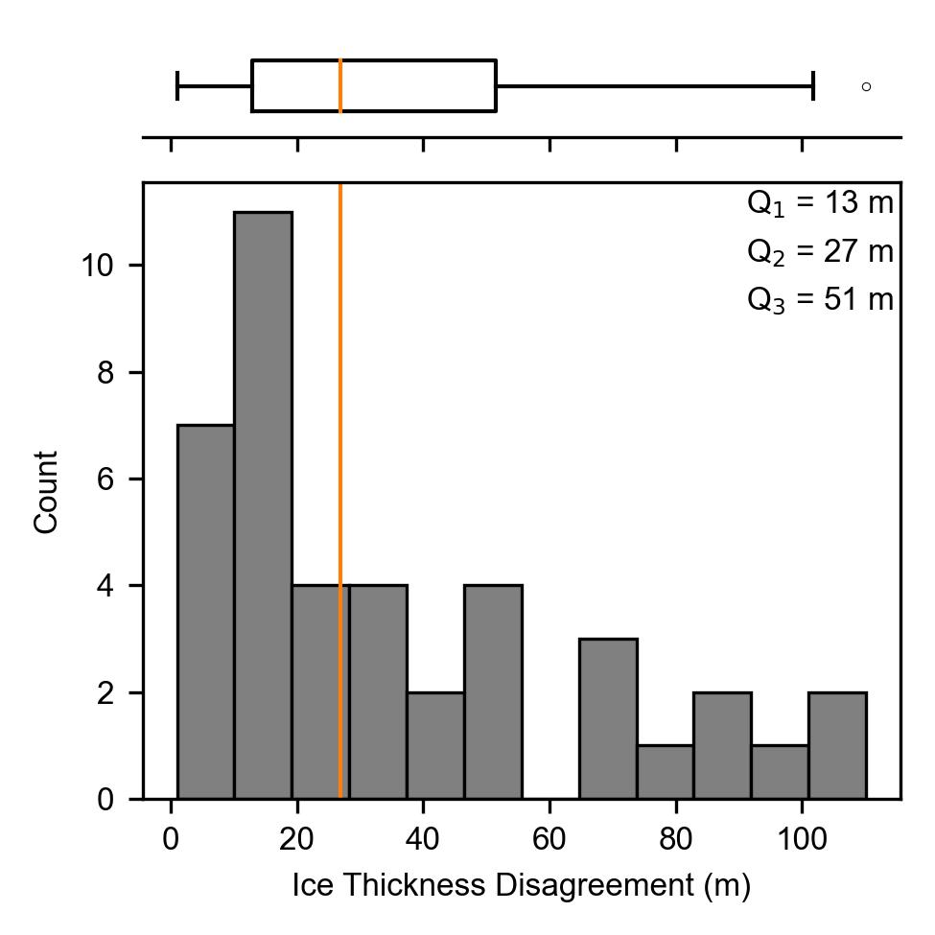

**Figure S6.** Statistical analysis of crossover disagreement between Groundhog radar-derived measurements of ice thickness. Qn denotes the nth quantile. Orange line in the upper boxplot (and histogram) corresponds to the median (Q2). The left and right edges of the box correspond to the first quantile (Q1) and third quantile (Q3), respectively. Outliers beyond boxplot tails are shown by white circles. Histogram count corresponds to the number of radar measurements crossings.

**Table S1.** Radar constrained flux entering the Great Gorge ($q_{in}$), down-glacier flux ($q_{out}$), and specific mass balance ($B_{a}$) between radar-constrained flux gates required by mass conservation for the range of $γ$-factors considered in this study. 1 is for a symmetric bed shape at the down-glacier radar-constrained flux gate, while 2 is for an asymmetric bed shape (Figure S2).

|  |  |  |  |  |  |
| --- | --- | --- | --- | --- | --- |
|  | (km3 yr-1) | (km3 yr-1) | (km3 yr-1) | (m w.e. yr-1) | (m w.e. yr-1) |
| 0.825 | 0.19 | 0.05 | 0.06 | -2.33 | -2.24 |
| 0.85 | 0.20 | 0.06 | 0.07 | -2.37 | -2.28 |
| 0.875 | 0.20 | 0.06 | 0.07 | -2.41 | -2.31 |
| 0.9 | 0.21 | 0.06 | 0.07 | -2.45 | -2.35 |
| 0.925 | 0.21 | 0.06 | 0.07 | -2.48 | -2.38 |
| 0.95 | 0.22 | 0.06 | 0.07 | -2.52 | -2.42 |
| 0.975 | 0.22 | 0.06 | 0.08 | -2.56 | -2.45 |

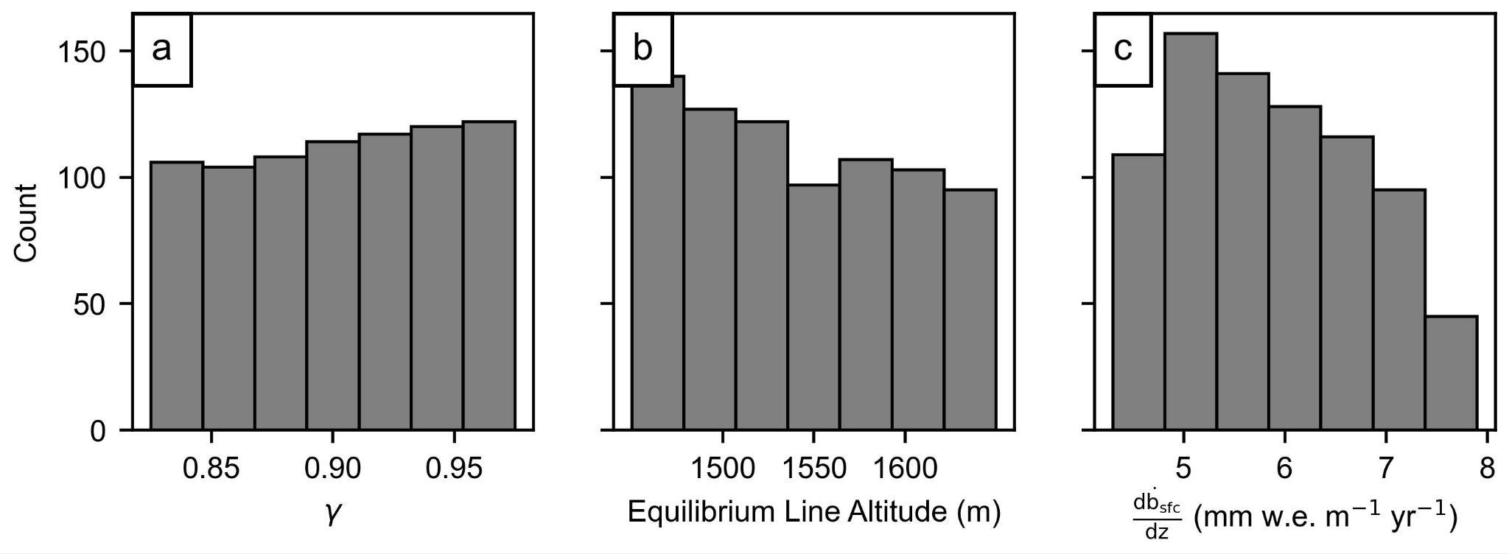

**Figure S7.** Distribution of mass conservation model parameters which were simulated to invert for bed position across the model domain.

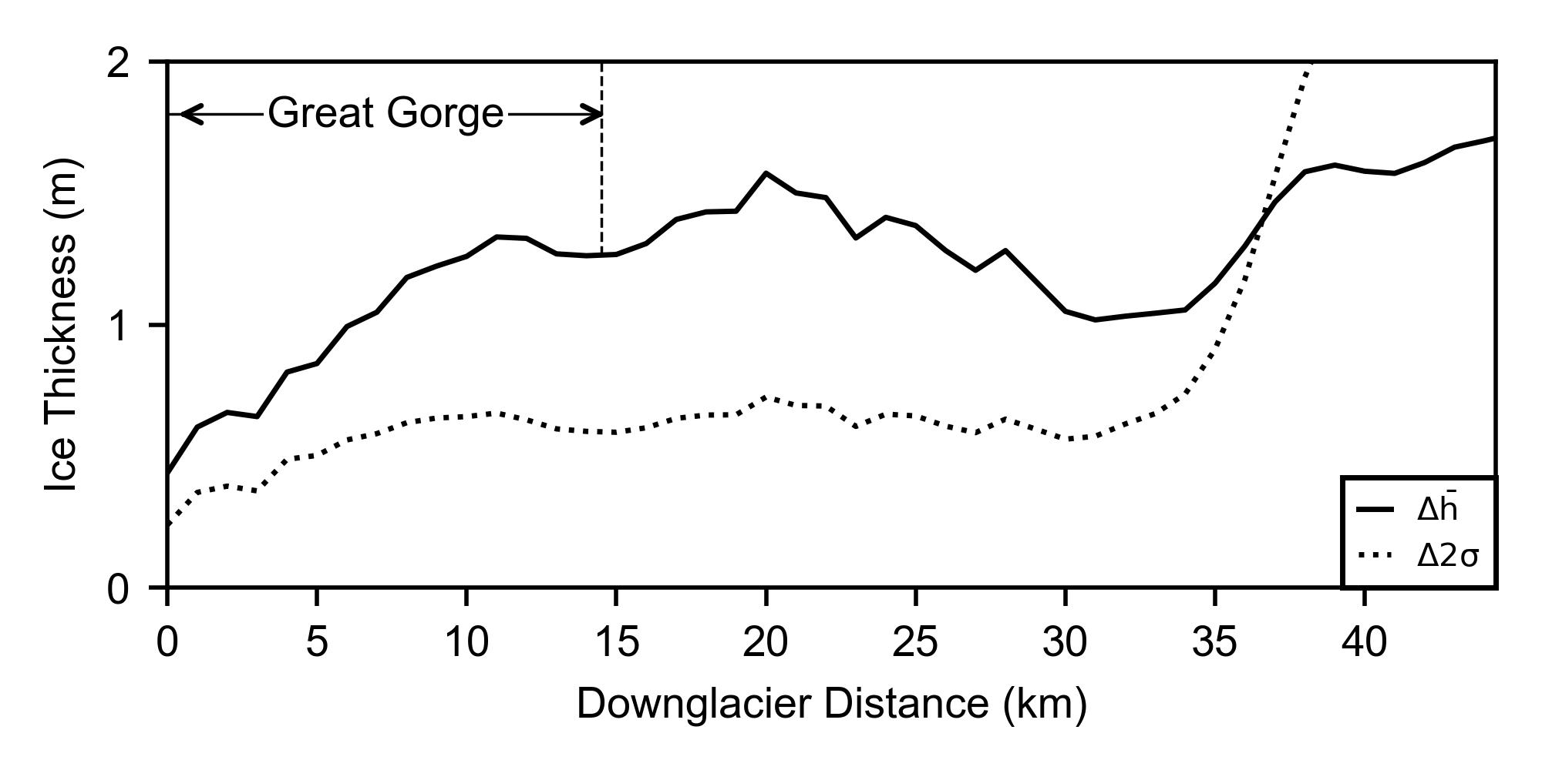

**Figure S8.** Comparison showing the absolute deviation between the mean centerline thickness solution and 2σ uncertainty for all model runs which produced a relative down-glacier ice flux misfit of less than 25% and those which produced a relative down-glacier ice flux misfit of less than 10%.

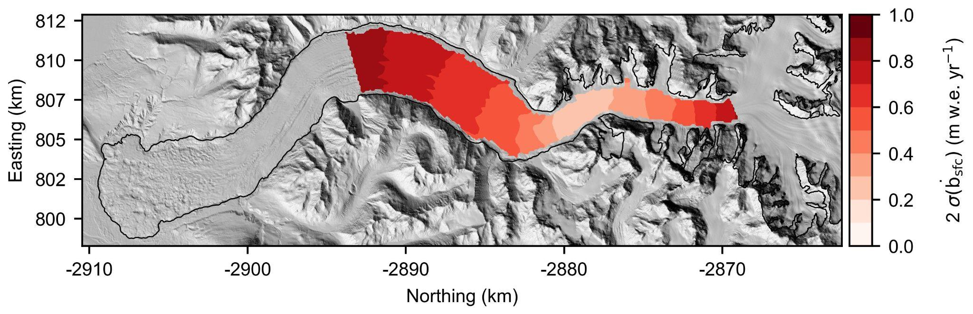

**Figure S9.** 2σ uncertainty in modeled glacier surface mass balance between radar-constrained ice flux gates.