**Supplement Figures:**

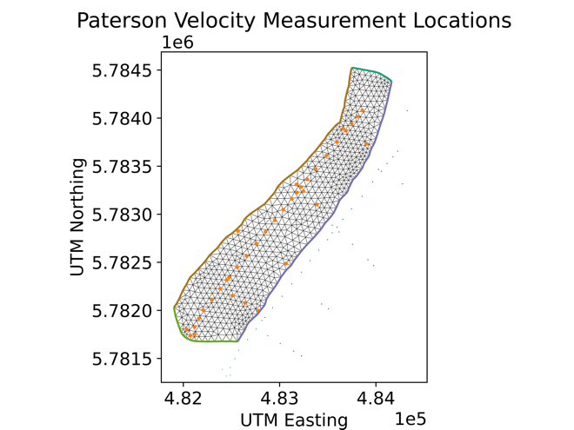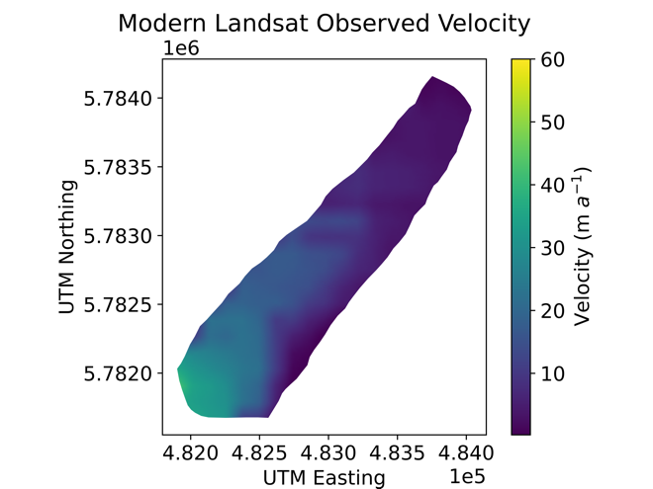

**b**

**a**

**Fig. S1.** a) Locations of historical velocity point measurements in the 1960s (Paterson, 1962) and b) Landsat derived surface velocities from 2018 (Armstrong, 2022).

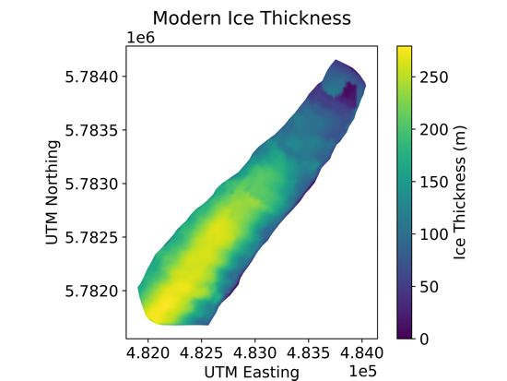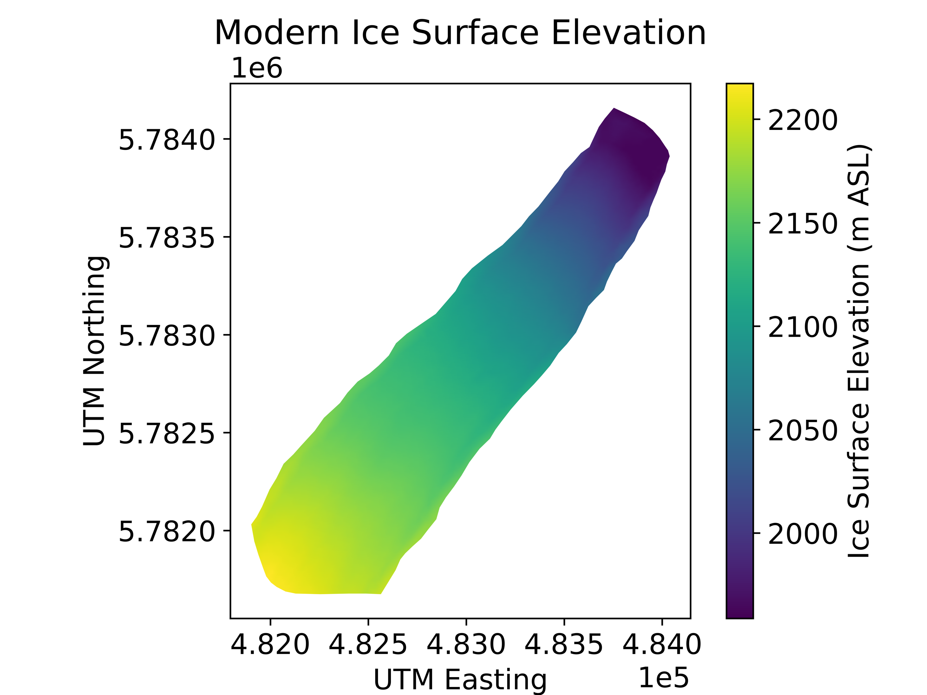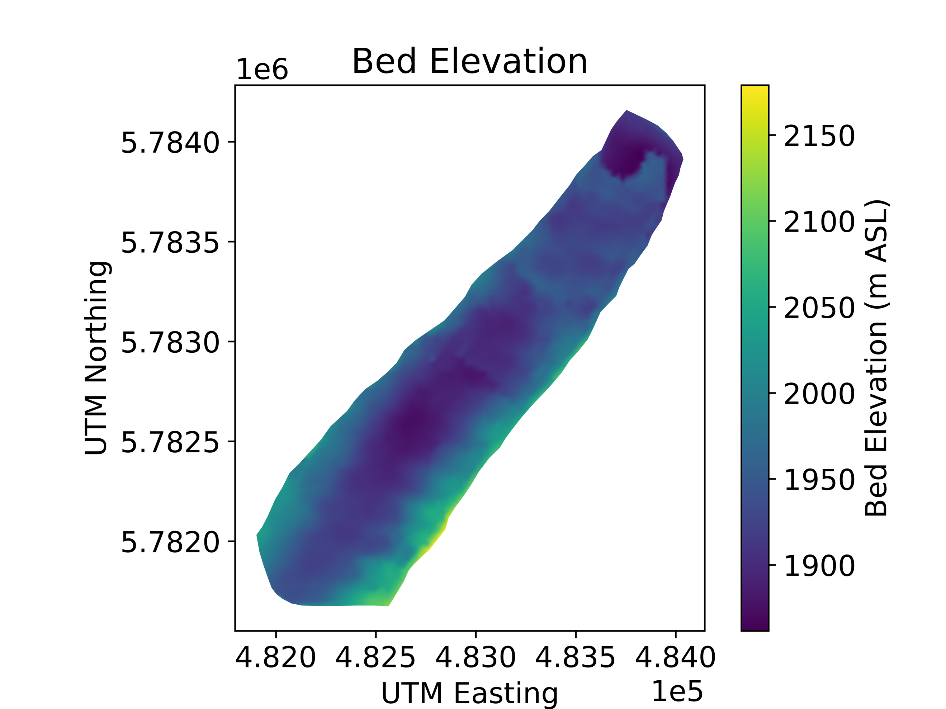

**a**

**b**

**c**

**Fig. S2.** Modern day input parameters used to initialize 3D-hybrid model in Icepack to invert for basal friction. a) Ice surface elevation from Menounos and others 2019. b) Ice thickness from Armstrong and others 2022 and Farinotti and others 2019. c) Bed elevation derived as the difference between panels a and b.

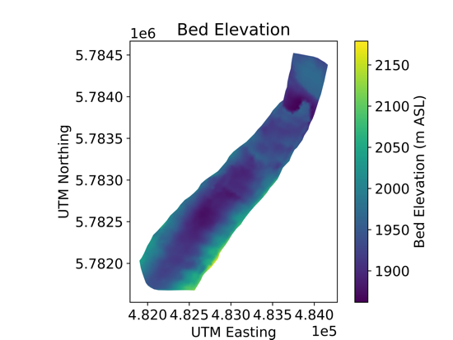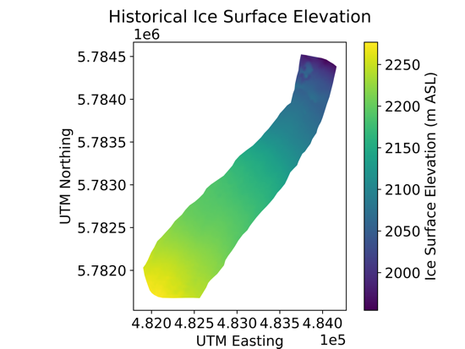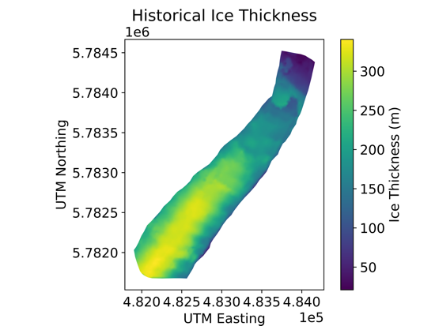

**a**

**b**

**c**

**Fig. S3.** Historical input parameters used to initialize 3D-hybrid model in Icepack to invert for basal friction. a) Ice surface elevation from (Armstrong and others 2022; Menounos and others 2019; Tennant and Menounos, 2013) b) Ice thickness derived as the difference between panels a and c. c) Bed elevation derived as the difference between modern surface elevation and ice thickness above in Fig. S1.

**Fig. S4.** Change in ice thickness throughout the model domain from historical to modern glacier geometries. Thinning rates of approximately 1 meter per year yield 50-60 m decreases in ice thickness throughout much of Athabasca Glacier.

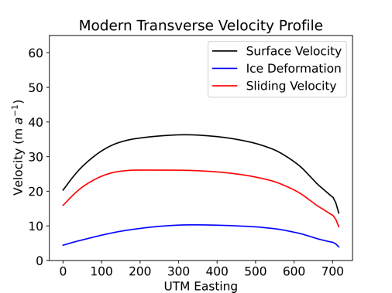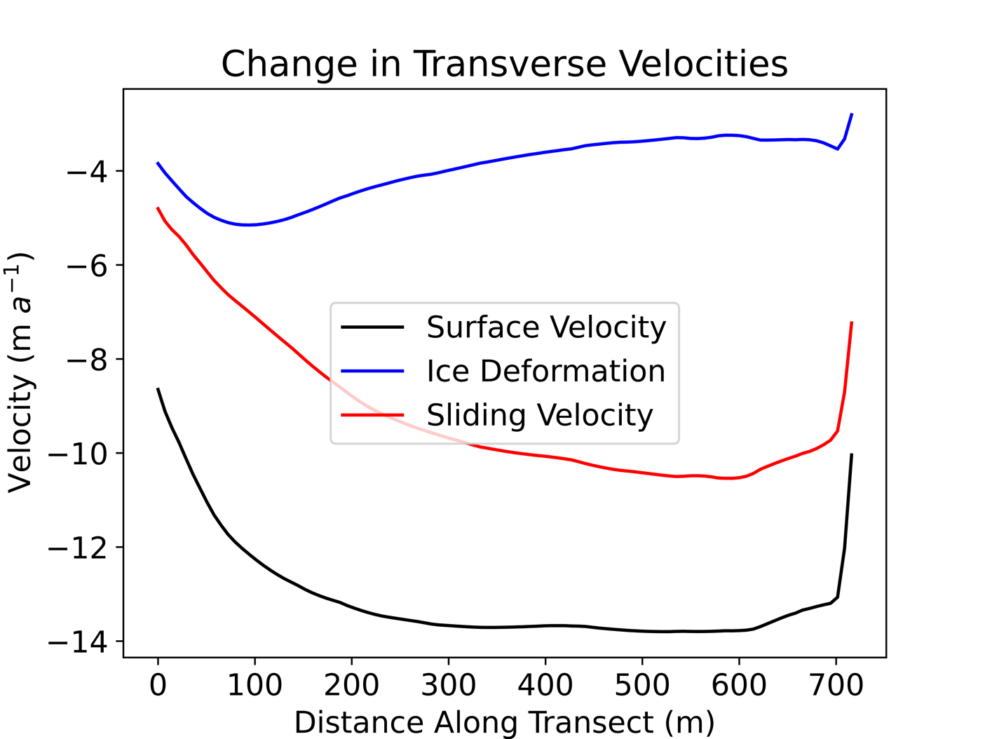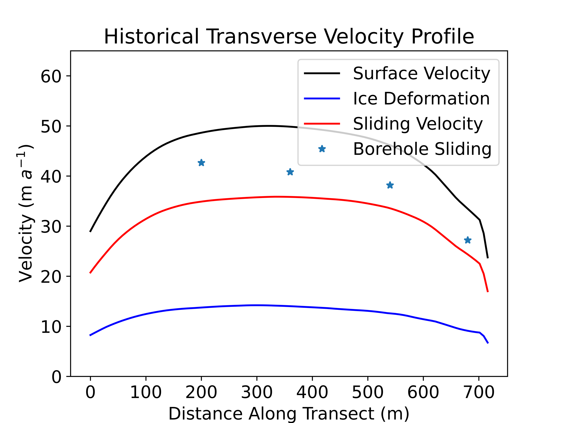

**a**

**b**

**c**

**Fig. S5.** Results from 3D Icepack model friction inversion. Surface (black), basal (red), and ice deformation velocities along a transverse valley profile for a historical (a) and modern (b) parameterization of Athabasca Glacier. The profile (x=0) begins on the western margin of Athabasca Glacier (seen in Fig. S6). A majority of the total decline in ice velocity is attributable to a decline in basal velocities (c).

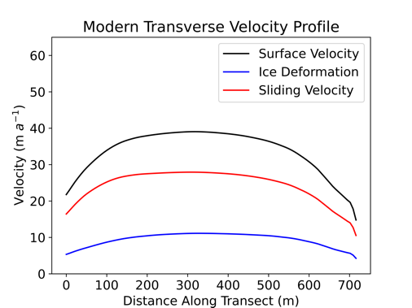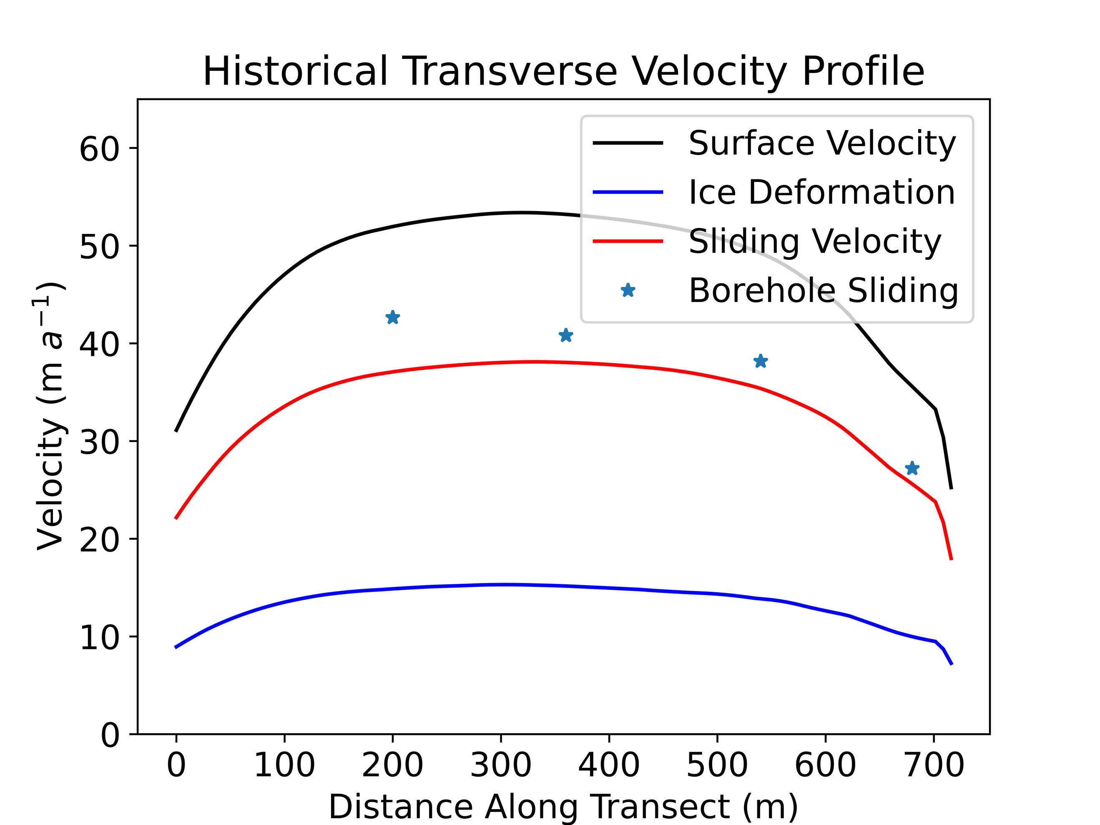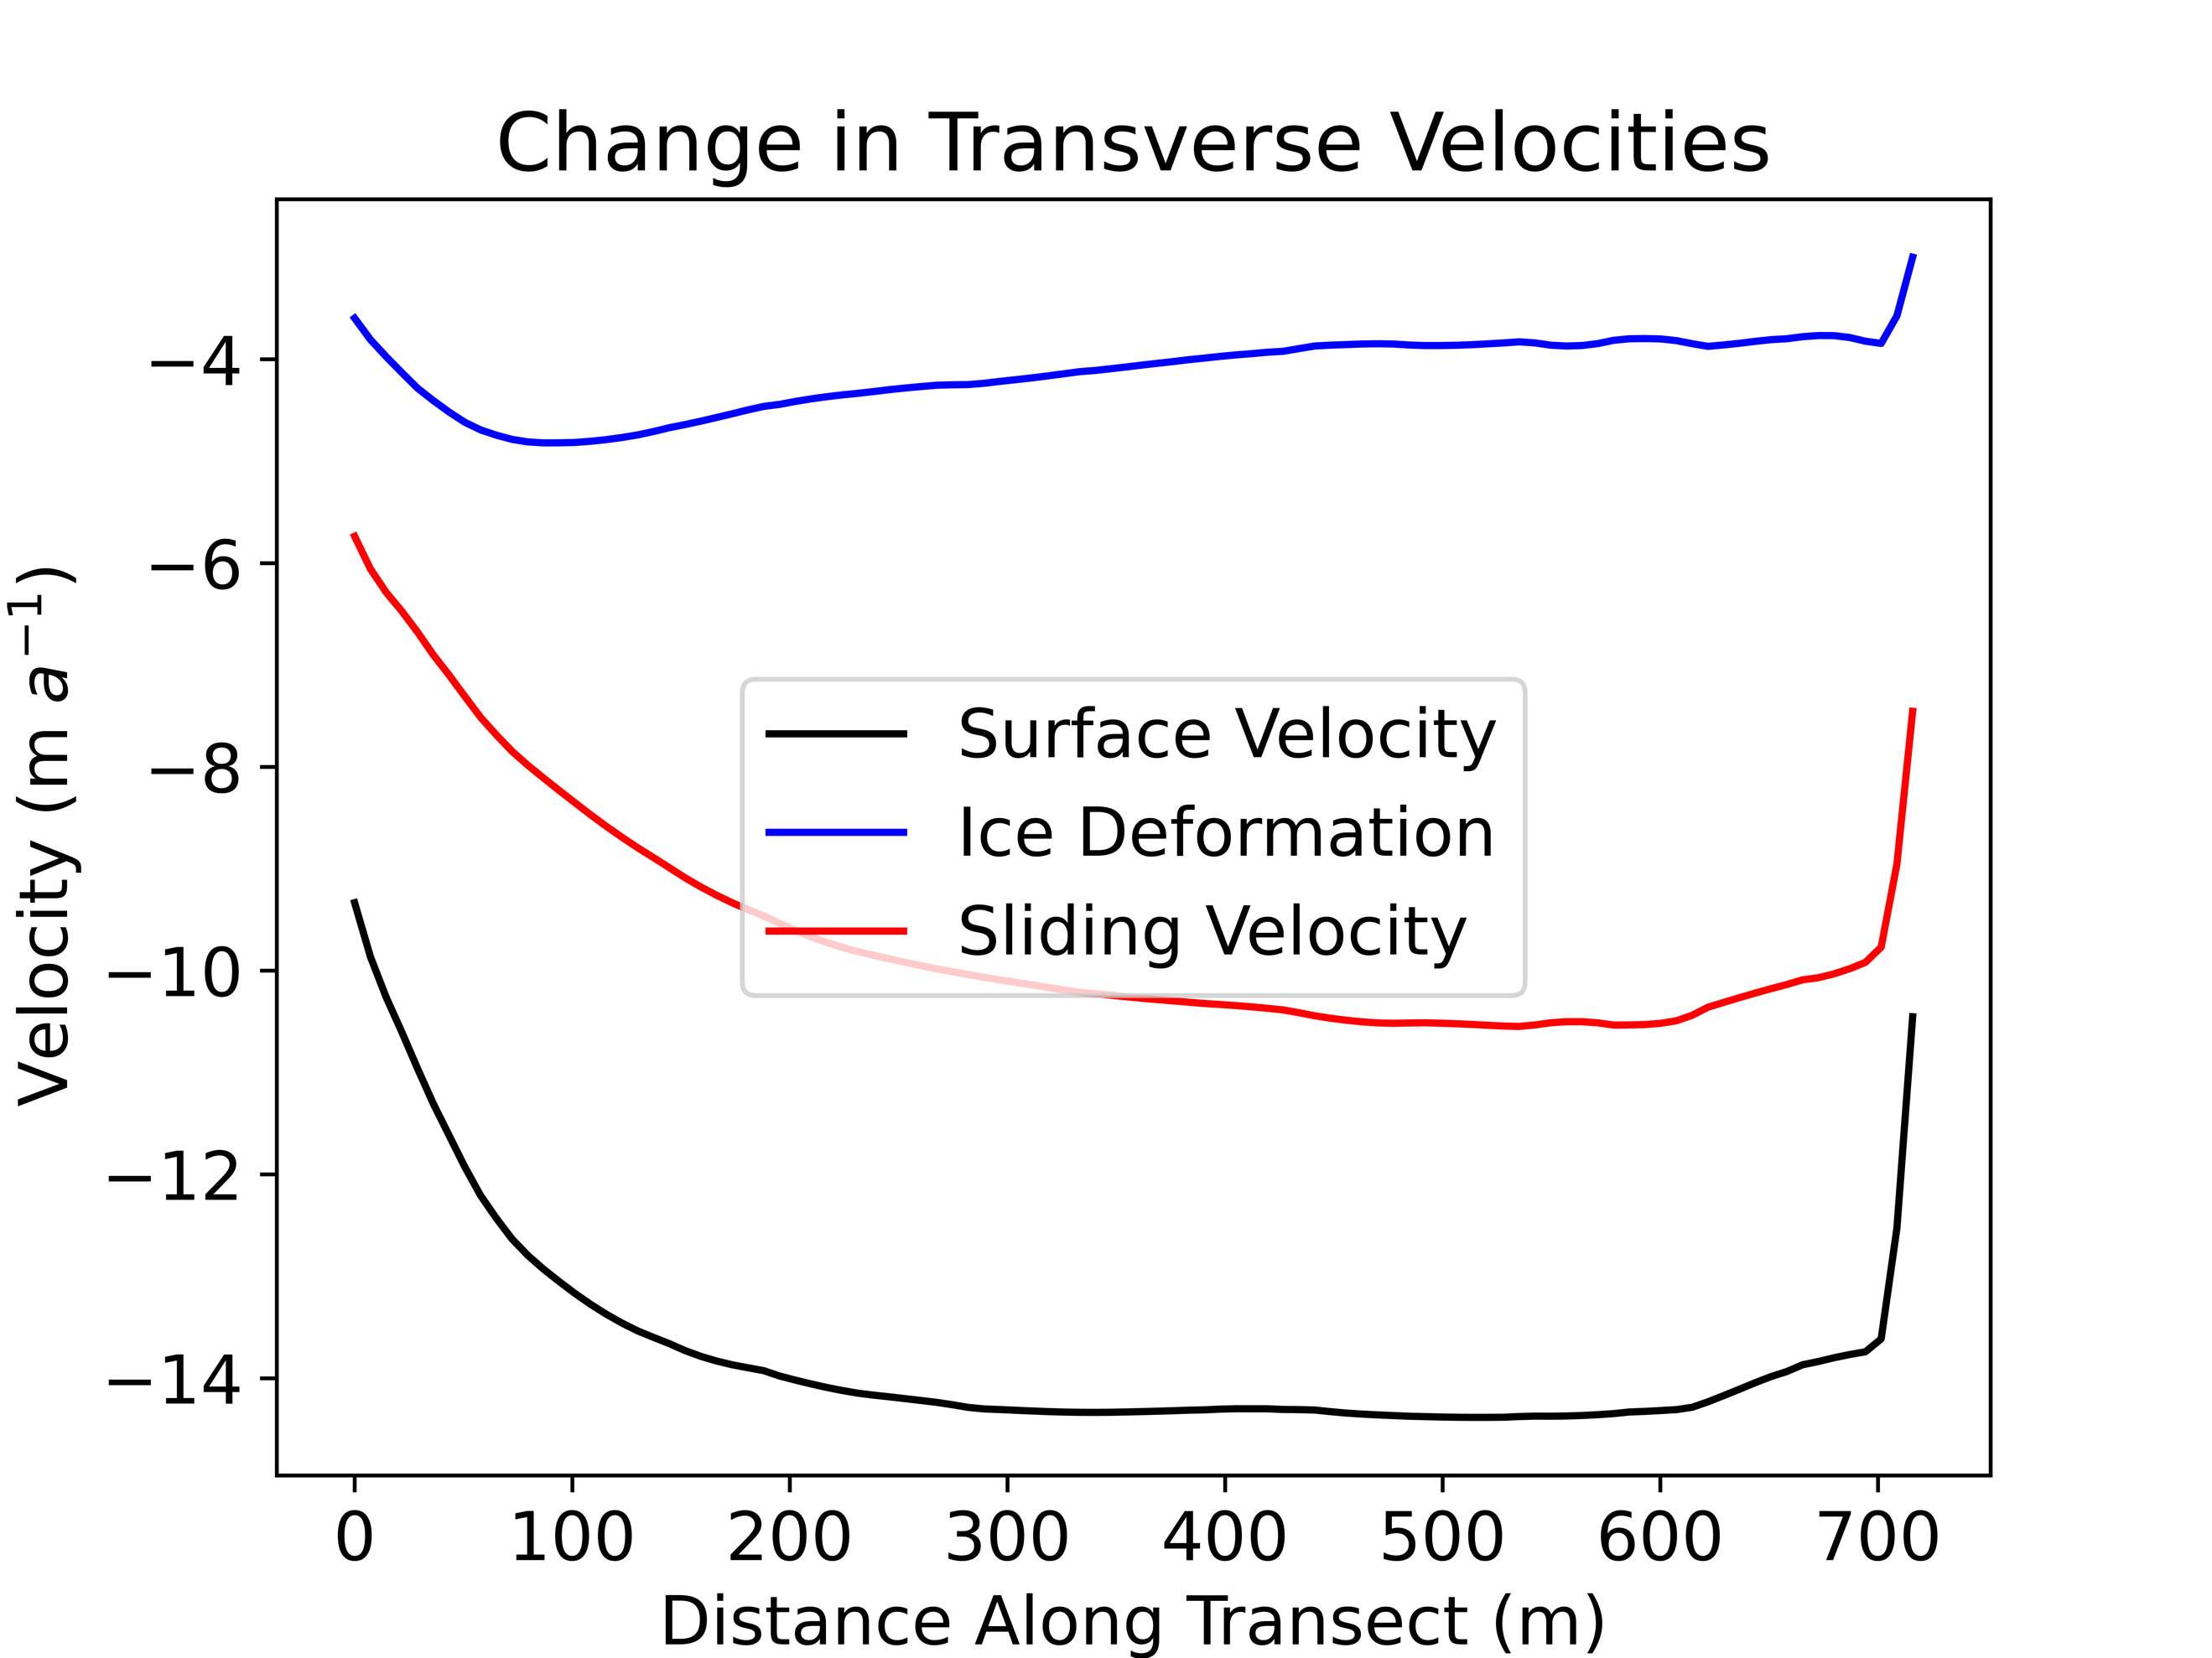

**a**

**b**

**c**

**Fig. S6.** Results from friction inversion for a historical (a) and modern (b) parameterization of Athabasca Glacier using ice rheology values of *n*=3 and *A*=3.2×10-24 Pa-3 s-1. Minimal changes in ice deformation velocities, on the order of 1 m a-1 are observed along the same transverse profile from Fig. S5 using *n*=3 and *A*=2.70×10-24 Pa-3 s-1 (c).

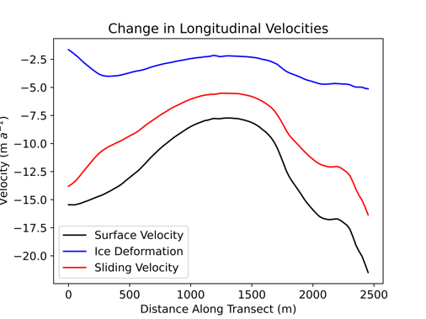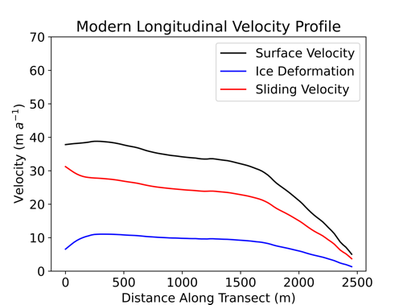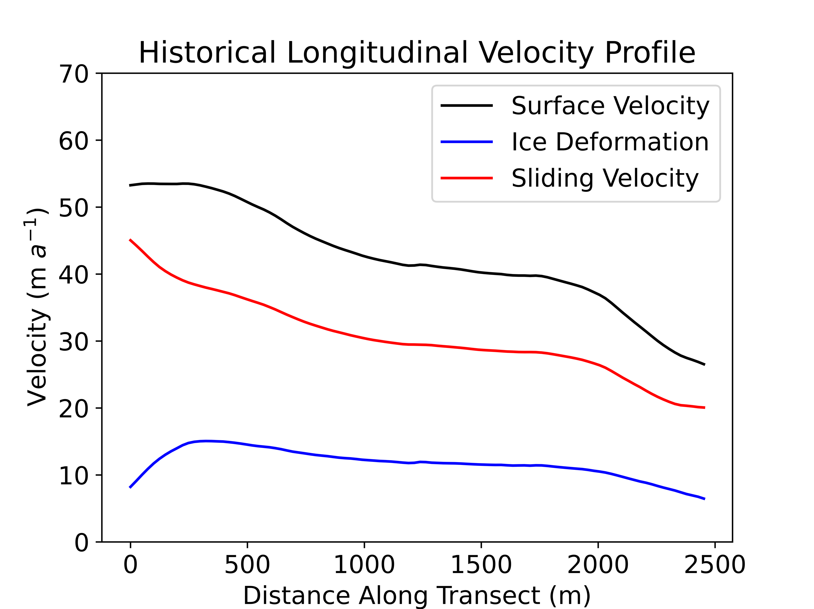

**a**

**b**

**c**

**Fig. S7.** Results from friction inversion for a historical (a) and modern (b) parameterization of Athabasca Glacier using ice rheology values of *n*=3 and *A*=3.2×10-24 Pa-3 s1. Minimal changes in ice deformation velocities, on the order of 1 m a-1 are observed along the same longitudinal profile from Fig. 8 using *n*=3 and *A*=2.70×10-24 Pa-3 s-1 (c).

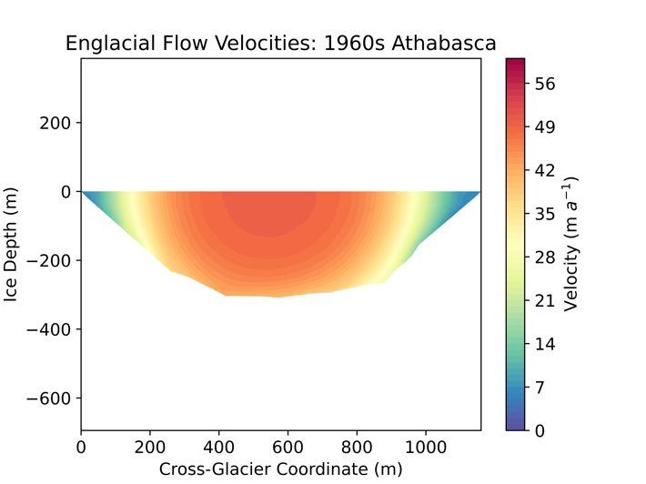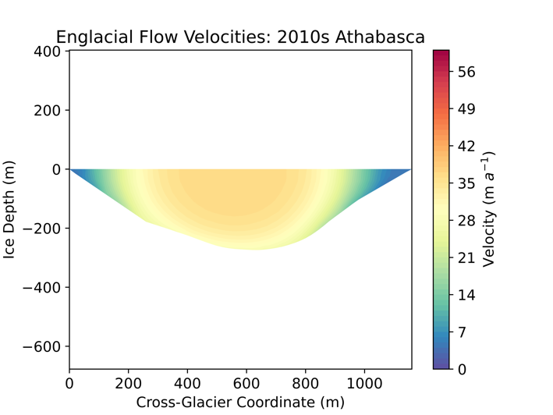

**a**

**b**

**Fig. S8.** Results from 2D valley cross-section Poisson model. a) Cross sectional view of modeled englacial and basal velocities in the late 1960s with basal velocities as constrained by Raymond (1971) and b) 50 years later in the late 2010s with a 30% decline in basal velocities.

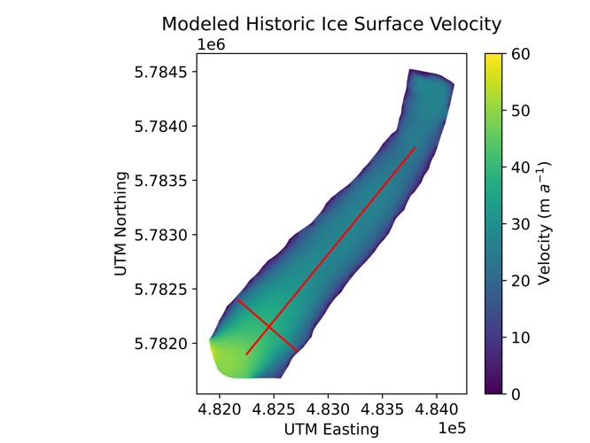

**a**

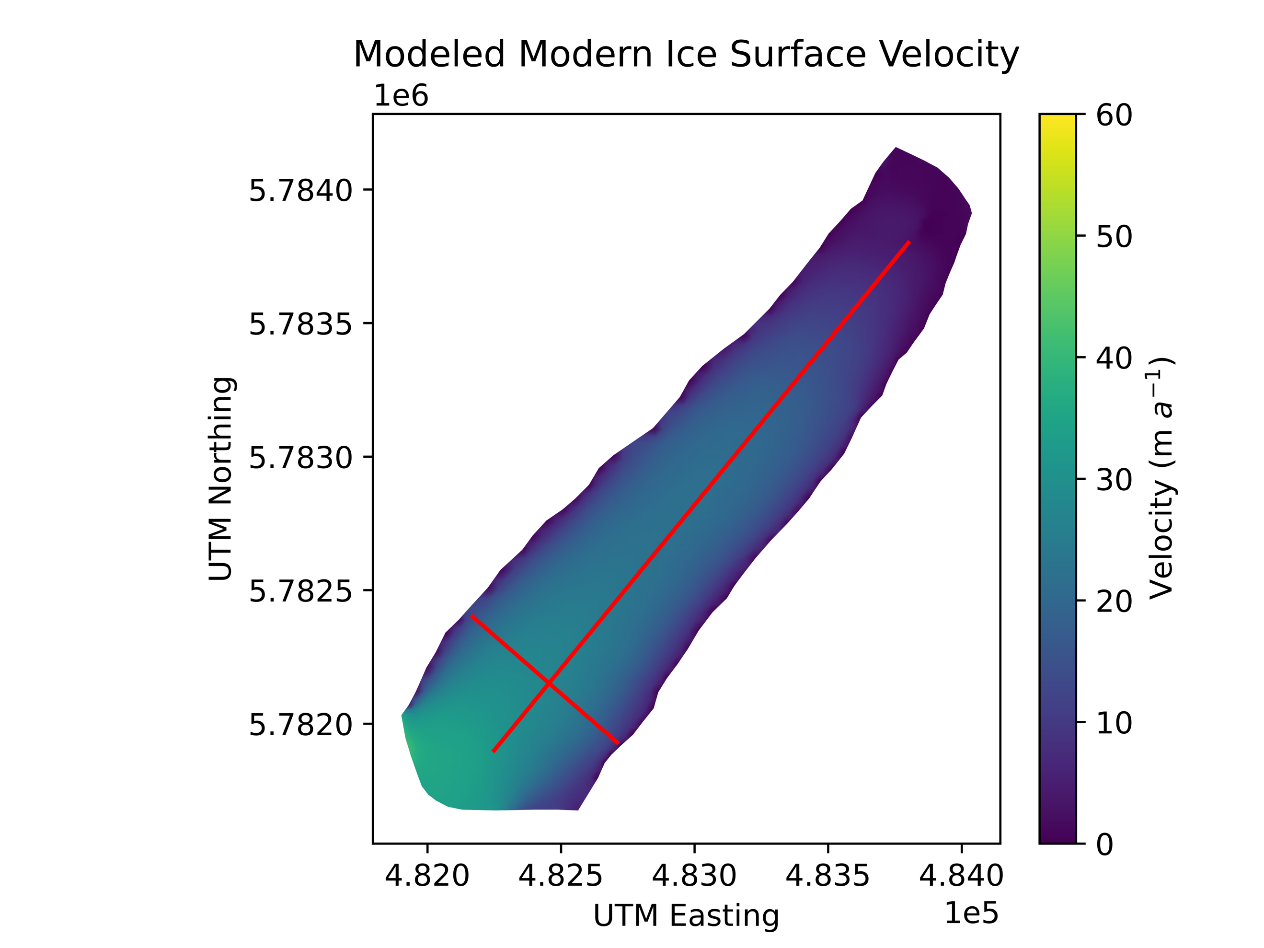

**b**

**Fig. S9.** Surface velocity fields inferred from model inversions for a historical (a) and modern (b) parameterization of Athabasca Glacier. Total surface velocities have declined across the entire glacier surface over the past 50 years.