Supplementary Information:
Potential threats of glacial lake changes to the Sichuan-Tibet railway
Menger Peng^{1, 2}, Guoqing Zhang¹, Jinyuan Yu³, Weicai Wang¹, Fenglin Xu^{1, 2}, Sonam Rinzin^{1,4}

¹ State Key Laboratory of Tibetan Plateau Earth System, Environment and Resources (TPESER), Institute of Tibetan Plateau Research, Chinese Academy of Sciences, Beijing, China
² University of Chinese Academy of Sciences, Beijing, China
³ School of Ecology and Environment, Tibet University, Lhasa, China
⁴ School of Geography, Politics, and Sociology, Newcastle University, United Kingdom

Correspondence: Guoqing Zhang (guoqing.zhang@itpcas.ac.cn)

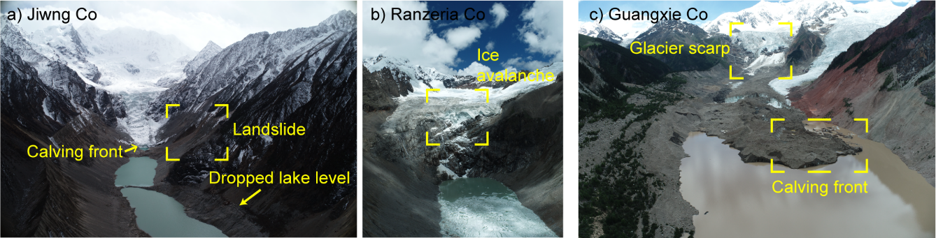Fig. S1 Surveyed historical outburst lakes. a) Jiweng Co, b) Ranzeria Co, c) Guangxie Co.

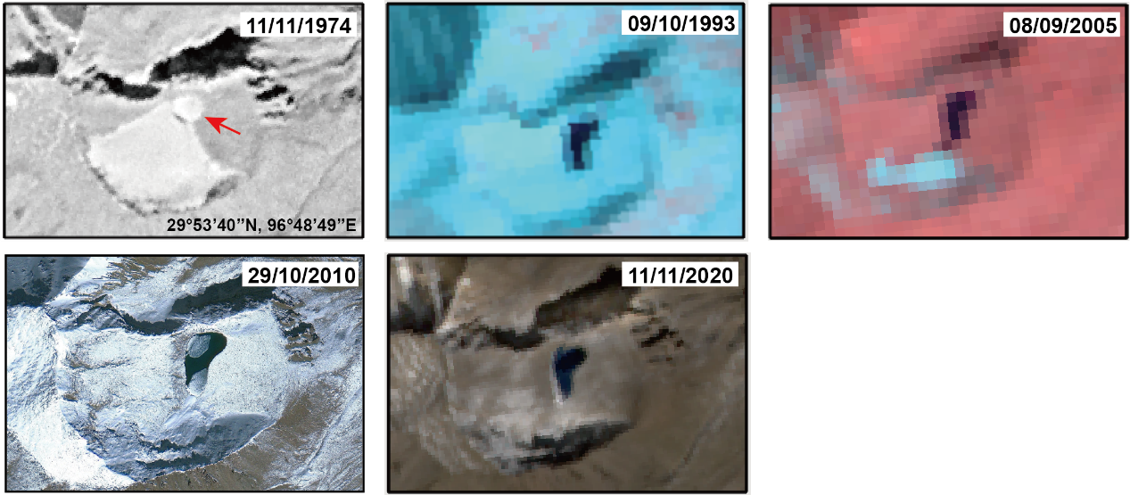

Fig. S2 Time series of the disappearance of a glacier with a lake transforming from proglacial into non-glacier-fed.

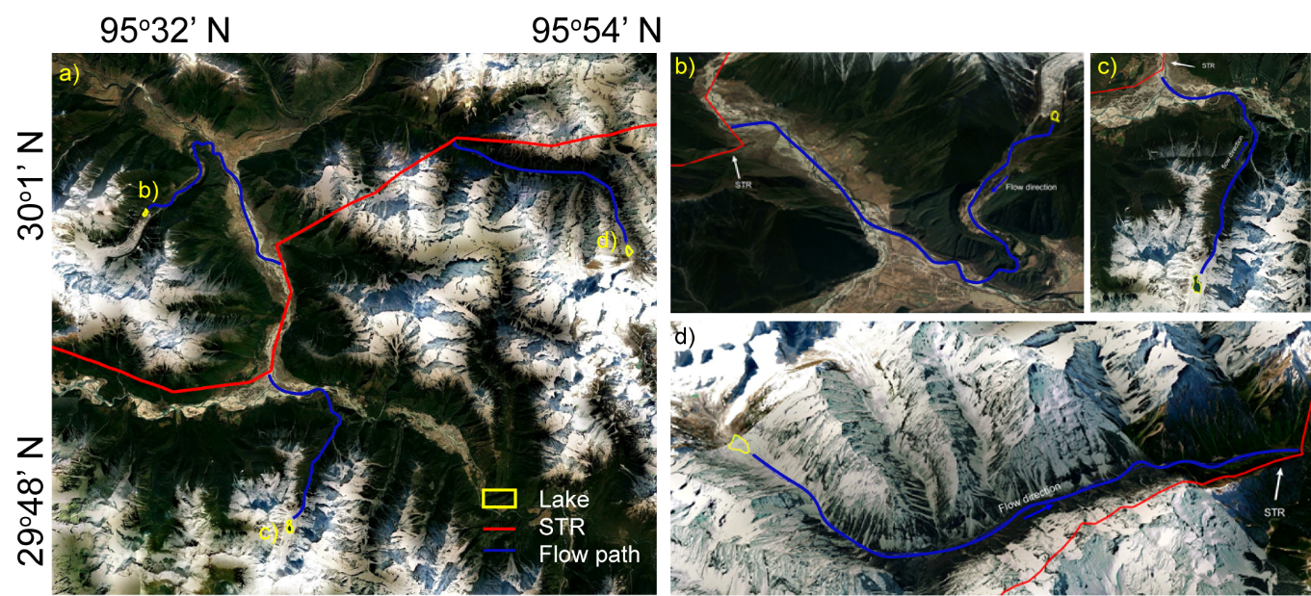
Fig. S3 Overview of GLOF high susceptibility lakes that may threat the STR.

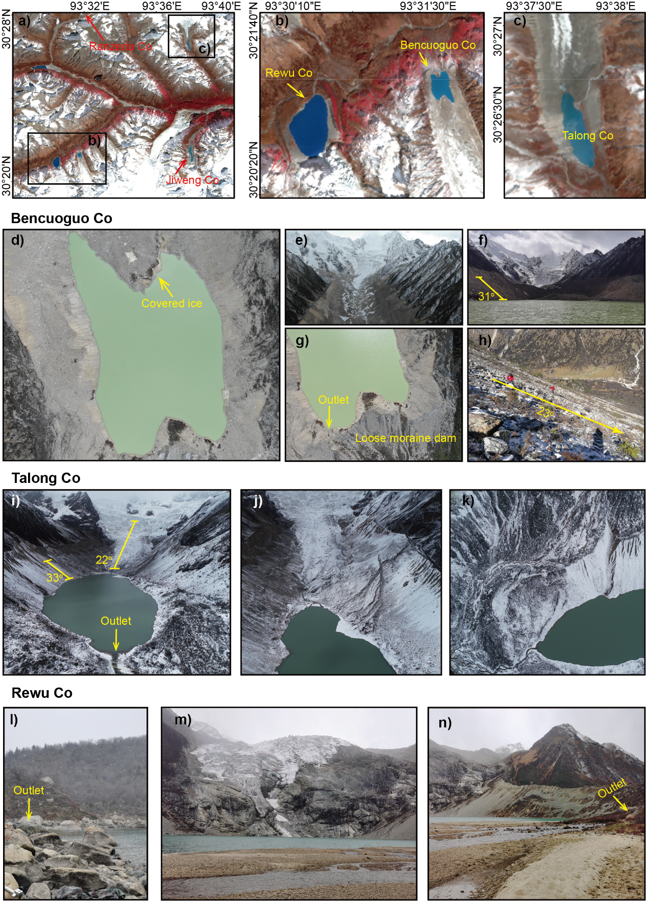
Fig. S4 Investigated lakes that are hazardous. a) The overview of the location of these three hazardous lakes, including Rewu Co, Bencuoguo Co, and Talong Co, and two outburst lakes, Jiweng Co and Ranzeria Co. b) The overview of Rewu Co and Bencuoguo Co. c) The overview of Talong Co. d–h) The detailed survey photo of Bencuoguo Co. i–k) The detailed survey photo of Talong Co. l–n) The detailed survey photo of Rewu Co.

Table S1. The list of Chinese meteorological stations whose data were utilized in this study.

Station number | Name | Latitude/(º) | Longitude/(º) | Elevation/m | Start year | End year
55299 | Naqu | 3129 | 9204 | 4507 | 1955 | 2017
55493 | Damxung | 3029 | 9106 | 4200 | 1963 | 2018
55593 | Maizhokunggar | 2951 | 9144 | 3804 | 1978 | 2018
56116 | Dêngqên | 3125 | 9536 | 3873 | 1955 | 2018
56128 | Riwoqê | 3113 | 9636 | 3810 | 1979 | 2018
56137 | Qamdo | 3109 | 9710 | 3306 | 1955 | 2018
56144 | Dêgê | 3148 | 9835 | 8184 | 1957 | 2018
56223 | Lhorong | 3045 | 9550 | 3640 | 1979 | 2018
56227 | Bomê | 2952 | 9546 | 2736 | 1961 | 2018
56228 | Baxoi | 3003 | 9655 | 3260 | 1980 | 2018
56257 | Litang | 3000 | 10016 | 3948 | 1955 | 2018
56312 | Nyingchi | 2940 | 9420 | 2991 | 1955 | 2018
56317 | Mainling | 2913 | 9413 | 2950 | 1980 | 2018
56331 | Zogang | 2940 | 9750 | 3780 | 1978 | 2018
56374 | Kangding | 3003 | 10158 | 2616 | 1955 | 2018

Table S2. Comparison of hazard assessment with previous study in this study area (only the glacial lakes matched with previous study).

This study | Zheng and others (2021)
 | VH | H | M | L | VL
VH | 28 | 3 | 1 | 0 | 0
H | 47 | 17 | 2 | 1 | 1
M | 28 | 66 | 42 | 12 | 7
L | 7 | 23 | 52 | 47 | 17
VL | 0 | 18 | 30 | 47 | 34
This study | Zhang and others (2023)
 | VH | H | M | L | VL
VH | 26 | 6 | 1 | 0 | 1
H | 19 | 24 | 20 | 8 | 2
M | 7 | 32 | 55 | 18 | 9
L | 1 | 12 | 51 | 22 | 11
VL | 0 | 12 | 39 | 32 | 10

Table S3. Comparison between bathymetry-based volume and volume from formula.

Lake name | Area  (km²) | Bathymetry-derived volume (10⁶ m³) | Calculated volume (10⁶ m³)
Bencoguo Co | 0.12 | 1.73 | 2.13
Jiweng Co | 0.26 | 1.69 | 6.36
Ranzeria Co | 0.30 | 3.82 | 7.92
Rewu Co | 0.44 | 14.12 | 13.43
Talong Co | 0.12 | 1.65 | 2.28

References
Zhang T, Wang W, An B and Wei L (2023) Enhanced glacial lake activity threatens numerous communities and infrastructure in the Third Pole. Nat Commun 14(1), 8250. doi: 10.1038/s41467-023-44123-z.
Zheng G and 11 others (2021) Increasing risk of glacial lake outburst floods from future Third Pole deglaciation. Nature Climate Change 11(5), 411-417. doi: 10.1038/s41558-021-01028-3.

