**SUPPLEMENTARY INFORMATION FOR**

**MODIS land surface temperature in East Antarctica: accuracy and its main affecting factors**

**Zhaosheng Zhai1, Yetang Wang1*, Carleen H. Reijmer2, Paul C. J. P. Smeets2, Xueying Zhang1, Wuying Zhang1**

1 College of Geography and Environment, Shandong Normal University, Jinan 250014, China

2 Institute for Marine and Atmospheric Research Utrecht, Utrecht University, Utrecht, Netherland

* Corresponding author: Yetang Wang <[yetangwang@sdnu.edu.cn](mailto:yetangwang@sdnu.edu.cn)>

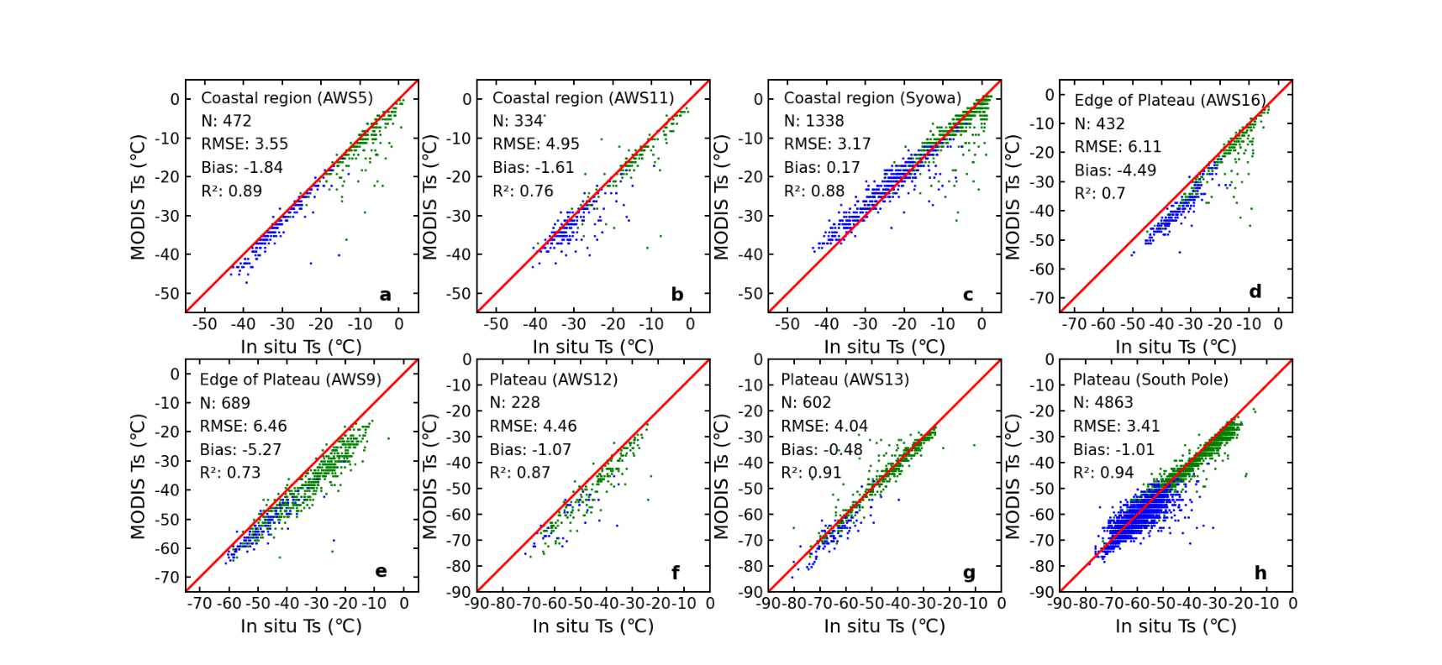

**Fig.S1.** A comparison between the *in situ Ts* and MxD11C1 LST at satellite overpass times at several stations with relatively long time series located on the Antarctic coast (a-c), edge of the plateau (d-e), and East Antarctic Plateau (f-h). The red line represented the one-to-one line. The green and blue points represented the samples during warm period (October to March of the following year) and during cool period (April to September), respectively. N was the paired amount of two types of LST observations.

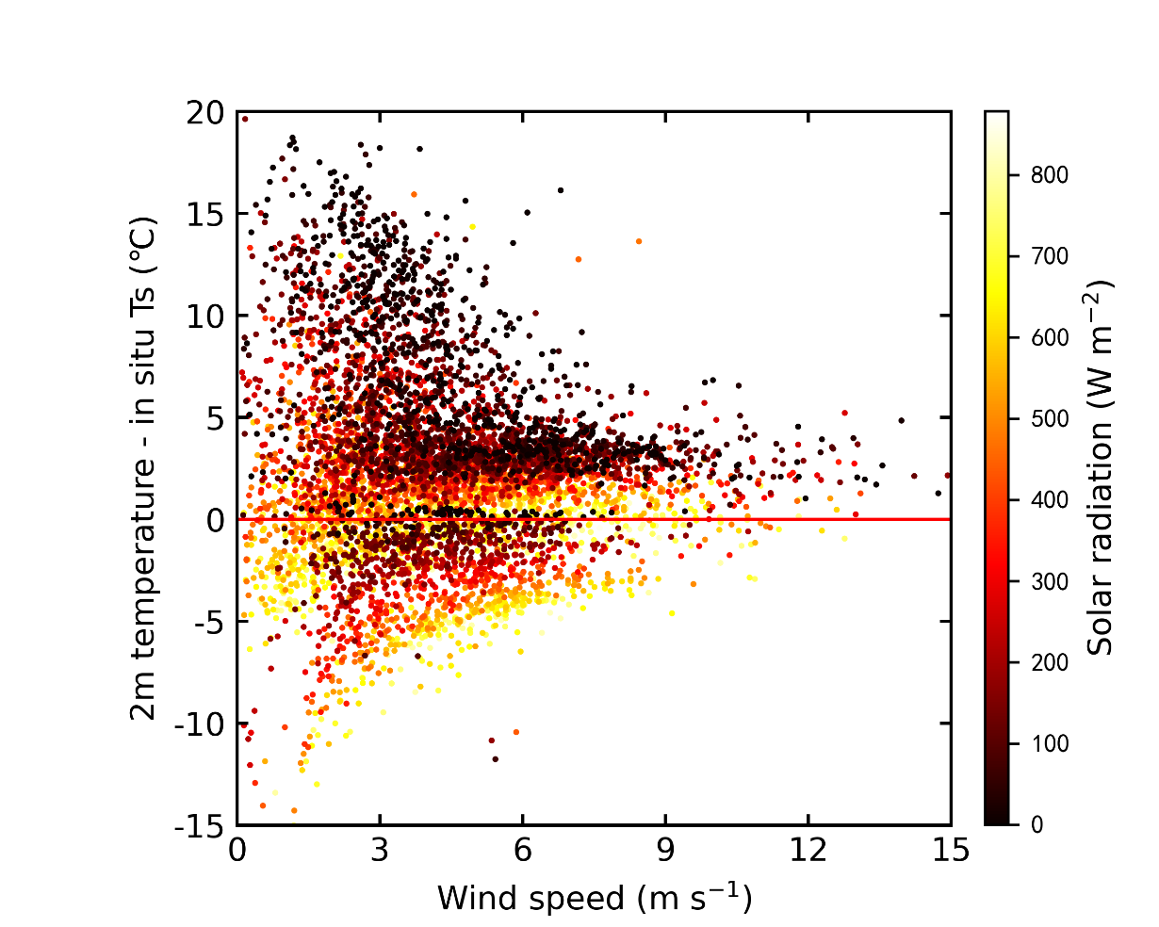

**Fig.S2.** The relationship between near-surface temperature inversions (℃) and wind speed (m s-1), solar radiation (W m-2) at all stations. The red line denoted that the bias values between 2 m temperature and *in situ Ts* were equal to 0 ℃. Obviously, near-surface temperature inversions tend to occur at the conditions of low solar radiation and low wind speed.

**Table S1.** Correlation coefficients (*r*) between MODIS LST biases and other environmental factors at different regions. Bolded *r* values were statistically significant at *p < 0.05* level.

|  |  |  |  |  |
| --- | --- | --- | --- | --- |
|  | All stations | Antarctic coast | Edge of the Plateau | Antarctic plateau |
| MODIS view angle | -0.01 | 0.08 | 0 | -0.03 |
| Relative humidity | **0.12** | -0.03 | -0.04 | 0 |
| Solar radiation | 0.04 | 0.06 | 0.05 | **-0.22** |
| Wind speed | -0.01 | -0.02 | 0.01 | -0.03 |

**Table S2.** Correlation coefficients (*r*) between solar radiation, wind speed and near-surface temperature inversions at different regions. Bolded *r* values were statistically significant at *p < 0.05* level.

|  |  |  |  |  |
| --- | --- | --- | --- | --- |
|  | All stations | Antarctic coast | Edge of the Plateau | Antarctic plateau |
| Solar radiation | **-0.55** | **-0.60** | **-0.58** | **-0.40** |
| Wind speed | **-0.13** | **-0.18** | **-0.13** | 0.09 |