Sub-regional variability in the influence of ice-contact lakes on Himalayan glaciers

Alex C. SCOFFIELD¹, Ann V. ROWAN², Duncan J. QUINCEY¹, Jonathan. L. CARRIVICK¹, Andrew J. SOLE³ & Simon J. COOK⁴

¹ School of Geography and water@Leeds, University of Leeds, Leeds, LS2 9JT, UK
² Department of Earth Science, University of Bergen and Bjerknes Centre for Climate Research, Bergen, Norway
³ Department of Geography, University of Sheffield, Sheffield, S10 2TN, UK
⁴ Department of Geography and Environmental Science, University of Dundee, Dundee, DD1 4HN, UK

*Corresponding author: gyacs@leeds.ac.uk

Supplementary
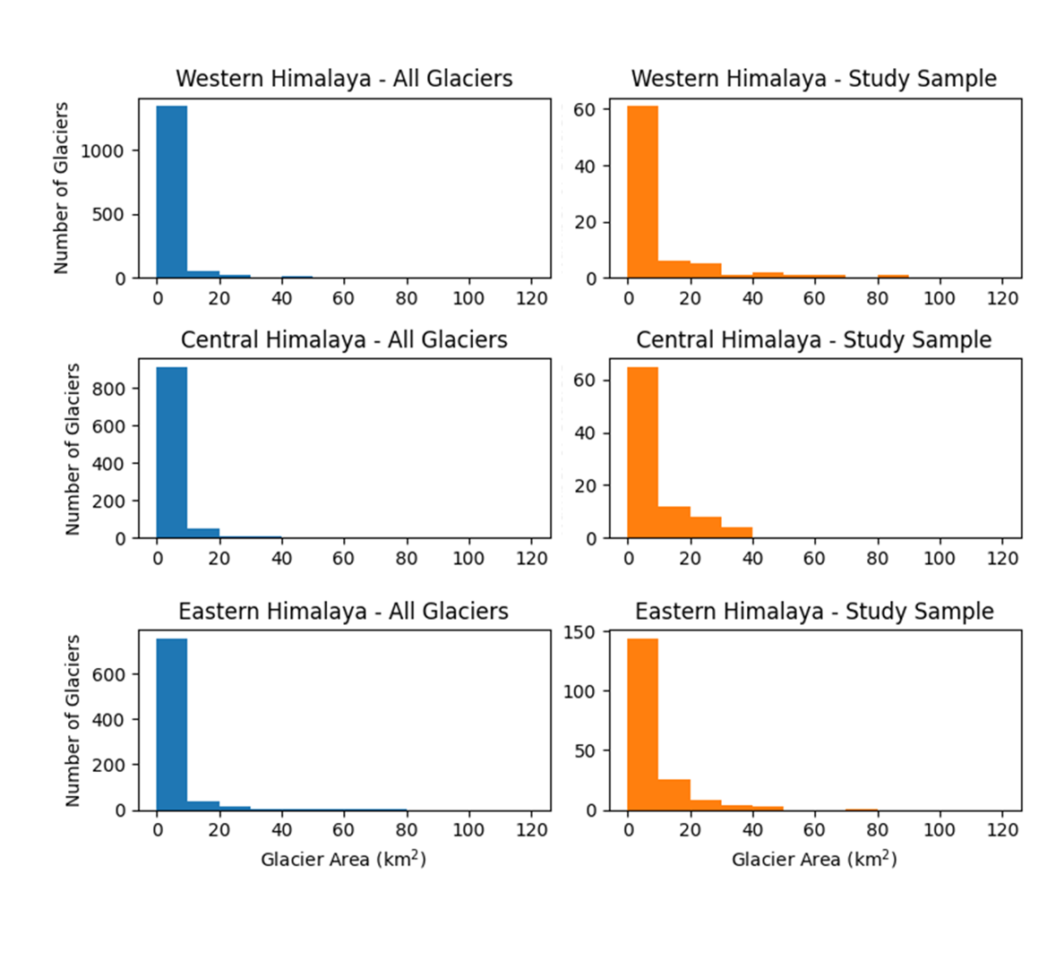

Figure S1. Histograms of glacier area for all glaciers (>1 km²) and this study’s sample within the studied sub-regions; Western Himalaya, Central Himalaya and Eastern Himalaya.
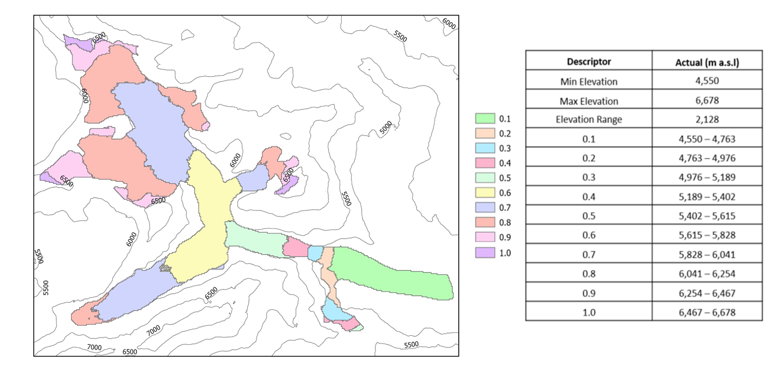
Figure S2. Example of elevation bins normalised to individual glacier elevation (GLIMS ID: G087008E27832N).

Table S1. Table summarising mean rate of annual surface elevation change during 2000 and 2020 for land-terminating and lake-terminating glaciers in Western Himalaya (n=38, n=40), Central Himalaya (n=45, n=44) and Eastern Himalaya (n=93, n=92).

Group | Western Himalaya |  | Central Himalaya |  | Eastern Himalaya
 | m a⁻¹ | p value | m a⁻¹ | p value | m a⁻¹ | p value
Lake-Terminating | -0.54 ± 0.09 | 0.42 | -0.72 ± 0.07 | 0.66 | -0.68 ± 0.05 | < 0.001
Land-Terminating | -0.49 ± 0.07 |  | -0.70 ± 0.07 |  | -0.54 ± 0.04
Lake-Debris | -0.53 ± 0.13 | 0.60 | -0.66 ± 0.12 | 0.85 | -0.69 ± 0.08 | 0.02
Land-Debris | -0.48 ± 0.09 |  | -0.67 ± 0.11 |  | -0.56 ± 0.06
Lake-Clean | -0.56 ± 0.12 | 0.54 | -0.77 ± 0.09 | 0.41 | -0.67 ± 0.07 | < 0.001
Land-Clean | -0.50 ± 0.12 |  | -0.72 ± 0.09 |  | -0.51 ± 0.06

Table S2. Table summarising mean rate of annual surface elevation change across normalised glacier elevation during 2000 and 2020 for glaciers by terminus and surface cover type in Western Himalaya (n = 78).

 | Western Himalaya (m a⁻¹)
 | 0.1 | 0.2 | 0.3 | 0.4 | 0.5 | 0.6 | 0.7 | 0.8 | 0.9 | 1.0
Lake | -1.52 | -1.17 | -0.73 | -0.53 | -0.38 | -0.28 | -0.19 | -0.15 | -0.27 | -0.15
Land | -1.15 | -1.09 | -0.81 | -0.51 | -0.31 | -0.26 | -0.23 | -0.24 | -0.17 | -0.12
Lake-Debris | -1.51 | -1.16 | -0.71 | -0.46 | -0.32 | -0.24 | -0.15 | -0.16 | -0.33 | -0.18
Land-Debris | -1.04 | -1.02 | -0.76 | -0.51 | -0.32 | -0.30 | -0.29 | -0.28 | -0.15 | -0.08
Lake-Clean | -1.54 | -1.18 | -0.76 | -0.62 | -0.46 | -0.33 | -0.24 | -0.13 | -0.19 | -0.11
Land-Clean | -1.31 | -1.19 | -0.86 | -0.51 | -0.29 | -0.19 | -0.15 | -0.17 | -0.18 | -0.17

Table S3. Table summarising rate of annual mass change across normalised glacier elevation during 2000 and 2020 for glaciers by terminus and surface cover type in Central Himalaya (n = 89).

 | Central Himalaya (m a⁻¹)
 | 0.1 | 0.2 | 0.3 | 0.4 | 0.5 | 0.6 | 0.7 | 0.8 | 0.9 | 1.0
Lake | -1.76 | -1.37 | -0.96 | -0.72 | -0.53 | -0.40 | -0.40 | -0.38 | -0.30 | -0.30
Land | -1.53 | -1.21 | -0.90 | -0.67 | -0.54 | -0.55 | -0.45 | -0.39 | -0.30 | -0.41
Lake-Debris | -1.69 | -1.18 | -0.84 | -0.63 | -0.44 | -0.33 | -0.40 | -0.35 | -0.17 | -0.29
Land-Debris | -1.24 | -1.13 | -0.83 | -0.60 | -0.51 | -0.54 | -0.48 | -0.41 | -0.40 | -0.53
Lake-Clean | -1.82 | -1.51 | -1.04 | -0.79 | -0.60 | -0.45 | -0.40 | -0.40 | -0.38 | -0.30
Land-Clean | -1.72 | -1.26 | -0.94 | -0.72 | -0.56 | -0.55 | -0.42 | -0.38 | -0.24 | -0.34

Table S4. Table summarising mean rate of annual surface elevation change across normalised glacier elevation during 2000 and 2020 for glaciers by terminus and surface cover type in Eastern Himalaya (n = 185).

 | Eastern Himalaya (m a⁻¹)
 | 0.1 | 0.2 | 0.3 | 0.4 | 0.5 | 0.6 | 0.7 | 0.8 | 0.9 | 1.0
Lake | -1.80 | -1.33 | -0.87 | -0.61 | -0.48 | -0.37 | -0.33 | -0.35 | -0.32 | -0.32
Land | -0.98 | -0.94 | -0.71 | -0.56 | -0.45 | -0.41 | -0.35 | -0.29 | -0.31 | -0.31
Lake-Debris | -1.76 | -1.29 | -0.85 | -0.60 | -0.52 | -0.42 | -0.35 | -0.37 | -0.33 | -0.35
Land-Debris | -0.75 | -0.95 | -0.79 | -0.64 | -0.51 | -0.47 | -0.41 | -0.34 | -0.33 | -0.41
Lake-Clean | -1.84 | -1.36 | -0.89 | -0.61 | -0.44 | -0.33 | -0.31 | -0.34 | -0.32 | -0.29
Land-Clean | -1.20 | -0.93 | -0.64 | -0.50 | -0.39 | -0.36 | -0.30 | -0.24 | -0.30 | -0.22

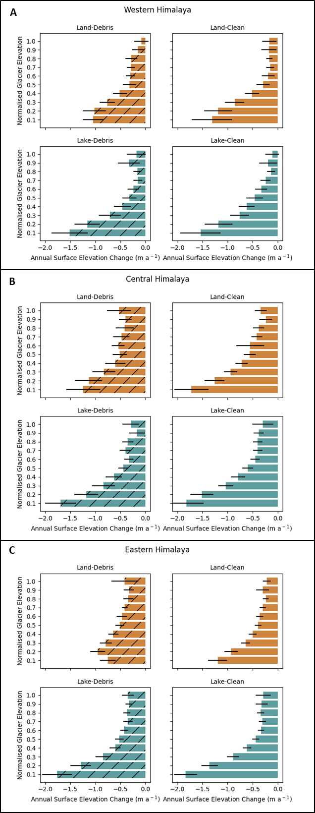
Figure S3. Mean rate of annual surface elevation change of glaciers by terminus and surface cover type between 2000 and 2020 across normalised glacier elevation for A) Western Himalaya (n=78), B) Central Himalaya (n=89) and Eastern Himalaya (n=185).

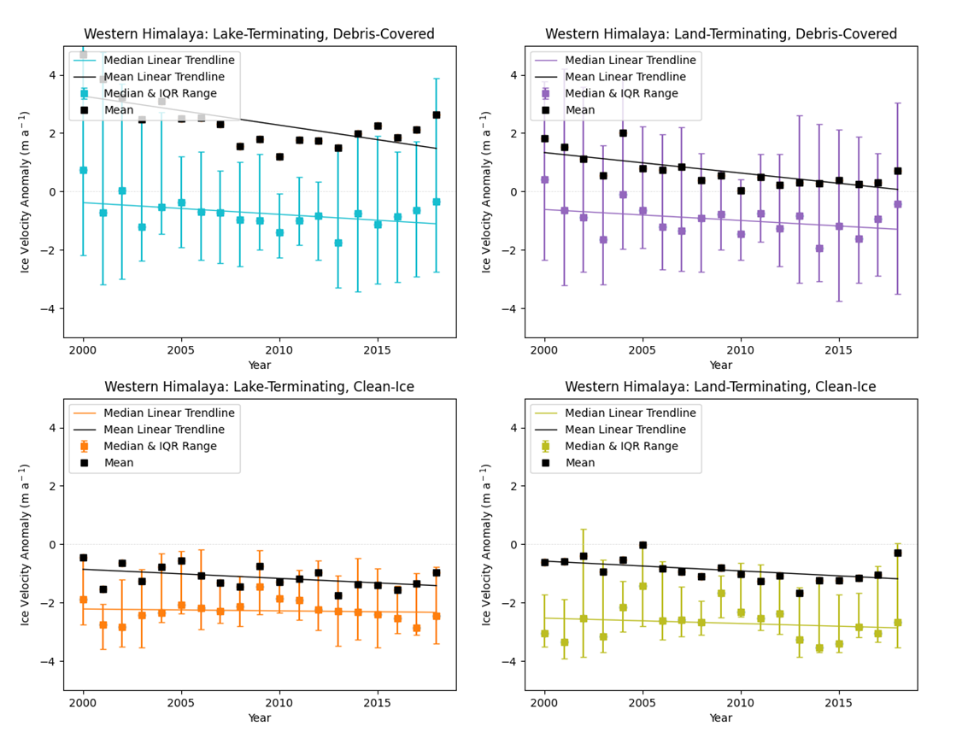

Figure S4. Median velocity anomaly, mean velocity anomaly and its interquartile range for glaciers by surface and terminus cover type in the Western Himalaya (see Table S5 & S6 for decadal change rates). Velocity anomaly is the difference between the annual velocity of an individual glacier and the mean velocity of the total glacier sample (n = 352).

Table S5. Median velocity anomaly change rate between 2000 and 2018 (m a⁻¹ decade⁻¹) for glaciers by surface and terminus cover type in the Western Himalaya.

 | Decadal Change Rate (m a⁻¹ decade⁻¹) | CI95 | R² | p
Lake-Debris | -0.40 | 0.04 | -0.42 | 0.072
Land-Debris | -0.38 | 0.05 | -0.38 | 0.111
Lake-Clean | -0.06 | 0.03 | -0.1 | 0.681
Land-Clean | -0.19 | 0.05 | -0.19 | 0.446

Table S6. Mean velocity anomaly change rate between 2000 and 2018 (m a⁻¹ decade⁻¹) for glaciers by surface and terminus cover type in the Western Himalaya.

 | Decadal Change Rate (m a⁻¹ decade⁻¹) | CI95 | R² | p
Lake-Debris | -0.99 | 0.06 | -0.65 | 0.003
Land-Debris | -0.70 | 0.04 | -0.71 | 0.001
Lake-Clean | -0.31 | 0.03 | -0.47 | 0.04
Land-Clean | -0.34 | 0.03 | -0.48 | 0.04

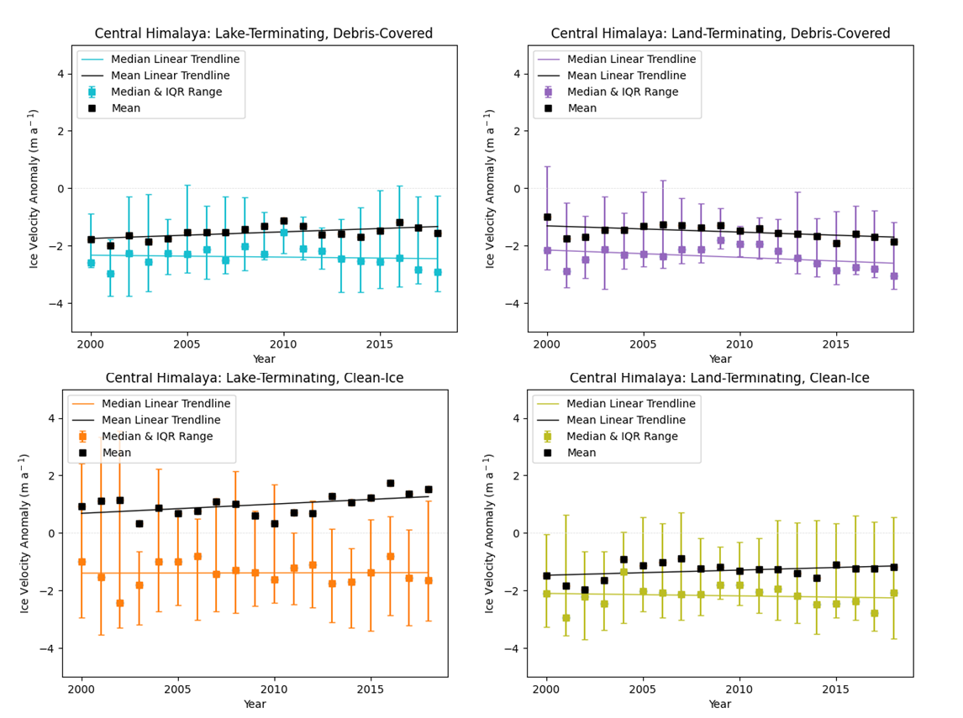
Figure S5. Median velocity anomaly, mean velocity anomaly and its interquartile range for glaciers by surface and terminus cover type in the Central Himalaya (see Table S7 & S8 for decadal change rates). Velocity anomaly is the difference between the annual velocity of an individual glacier and the mean velocity of the total glacier sample (n = 352).

Table S7. Median velocity anomaly change rate between 2000 and 2018 (m a⁻¹ decade⁻¹) for glaciers by surface and terminus cover type in the Central Himalaya.

 | Decadal Change Rate (m a⁻¹ decade⁻¹) | CI95 | R² | p
Lake-Debris | -0.07 | 0.03 | -0.11 | 0.652
Land-Debris | -0.25 | 0.03 | -0.4 | 0.093
Lake-Clean | 0.01 | 0.04 | 0.01 | 0.957
Land-Clean | -0.09 | 0.03 | -0.13 | 0.585

Table S8. Mean velocity anomaly change rate between 2000 and 2018 (m a⁻¹ decade⁻¹) for glaciers by surface and terminus cover type in the Central Himalaya.

 | Decadal Change Rate (m a⁻¹ decade⁻¹) | CI95 | R² | p
Lake-Debris | 0.23 | 0.02 | 0.59 | 0.008
Land-Debris | -0.22 | 0.02 | -0.53 | 0.02
Lake-Clean | 0.32 | 0.03 | 0.48 | 0.036
Land-Clean | 0.18 | 0.02 | 0.35 | 0.137

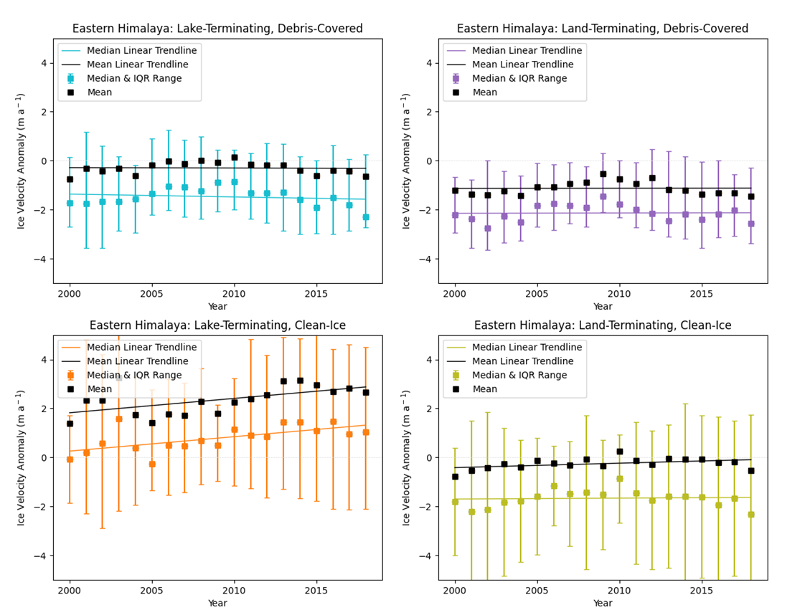
Figure S6. Median velocity anomaly, mean velocity anomaly and its interquartile range for glaciers by surface and terminus cover type in the Eastern Himalaya (see Table S9 & S10 for decadal change rates). Velocity anomaly is the difference between the annual velocity of an individual glacier and the mean velocity of the total glacier sample (n = 352).

Table S9. Median velocity anomaly change rate between 2000 and 2018 (m a⁻¹ decade⁻¹) for glaciers by surface and terminus cover type in the Eastern Himalaya.

 | Decadal Change Rate (m a⁻¹ decade⁻¹) | CI95 | R² | p
Lake-Debris | -0.12 | 0.03 | -0.18 | 0.471
Land-Debris | 0.01 | 0.03 | 0.02 | 0.935
Lake-Clean | 0.59 | 0.04 | 0.63 | 0.004
Land-Clean | 0.04 | 0.03 | 0.06 | 0.802

Table S10. Mean velocity anomaly change rate between 2000 and 2018 (m a⁻¹ decade⁻¹) for glaciers by surface and terminus cover type in the Eastern Himalaya.

 | Decadal Change Rate (m a⁻¹ decade⁻¹) | CI95 | R² | p
Lake-Debris | -0.01 | 0.02 | -0.03 | 0.891
Land-Debris | 0.01 | 0.02 | 0.02 | 0.939
Lake-Clean | 0.59 | 0.04 | 0.57 | 0.011
Land-Clean | 0.18 | 0.02 | 0.44 | 0.059

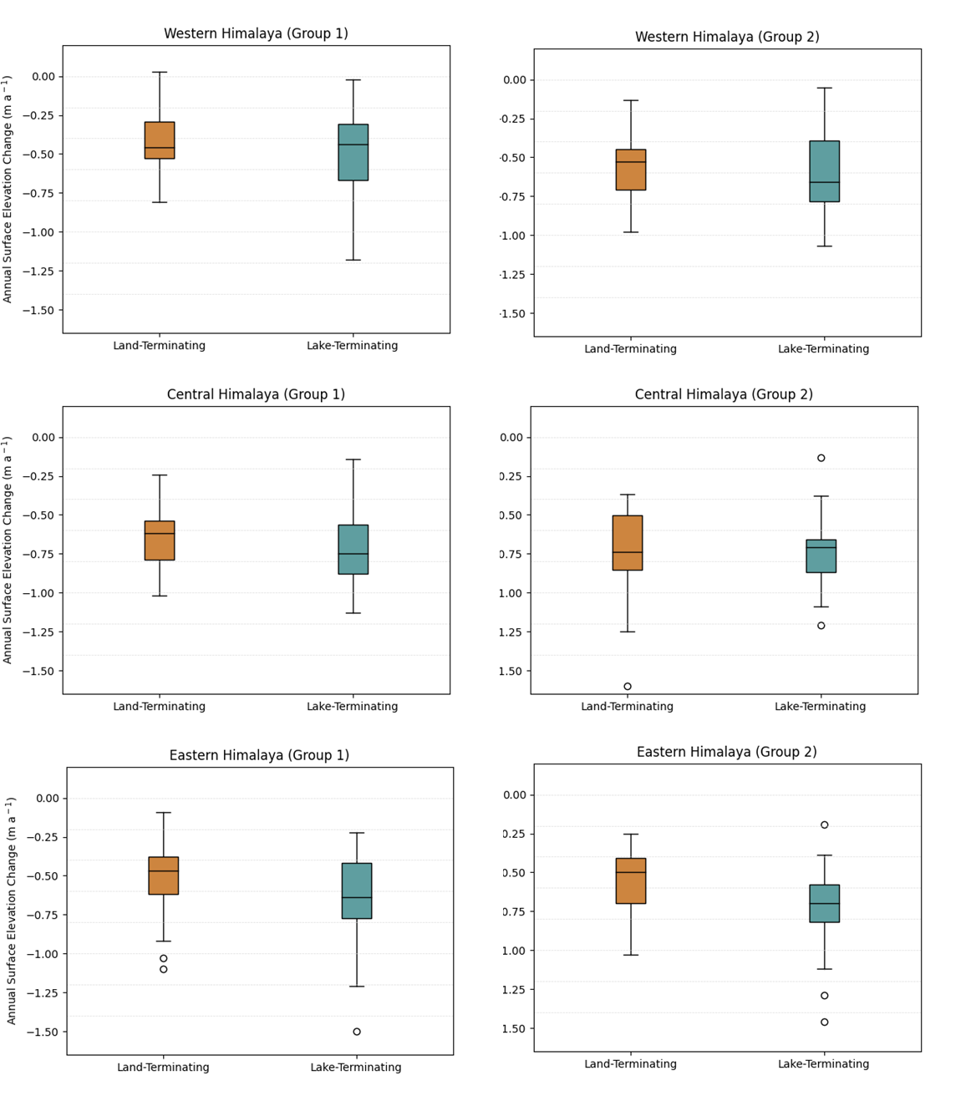
Figure S7. Boxplots summarising rate of mean surface elevation change between 2000 and 2019 for glaciers by terminus type in two randomly selected groups for Western, Central and Eastern Himalaya.
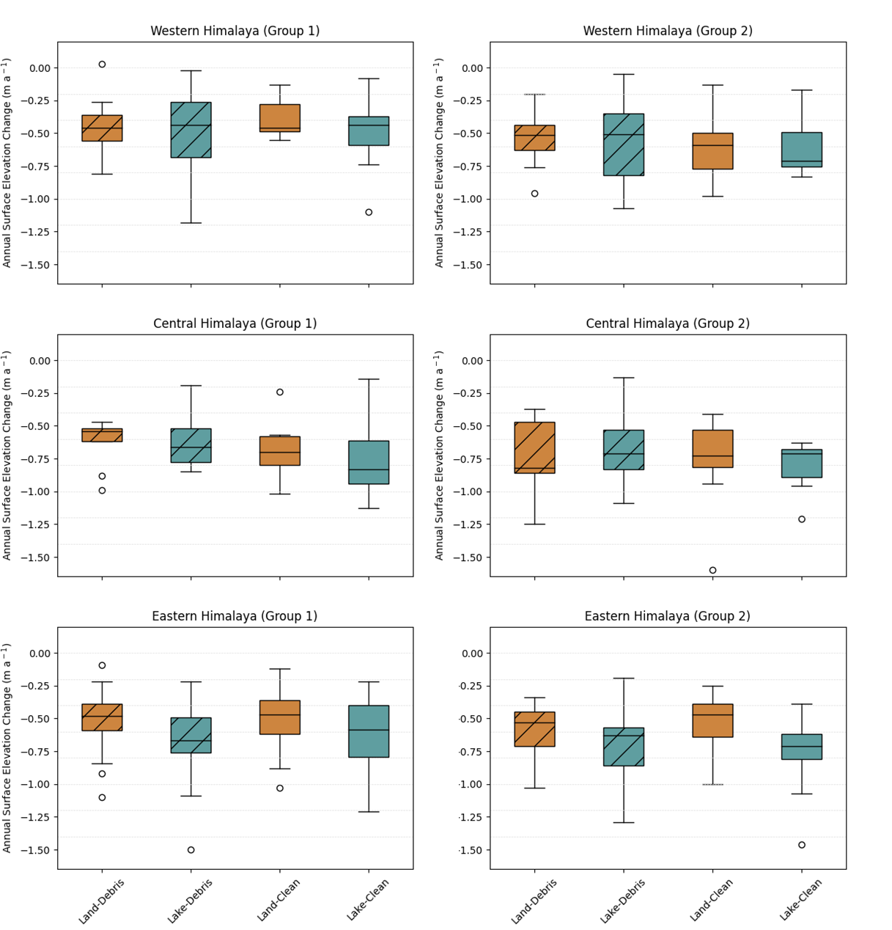
Figure S8. Boxplots summarising rate of mean surface elevation change between 2000 and 2019 for glaciers by terminus and surface cover type in two randomly selected groups for Western, Central and Eastern Himalaya.

Table S11. Table summarising output of statistical tests between terminus and surface cover type in two randomly selected groups for Western, Central and Eastern Himalaya.
 |  |  | Group 1 | Group 2
Western Himalaya | Lake | Land | p = 0.36 | p = 0.77
 | Lake-Debris | Land-Debris | p = 0.72 | p = 0.74
 | Lake-Clean | Land-Clean | p = 0.29 | p = 0.93
 | Lake-Debris | Lake-Clean | p = 0.84 | p = 0.79
 | Land-Debris | Land-Clean | p = 0.52 | p = 0.58
Central Himalaya | Lake | Land | p = 0.69 | p = 0.83
 | Lake-Debris | Land-Debris | p = 0.90 | p = 0.82
 | Lake-Clean | Land-Clean | p = 0.61 | p = 0.52
 | Lake-Debris | Lake-Clean | p = 0.29 | p = 0.26
 | Land-Debris | Land-Clean | p = 0.44 | p = 0.88
Eastern Himalaya | Lake | Land | p = 0.02 | p < 0.001
 | Lake-Debris | Land-Debris | p = 0.10 | p = 0.07
 | Lake-Clean | Land-Clean | p = 0.12 | p < 0.001
 | Lake-Debris | Lake-Clean | p = 0.53 | p = 0.69
 | Land-Debris | Land-Clean | p =0.83 | p = 0.16

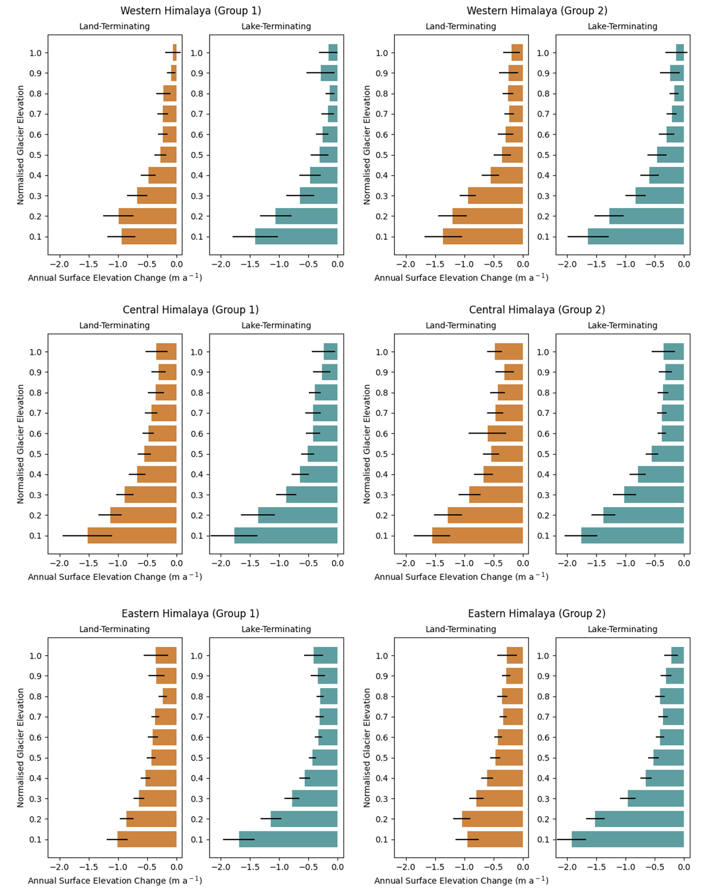
Figure S9. Mean rate of surface elevation change of land-terminating and lake-terminating glaciers between 2000 and 2019 across normalised glacier elevation in two randomly selected groups for Western, Central and Eastern Himalaya.

Table S12. Table summarising output of statistical tests between lake-terminating and land-terminating glaciers across normalised glacier elevation in two randomly selected groups for Western, Central and Eastern Himalaya.

 |  | p value
Sub-Region | Group | 0.1 | 0.2 | 0.3 | 0.4 | 0.5 | 0.6 | 0.7 | 0.8 | 0.9 | 1.0
Western Himalaya | Group 1 | 0.05 | 0.70 | 0.85 | 0.98 | 0.64 | 0.59 | 0.43 | 0.19 | 0.15 | 0.31
 | Group 2 | 0.25 | 0.63 | 0.33 | 0.72 | 0.35 | 0.92 | 0.65 | 0.23 | 0.97 | 0.59
Central Himalaya | Group 1 | 0.39 | 0.21 | 0.94 | 0.73 | 0.64 | 0.42 | 0.91 | 0.67 | 0.76 | 0.48
 | Group 2 | 0.34 | 0.57 | 0.41 | 0.28 | 0.90 | 0.21 | 0.33 | 0.41 | 0.92 | 0.29
Eastern Himalaya | Group 1 | < 0.001 | 0.01 | 0.10 | 0.57 | 0.95 | 0.21 | 0.25 | 0.14 | 0.93 | 0.69
 | Group 2 | < 0.001 | < 0.001 | 0.05 | 0.54 | 0.39 | 0.84 | 0.66 | 0.33 | 0.63 | 0.68

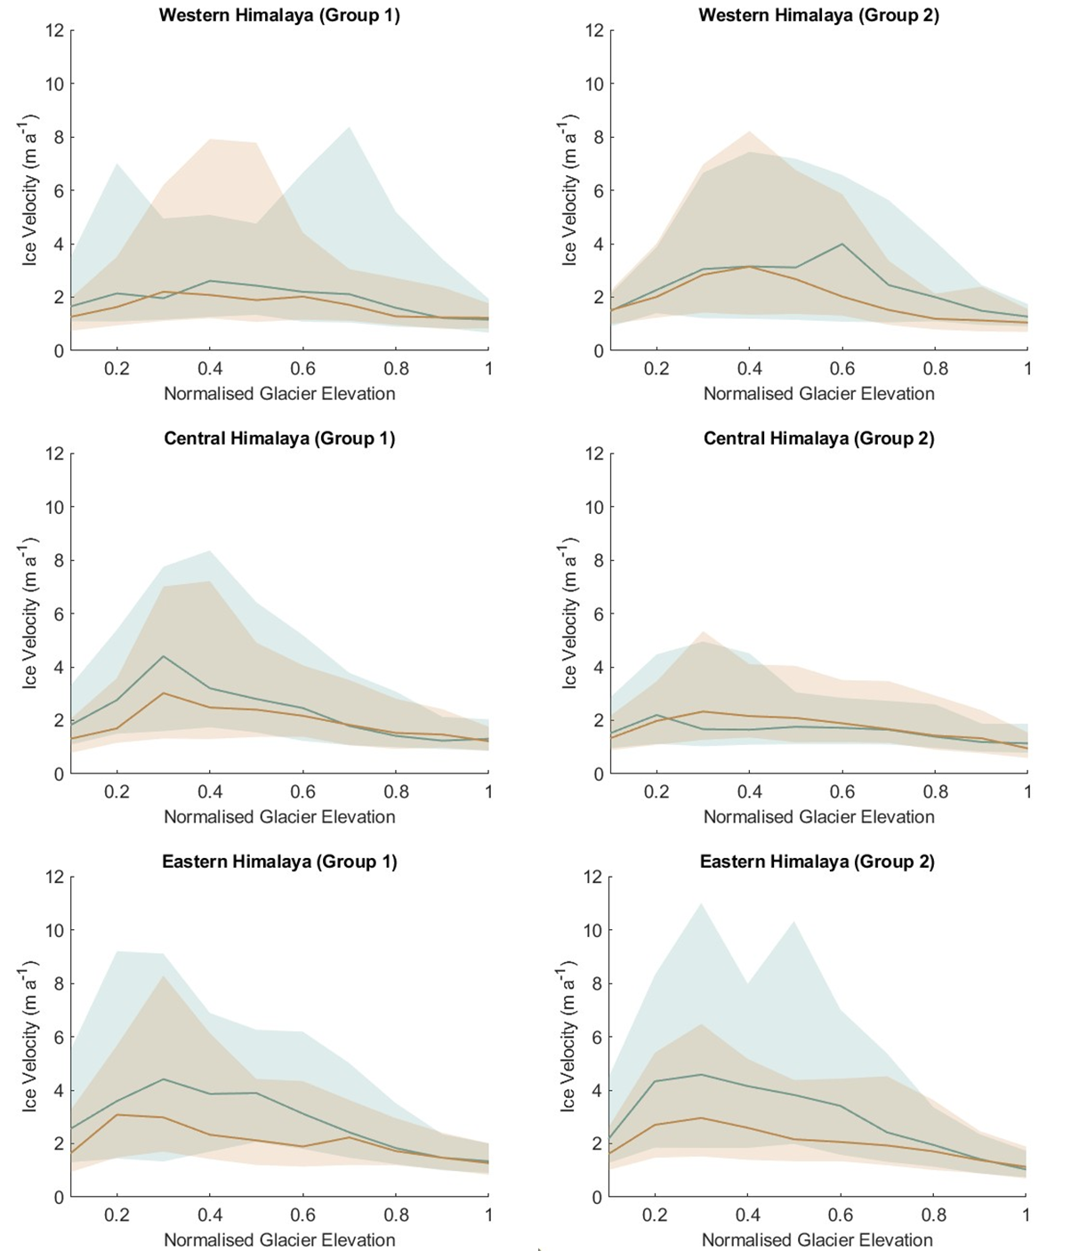
Figure S10. Median velocity across normalised glacier elevation between 2013 and 2018 for lake-terminating and land-terminating glaciers in two randomly selected groups for Western, Central and Eastern Himalaya. The interquartile range is indicated by the shading for each line.
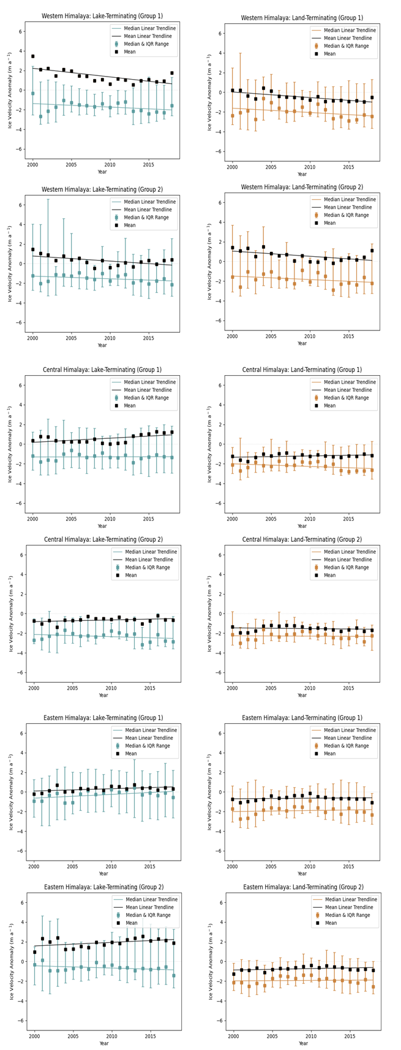
Figure S11. Median velocity anomaly, mean velocity anomaly and its interquartile range for lake-terminating and land-terminating glaciers in two randomly selected groups for Western, Central and Eastern Himalaya between 2000 and 2018. Velocity anomaly is the difference between the annual velocity of an individual glacier and the mean velocity of the total glacier sample (n = 352).

