Supplementary Information

Heatwaves in summer 2022 forces substantial mass loss for Urumqi Glacier No. 1, China
Chunhai Xu, Huilin Li, Feiteng Wang, Zhongqin Li, Ping Zhou and Shuangshuang Liu
State Key Laboratory of Cryospheric Science/Tien Shan Glaciological Station, Northwest Institute of Eco-Environment and Resources, Chinese Academy of Sciences, Lanzhou 730000, China

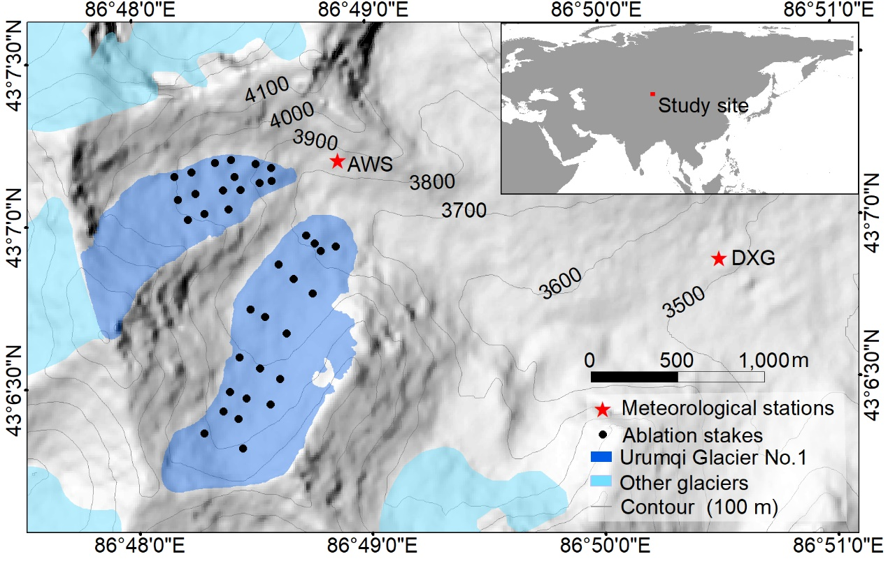
Figure S1. Topographic map of the Urumqi Glacier No. 1 showing the distribution of ablation stakes in 2022 and the location of the Daxigou Meteorological Station (DXG) and Automatic Meteorological Station (AWS). The hillshade in the background is from the ALOS (Advanced Land Observing Satellite) digital elevation model (DEM)), and the numbers denote elevations of the contours. The inset shows the location of the study site.

Figure S2. Probability distribution functions (black solid line) for summer air temperature (a) and annual mass balance (b) during the period 1959–2022. The 90% quantile, 95% quantile and 97.5% quantile for the thresholds of high summer air temperature and low annual mass balance are given.

Figure S3. Daily precipitation and average air temperature observed at the Automatic Meteorological Station (at the moraine ridge of Urumqi Glacier No. 1 with an altitude of 3835 m a.s.l.; Fig. S1)

Figure S4. The mass balance year (the previous 1 September to the next 31 August) total precipitation at Daxigou Meteorological Station.

Table S1. Landsat images that were used to retrieve the surface albedo for Urumqi Glacier No.1. The images can be freely downloaded at the US Geological Survey (USGS, https://earthexplorer.usgs.gov/).
Path/row | Date (day/month/year) | Sensor | Resolution (m) | Sun azimuth (°) | Sun elevation (°)
143/30 | 26/06/2022 | OLI | 30 | 133.90 | 64.23
143/30 | 05/07/2022 | ETM+ | 30 | 105.74 | 49.03
143/30 | 22/07/2022 | ETM+ | 30 | 107.74 | 46.76
143/30 | 05/08/2022 | OLI | 30 | 139.94 | 58.50
143/30 | 13/08/2022 | OLI | 30 | 142.30 | 56.57
143/30 | 06/09/2022 | OLI | 30 | 150.52 | 49.75

