Annual mass balance time series of Dongkemadi Glacier, 2000-2020, from a linear albedo-based model using geodetic data and validated with the glaciological method

Lin Liu^{1*}, Zhimin Zhang², Yongling Sun³, Xuguo Shi⁴, Liming Jiang⁵

Table S1 Annual glacier mass balances in 2000-2020 estimated from the parameter scenarios t12, t13, t23 and Hugonnet (Numbers listed in this table are rounded to two decimal places).
Year | Scenario t12  (m w.e.) | Scenario t13  (m w.e.) | Scenario t23  (m w.e.) | Scenario Hugonnet (m w.e.)
2000 | −0.43±0.27 | −0.39±0.21 | −0.49±0.48 | -0.41±1.18
2001 | 0.10±0.29 | −0.03±0.22 | 0.27±0.50 | 0.02±1.29
2002 | −0.51±0.27 | −0.45±0.20 | −0.60±0.48 | -0.47±1.16
2003 | 0.14±0.30 | 0.00±0.22 | 0.34±0.51 | 0.06±1.31
2004 | −0.06±0.28 | −0.14±0.21 | 0.04±0.49 | -0.11±1.26
2005 | −0.15±0.28 | −0.20±0.21 | −0.08±0.49 | -0.18±1.24
2006 | −1.17±0.24 | −0.90±0.19 | −1.54±0.46 | -1.00±1.04
2007 | −0.53±0.27 | −0.46±0.20 | −0.63±0.48 | -0.49±1.16
2008 | 0.35±0.31 | 0.15±0.23 | 0.64±0.52 | 0.23±1.35
2009 | −0.04±0.29 | −0.12±0.22 | 0.08±0.50 | -0.09±1.26
2010 | −1.14±0.24 | −0.88±0.19 | −1.50±0.46 | -0.98±1.05
2011 | −0.24±0.28 | −0.26±0.21 | −0.22±0.49 | -0.25±1.22
2012 | −1.05±0.25 | −0.82±0.19 | −1.37±0.46 | -0.90±1.06
2013 | −1.27±0.24 | −0.97±0.18 | −1.69±0.45 | -1.08±1.24
2014 | −0.67±0.26 | −0.55±0.20 | −0.82±0.47 | -0.60±1.13
2015 | −1.06±0.25 | −0.83±0.19 | −1.39±0.46 | -0.91±1.06
2016 | −1.21±0.24 | −0.93±0.19 | −1.60±0.45 | -1.03±1.03
2017 | −0.28±0.28 | −0.29±0.21 | −0.27±0.49 | -0.29±1.21
2018 | −0.88±0.25 | −0.70±0.19 | −1.13±0.47 | -0.77±1.09
2019 | −0.69±0.26 | −0.57±0.20 | −0.85±0.47 | -0.61±1.13
2020 | −0.21±0.28 | −0.24±0.21 | −0.17±0.49 | -0.23±1.23

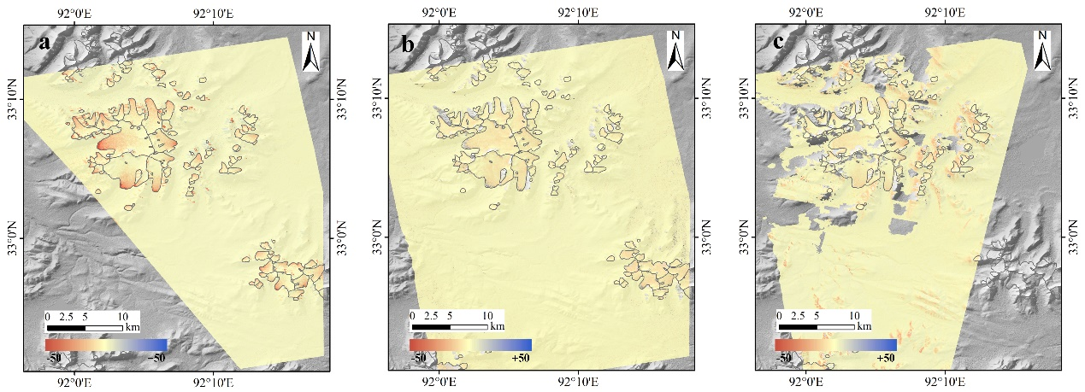
Fig. S1. Surface elevation changes for the Dongkemadi Glacier and its surroundings during the time periods of 2000–2012 (a), 2012–2014 (b), and 2014–2018 (c).
Fig. S2. The distribution of the elevation differences over the off-glacier regions (three-sigma filter was used to identify outliers) during the time periods of 2000–2012 (a), 2012–2014 (b), and 2014–2018 (c). Med is the median value and SD is the standard deviation.

