Rapid and synchronous response of outlet glaciers to ocean warming on the Barents Sea coast, Novaya Zemlya.
Authors: *Rachel Carr, Zoe Murphy, Peter Nienow, Livia Jakob and Noel Gourmelen
*Contact author: Rachel.carr@newcastle.ac.uk
Journal of Glaciology

Supplementary Information

Table S1. List of glacier IDs, terminus types, parent ice mass, coast, full names and Randolph Glacier Inventory (RGI) IDs. Glacier locations are given in Figure 1. Glacier ID’s were determined from the names in the World Glacier Inventory, where available. Where glaciers have multiple termini, they are numbered sequentially, with 1 as the main terminus and 2 as the secondary terminus, as determined from ice flow. Unnamed land-terminating outlet glaciers were given the ID ‘NZL’, for the main ice mass, LED for Sub1 and YUZ for Sub2 plus a sequential number.
Glacier ID | Full name | Terminus type | Ice mass | Coast | Randolph Glacier Inventory ID
ARK | Arkhangelskolgu | Land | Northern ice cap | Barents | RGI30-09.00060
BRO | Brounova | Marine | Northern ice cap | Barents | RGI30-09.00141
CHA | Chaveva | Marine | Northern ice cap | Barents | RGI30-09.00935
CHE | Chernysheva | Marine | Northern ice cap | Barents | RGI30-09.00136
GLA | Glazov | Marine | Northern ice cap | Barents | RGI30-09.00132
INO | Inostrantseva | Marine | Northern ice cap | Barents | RGI30-09.00070
KRA1 | Kraynij 1 | Marine | Northern ice cap | Barents | RGI30-09.00134
KRA2 | Kraynij 2 | Marine | Northern ice cap | Barents | RGI30-09.00134
KRI | Krivosheina | Marine | Northern ice cap | Barents | RGI30-09.00088 and RGI30-09.00060
KRO | Kropotkina | Marine | Northern ice cap | Kara | RGI30-09.00114
LED1 | N/A | Lake | Sub1 | N/A | RGI30-09.00079
LED2 | N/A | Lake | Sub1 | N/A | RGI30-09.00099
LED3 | N/A | Lake | Sub1 | N/A | RGI30-09.00127
LED5 | N/A | Land | Sub1 | N/A | RGI30-09.00096
MAK | Maka | Marine | Northern ice cap | Barents | RGI30-09.00080
MG | Moshnyj | Marine | Northern ice cap | Kara | RGI30-09.00065
NAL | Nalli | Land | Northern ice cap | Kara | RGI30-09.00073
NII | Niiga | Land | Northern ice cap | Kara | RGI30-09.00115
NIZ | Nizkiy | Marine | Northern ice cap | Barents | RGI30-09.00051
NOR | Nordenskjold | Marine | Northern ice cap | Barents | RGI30-09.00077
NZL1 | N/A | Land | Northern ice cap | Kara | RGI30-09.00113
NZL2 | N/A | Land | Northern ice cap | Kara | RGI30-09.00114
NZL3 | N/A | Land | Northern ice cap | Kara | RGI30-09.00112
NZL4 | N/A | Land | Northern ice cap | Barents | RGI30-09.00932
NZL5 | N/A | Land | Northern ice cap | Barents | RGI30-09.00138
NZL6 | N/A | Land | Northern ice cap | Barents | RGI30-09.00138
NZL7 | N/A | Land | Northern ice cap | Barents | RGI30-09.00144
NZL8 | N/A | Lake | Northern ice cap | Barents | RGI30-09.00083
NZL9 | N/A | Lake | Northern ice cap | Barents | RGI30-09.00086
OGA1 | Oga 1 | Marine | Northern ice cap | Kara | RGI30-09.00120
OGA2 | Oga 2 | Land | Northern ice cap | Kara | RGI30-09.00071
POL | Polisadova | Marine | Northern ice cap | Kara | RGI30-09.00118
ROZE | Roze | Marine | Northern ice cap | Kara | RGI30-09.00111
ROZH | Rozhdestvenskogo | Marine | Northern ice cap | Kara | RGI30-09.00094
RYK | Rykachova | Marine | Northern ice cap | Barents | RGI30-09.00139
SH | Shokalskogo | Marine | Northern ice cap | Barents | RGI30-09.00081 and RGI30-09.00059
SHU1 | Shury 1 | Marine | Northern ice cap | Kara | RGI30-09.00116
SHU2 | Shury 2 | Marine | Northern ice cap | Kara | RGI30-09.00116
SRE | Srednij | Marine | Northern ice cap | Kara | RGI30-09.00055
TAI1 | Taisija 1 | Marine | Northern ice cap | Barents | RGI30-09.00927
TAI2 | Taisija 2 | Marine | Northern ice cap | Barents | RGI30-09.00927
VEL | Vel’Kena | Marine | Northern ice cap | Barents | RGI30-09.00066
VER | Vershinskogo | Marine | Northern ice cap | Kara | RGI30-09.00087
VIJ | Vil’kitskogo Juz | Marine | Northern ice cap | Barents | RGI30-09.00069
VIS | Vil’kitskogo Sev | Marine | Northern ice cap | Barents | RGI30-09.00057
VIZ | Vize | Marine | Northern ice cap | Barents | RGI30-09.00064
VOE | Voejkova | Marine | Northern ice cap | Barents | RGI30-09.00090
VYL1 | Vylki 1 | Marine | Northern ice cap | Kara | RGI30-09.00116
VYL2 | Vylki 2 | Marine | Northern ice cap | Kara | RGI30-09.00116
YUZ1 | N/A | Land | Sub2 | N/A | RGI30-09.00369
YUZ2 | N/A | Land | Sub2 | N/A | RGI30-09.00352
YUZ3 | N/A | Lake | Sub2 | N/A | RGI30-09.00368
YUZ4 | N/A | Land | Sub2 | N/A | RGI30-09.00362

Table S2. Start and end dates of seasonal retreat for the six selected study glaciers on the Barents Sea coast, for the period 2016-2020. Full glacier names and RGI IDs are given in Table S1. ND indicates that the transition between retreat / advance was not captured, due to missing data.
Glacier ID | 2016 |  | 2017 |  | 2018 |  | 2019 |  | 2020
 | Start | End | Start | End | Start | End | Start | End | Start | End
CHA | 08/07 | 12/12 | 22/06 | 25/11 | 05/06 | 04/10 | 24/06 | 03/11 | 19/04 | 03/12
KRI | 14/07 | 27/12 | 24/08 | 22/12 | 19/06 | ND | 03/07 | ND | 07/07 | 06/12
NOR | 06/07 | 08/01 | 25/06 | 02/10 | 07/07 | ND | 15/07 | ND | 13/07 | 24/11
SH | 13/07 | 18/11 | 28/07 | 13/11 | 03/07 | 20/11 | 25/04 | 07/10 | 30/06 | 28/10
VIJ | 18/07 | 03/12 | 13/06 | 28/11 | 08/07 | ND | 15/07 | 24/12 | 21/06 | 12/11
VIS | 08/07 | 09/11 | 19/07 | 22/12 | 08/07 | ND | 10/07 | ND | 21/06 | 06/12

Table S3. Start and end dates of seasonal retreat for the six selected study glacierson the Kara Sea coast, for the period 2016-2020. Full glacier names and RGI IDs are given in Table S1. ND indicates that the transition between retreat / advance was not captured, due to missing data.
Glacier ID | 2016 |  | 2017 |  | 2018 |  | 2019 |  | 2020
 | Start | End | Start | End | Start | End | Start | End | Start | End
KRO | 22/05 | 18/11 | 04/07 | 13/11 | 16/06 | 15/10 | 07/05 | 10/10 | 06/06 | 16/10
POL | 01/07 | 25/10 | 13/07 | 20/10 | 18/06 | 27/10 | 03/08 | 02/01 | 05/07 | 22/09
ROZE | 01/07 | 25/10 | 04/07 | 14/09 | ND | 27/10 | 22/07 | 22/10 | 01/06 | 16/10
SHU1 | 28/07 | 03/12 | 29/06 | 01/11 | 18/06 | 08/11 | 10/07 | 03/11 | 01/06 | 21/11
VER | 05/06 | 25/10 | 10/07 | 01/11 | 09/07 | 03/10 | 03/07 | 22/10 | 05/07 | 09/11
VYL2 | 01/07 | 03/12 | 08/07 | 20/10 | 18/06 | 15/10 | 15/07 | 03/11 | 05/07 | 09/11

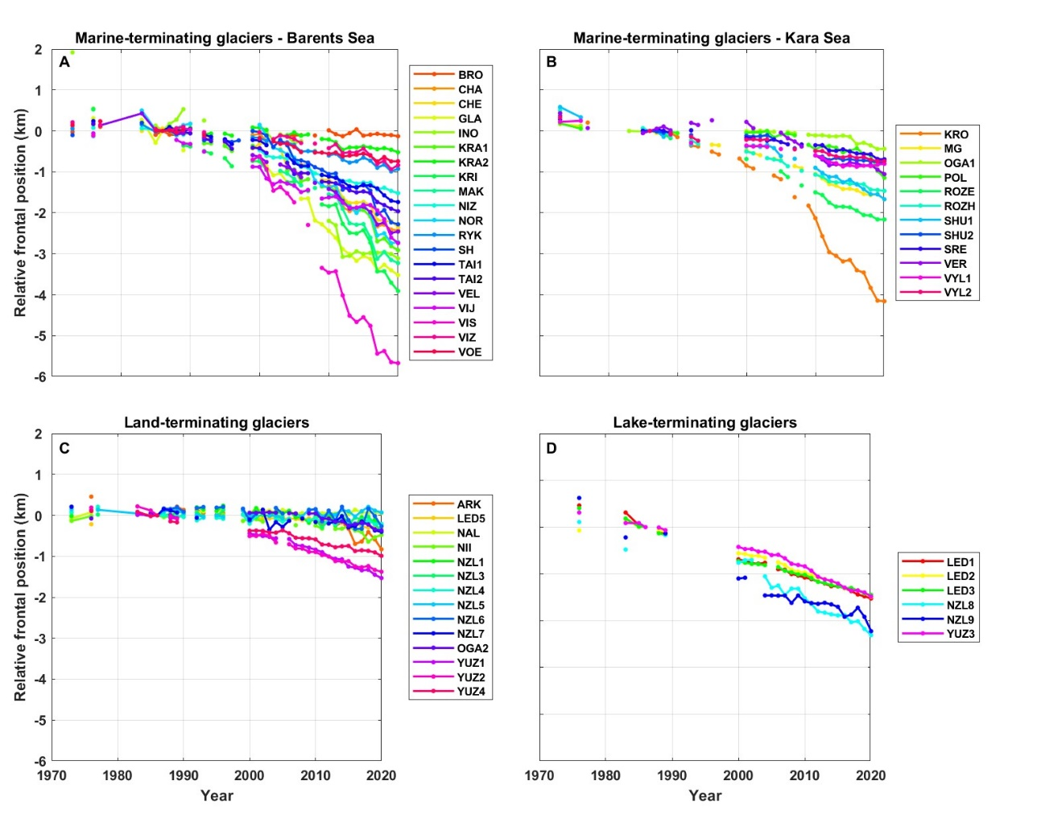
Figure S1. Relative frontal position change of the study glaciers between 1973/76 and 2020, grouped according to terminus type: A) Marine-terminating outlets on the Barents Sea coast; B) Marine-terminating outlets on the Kara Sea coast C) Land-terminating outlets on the Barents Sea coast; D) Lake-terminating outlets on the Barents Sea coast. Frontal positions are relative to 1986, which is the earliest date common to all glaciers. Frontal positions are colour-coded according to glacier name and given in alphabetical order. Glacier locations are shown in Figure 1.

