Supporting Material for

**The speedup of Pine Island Ice Shelf between 2017 and 2020:**

**Revaluating the importance of ice damage**

S. Sun1 and G. H. Gudmundsson1

1Department of Geography and Environmental Sciences, Northumbria University, Newcastle upon Tyne, UK.

**Contents of this file**

Figures S1 to S7

Fig. S1. The left figure presents the evolution of the ice front between 2017 and 2020, with the solid thick line representing the ice front positions after each calving event. The arrows represent the direction and extent of ice-front retreat after the calving events. The right satellite images are from Sentinel 1A/B, presenting the conditions of the calving events.

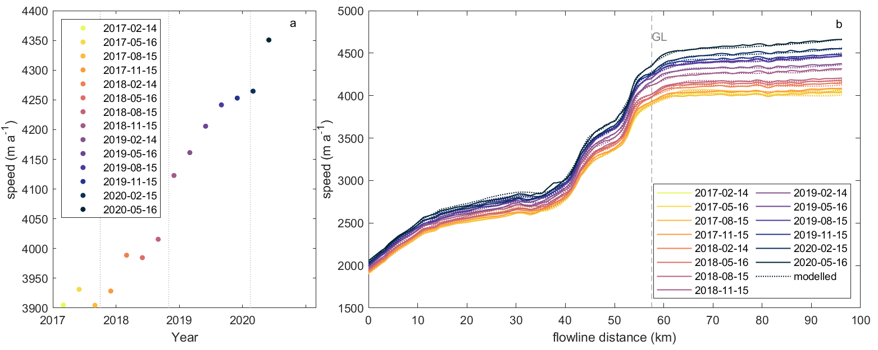

Fig. S2. Trimonthly observed time series of ice speed at the grounding line (a) and along the flowline (b), which are labelled in Fig. 1 by the red dot and the white line (Joughin et al., 2021).

Fig. S3. Computational mesh of the ice sheet model Úa. The background field is an example of modelled ice speeds, after inversion using Sentinel 1A/B velocities from Feb 2017.

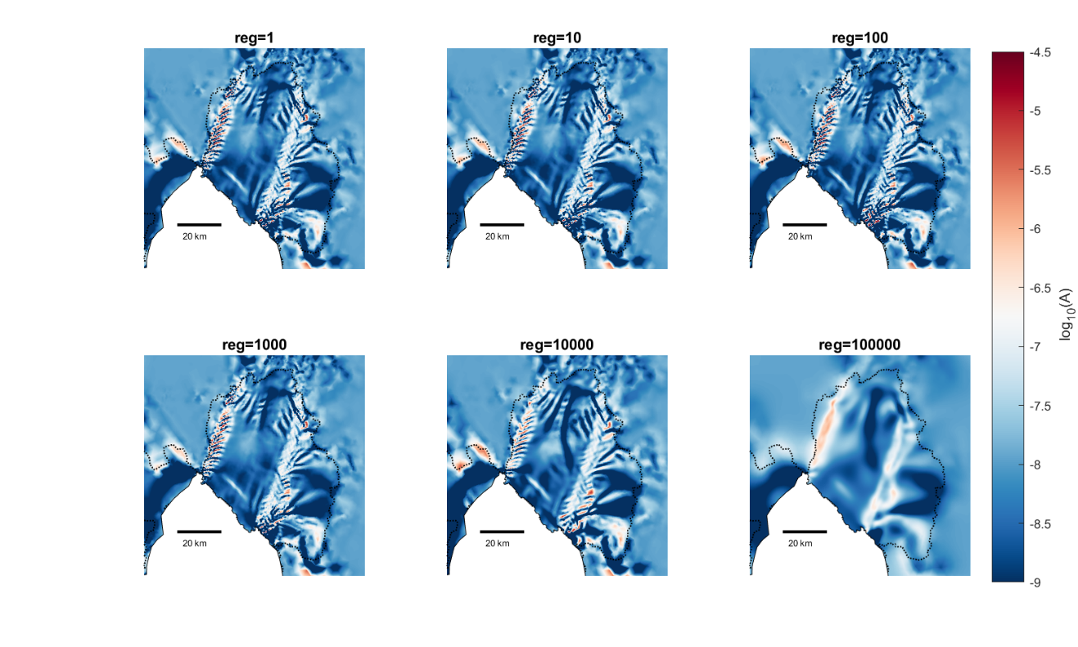

Fig. S4. Ice-softness factor $A$ as determined through data inversion to match the observational velocity field on 14-Feb-2017 using regularization parameters of different magnitude. Changing the numerical values by a factor of two did not significantly change the extent of ice-shelf areas affected by damage.

Fig. S5. Velocity differences caused by prescribing ice front retreat. This is a duplicate experiment of Joughin and others, (2021). We set up the ice-sheet model with geometry and velocity in good agreement with observational data in 2017, then perturb the ice front location by removing frontal ice to match the ice front location of 2020.

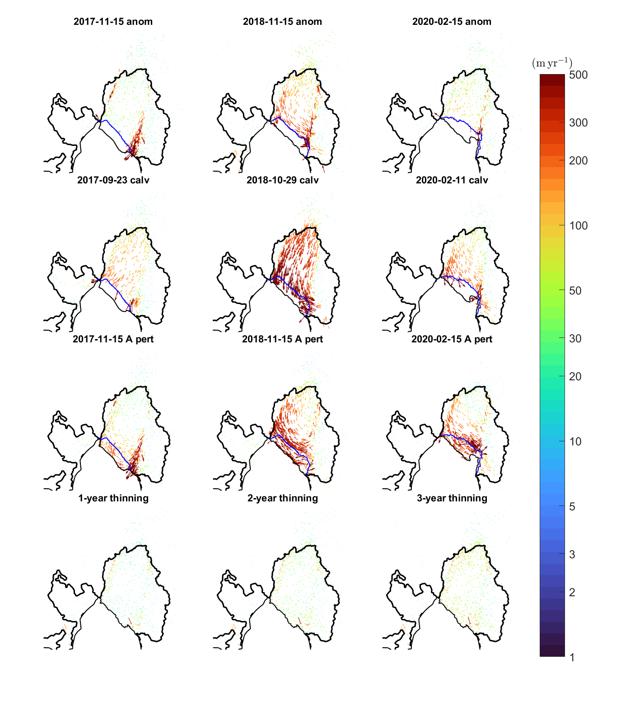Fig. S6. Top Row: observed differences in velocities before and after each of the three calving events considered (same as $a_{1}$ to $a_{3}$ in Fig. 3 main text). Second row from top shows modelled perturbations in velocities when only the calving front geometry is updated, but $A$ and $C$ distributions are unchanged (based on inversion prior to first calving event. In the third row from top, only $A$ is updated, and in the bottom row only the overall ice-shelf thickness is modified. None of these experiments replicate observations. While changing the frontal geometry (second row) does produce significant changes in velocities, these do not agree with measurements. Hence, the observations cannot be explained solely in terms of frontal geometry changes due to calving.

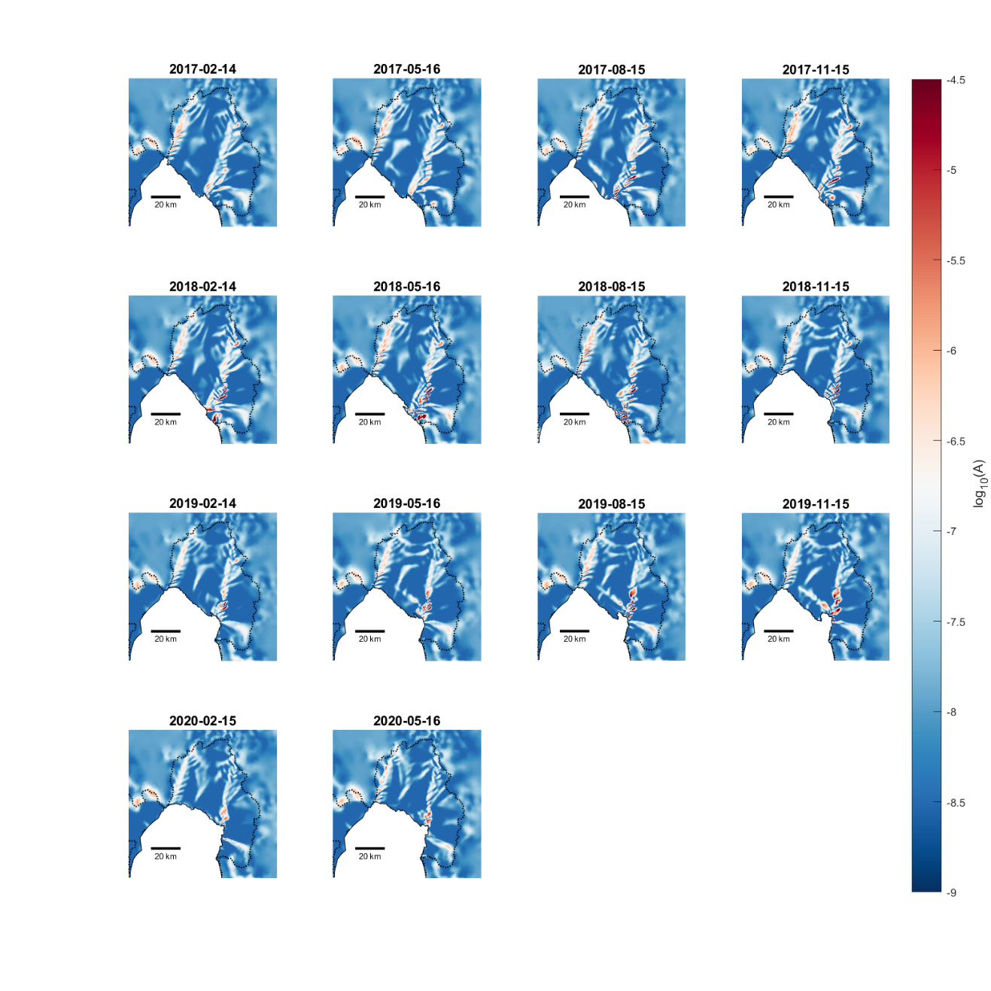

Fig. S7. Spatio-temporal evolution of the ice-softness factor $A$, as determined through data inversion inverting for both $A$ and $C$, and with the frontal geometry updated and consistent with the epoch for which the velocity data was obtained. Significant systematic temporal changes in the $A$ field can clearly be identified, particularly within the left-hand margin and towards the calving front.

**REFERENCES**

**Joughin I, Shapero D, Smith B, Dutrieux P and Barham M** (2021) Ice-shelf retreat drives recent Pine Island Glacier speedup. *Science Advances* **7**(24), eabg3080 ([doi: 10.1126/sciadv.abg3080](https://doi.org/10.1126/sciadv.abg3080))